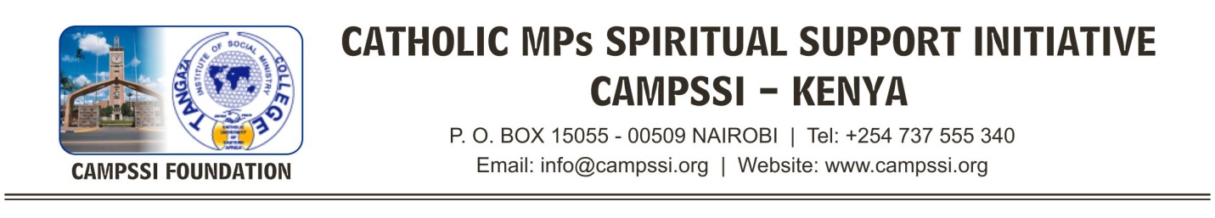
6TH OCTOBER 2017

Written Submission to the Human Rights Committee
General Comment on Article 6 (Right to Life) of the International Covenant on Civil and Political Rights
Submitted by Parliamentarians United for Africa

WE, THE UNDERSIGNED, ARE WRITING AS ELECTED AND APPOINTED REPRESENTATIVES OF THE PEOPLE OF KENYA to express our common values and express our solidarity on the importance of the family. We want to see greater emphasis on policy and programs that focus on human rights, which we believe begin at conception, not at birth. We believe that life begins at conception and are of the firm belief that the unborn child has a right to life and represent the most fragile and vulnerable member of the human family. African culture esteems the family and holds that association as the first and highest association of society. We express our deep dissatisfaction and opposition to any removal of the classification of unborn children from the human family and all necessary protections to protect the sanctity of life from conception.
Article 6 of the International Covenant on Civil and Political Rights affirms “Every human being has the inherent right to life. This right shall be protected by law. No one shall be arbitrarily deprived of his life.”
We believe that it is our duty to value and protect the entire human family from conception and do not accept any subsequent and arbitrary time period as the beginning of life or any arbitrary exclusion of the child in the womb from possessing a right to life.
We, as representatives of people in Africa, have a strong sense that life begins at the moment of conception and stand together for life, especially when our common value system is confronted by imposed external definitions of life.
We are united in opposing the provision in the General Comment that seeks to exclude unborn children from the inherent right to life and to allow their demise through abortion.
We have identified a similar concerning trend coming from Western and donor countries that seek to impose upon our countries an ideology that is contrary to our belief in protecting life from its earliest stage. In no circumstance should abortion be disguised as a “health right” or described as a “woman’s human right.” Abortion is a violent act of elimination that can never be synonymous with human rights. It is abhorrent.
We submit our objection to General Comment’s proposed denial of the right to life to unborn children and request an immediate cessation to actions that seek to redefine the right to life in a way that is contrary to our conviction that human dignity and the right to life begins at conception.

Signed,

CATHOLIC MPs SPIRITUAL SUPPORT INITIATIVE – KENYA

No. | MEMBER OF CONSTITUENCY/COUNTY | CONSTITUENCY/COUNTY
 | Hon. Dr. Chrisantus Wamalwa | Kiminini
 | Hon. Dr. Sakwa John Bunyasi | Nambale
 | Hon. Prof. Jacqueline Oduol | Nominated
 | Hon. Kimani Kuria | Molo
 | Hon. Charles Muriuki Njagagua | Mbeere Sout
 | Hon. Atanas Wafula Wamunyinyi | Kanduyi
 | Hon. David Gikaria | Nakuru East
 | Hon. Anne Wanjiku Kibe | Gatundu North
 | Hon. Patrick Musimba | Kibwezi West
 | Hon. Jude Njomo | Kiambu
 | Hon. Francis Chachu Ganya | North Horr
 | Hon. Charles N. Nguna | Mwingi West
 | Hon. Charles Kilonzo | Yatta
 | Hon. Timothy Wanyonyi | Westland
 | Hon. Sarah Paulata Lekorere | Laikipia North
 | Hon. Mary Wamaua | Maragwa
 | Hon. Guyo Ali Wario | Garsen
 | Hon. Antony Kimani Ichungwa | Kikuyu
 | Hon. Julius Melly Kipbiwott | Tinderet
 | Hon. Jeremiah Ng’ayu Kioni | Ndaragwa
 | Hon. Faith Gitau | Nyandarua County
 | Hon. Moses Kuria | Gatundu South
 | Hon. Joseph Manje | Kajiado North
 | Hon. Robert Pukose | Endebbes
 | Hon. Andrew Mwadime | Mwatate
 | Hon. Sabina Chege | Muranga County
 | Hon. Catherine Wambilianga | Bungoma County
 | Francis Munyua Waititu | Juja
 | Hon. Fernidard Wanyuonyi | Kwanza
 | Benjamin Wasjhiali | Mumias East
 | Hon. George Theuri | Embakasi East
32. | Hon. Mithika Linturi | Meru County
33. | Hon. Irungu Kangata | Muranga County
34. | Hon. Lillian Tomitom | Pokot County
35. | Hon. Emmanuel Wangwe | Navokholo
36. | Hon. Moses Injedi | Malava

END

