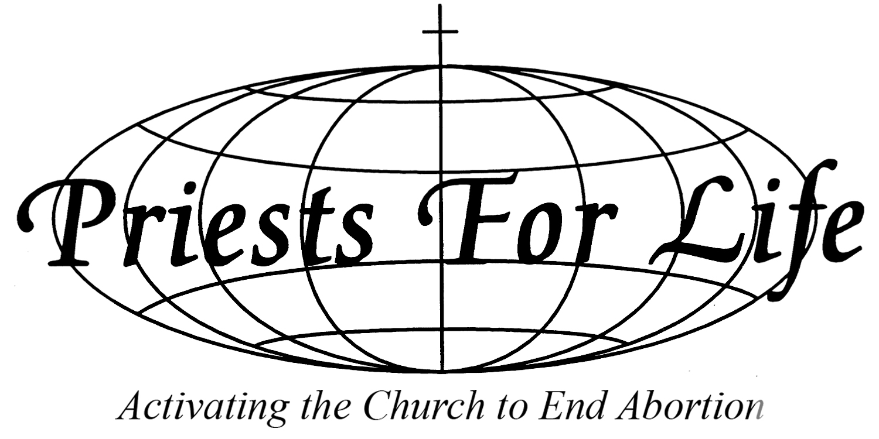

Submission to the Human Rights Committee on the Draft General Comment No.36 on Article 6 of the ICCPR – Right to life

Submitted by Priests for Life
Special Consultative Status ECOSOC

Priests for Life welcomes the opportunity to submit its observations on the draft General Comment No.36 Article 6 of the ICCPR – Right to Life. Priests for Life works to advance respect for the dignity of life and to ensure its protection at every stage of development from conception to natural death. This submission addresses our concerns with sections of the draft General Comment (GC) as they relate, and at times conflict, with advancement of human dignity and the right to life for all.
Inherent dignity of the human person
Paragraph 2 begins with the affirmation that Article 6 “recognizes and protects the right to life of all human beings” and asserts that it “is most precious for its own sake as a right that inheres in every human being, but it also constitutes a fundamental right”. Affirming the inherent right to life of every human being as precious and fundamental is a guiding principle for mankind.
The GC affirms that “No one shall be arbitrarily deprived of his life”, a statement that confirms that no human being should be perceived or treated as someone of little or no worth or not having a right to life.
Paragraph 3 upholds that “The right to life is a right which should not be interpreted narrowly” and that individuals are entitled to be “free from acts and omissions intended or expected to cause their unnatural or premature death”. This broad application makes no exception for any circumstance to justify a direct act that brings about “unnatural or premature death”.
Abortion advocacy conflicts with the right to life
Paragraph 9 is unacceptable as currently written.
Paragraph 9 presents a diametrically opposed view of the inclusive right to life presented in the preceding sections as it advocates for the taking of a life in abortion, cloaked in an euphemistic term that ignores the humanity and inherent right to life of the preborn child—“regulate terminations of pregnancy”. The only acknowledgement of the humanity of the child is in the proposal for abortion during circumstances when “the foetus suffers from fatal impairment” which advances death as a “solution” in a comment on “the right to life”.
There is no consideration in the GC of the fact that a preborn child can feel pain beginning at 20 weeks gestation—perhaps earlier— and that the violence of abortion is “cruel, inhuman and degrading treatment or punishment” as proscribed by article 7 of the ICCPR (prohibition of torture or cruel, inhuman or degrading treatment or punishment). Nor is there any recognition of the fact that the right to life of children in the womb is increasingly benefitting from in utero medical treatments and corrective surgeries.
The diverse laws of Member States on abortion are not respected in the GC. Globally, more countries protect the unborn in law and restrict access to abortion than allow abortion on demand. The 2014 U.N. report “Abortion laws and other reproductive rights policies and data around the world” reveals that “only about one third of countries (36 per cent) permitted abortion for economic or social reasons or on request.”
Paragraph 64 addresses the critical issue of violence against women and girls but the GC is devoid of any mention of this very first act of gender-based violence directed against girls—sex selection abortion. This deadly act of discrimination destroys the lives of tens of millions of girls but is shockingly absent in the GC. The right to life of baby girls needs to be protected around the world before birth if their lives are to free of from violence and discrimination after birth.
Paragraph 9 conflicts with Paragraph 2 and its admonishment that “No one shall be arbitrarily deprived of his life” and Paragraph 3: “Article 6 guarantees this right for all human beings, without distinction of any kind including for persons suspected or convicted of even the most serious crimes.”
The failure to apply the right to life to children in the womb creates an exception based on the distinction of their age— first stage of the life cycle— and location in the womb.
Paragraph 2 rightfully affirms that the right to life “is the supreme right from which no derogation is permitted” acknowledging that the “right to life has crucial importance both for individuals and for society as a whole”.
Prenatal Right to Life
Paragraph 52 acknowledges the unborn child’s independent right to life by prohibiting application of the death penalty on pregnant women. Regrettably, there is a lack of consistency and cohesion in the GC’s selective and arbitrary acknowledgement of the right to life failing to apply it during the first stage of human life and only recognizing it prenatally when it is threatened by application of the death penalty.
This contrasts with the American Convention on Human Rights which recognizes the child’s right to life and prohibits the death penalty for pregnant women. The Convention acknowledges the right to life of the child existing from conception: “Every person has the right to have his life respected. This right shall be protected by law and, in general, from the moment of conception. No one shall be arbitrarily deprived of his life.” The Convention also bans application of capital punishment to pregnant women: “Capital punishment shall not be… applied to pregnant women.”
Duty to protect the right to life
The first line of the ICCPR Preamble declares, “…recognition of the inherent dignity and of the equal and inalienable rights of all members of the human family is the foundation of freedom, justice and peace in the world,” and “Recognizing that these rights derive from the inherent dignity of the human person.”
The ICCPR recognizes a duty stated in the Preamble that applies to all: “Realizing that the individual, having duties to other individuals and to the community to which he belongs, is under a responsibility to strive for the promotion and observance of the rights recognized in the present Covenant.”
The “recognition” that human beings have "inherent dignity" in Paragraph 2 is an acknowledgement that governments and international bodies can neither bestow nor remove human dignity. They exist to preserve and protect inherent rights beginning with the right to life, beginning when life begins—at conception—and ending at natural death. Paragraph 10 introduces concepts that endorse a “right to die”, in direct conflict to the right to life.
Paragraph 30 informs that “The duty to protect life also implies that States parties should take appropriate measures to address the general conditions in society that may eventually give rise to direct threats to life or prevent individuals from enjoying their right to life with dignity”. It can be argued that when government and society fail to provide a pregnant woman with the necessary support she needs for her child, fail to provide access to critical maternal health care, nutrition, and skilled birth attendance to ensure that both mother and child survive and thrive, they fail in their duty to adequately protect the right to life of both.
This failure manifests in the high rate of child mortality, especially newborn mortality, in the world today that ends the lives of over 2.9 million newborns a year. More than 800,000 babies — one in four newborns — die each year because they are born too soon or too small as a result of poor maternal nutrition.

Conclusion
Abortion by its very nature is in conflict with the right to life. The lives of children living but not yet born are deserving of protection as members of the human family and holders of an independent right to life by virtue of their human status. By advancing abortion while denying preborn children a right to life, the HRC fails in its duty to protect the rights of all human beings.
This failure renders an unborn child’s right to life contingent on whether or not she is “wanted” by another, considered “an inconvenience” or “a threat”, or deemed “not perfect” enough.
Selective exclusion of the “right to life” for any member of the human family impacts the right to life of all by bestowing an arbitrary status to an inalienable right.
It is our collective duty to ensure that no one is left out and that all are assured of their right to life. This includes unborn children who, as the youngest and most vulnerable members of the human family, represent the most at risk group in the world today. The GC is in conflict as it advances abortion—a denial of the right to life based on arbitrary measures— while stating that “no one shall be arbitrarily deprived of his life and that the right shall be protected by law”.
Priests for Life believes that the recognition of the “Right to life” for every human being cannot exclude the unborn or consider their inherent right to life “an exception” to the Article.

United Nations, Department of Economic and Social Affairs, Population Division. Abortion policies and reproductive health around the world, 2014. http://www.un.org/en/development/desa/population/publications/pdf/policy/AbortionPoliciesReproductiveHealth.pdf
The American Convention on Human Rights, Inter American System of Justice, Article 4.1.
Ibid, section 5.
“Levels & Trends in Child Mortality”, United Nations Inter-agency Group for Child Mortality Estimation (UN IGME), 2013. http://www.data.unicef.org/fckimages/uploads/1410869227_Child_Mortality_Report_2014.pdf

