Draft general comments (No. 36) on art. 6 of the International Covenant on Civil and Political Rights with regard to the right to life (article 6 of the Covenant)
Submission to the UN’sCommittee on Human Rights
from Shout For Life Association, Hungary
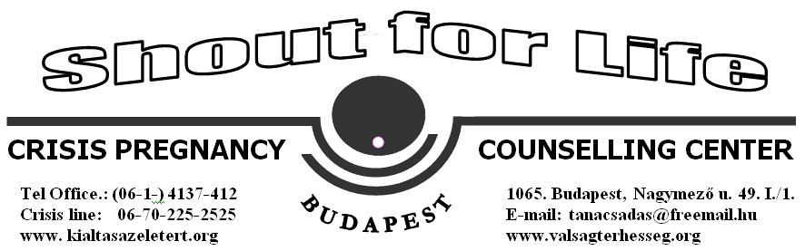

Email: valsagterhesseg@gmail.com

International Covenant on Civil and Political Rights art. 6.1: “Every human being has the inherent right to life. This right shall be protected by law. No one shall be arbitrarily deprived of his life.”

1. Introduction
Shout For Life is an association established in 2000 with the aim to protected all Human life from conception on-wards.
We provide:
- Free pregnancy tests and pregnancy counseling
- Abstinence counseling/education
- Post abortion healing counseling and seminars
- Maternity help
- Training seminars
Especially during Post abortion counseling/healing seminars we regular receive girls who are hurt by a former abortion and are in desperate need for emotional healing.
We also have worked closely together with Silent no More initiatives who have dealt with numerous cases of women who have testified of being hurt by a former abortion, and regret their former decisions of abortion.
We also closely work together with “Schreeuw om Leven” in Holland in their work against euthanasia that has grown exponentially in Holland and has unfortunately taken life's of people even against their will.
We there fore strongly oppose the interpretation of the right to life as including abortion and assisted suicide, as it is now in paragraphs 9 and 10 of the General Comments see the following points:

2. Paragraph 9

The right to life is the most foundational right under the law. Noting that human rights’ institutions must protect the most vulnerable, and that unborn children are human beings and members of the human family, we urge the Committee to change pharagraph 1.9.
According to Paragraph 1. 2 “the right to life is a right which should not be interpreted narrowly,” and, “Article 6 guarantees this right for all human beings, without distinction of any kind”.
Noting that the unborn children are also human beings, and they are the members of the human race, and that there is no right to abortion under international law,weurge the UN Human Rights Committee to recognize that children in the womb also have the right to life, so that, under no circumstances, can they be excluded from Article 6 of the International Covenant on Civil and Political Rights.

We call upon the Committeenot to undermine the national sovereignty of Member States.Article 2 of the Hungarian Constitution states: “Human dignity shall be inviolable. Every human being shall have the right to life and human dignity; the life of the foetus shall be protected from the moment of conception.”Thereforewe, Hungarians, can not accept Paragraph 1.9. which contradicts with Hungarian Constitution that is in line with the Preamble of the Convention on the Rights of the Child, which gives legal protection to children, “before as well as after birth” and Art. 6. of the same convention which, “guarantees this right for all human beings, without distinction of any kind.”

3. Paragraph 10
Neither the ICCPR,nor other international institutions, recognize a “right to die”. The European Court of Human Rights has found that the right to life “cannot, without a distortion of language, be interpreted as conferring the diametrically opposite right, namely a so-called right to die.”

Noting that human rights’ institutions must protect the most vulnerable (like the elderly or terminally-ill people), we urge the Committee to change pharagraphs 1.10 of the General Comments, to not include assisted suicide in any form, but, rather, to include the promotion and strong support of palliative care, and other means to improve the quality of life of those who suffer catastophic accidents, those who are terminally-ill, and, or, all those who experience severe physical or mental pain and suffering.

4. Conclusion
We strongly oppose the interpretation of the right to life as including abortion and assisted suicide, as it is now in paragraphs 9 and 10 of the General Comments.When speaking of universal human rights, the United Nations should apply them to all human beings, including human beings who have not yet been born, as well as the elderly and the terminally-ill.

In conclusion, we ask that paragraph 9 be completely changed, or - at least - omitted. In addition, the right to life of the unborn child must be included in the drafting of the GeneralComment. We also ask that paragraph 10 be changed, so asnot to include assisted suicide, in any form, but, rather, to include the promotion and strong support of palliative care, and other means to improve the quality of lifeof people in need.

UN General Assembly, International Covenant on Civil and Political Rights, 16 December 1966, United Nations, Treaty Series, vol. 999, p. 171, art. 6.1.
Vo v. France Appl. No. 53924/00; (2005) 40 EHRR 12Id., § 84.
Hungary 2011 (rev. 2013).
Pretty v. the United Kingdom, no. 2346/02, 29 April 2002 §§ 39-40 (Chamber judgment).

