**Ein Bild, das Text enthält.
**

**NEWSLETTER: COMMITTEE ON ENFORCED DISAPPEARANCES**

***Third edition***

**Geneva, 23 December 2020**

**10th ANNIVERSARY OF THE ENTRY INTO FORCE OF THE CONVENTION FOR THE PROTECTION OF ALL PERSONS FROM ENFORCED DISAPPEARANCE**

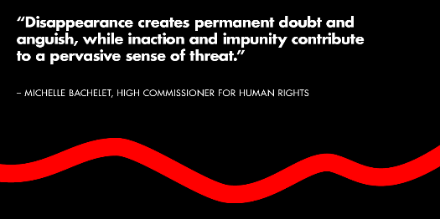

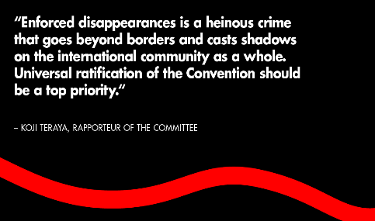

Ten years ago, on 23 December 2010, the International Convention for the Protection of All Persons against Enforced Disappearance entered into force. Lots has been achieved throughout these 10 years, but far more remains to be done to eradicate and prevent enforced disappearances around the world.

On this occasion, the Committee and its Secretariat want to reiterate their full commitment to support victims, States, civil society organizations, national human rights institutions and all actors involved in the fight against enforced disappearances, and send a new call for action to all States to ratify the Convention.

Below, you will have access to a video, a radio podcast and articles that have been released on 23 December 2020, as well as access to a ten day tweeter campaign published on the new [Treaty Bodies tweeter account](https://twitter.com/UNTreatyBodies) (<https://twitter.com/UNTreatyBodies>). Do not hesitate to retweet, share and use this material.

* ***A ten day tweeter campaign*** on the [Human Rights Treaty Bodies tweeter account](https://twitter.com/UNTreatyBodies)

See [#EnforcedDisappearances](https://twitter.com/hashtag/EnforcedDisappearances?src=hashtag_click) [#CED10](https://twitter.com/hashtag/CED10?src=hashtag_click)

[#CED10](https://twitter.com/hashtag/CED10?src=hashtag_click) [#StandUp4HumanRights](https://twitter.com/hashtag/StandUp4HumanRights?src=hashtag_click)

* **A call for action to ratify the Convention** through a [video featuring members of the Committee and its Secretariat](https://fb.watch/2yUHSo_DZC/) (French and Spanish versions of the video will be released in January): “No State, be it in the North, South, East or West, is immune from the risk and corrosive effects of enforced disappearance.” The Committee on Enforced Disappearances and its Secretariat work daily to support victims, civil society organizations, National Human Rights Institutions and States to eradicate and prevent this heinous crime. Universalizing the Convention for the Protection of all Persons from Enforced Disappearance must be a pressing priority for all.
* ***A webstory on*** [***OHCHR webpage***](https://www.ohchr.org/EN/NewsEvents/Pages/CED10.aspx) ***and*** [***blog site***](https://unhumanrights.medium.com/bringing-justice-to-the-disappeared-5e4e8c75e149)***:***

[Convention helps bring justice and focus to the disappeared](https://www.ohchr.org/EN/NewsEvents/Pages/CED10.aspx): “I want the Committee to help with advice and support to ensure that those responsible are brought to justice. I am pleading with the Committee to help and support the victims of enforced disappearances. I want the Committee to guide my government to take action.” The issue of enforced disappearances is not an artefact from the past, but continues to happen today. Adopting the Convention shows support to the countless thousands of victims across the globe.

* **A press release:** on 22 December 2020, the [Committee registered its 1,000th urgent request to locate victims](https://www.ohchr.org/EN/NewsEvents/Pages/DisplayNews.aspx?NewsID=26616&LangID=E) of enforced disappearance. This case relates to the disappearance of Mr. Arshad Haibat Fakhry on 20 November 2020, when he was taken by armed uniformed individuals from the Ishtar Sheraton Hotel in Baghdad where he was working. While #EnforcedDisappearance is occurring across the world and in various contexts, only 63 States have ratified the Convention. Many more States must demonstrate to the world their commitment to ending this crime through the urgent ratification of the Convention.
* **An article by UNOG (in French):** [Disparitions forcées : il y a dix ans, la Convention suspendait le temps](https://www.ungeneva.org/fr/news-media/news/2020/12/disparitions-forcees-il-y-dix-ans-la-convention-suspendait-le-temps): Face au crime de disparition forcée, il fallait absolument « suspendre le temps jusqu’à ce que le cas soit élucidé», comme le préconisait [Louis Joinet](https://information.tv5monde.com/info/mort-de-louis-joinet-un-epris-de-justice-322868). C’est précisément ce à quoi est parvenue la Convention à travers l’article 24, qui consacre le droit de savoir. Mais des défis subsistent. « Aucune femme, aucun homme ni aucun enfant ne devrait jamais être effacé, en secret, de la surface de la terre. Il est essentiel d’assurer la ratification universelle de la Convention », a rappelé il y a quelques jours la Haute-Commissaire aux droits de l’homme, Michelle Bachelet. Aucune circonstance exceptionnelle ne peut être invoquée pour justifier une disparition forcée. Les victimes doivent savoir que le Comité peut leur venir en aide, à condition que les Etats démontrent officiellement leur engagement contre ce crime odieux en ratifiant la Convention.
* **Radio podcast (in French)**: accessible on [PODBEAN](http://www.onuinfogeneve.podbean.com) and [SPOTIFY](https://open.spotify.com/episode/4uXYiGvroRtK25WMT7XOHc): Les disparitions forcées représentent aujourd’hui un défi majeur à relever dans le domaine des droits de l’homme. Les défenseurs des droits de l’homme, les journalistes, ou les membres de l’opposition sont particulièrement visés par cette pratique répandue aux quatre coins du monde. Ce 23 décembre marque le 10e anniversaire de l’entrée en vigueur de la Convention pour la protection de toutes les personnes contre les disparitions forcées. Pour évoquer la Convention et le travail du Comité sur les disparitions forcées, nos deux invités cette semaine sont: Albane Prophette-Pallasco, la Secrétaire du Comité sur les disparitions forcées, et Olivier de Frouville, Professeur de droit public à l’Université Paris 2 - Panthéon Assas et expert de ce Comité.

*With this newsletter, the Committee on Enforced Disappearances (CED) aims at strengthening its links and interaction with victims, civil society organizations, experts, State authorities and other stakeholders, and inform about its work. It contains information about the activities of the Committee, its sessions and the decisions and recommendations adopted in that context, and about relevant developments related to the Committee’s work.*

If you do not wish to receive this newsletter, please let us know sending an email to [ced@ohchr.org](mailto:ced@ohchr.org), and we will proceed accordingly. In case of interest, do not hesitate to share this newsletter with your respective networks. Interested stakeholders can subscribe to this newsletter by sending an email to [ced@ohchr.org](mailto:ced@ohchr.org)