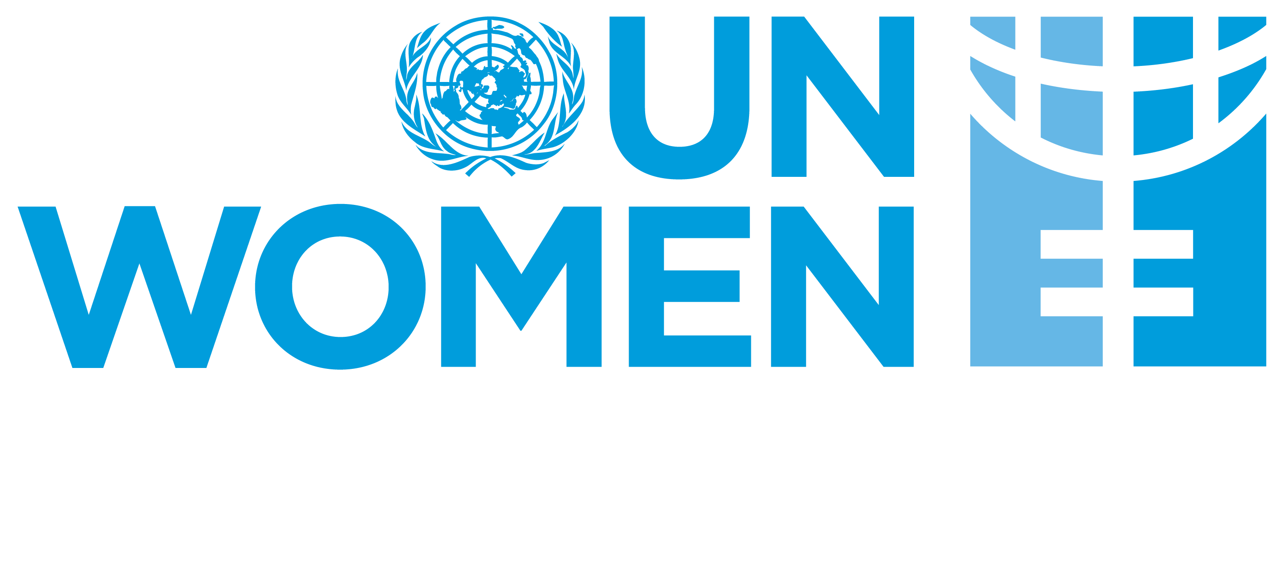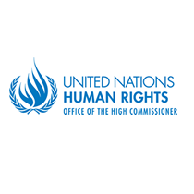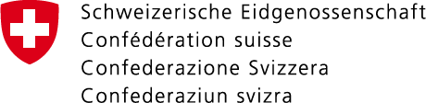

**CEDAW and Women, Peace and Security: Strengthening the Synergies for Better Implementation and Accountability**

**Side event during the seventy-second session of the CEDAW Committee**

**Geneva, Palais des Nations, Room XVI**

**1 March 2019, 13:00 – 15:00**

**Agenda**

|  |  |
| --- | --- |
| 13:10 – 13:25 | **Welcoming Remarks** s. Hilary Gbedemah, Chair of the CEDAW Committee  n Rights  **Ambassador Daniel Klingele**, Deputy Director of the Directorate of International Law, Federal Department of Foreign Affairs  **Mr. Ibrahim Salama**, Chief, Human Rights Treaties Branch, Office of the High Commissioner for Human Rights |
| 13:25 – 14:10 | **Panel Discussion: Strengthening the Synergies between CEDAW and WPS. Where are we today, and how can we move forward?**  **Pramila Patten,** Special Representative of the Secretary-General for Sexual Violence in conflict (joining via video message)  **Bandana Rana**, Chair of the CEDAW Task Force on WPS women, peace and security  **Hanaa Edwar,** Co-founder, Iraqi Women’s Network  **Christine Loew,** Director of UN Women Liaison Office Geneva  **Moderator: Mavic Cabrera Balleza,** CEO, Global Network of Women Peacebuilders |
| 14:10 – 14:15 | **Intervention from the floor**  Ambassador Elisabeth Tichy-Fisslberger, Permanent Representative of Austria to the United Nations Office in Geneva |
| 14:15 – 14:30 | **Question and answer session** |
| 14:30 – 14:40 | **Final thoughts from the panelists** |
| 14:40 – 14:45 | **Closing remarks**  Mavic Cabrera Balleza, CEO, Global Network of Women Peacebuilders  Ms. Hilary Gbedemah, Chair of the CEDAW Committee |