RIGHT OF INDIGENOUS WOMEN
A REPORT BY THE ADI SHAIVITE MINORITY TRADITION (ASMT) HINDU COMMUNITY
JUNE 2021
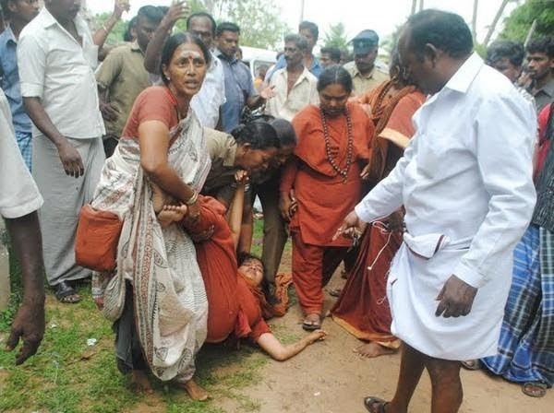

Introduction
- The human rights situation for women and children in India is abysmal. Despite tremendous public outcry against crimes against women and children such as rape, sexual violence, gender-based harassment, and female infanticide happen unabated in India. The State of the Republic of India has been either unwilling or unable to curtail these crimes. India is the most dangerous country for sexual violence against women, according to the Thomson Reuters Foundation 2018 survey. According to the National Crimes Records Bureau, the rape of minor girls increased by 82% in the year 2016 compared with the previous year. Sexual violence and brutal rape have been weaponized against minority women and children by extremist militant elements at the highest levels of governance. This weaponization of sexual violence targeting women and children is part of a more pervasive and systematic campaign targeting certain indigenous spiritual traditions, minority communities, and their leaders, especially those from linguistic and religious minority groups, and of dark-skinned people of indigenous spiritual traditions, and of ethnic native-Hindu tribes that have existed in India for millennia. One such indigenous spiritual tradition currently targeted for extermination by the Neo-Hindutva extremist militants is the Hindu Adi Shaiva Minority Tradition (“ASMT”) in India. The women, children, and young girls of the ASMT community were the most vulnerable target of the Neo-Hindutva extremism.
- The ASMT explicitly rejects extremism of all types. The extremist militant elements are opposed to ASMT’s stance when it comes to the rights of women, including otherwise marginalized Dalit women, and the rights of members of the LGBTQ+ and transgendered communities. The neo-Hindutva terrorists despise Hindu women in monastic and priestly roles. The spiritual head of ASMT has publicly declared himself to be transcendental gender and possessing multiple gender components. The neo-Hindutva extremists see LGBTQ+ rights as immoral. The ASMT freely ordains women into Sannyasa (the monastic order), recognizes 11 genders, and performs specific temple rituals for gay marriage, as per more than 5000-year-old indigenous spiritual scriptures. The ASMT represents one of the most progressive ideologies and is a target of persecution by the neo-Hindutva extremists.
- ASMT tradition is ancient. Around 3200BCE, the Mahabharata war ended in the Indian sub-continent. At that time, at least 56 nations in Asia gave shelter to more than 10,000 Hindu communities and protected the rights of women. These 56 nations spanned from Gandhara (in Afghanistan) to Kadaram (Kedah in Malaysia). The town of Parshu in present-day Iran finds mention in ancient Hindu scriptures as a Hindu city today has no Hindu men or women. The four thousand indigenous people of Kalash (Chitral Valley, Pakistan), the only survivors of the ancient ASMT tradition in the region though separated over a distance of 10000 KMs, are no different from indigenous Adi Shaivas of Kashmir (North India), or indigenous Adi Shaivas of Tamil Nadu (South India), or the Adi Shaivas of Bali (Indonesia). Although Hinduism is alive as a culture, its political and religious legitimacy was wiped from the geography of Asia, as these nations got invaded and colonized. These invasions caused a genocide, where per estimates 80 million to 400 million people were killed through massacre, mass gang rapes, and torture. Thousands of temples, universities, and libraries were destroyed. The ten thousand Hindu communities which existed by 3200BCE were reduced to three thousand.
- In Hinduism, the highest reverence is attributed to the Guru (the spiritual guide in the body, or, in principle in the form of teachings as scripture, or a worshipped Deity). Hindu scriptures declared, “Indeed, the Guru is the whole universe….There is nothing higher than the Guru. Therefore, worship the Guru.” In Hindu families, the mother is worshipped as the first Guru of the child. In Hinduism, all women are not merely respected as equal to men, rather worshipped as a manifestation of Devi Parashakti (supreme primordial cosmic divinity). In Hinduism, young girls are worshipped from infancy as an incarnation of Divine mother Goddess as worship of it is considered to bring fortune and well-being.
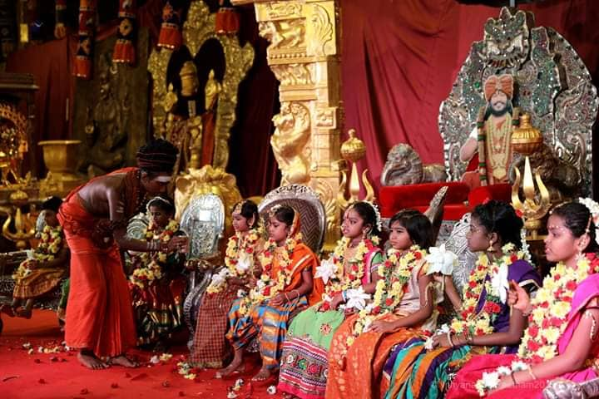
(Oct 2018) As part of the festival of Navaratri, a young ASMT girl receiving Kumari Puja, a ritual where Devi Parashakti (primordial Hindu divinity and supreme God) is invoked in women and small girls, and puja (worship) is offered to them.
- In ancient Hindu nations, some young girls, who cognized themselves as a manifestation of Divine Mother, chose to never marry any human and dedicated themselves to the administration of Hindu temples and worship of the Deity (or God) of the temple. There were many such monastic traditions, such as Rudrakanyas (Daughters of Lord Rudra) and Devadasis. Colonial views on Devadasi were highly subversive, leading to their socio-economic deprivation and exploitation. The colonial-era government of India ran State-sponsored brothels through several legislations. This practice was severely criticized by citizens of England and other European countries. British Government also established institutions known as Lock Hospitals where women were brought to be treated for venereal diseases. However, many of the women admitted to these hospitals, including many Devadasi, were identified through the registry and were brought to the hospitals against their will. A number of these women were never seen again by their families. Over time through hate literature, the Hindu nuns (Rudrakanyas and Devadasis) were stigmatized as prostitutes during the colonial era. After independence, the State of Tamil Nadu passed legislation criminalizing the tradition. This bill, stereotyped and marginalized the Devadasis by addressing them as prostitutes. The will was opposed by Devadasis but enacted and made into a law. This reinforced the colonial stigma around the tradition undermining the human rights of Hindu nuns.

Challenges face by ASMT women

(a) Shaming of child rape victims by media
- In 2009, a twelve-year-old ASMT girl was kidnapped and molested by a Neo-Hindutva extremist. The US courts sentenced the child rapist to 57 months imprisonment. This did not remedy the damage. The child rapist filed several vexatious litigations in India and the US. In the US, these false allegations by the child rapist, such as calling the child a “liar”, and her parents and community part of a “brainwashing”, “cult” etc., were all rejected by the court with a penalty for defamation with cost. This did not deter the neo-Hindutva media from victimizing the child with hours of hate speech on television, for which one Samaya TV was penalized USD 5 Million by a US court. Even this has failed to redress the situation.

(b) Shaming and sexual objectification of women and girls by media
- In India, the Neo-Hindutva media ran 14,000 hours of hateful programs marginalizing ASMT actress Ranjitha, ASMT nuns, ASMT women, and girls who had been raped by neo-Hindutva militants. The neo-Hindutva media publicly addressed them as “brainwashed”, “sodomized disciples”, “witches”, “prostitutes”, “cult worshippers”, (child) “sex slaves”, and also published violence-inciting prejudicial narratives such as “Hang the Sin Swamis (Hindu monks and nuns)” etc. Previously, before the sensational release of the doctored video, the senior and aged female monks who used to attend phone calls of devotees seeking spiritual counseling were faced to pick up phone calls demanding prostitution from them. Several media houses continue to publish such defamatory articles, causing marginalization of the ASMT women and girls, and dangerously inciting mob violence and rape against them.
- People have resorted to violence after reading or watching such material, as perpetrators have directly commented on the online versions of these media clips openly accepting that they have “hit one nithyananda people”, and also suggesting others should do the same by saying, “I request everyone to hit them nicely. Even don't show courtesy for women in nithyanandha ashram. They are the most dangerous.”
- 18 Jan 2018, young female nun Ma Nithyananditha received death threats over the phone by fans of V. Ramasamy, Ma Nithyananditha had voiced out against defamatory sexualization of Hindu female saint Aandal by V. Ramasamy and politically owned media. Several obscene morphed videos depicting Ma Nithyananditha and other ASMT children were uploaded on social media by followers of Ramasamy.
- ASMT as a tradition fundamentally respects women as embodiments of divine mother Goddess, and it is extremely painful for the community to witness this smear campaign, on ASMT women. This smear campaign is not just limited to ASMT women, ASMT female monks, but the most vulnerable target of this persecution, are the ASMT girls, especially those minor girls who pursue religious studies to become nuns.
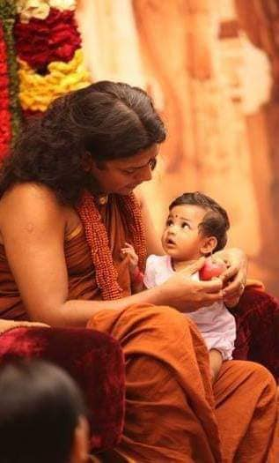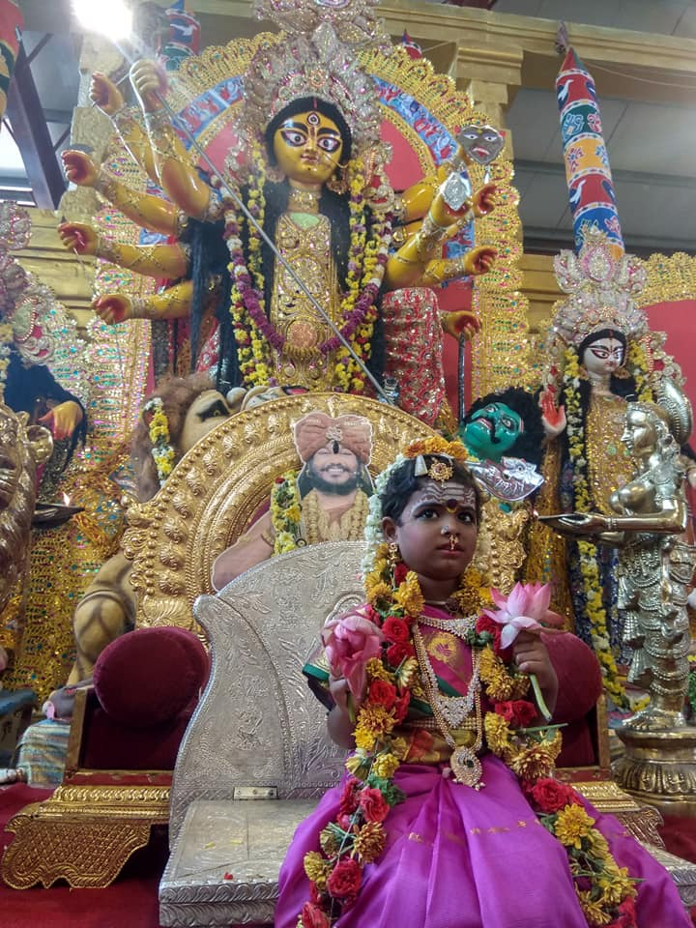
(LEFT) The SPH Nithyananda Paramashivam, with a girl child of a pre-monastic family member.
(RIGHT) 17 Oct 2018: As part of the festival of Navaratri, a young ASMT girl waiting for Kumari Puja, a ritual where Devi Parashakti (primordial Hindu divinity and supreme God) is invoked in a small girl, and puja (worship) is offered to Her. (link to album)
- Many ASMT girls who have now grown up to become nuns, had grown up in the lap of the SPH Nithyananda Paramashivam and strongly relate with Him not just as a Guru but a father figure also. As per the law in India Hindu nuns are allowed to have the name of their Guru in the place of their father in their passports. It is extremely traumatizing for these girls to be sexually linked with the SPH by the Indian media.
- The media targeted ASMT minor girls by publishing their pictures in the national newspapers with vulgar captions. Young ASMT female monks were sexually linked with their Guru (spiritual guide and leader), the SPH, by entire cover page and several pages of yellow tabloids being dedicated to malign sacred sentiments of disciple hood. The media published fake interviews of ASMT actress Ranjitha defaming her for being a disciple of the SPH. Nakkheeran Gopal and other media heads pressured Ranjitha to commit suicide and circulated false news of the same in media as a rumor.
- Such targeted persecution of Hindu nuns and female religious leaders is not limited to the ASMT but is aimed at destroying the rights of indigenous female spiritual leaders. Vexatious litigations have been used to persecute female Hindu spiritual leaders of minority communities on absurd allegations of indecent dressing booking it under anti-superstition laws.

(c) Intersectional sexual abuse of ASMT nuns especially targeting those from Dalit communities
- An ASMT female monk from Dalit origin, Ma Nithya Supriyananda Swami, has faced intersecting discrimination for multiple reasons (1) ASMT origin (2) Dalit origin (3) Female monk (nun). Ma Nithya Supriyananda heads the Tamil language publication department of an ASMT monastery. On 9 May 2010, she and her team were addressed as “sex slaves” by Tamil yellow Tabloid writer Charu Nivedita. She filed a defamation case against the magazine and writers, which has been pending in the courts for a decade.

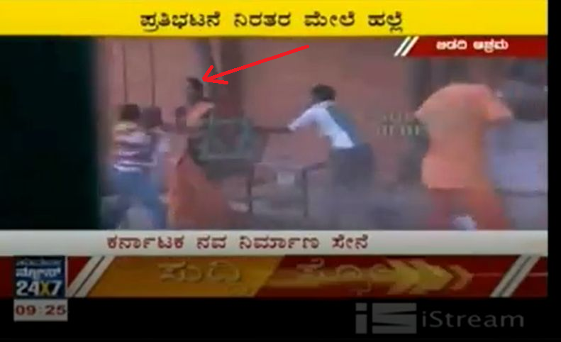  7 June 2012: Ma Nithya Jnanatmananda Swami protecting herself with a chair while Suvarna TV channel journalists and associated Nav Nirman Sene militants molest and attempt to rape her. | 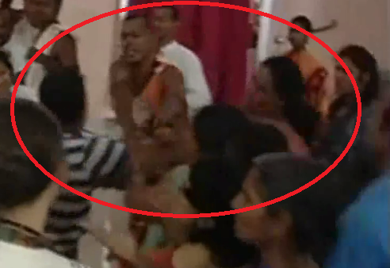  8 June 2012: Ma Nithya Achalananda Swami was molested and groped by Suvarna TV channel journalists and associated Nav Nirman Sene militants. (See Video clip)

- 7 Jun 2012, BJP owned Suvarna TV’s chief editor Ajith and the militants sexually assaulted female monks beat up ASMT members present on the campus. They gang-raped ASMT nun Ma Nithya Jnanatmananda Swami. This criminal act was live broadcasted on national and regional television. 28 Oct 2015, an ASMT female monk was molested and escaped an attempted rape by a neo-Hindutva militant who was declared innocent in a subsequent court trial. Ma Nithya Jnanatmananda Swami watching her sister monks being raped and denied justice was forced to flee India because of blackmail by terrorists threatening her to withdraw the case. The case filed by the ASMT nun is still pending in courts as of 2021. In the same attack of June 2012, Ma Nithya Achalananda Swami was also sexually and physically assaulted by Ajith and other militants who groped her chest and recorded it on camera to blackmail her and used it to publicly shame her. The summons issued by the court for Ajith to appear has not been delivered by the police.

(d) Image morphing deepfake technology to publicly shame women and girls
- In the last decade, especially in India, there has been an alarming trend in the mainstream media and social media of sensational screening and manufacture of misinformation and hate speech that is marginalizing minority communities, especially targeting women with the use of image morphing and deep-fake videos. Although there are many instances of attacks against followers of the ASMT and their spiritual leader, a particular focus of attacks has been a fabricated video of 2010 of the ASMT actress Ranjitha. The video was repeatedly and sensationally broadcasted by Sun TV and various media channels to defame her character, and to delegitimize her Guru the Supreme Pontiff of Hinduism (SPH), Jagatguru Mahasannidhanam (JGM), His Divine Holiness (HDH) Bhagavan Sri Nithyananda Paramashivam. Forensic examinations have shown the video to be fabricated, super-imposing videos of the two individuals. The Chief Operations Officer of the Sun TV, a politically owned media house run by the DMK party, gave a media interview and affidavit in a US court acknowledging the detailing the history and methodology of the blackmail and extortion followed by the channel, particularly in targeting the ASMT community and its leader the SPH involving the fabricated video. This confession and affidavit did not remedy the situation as the channel kept victimizing the actress.

(e) No Legal Recourse Available in India especially for women from a marginalized background
- The ASMT actress, Ranjitha, petitioned in the Karnataka High Court and all available forums for several years. Although the courts ordered in her favor restraining the misinformation and telecast of fabricated deep-fake videos, the neo-Hindutva media kept pushing the implementation of the order to various quasi-legal institutions (self-regulatory bodies run by the media itself). Finally, the media self-regulatory quasi-legal body, the NBSA ordered its member channels to remove fabricated defamatory videos from their websites. None of the media houses complied with the order and kept reuploading, re-telecasting the same footage, and continue the misinformation propaganda to date. Any complaint on media in the High Court is redirected to NBSA, BCCC, or other such bodies which do not even have a website listing their policies to self-regulate. The NBSA as a self-regulatory body is toothless and is known to disregard its own guidelines and orders even when the member channels ridicule and shame dead celebrities. The NHRC (National Human Rights Commission) has maintained silence on the subject and pushed the responsibility on the State executive. A politically owned neo-Hindutva media channel aired a media report where it accused the ASMT leader SPH Nithyananda Paramashivam of raping His own biological mother (a Hindu nun) on the occasion of His father’s sad demise. The channel went on to justify their sadist sexual objectification of Hindu nuns terming it as “unbiased reporting”. Indian Courts are unwilling or unable in protecting ASMT women, especially nuns and children.
- Even where ASMT nuns, ASMT women, and girls have won legal battles, it has been futile as these court orders were never executed as seen in the case of Ranjitha versus several media houses. The ordeal of Ranjitha or other ASMT women and nuns is not unique – court orders are not executed by the government executive, especially in absence of political motivation. The Indian government and Indian State departments are perceived as one of the most corrupt in the world. The mainstream Indian media and social media influencers exercise a massive influence on the masses and even the Court judges. The media is easily able to sway public opinion and even sway the opinion of judges. In a court proceeding directly involving the ASMT, the court explicitly mentioned how the court was prone to prejudice by this negative media propaganda. Though media can influence the judiciary in India, the court judgments are toothless in curbing the media's hate propaganda. Neo-Hindutva media wilfully dishonors court orders without any consequence. Though there is a possibility of legal recourse outside India, wherein 2017, a US Court penalized a neo-Hindutva media to the tune of $USD 5 Million for civil conspiracy, defamation targeting the ASMT community, and secondary victimization of an ASMT child-rape victim, such avenues are neither accessible to most nor legally tenable in all situation.

(f) State Terrorism
- 17 Sep 2013, the Karnataka State Department of Women and Children forcibly, cruelly, and illegally interrogate children in the ASMT school (Gurukul). The interrogation was done without the consent of the parents, with no video recording of the examiners, late-night beyond the time permissible by law. The State interrogators shamed and ridiculed the children, particularly girls for their dress, pressured them to quit their spiritual-religious lifestyle, and forced children to eat unhealthy substances avoided in the ASMT lifestyle. The lawyer of the school was sued by the State for intervening in the violation of the rights of children and parents. Several such raids were done by the State and many vexatious legal proceedings and orders were executed by the State to forcibly shut down the school.
- In November 2019, the Gujarat State government (CWC) Child Welfare Commission officials raided the female monastery and molested the children studying there. The CWC officials were pulled up by the parents of these children in the High Court. The police complaint against the State authorities was closed without investigation and the petition to the Court was forced to be withdrawn by the Court. Instead, a false case was charged against the women monk heads, and they were kept under custody for almost 3 months. The only women monastery and Hindu University were demolished. The false case is still not closed.

Recommendations

(a) Study the use of media for negatively stereotyping women, girls and female monks
- While the use of information and communications technology has contributed to the empowerment of women and girls, its use has also generated new forms of violence against women and girls. The use of media (both conventional and social) for negative stereotyping and persecution of women, girls and female monks, especially from marginalized communities should be studied, added to the scope of Women Observatories, and brought to check.

(b) Recognize other forms of hate speech
- Apart from discrimination based on gender, race, sexual orientation, hate speech such as dehumanization and other forms of hateful and degrading expression of free speech should be brought under check by social media and internet intermediaries.

(c) International condemnation of deep-fake and other sophisticated smear campaigns
- The victims of this new form of persecution, which involves deep-fake and sophisticated smear campaigns should be supported by condemnation of the violence and propaganda waged against them. The use of deep-fake videos for targeting women should be brought to check and condemned internationally.

(d) Stop detribalization of indigenous girls in the name of modernization
- Tribal and indigenous girls should be protected from detribalization and persecution by the State as highlighted in this report. This persecution is often difficult to understand as it waged in the guise of women empowerment and child protection, which is essentially a new form of the civilizing mission.

https://www.cnn.com/2018/06/25/health/india-dangerous-country-women-survey-intl/index.html
https://www.hrw.org/news/2018/01/18/india-unchecked-attacks-religious-minorities
www.ndtv.com/cities/2-cops-in-uttar-pradeshs-gorakhpur-suspended-for-alleged-inaction-in-gang-rape-case-2383376 https://theprint.in/opinion/the-kathua-rape-case-has-brought-up-disturbing-memories-of-jammus-history/53039/
http://poll2018.trust.org/
http://ncrb.gov.in/
https://www.theguardian.com/commentisfree/2015/nov/12/india-hindu-taliban-narendra-modi
https://www.amnesty.org/en/countries/asia-and-the-pacific/india/report-india/
https://southasia.ucla.edu/social-life/various-articles/hinduism-versus-hindutva/
ASMT (Adi Shaiva Minority Tradition) is the sect of Hinduism which worships Lord Paramashiva, as per the Hindu Vedagamas scripture - Kāmikāgama – that mentions that Ādiśaivites are born in the family of sages who were initiated directly by Śiva (Paramashiva) immediately after the creation of the world. www.wisdomlib.org/definition/adishaiva
“Being gay is against Hindutva, it needs a cure,” BJP MP Subramanian Swamy (10 June 2018) ; Homosexuality not a crime, but against nature: RSS - militant wing of neo-Hindutva extremists (SEPTEMBER 06, 2018)
https://www.nithyananda.org/photo-gallery/nithyananda-diary-30th-november-2018-nithyananda-peetham-bengaluru-aadheenam-uttamotam pictures from daily rituals of ASMT temples showing ASMT nuns performing temple rituals which are ordained for all genders as per Hindu scriptures but prohibited for women by the Hindutva extremists
https://timesofindia.indiatimes.com/city/madurai/transgenders-extend-support-to-nithyananda/articleshow/13159083.cms
https://www.newsclick.in/Hindutva-War-Women-gendered-face-saffron-fascism
(i) https://www.youtube.com/watch?v=PwSYdVulzq0 ; (ii) Saakshi, 30 April 2010, Page : 11, Title : I am not a man ; (iii) Times of India, 30 April 2010, I’m not a man
(i) “Being gay is against Hindutva, it needs a cure,” BJP MP Subramanian Swamy (10 June 2018) (ii) “Homosexuality not a crime, but against nature” : RSS - militant wing of neo-Hindutva extremists (SEPTEMBER 06, 2018)
(i) Ved Veer Arya, “THE CHRONOLOGY OF INDIA: From Manu to Mahabharata”, Aryabhata Publications, ISBN 8194321301 (ii) Nilesh Oak estimates the period as 5561BCE, “When Did The Mahabharata War Happen?: The Mystery of Arundhati”, ISBN 0983034400
(i) Saktisangama Tantra, Chapter- Sundari Khandha, Saptam Patala, Verses 16-73, refer Saktisangama Tantra Vol III https://archive.org/details/SaktisangamaTantraVolIIIGaekwadOrientalSeries/page/n83/mode/2up (ii) List of 56 nations https://docs.google.com/document/d/1H7OJADdrFjrdl8nR5KMuc7sJkG6zXOob0K6X5wbmBno/view
ASMT Veda Agama Scripture - PARAMANANDA-TANTRA, Chapter 2, verses 7-10
Badian, Ernst (1987), "Alexander at Peucelaotis", The Classical Quarterly, 37 (1): 117 - 128, doi:10.1017/S0009838800031712, JSTOR 639350
Tamil: கடாரம்; kadāram
Parshu, Rahimabad Rural District, Rahimabad District, Rudsar County, Gilan Province, Iran
(i) Rigveda VII. 83, 1 , (ii) Pāṇini, V, 3, 117.
2013 Census Report of CIADP/AVDP/KPDN. (2013). Local Census Organization, Statistics Division
Jamil, Kashif (19 August 2019). "Uchal - a festival of shepherds and farmers of the Kalash tribe". Daily Times. “Some of their deities who are worshiped in Kalash tribe are similar to the Hindu god and goddess like Mahadev in Hinduism is called Mahandeo in Kalash tribe.”
Flood, Gavin. 1996. An Introduction to Hinduism. P.164-167
Flood, Gavin. D. 2006. The Tantric Body. P.122
Helen M. Creese (2016). Bali in the Early Nineteenth Century: The Ethnographic Accounts of Pierre Dubois. BRILL Academic. pp. 226 - 227. ISBN 978-90-04-31583-9.
https://gov.shrikailasa.org/persecution
ASMT Veda Agama Scripture - PARAMANANDA-TANTRA, Chapter 2, verses 7-10
3,000 communities and 25,000 sub-communities (i) https://economictimes.indiatimes.com/news/politics-and-nation/young-angry-and-untouchable-indias-low-caste-threat-to-modi/articleshow/67589578.cms , (ii) https://edition.cnn.com/2001/WORLD/asiapcf/south/08/17/india.caste/
गुरुरेव जगत्सर्वं ब्रह्मविष्णुशिवात्मकम्। गुरोः परतरं नास्ति तस्मात्सम्पूजयेद्गुरुम्॥८०॥ Verse 80, Guru Gita, Skandapurana
एवं यः पूजयेद्देवि प्रतिवर्ष यतव्रतः ।षण्मास वा त्रिमास वा मासे मासेऽथवा प्रिये ॥ ३७ ।।तिस्रो वा पश्चषा सप्त पूजयेदेवताधिया ।सर्वैश्वयसमृद्धात्मा स भवदावयोः प्रियः ॥ ३८ ॥ O My Beloved ! One who either every year or every six months, or every three months or every month worships three, five or seven young ladies or girls treating them as Devatās, obtains all splendours and also becomes a favourite of both of Us. Kularnava tantra, 10th Ullasa, Verse 37-38, https://archive.org/details/Kularnava/mode/2up
https://unframed.lacma.org/2013/05/15/devadasi-the-eternal-dancer
(i) Crooke, W., Encyclopaedia of Religion and Ethics, Vol. X, Eds., James Hastings & Clark Edinburg, 2nd Impression, 1930. (ii) Iyer, L.A.K, Devadasis in South India: Their Traditional Origin And Development, Man in India, Vol.7, No. 47, 1927. (iii) V.Jayaram. "Hinduism and prostitution". Hinduwebsite.com. (iv) "Donors, Devotees, and Daughters of God: Temple Women in Medieval Tamilnadu - Reviews in History". History.ac.uk.
(1) Cantonment Act of 1864, (2) Cantonment Act of 1895, (3) Contagious Disease Act 1868.
Hamilton, Margaret. “Opposition to the Contagious Diseases Acts, 1864-1886.” Albion: A Quarterly Journal Concerned with British Studies, vol. 10, no. 1, 1978, pp. 14–27. JSTOR, www.jstor.org/stable/4048453. Accessed 18 June 2021.
Soneji, Davesh (2012). Unfinished Gestures: Devadasis, Memory and Modernity in South India. Chicago: University of Chicago Press. pp. 112. ISBN 978-0-226-76809-0.
(i) 1947 Madras Devadasis (Prevention of Dedication) Act (ii) 1956 Madras Anti-Devadasi Act
Moovalur A. Ramamrithammal (2003). K. Srilata (ed.). Lobbying for Devadasi Abolition: From Artiste to Prostitute. The Other Half of the Coconut: Women Writing Self-respect History. Zubaan. p. 100. ISBN 978-8186706503.
State of Washington v. Vinay Keshavan Bharadwaj (Case No.10-1-10009-8 SEA) https://drive.google.com/file/d/1OnFmhM1bacqa1JB8HcMzVrl352shNXwf/view
State v. Bharadwaj, Nos.74013-0-I ( December 27, 2016 ), https://law.justia.com/cases/washington/court-of-appeals-division-i/2016/74013-0.html
Superior Court Of the State California, County of San Bernardino, Vinay v. Nithyananda Foundation CIVRS 1013793, 4 April 2013, nithyananda.org/sites/default/files/news/vinay%20bharadwaj%20order%20for%20attorney%20fees.pdf
Life Bliss Foundation vs Samaya TV in CIVRS 1410615 filed in the Superior Court of California, County of San Bernardino, order dated 8 Dec 2017 https://nithyanandatruth.org/2017/12/10/5-million-judgement-against-samaya-tv-by-usa-court-for-defamation-of-his-divine-holiness-nithyananda/
https://docs.google.com/spreadsheets/d/1Opin5NMenD_f2WYQZ_M74dL96tN3PpU0uC2QuNTFba4/edit
https://www.newindianexpress.com/states/karnataka/2010/dec/10/nithyananda-sodomised-his-disciples-209732.html
Worship of divine feminine consciousness during Chandi Homa maligned as witch craft https://www.youtube.com/watch?v=M6T8GwNo8SM
“‘They are continuously harassed in public for no fault of theirs’, said Nithyananda. According to Nithyananda, sarees of at least ‘17 women devotees were pulled’ in public, at seven places his Brahmacharis were thrashed and the Ashram call centre received about 300 phone calls for prostitution.” https://www.deccanherald.com/content/152493/cid-report-stolen-says-nithyananda.html
(i) CC 25289/12, 21 Dec 2012, CMM Court Bangalore, ASMT Dalit Nun Ma Nithya Supriya Swami v. Charu (Kumudam Reporter) (ii) https://www.vikatan.com/news/coverstory/114380-the-psychology-behind-the-cults-worshippers.html Date: 24/Jan/2018
5 March 2010 - Headlines Today - 8:20PM – Hang the Sin Swamis (Hindu monks) docs.google.com/document/d/1f7CEsZDNw5Tl8wJX3fckhmEGqOyESHgy7GgXJiai8vo
“‘They are continuously harassed in public for no fault of theirs’, said Nithyananda. According to Nithyananda, sarees of at least ‘17 women devotees were pulled’ in public, at seven places his Brahmacharis were thrashed and the Ashram call centre received about 300 phone calls for prostitution.” https://www.deccanherald.com/content/152493/cid-report-stolen-says-nithyananda.html
Profile with the name Parthasarathy J (The Rock) commented (comment id : UgzPVRI09bZwNd_IaUF4AaABAg ), "I have hit one nithyanandha people when they try to encourage near pallavaram. I request everyone to hit them nicely. Even don't show courtesy for women in nithyanandha ashram. They are the most dangerous" https://youtu.be/eRIYu2xguG8
"Tamil lyricist Vairamuthu gets Padma Bhushan". Business Standard.
“नवम्यामेकवर्षादिनववर्षान्तकन्यकाः । बाला शुद्धा च ललिता मालिनी च वसुन्धरा । सरस्वती रमा गारी दुर्गा च नव कात्तिताः ॥२७॥“ “In the same order upto the ninth day of the fortnight girls from one to nine years respectively should be wor- shipped as usual. These nine girls respectively are named as : 1. Bālā, 2. Sudbā, 3. Lalitā, 4. Mālini, 5. Vasundharā, 6. Sarasvati; 7. Rama, 8. Gauri, and 9. Durga .” Kularnava Tantra, 10th Ullasa, verse 27, https://archive.org/details/Kularnava/mode/2up
news18.com/news/india/govt-appeases-sadhus-by-allowing-gurus-name-instead-of-parents-in-passport-1326843.html
2 Feb 2011, DNA India, "After Ranjitha, Nithya claims sex video was not of him", the picture shows a minor ASMT girl's picture. This news clip caused victimization of the child in school and neighbourhood for being captured in a vulgar news item while cheering for the SPH.
Tamil yellow Tabloid NAKKHEERAN edition with monk Ma Nithya Preetananda’s full size picture https://drive.google.com/open?id=1pxScgv6iDqgMv7VNlWZAWSeUj3M_PLao
https://www.mangaloretoday.com/titbits/It-rsquo-s-my-offering-to-Swamiji-Ranjitha.html
https://indianexpress.com/article/india/india-others/new-complaint-lodged-against-godwoman-radhe-maa/
9 May 2010 https://drive.google.com/open?id=1ETDbGI0PhJ-Wz2n6bYlOjG6xBu79fWJv In the above magazine link, Charu Nivedita asked the following obscene questions openly addressing monks and members of the ASMT community in his article: “I would like to ask, to those like the head of Tamil publication dept. Supriya and actress Ragasudha: Did you sign Nithyananda’s sex agreement after reading it? Did he have the above said tantric sex with you?”
(i) CC 25289/12, 21 Dec 2012, CMM Court Bangalore, ASMT Dalit Nun Ma Nithya Supriya Swami v. Charu (Kumudam Reporter) (ii) https://www.vikatan.com/news/coverstory/114380-the-psychology-behind-the-cults-worshippers.html Date: 24/Jan/2018
FIR 300/2012, Bidadi PS, Ramanagara, Karnataka, https://shrikailasa.github.io/persecution_evidences/CC233-2020-FIR300-2012-MaJnanatmaSwami.pdf
FIR 587/15, Tiruvarur Town PS, 27/Oct/2015 https://shrikailasa.github.io/persecution_evidences/CC37-2015_FIR587-2015_MaJyotikaSwami.pdf
https://youtu.be/BHf5h0KtIIc
India TV report “It is our campus sir, we have right to our protection you cannot come and destroy us like this. I am also a girl, I have a right to my security. Somebody attacks me, you are not going to save me, I have to save myself”, https://youtu.be/1-43XTF18Lc at 3 mins 49 secs.
https://news.un.org/en/story/2021/03/1087412
theprint.in/world/uks-communications-regulator-imposes-20000-fine-on-republic-bharat-for-hate-speech/572131/
https://www.thequint.com/news/webqoof/explained-why-fake-news-misinformation-around-women-more-than-men
scroll.in/latest/877007/network-of-women-in-media-demands-immediate-end-to-online-vilification-of-journalist-rana-ayyub
Kietzmann, J.; Lee, L. W.; McCarthy, I. P.; Kietzmann, T. C. (2020). "Deepfakes: Trick or treat?". Business Horizons. 63 (2): 135–146. doi:10.1016/j.bushor.2019.11.006
https://www.newindianexpress.com/nation/2013/sep/03/Channel-ordered-to-apologise-to-Ranjitha-512987.html ; https://www.deccanherald.com/content/355108/bccc-tells-channel-apologise-airing.html
https://www.imdb.com/name/nm1043431/
WP 7767/2010 http://judgmenthck.kar.nic.in/judgments/bitstream/123456789/427478/1/WP7767-10-12-08-2010.pdf
(i) https://www.nithyananda.org/sites/default/files/news/lenin-arrested/edward-joe-report.pdf (ii) https://www.nithyananda.org/sites/default/files/news/lenin-arrested/bryan-neumeister-report.pdf (iii) https://www.nithyananda.org/sites/default/files/news/lenin-arrested/David-NCAVF-Report-for-Life-Bliss.pdf (iv) https://www.nithyananda.org/sites/default/files/news/lenin-arrested/joe-yonowitz-report.pdf
18 Dec 2012 - Jaya TV - Hansraj Saxena’s Statement - Jaya TV - https://youtu.be/YdLDypTvbBk
US District Court, Central District of California, Case 5:13-cv-00393-VAP (SPx), document 156-3, 3 Nov 2014, Declaration of Dharmaraja Hansraj Saxena https://drive.google.com/file/d/0Bxdhe28M7ijWSmRUQzYwUzBFTEU/view
W.P. 8619/2011, WP 7767/2010, 14/527/10-11-PCI, 2 Sept 2013 BCCC Order, NBSA #32/2014, etc.
http://www.nbanewdelhi.com/assets/uploads/pdf/Fourth_Annual_Report_2010-11.pdf Item#4 http://www.nbanewdelhi.com/assets/uploads/pdf/Fifth_Annual_Report_2011-12.pdf Page 35 http://www.nbanewdelhi.com/assets/uploads/pdf/Annual_Report_2012-13.pdf Page 32 http://www.nbanewdelhi.com/assets/uploads/pdf/Seventh_Annual_Report_2013-14.pdf Page 84
News Broadcasting Standards Authority Order No. 32 (2014) dated 27 Aug 2014, found Zee TV and Aaj Tak in contempt of court, and were ordered to apologize and also delete all similar videos from their websites also (refer point - 6 of the same order). http://www.nbanewdelhi.com/assets/uploads/pdf/2014_12_ORDER_NO_32_DT__27_8_14.pdf
https://youtu.be/OaWpcJimbvo ( from 0:13 to 0:22 and 2:00 to 2:06 ), http://youtu.be/zuFe8apSDBg ( 0:06 to 0:16, 0:43 to 1:05), http://youtu.be/LeNyiSpTBQw ( 0:31 to 0:37, 0:42 to 1:17), http://youtu.be/bfKBwFTxjvg ( 0:18 to 0:54, 1:39 to 1:51), https://youtu.be/_wjS6AH0hwA ( 0:00 to 0:07, 0:23 to 0:30), http://youtu.be/LJEoh8dHJtE (full video by Nakkheeran / recently restrained by Google for some geographies), etc.
https://thewire.in/media/what-happens-when-you-complain-to-a-standards-authority-about-republic-tv
https://thewire.in/media/sushant-singh-rajput-death-aaj-tak-zee-news-abp-nhrc
Ibid.
ZMCL to Lakshmi Malladi dated 25 Oct 2017, drive.google.com/file/d/1loqzwnyv674XYVWqkX9EReCnKt7ygvlH/view, in reply to NBSA complaint to Guru Ghantaal Zee News - http://youtu.be/AmDr3wb7FPk
https://www.thehindu.com/news/national/karnataka/no-govt-mechanism-to-implement-courts-orders/article33235504.ece
https://www.bloomberg.com/news/articles/2019-07-24/india-has-been-accused-of-overstating-its-growth-statistics
India most corrupt country in Asia’ | The Express Tribune. https://tribune.com.pk/story/2273544/india-most-corrupt-country-in-asia (Accessed: 25 April 2021).
(i) https://www.dnaindia.com/india/photo-gallery-contemporary-media-trials-on-social-media-has-an-influence-how-a-judge-decides-a-case-justice-sikri-2718374 (ii) https://thewire.in/communalism/delhi-riots-misinformation-radicalisation-social-media
(i) 1997 (8) SCC 386, State of Maharashtra vs. Rajendra Jawanmal Gandhi, Supreme Court observation. (ii) M.P. Lohia v. State of West Bengal, AIR 2005 SC 790 (iii) In Dm v. MA Hamid Ali Gardish, AIR 1940 Oudh 137, (Para 137C2) (iv) Saibal Kumar Gupta and Ors. v. B.K. Sen and Anr, AIR 1961 SC 633, (v) Y.V. Hanumantha Rao v. K.R. Pattabhiram and Anr, AIR1975 AP 30 (vi) November 3, 2006, former chief justice of India Y K Sabharwal expressed concern over trial by media.
HC Karnataka order to Crl. P. 2328/2010, dated 11 June 2010, point number 13 (page number 12) http://judgmenthck.kar.nic.in/judgments/bitstream/123456789/388329/1/CRLP2328-10-11-06-2010.pdf
https://supremoamicus.org/wp-content/uploads/2019/11/A27vol14.pdf
Life Bliss Foundation v Samaya TV, RSM Broadcasters Private Limited & Others (CIVRS 1401615) https://nithyanandatruth.org/2017/12/10/5-million-judgement-against-samaya-tv-by-usa-court-for-defamation-of-his-divine-holiness-nithyananda/
http://shrikailasa.github.io/persecution_evidences/gurukul/CWC_Representatives_17-Sep-2013.png - Letter from CWC representative Radhka. K acknowledging with a signed letter that she came to see gurukul with police beyond legally permissible time (click here to see video evidence)
http://shrikailasa.github.io/persecution_evidences/gurukul/Letter_CWC_Representative_Radhka._K_17-Sep-2013.png
FIR 340/13 Bidadi PS dated 19-Sept-2013 u/s IPC 186 against Ragasudha (lawyer of the ASMT school and parents)
In High Court of Gujarat, R/SCR.A/26/2020, https://indiankanoon.org/doc/74023602/
https://undocs.org/en/A/HRC/38/47A/HRC/38/47
https://www.oxfordreference.com/view/10.1093/oi/authority.20110803095614878

