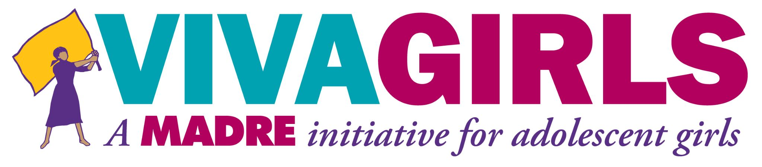
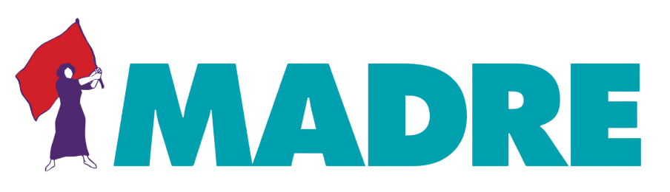

Cindy Naameni Kobei
Kenya, June 14, 2021

Statement on girls' and young women's perspectives on the general recommendation on the rights of Indigenous women and girls.
Thank you, Madame Chairperson, for giving me this opportunity to address the Committee.
My name is Cindy Naameni Kobei from the Indigenous Ogiek community of Kenya. The Ogiek community lives in the Mau Forest which is the largest forest in East Africa. The Ogiek community have been victims of historical injustices that have deprived the Ogiek community, as a whole, of their rights as Kenyan Citizens. Ogiek Indigenous women and girls are the most vulnerable members of our community. The Ogiek Youth Council is made up of young people from the counties inhabited by the Ogiek community here in Kenya and was formed in 2019. The council seeks to empower and advocate for human rights with a special focus on young people and girls. I am the chair of the Ogiek Youth Council. It was formed after realizing that there was a lack of youth voice in the Ogiek struggle.

I started my activism to ensure that Indigenous girls, like myself, are empowered to fight discrimination. Discrimination is prevalent both agaist my community and within my community due to patriarchal leadership. Indigenous women and girls are seen as lesser beings and are unable to perform duties that a man can do. During community meetings, only men are and a few women are invited, with no young women participating. This is what motivated me to be more aggressive in my activism. I wanted to become a lawyer to stand up to the external discrimination my community faces and to fight for the rights of Indigenous girls. I am currently pursuing a PostGraduate Diploma in Law as a result. I know that once a girl is educated or empowered she will be able to speak out more and even contribute to community discussions and voice dissent to external discrimination.
Most Indigenous girls are unaware of their rights: such as the right to education, the right to healthcare, and the right to basic needs in general. I have mentored over 200 Indigenous girls in the past year and hope to reach more in the coming year. During these mentorship programs, we train and mentor girls on their rights including the effects of harmful cultural practices on their lives, the importance of education, and also their rights. Apart from mentorship programs, I have also conducted training on climate change and renewable energy. Most Indigenous girls are unaware of the changes happening in their environment. The Ogiek Youth Council has built their capacity on how to combat climate and also helped them understand the relationship between climate change and harmful cultural practices which accelerates discrimination.

I am also part of the African Indigenous Women’s Organization (AIWO), which is a regional network of Indigenous women in Africa. The members of this network are composed of African Indigenous Women Representing NGOs, Community Based Organizations, and other grass-root organizations. AIWO works towards the promotion of women’s and Indigenous peoples’ rights which include social, economic, and political empowerment of Africa.

Context of the Ogiek community
The Ogiek community is a hunter-gatherer community residing in Mau Forest, Kenya. Mau Forest has been their ancestral home since time immemorial. It is Kenya’s largest water tower.

Conflict and Human Rights Violations disorient the lives of the Ogiek People especially Indigenous women and girls who are mostly affected. Since Kenya’s independence in 1963 and before it, the community has been routinely subjected to forced evictions from their ancestral land by the Kenyan government. They are not consulted and no compensation is granted. Their rights over the traditionally owned land have been systematically denied and ignored. To date, the community has been struggling for land. They have been in and out of courts and have taken a step further and taken the case to the African Court of Human and Peoples’ Rights.

During the numerous evictions, their properties are destroyed, lives are lost, people are injured, women and girls are raped. The evictions threaten the very existence of the community. Apart from the numerous human rights violations, there are few schools in the areas where the community resides and some have to travel long distances to access education. In some areas, the roads are not passable and young school-going girls have to use unsafe means of transport to access education. There are also no hospitals in the area where the community resides, only small non-facilitated dispensaries are nearby. Due to the struggle for ancestral land, the community fights for land with other communities that have encroached on the area. The fights later progress and harm the vulnerable members of the community who are women, girls, and children. During the conflict, police officers specifically target Ogiek People with claims that they caused conflict.

Issues Indigenous Girls face in Africa:
It is important to include an Indigenous girls’ perspective in the general recommendation because Indigenous girls face different challenges which will not be mentioned by Indigenous women. An indigenous girls’ perspective is also important because for an Indigenous girl to be properly nurtured her challenges need to be addressed and also for the future of Indigenous women’s movement which will be stronger in the coming years with the support of indigenous girls. Indigenous girls are the leaders of today and not tomorrow. Including an Indigenous girls’ perspective will reduce the counter effect of the challenges facing Indigenous women and girls. This being the first time that the general recommendation has included Indigenous women and girls then it shows that there is a future for Indigenous girls in Kenya, Africa, and beyond.
A few of the key issues faced by Indigenous Girls in Africa are:
Climate change: Climate change is a deeply harmful issue not only in my community but across the world. For the Ogiek people, climate change has led to drought and increased harmful practices. Because Indigenous women and girls carry the heaviest load in the household they have to travel long distances to access water, which decreases their time for other pursuits (including education and leisure) and increases their chances of being raped and face violence.
Lack of information on their rights/ No equal rights: Indigenous girls are unaware of their rights. They have not been educated on their rights to access basic needs such as food, water, education among others. This is because most of them are school dropouts. The lack of information also leads to the low representation of women and girls in decision making platforms. This is the root of many forms of intersecting discrimination.

Indigenous girls lack access to education: In most households, educating girls is not seen as a priority. In most Indigenous communities, girls are seen as brides. They are seen as goods that will be sold off as wives to the highest bidder and educating them is not important. Indigenous girls are often left at home to cater to the rest of the family when the boys go to school. Some parents are also unable to pay school fees for the girl and they sell off the girl in exchange for cows or money to educate the boys in the family. This lack of education for Indigenous girls exacerbates the already existing inequalities among Indigenous women and girls and denies a generation of Indigenous Girls the education they need to demand their rights.

Harmful cultural practices: Practices such as Female Genital Mutilation and child marriages are still prevalent in the Ogiek community and in other Indigenous communities in Africa. For example, in West Africa, they still practice flattening of breasts. These practices are harmful to the life of young Indigenous girls. Female Genital Mutilation can lead to death due to bleeding and it increases the chances of contracting HIV/AIDS. Once a girl is mutilated she automatically is able to become a wife, this leads to child marriages. The CEDAW committee has recommended that the appropriate age of marriage is 18 years, however, the customary law of my community and other Indigenous communities in Africa have a minimum age of 12-16 years, the most important stages of a girls’ development. As a result of the harmful cultural practices, these Indigenous girls get pregnant at a tender age forcing children to be mothers to children. Cases of early pregnancies have been a great issue to the community but the situation has worsened during the COVID-19 pandemic. Cases of early pregnancies have increased in Kenya and Uganda among others. Once a girl gets pregnant she becomes a school dropout.
Lack of access to health care facilities and reproductive health products: Hospitals are not close to where the Ogiek community and other Indigenous communities live. One has to travel long distances to access the bare minimum form of healthcare. If there are hospitals nearby then there are no doctors, nurses, medicine, or facilities to cater to the community. This leads to increased mortality rates especially for the instances of early pregnancies. Girls living in rural areas have no access to sexual reproductive health products such as sanitary towels due to poverty. Indigenous girls in Kenya have turned to prostitution to be able to afford sanitary towels.

Therefore, I would like to make the following recommendations to the CEDAW committee to include in the General Recommendation:

- Member States need to invest in civic education for Indigenous girls. Girls need to be well equipped with knowledge of their rights. This will give Indigenous girls an opportunity to decide what they want to do with their bodies. It will also reduce discrimination as they will be able to speak for their rights.

- Member States should ensure that there is an implementation of the already existing laws that protect the girl and Indigenous girl against harmful cultural practices. In Kenya, there is a Prohibition of Female Genital Mutilation Act, however, FGM is still prevalent within Indigenous communities. The law should be upheld and the statutory law should work with customary law to ensure that FGM is eliminated and criminalized.

- Member States need to collaborate with the educational system to ensure that sanitary towels are affordable and offered to students to enable Indigenous girls to stay in school. A national policy should be passed by the Member States to create policies that ensure girls stay in school and have basic sexual and reproductive resources.

- Member States should ensure that there are equal opportunities for both girls and boys and ensure that they work with customary leaders to provide educational opportunities to Indigenous girls.

- Many Indigenous communities don’t have schools within their communities, schools need to be brought closer to communities to reduce the distance that Indigenous girls have to travel to attend school. This will help reduce the chances of harmful cultural practices, school dropouts, and sexual exploitation and trafficking.

- Schools should ensure that there is a monitoring body that ensures that children arrive at school and at home safely. They should also monitor at the grassroots level whether there are any dropouts to ensure progress is measurable.

- Member States and local government leaders should ensure that there is access to and quality healthcare within Indigenous communities.

- Member States need to work closely with Indigenous communities to address climate change, specifically the lack of water in Indigenous communities. Ensuring that Indigenous communities have access to water will decrease the time the girls spend traveling to collect water and protect them from being raped and violence.

- Member States need to ensure that Indigenous youth and girls have political participation and representation, especially Indigenous girls in government positions and decision-making bodies. The position should be at the national government because that is where legislators sit.

- Member States must integrate Indigenous knowledge to help combat climate change. Indigenous peoples have a vast knowledge of climate adaptation and mitigation. This indigenous knowledge also needs to be transferred from the older to the younger generation so as to improve the knowledge systems of Indigenous peoples.

Concluding remarks
Indigenous girls have been sidelined for many years and it is time for Indigenous girls to stand up and speak up. In summary, Indigenous girls from all over Africa face the same challenges. They have continuously been discriminated against, despite the existence of progressive legal instruments. Therefore is very important to ensure that girls are included in this general recommendation #39.

My vision for the future of Indigenous girls is that they will be able to have equal rights with the boy child. Indigenous Girls will be able to sustain the community. They have shown that it is possible through their ability to cater to their families. My vision for Indigenous girls is that they will be able to live in a gender-just environment.

Thank you so much CEDAW Committee members for giving me this opportunity and for also including a general recommendation for Indigenous women and girls. I am glad to be part of this historic moment.

