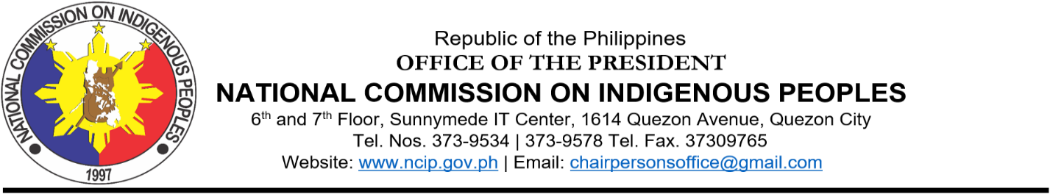
PHILIPPINE STATEMENT
ON THE
79th SESSION OF THE UN CEDAW COMMITTEE
21 June to 1 July 2021

Theme: “Effective participation, consultation and consent of indigenous women and girls in political and public life”

Chairperson, Distinguished Delegates,

The participation in political and public life of Indigenous Peoples or IPs that include indigenous women and girls is indeed crucial to our global goal to build back better. In order to have IPs benefit on equal footing with the rest of the population, taking measures to respect their cultural integrity should be with their participation, consultation and consent.

Notably, in the Philippines, these principles are explicitly enshrined in its constitution, the fundamental law of the land and in Republic Act 8371, the Indigenous Peoples Rights Act or IPRA, as it is popularly known. The right of IPs to participate fully at all levels of decision-making, the equal enjoyment and opportunities of indigenous women with men in matters which may affect their rights, lives and destinies as well as maintain and develop their Indigenous Political Structures or IPS and be given mandatory representation in policy-making bodies and other legislative councils to freely pursue their economic, social and cultural development with due respect and recognition to the participation of indigenous women on this concerns, are clearly elaborated and should not be taken for granted.

It is from this premise, that the National Commission on Indigenous Peoples or NCIP, a state mechanism that is mandated to respect, recognize, protect and promote the rights of IPs, has operationalized these basic tenets. It facilitates the process whereby IP leaders, women and men alike, are rather selected not elected by their respective communities themselves guided by their customary laws or indigenous processes to become their IP mandatory representative or IPMRs. Coupled with this, community consultations and assemblies encourage indigenous women and girls’ participation as it has been more effective and inclusive.

We support the CEDAW Committee, to have considered these themes for discussion as we believe, indigenous women and girls have much unique and responsive approaches to share and contribute as they are the current and future are the bearers of indigenous knowledge be it on health, agriculture, food, family and community security, environment, land and resources.

To truly facilitate indigenous women participation in the United Nations, we also look forward to the establishment of a category for Indigenous Peoples Political Structures or the equivalent traditional organizations that has evolved through generations, recognized and respected through IP customary laws where indigenous women are participating in matters affecting them.

For, given the serious consequences of COVID19 to indigenous communities, effective participation, consultation and consent of indigenous women and girls is the pivotal way to build back better.

Thank you and good day!

/dayang15June2021sgd

