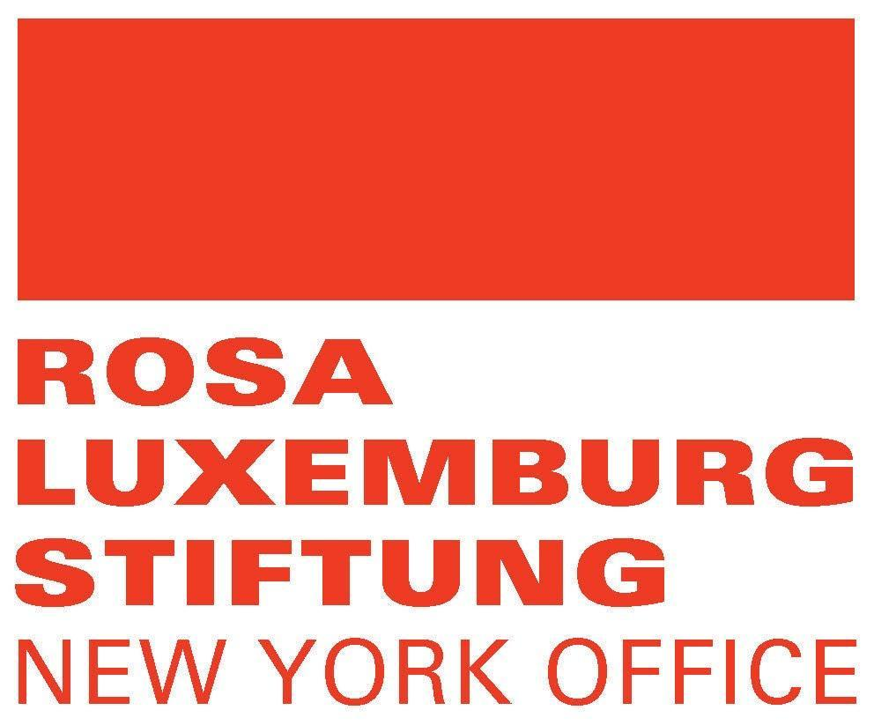
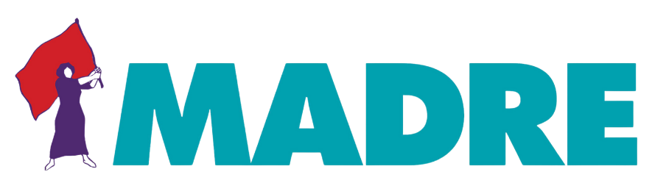

Statement by the International Delegation of Indigenous women from Nepal, Colombia, Guatemala, Nicaragua, and U.S.A on the CEDAW general discussion day on "the Rights of Indigenous Women and Girls"
Thank you, Madame Chairperson, for giving me this opportunity to address the Committee.
I am Pratima Gurung, an Indigenous woman with disabilities from a hilly, rural region of Nepal and President of the National Indigenous Disabled Women Association Nepal (NIDWAN). I’m speaking on behalf of a delegation of Indigenous women from Kenya, Nicaragua, Nepal, Colombia, Guatemala, and the U.S.A. We appreciate this opportunity to address you on critical issues for us and our communities.
We are very delighted to engage and participate in this historic event to raise our collective struggles and experiences that we have faced as Indigenous women and girls. Today, I am speaking on behalf of the 185 million Indigenous women and girls and 28 million Indigenous women and girls with disabilities who are invisible, voiceless, excluded in state mechanisms including the public and private sphere.
Indigenous women are a very diverse group, we are girls, youth, elderly, women with disabilities, and LGBTQ+ communities. We experience multiple forms of discrimination base on a rooted history of racism and discrimination against Indigenous Peoples. We lack health care access, education, and economic opportunities that impact our livelihoods. As an Indigenous woman with disabilities, I know that my identity remains personal to my daily experience, an experience of humiliation that is often ignored and not addressed, documented by the Member States.
For example in In Nepal, Indigenous women, girls, and women with disabilities are bound to live in a stateless position without recognition and no rights. This issue is such a critical problem for us because we want to be treated equally as other women and we want our collective rights and our intersecting identities to be protected because they are fundamental to who we are. We need to ensure that State laws and policies do recognize our rights and our distinctive needs.
Therefore, we would like to make the following recommendations to the CEDAW committee to include in the General Recommendation No. 39:
- Integrate the historical and systematic discrimination that Indigenous women and girls face in accordance with UNRIP to ensure the collective dimensions of the rights of Indigenous women and girls and their right to Free, Prior and Informed Consent (FPIC) are upheld and recognized by the Member States in national policies and framework.

- Include a holistic, intersectional, intercultural, gender, and disability lens that provides a comprehensive framework to address the types of issues that impact the lives of Indigenous women, girls, and women with disabilities.

- Link and bridge the individual and collective rights of Indigenous women and girls to address the unique and critical issues that they face such as discrimination and poverty. This to realize the rights of Indigenous women and affirm Indigenous knowledge, wisdom, oral history, practical experience, and the collective way of life.

- Define and provide the context of the unique experiences that Indigenous women, girls, and women with disabilities face and the legal measures and remedies to address those unique experiences, with their collective cosmovision, the rights of Nature, and ancestral guardians of Mother Earth.
- Provide mechanisms and language to address the violence that Indigenous women, girls, and women with disabilities face as a result of colonialism, racism, and imperialism. This will protect the rights of Indigenous women and demand that states create mechanisms of complaint and punishment at the national level.
- Ensure the full, effective, and meaningful participation of Indigenous women, girls, and women with disabilities at private, public, national, and local levels by realizing and respecting the value of nothing about us without us.
- Demand Member States provide disaggregated data to visibilize us, this data must be accurate and disaggregated by Indigenous identity, sexuality, gender, race, ethnicity, age, and disability.
Thank you for listening to me and providing us Indigenous women this opportunity.

