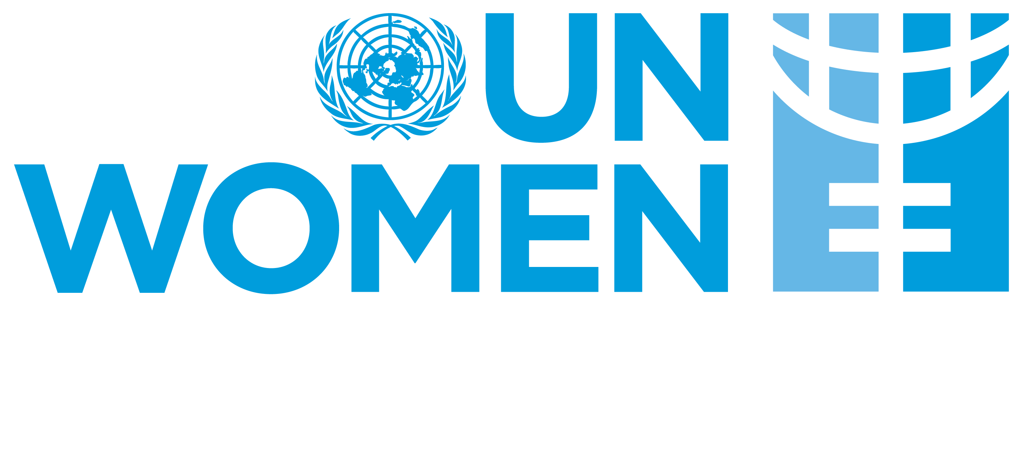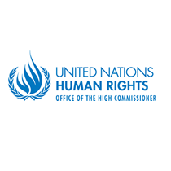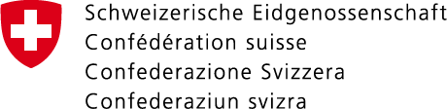

**CEDAW and Women, Peace and Security: Strengthening the Synergies for Better Implementation and Accountability**

**Side event during the seventy-second session of the CEDAW Committee**

**Geneva, Palais des Nations, Room XVI**

**1 March 2019, 13:00 – 15:00**

The Office of the High Commissioner for Human Rights (OHCHR), the Committee for the Elimination of Discrimination against Women, the Swiss Federal Department of Foreign Affairs, United Nations Entity for Gender Equality and the Empowerment of Women (UN Women) and the Global Network of Women Peacebuilders are pleased to invite you to a **panel discussion, which will examine the synergies between the Convention for the Elimination of all Forms of Discrimination Against Women (CEDAW) and the Women, Peace and Security (WPS) Resolutions, take stock of the achievements to date, and identify concrete strategies for further strengthening of the synergies.**

CEDAW and WPS together with other human rights treaties and International Humanitarian Law, provide a comprehensive framework for the protection and promotion of women’s rights, including in armed conflict. To ensure their effective implementation and strong accountability it is important to examine the synergies as well as the possible overlaps among the different legal frameworks, and ensure they mutually reinforce each other. This need for greater synergy was recognized in the General Recommendation 30 (GR 30), on women in conflict-prevention, conflict and post-conflict situations, which instructs all 189 States parties to CEDAW to report on the implementation of the WPS resolutions, and has been increasingly recognized.

**Opening remarks will be delivered by Mr. Ibrahim Salama,** Chief, Human Rights Treaties Branch, Office of the High Commissioner for Human Rights; **and Ambassador Daniel Klingele,** Deputy Director of the Directorate of International Law, Federal Department of Foreign Affairs

**The distinguished panellists include:**

**Pramila Patten,** Special Representative of the Secretary-General for Sexual Violence in conflict (joining via video message)

**Bandana Rana**, Chair of the CEDAW Task Force on WPS women, peace and security

**Hanaa Edwar**, co-founder of the Iraqi Women's Network

**Mavic Cabrera-Balleza**, Chief Executive Officer of the Global Network of Women Peacebuilders (moderator)

And other speakers, to be confirmed

**Closing remarks will be delivered by Christine Loew, Director of UN Women Liaison Office Geneva**

Please register at the [UNOG platform](https://reg.unog.ch/event/19401/) before **11 February 2018.**