DEFENDING THE HUMAN RIGHTS
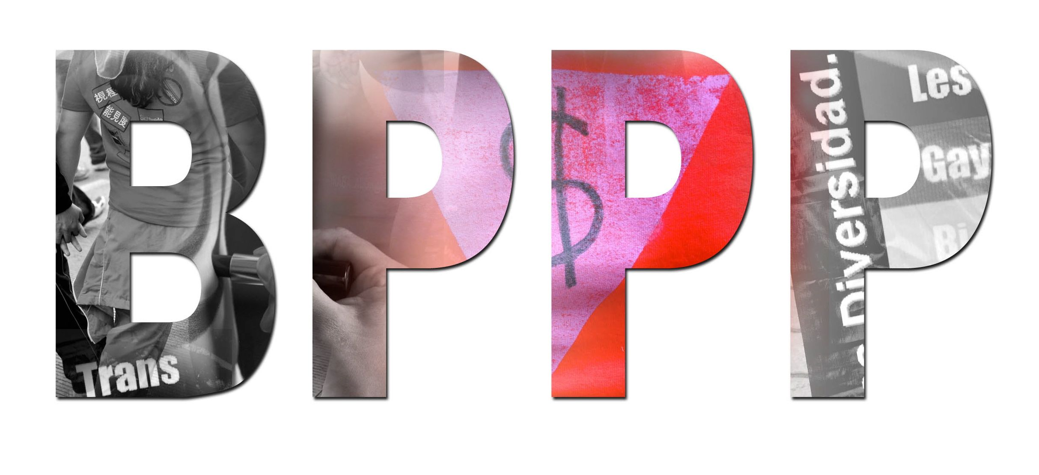
OF PEOPLE IN THE SEX TRADE

www.bestpracticespolicy.org

For the Attention of: Committee on the Elimination of Discrimination against Women

Subject: BPPP submission to the Committee on the Elimination of Discrimination Against Women on the draft General Recommendation on Trafficking in Women and Girls in the Context of Global Migration

Date: 18 February 2019

The Best Practices Policy Project welcomes the opportunity to provide a written submission to the Committee on the Elimination of Discrimination Against Women on the development of the General Recommendation on Trafficking in Women and Girls in the Context of Global Migration.

The Best Practices Policy Project takes note of the Concept Note dated 8 November 2018, prepared for the Committee on the Elimination of Discrimination Against Women, and that the
“aim of the current General Recommendation under elaboration is to interpret the definition,
scope and expectations regarding States parties’ obligations in relation to article 6 of the Convention to suppress all forms of trafficking in women and girls, ensuring that the human rights of women and girls are respected, protected and fulfilled in accordance with international law.” The United States has signed but not ratified the Convention. However, because the constituents of the Best Practices Policy Project--sex workers, people in the sex trade and related communities in the United States--are directly affected by anti-trafficking policies we look to the Convention for guidance on these issues.

Background

Sex workers in the United States face almost universal criminalization and are highly stigmatized. Anti-prostitution and related laws are used to arrest people working in public settings, and people (particularly migrants) working indoors in massage parlors and brothels, and sex workers who organize for their rights. Criminalization has a tremendous impact on people’s lives destabilizing their housing, access to healthcare, parental rights, access to financial services, technology, formal employment and education. Incarceration in the United States can permanently undermine people’s lives, leaving them harmed and in some cases leading to their deaths. Criminalization disproportionately impacts certain groups in society such as immigrants, transgender women, gender non-conforming people and people of color.

Current anti-trafficking measures, and how they impact negatively on sex workers’ rights

Misguided U.S. law and policy addressing trafficking in persons makes the lives of migrant sex workers more difficult. Migrant workers may be arrested, detained and subsequently deported in “raid and rescue” missions carried out by local law enforcement and federal immigration authorities. The current prosecution-oriented approach to anti-trafficking work in the United States also traumatizes trafficked persons. People trafficked into the sex sector in the United States are forced to comply with law enforcement and endure possible “re-victimization” in order to get benefits and status.

Internally in the United States anti-trafficking laws and policies affect many communities as well. “Anti‐trafficking” laws and policies enacted at the state level lead to mass arrests of young people, increased arrests and misgendering of transgender women of color, and the coercion of individuals to self­‐incriminate in order to access social services.

Recently, anti-trafficking advocacy in the United States has worked to prevent sex workers from communicating online, undermining incomes and preventing the sharing of vital health and rights information. We are greatly saddened by the loss of Backpage as a place for people to communicate after facing years of lawsuits. In addition to the closure of Backpage (which affects sex workers worldwide as well as in the United States), we are greatly concerned about the impact of new Federal anti-trafficking legislation passed last year. On Wednesday March 21, 2018, the US Senate passed the Stop Enabling Sex Traffickers Act, the counterpart to the House act Allow States and Victims to Fight Online Sex Trafficking Act. Together these laws are known as FOSTA-SESTA.

While the titles of the bills would lead the general public to believe that this legislation is to protect “victims of sex trafficking,” the intent is to shutter “websites that promote and facilitate prostitution.” Section § 2421A, for example, states that “Whoever uses or operates a facility or means of interstate or foreign commerce or attempts to do so with the intent to promote or facilitate the prostitution of another person shall be fined under this title, imprisoned for not more than 10 years, or both.” An aggravated offense in regards to any entity that “promotes or facilitates the prostitution of 5 or more persons” is tied to 25 years imprisonment.

This approach is out of step with globally accepted approaches to trafficking in persons and definitions in the Convention that explicitly do not equate sex work with trafficking, in order to avoid the criminalization of women’s lives. Article 6 of the Convention, for example, states that “States Parties shall take all appropriate measures, including legislation, to suppress all forms of traffic in women and exploitation of prostitution of women.” Similarly the Palermo Protocol clearly delineates sex work from human trafficking and prohibits the “exploitation of the prostitution of others or other forms of sexual exploitation, forced labour or services, slavery or practices similar to slavery, servitude or the removal of organs.”

FOSTA-SESTA has led to shuttering or limitations on speech in many online venues impacting sex workers worldwide as well as US sex workers. Transgender people of color have in particular been impacted by the closing of sites since the passage of the legislation. Some of our partner groups, such as Project Safe in Philadelphia, for example, have seen an uptick in the number of people doing street-based sex work and this is increasing risk for newer outdoor workers who have not cultivated the skills for doing street-based work and who do not have the social networks yet that people use to reduce risk.

Human Rights approaches

Our vision is to not only question these US policies domestically in efforts to protect the human rights of sex workers, but also to stop the diffusion of harmful policies that equate sex work with trafficking and undermine, through this confusion, already agreed to principles of human rights in regards to human trafficking. We encourage the CEDAW committee to clearly delineate sex work from trafficking in persons in order to to counter these confused policies that the United States attempts to export.

The US government's stance on human trafficking and its active exclusion of sex workers from its global AIDS funding through the “anti-prostitution loyalty oath” are harmful to significant numbers of low income women and transgender women worldwide and are a distraction from the core work of human rights in this area. These approaches counter the Convention’s Article 12 and General Recommendation 24 (1999). In reality these approaches by the United States have nothing to do with ending trafficking in persons but aim to criminalize sex work because of an outmoded moral objection to sex work and as a means to continue to incarcerate--and profit from the incarceration of--low income women, transgender women, migrants and other vulnerable groups. In our experience, ending the criminalization of sex workers lives, the recognition of sex work as work, and facilitation of labor rights for sex workers will allow for human rights violations perpetrated against sex workers to be addressed. We encourage the CEDAW committee to recognize that the criminalization of women for their work is a problematic practice.

For more information do not hesitate to contact the Best Practices Policy Project on be BestPracticesPolicyProject@gmail.com

Best Practices Policy Project, Streetwise and Safe, the Trafficking Victims Advocacy Project, the Legal Aid Society of New York, Criminalization of Transgender, Transsexual and Gender Nonconforming People of Color, Report to the Committee on the Elimination of Racial Discrimination, (2014).
Rachel Lovell, Mug Shots: Transgender “Johns”, RE/SEARCH (July 24, 2012).
Wahab, Stephanie & Meg Panichelli, Ethical and Human Rights Issues in Coercive Interventions With Sex Workers, 28(4) AFFILIA 344, 346 (2013); INCITE,NO SIMPLE SOLUTIONS (2011).
S.1693 - Stop Enabling Sex Traffickers Act of 2017, 115th Congress (2017-2018), https://www.congress.gov/bill/115th-congress/senate-bill/1693
https://www.congress.gov/115/crpt/hrpt572/CRPT-115hrpt572-pt1.pdf
Protocol to Prevent, Suppress and Punish Trafficking in Persons Especially Women and Children, supplementing the United Nations Convention against Transnational Organized Crime, adopted and opened for signature, ratification and accession by General Assembly resolution 55/25 of 15 November 2000.
Monica Jones, The Outlaw Project, Personal Communication (January 11, 2019).

