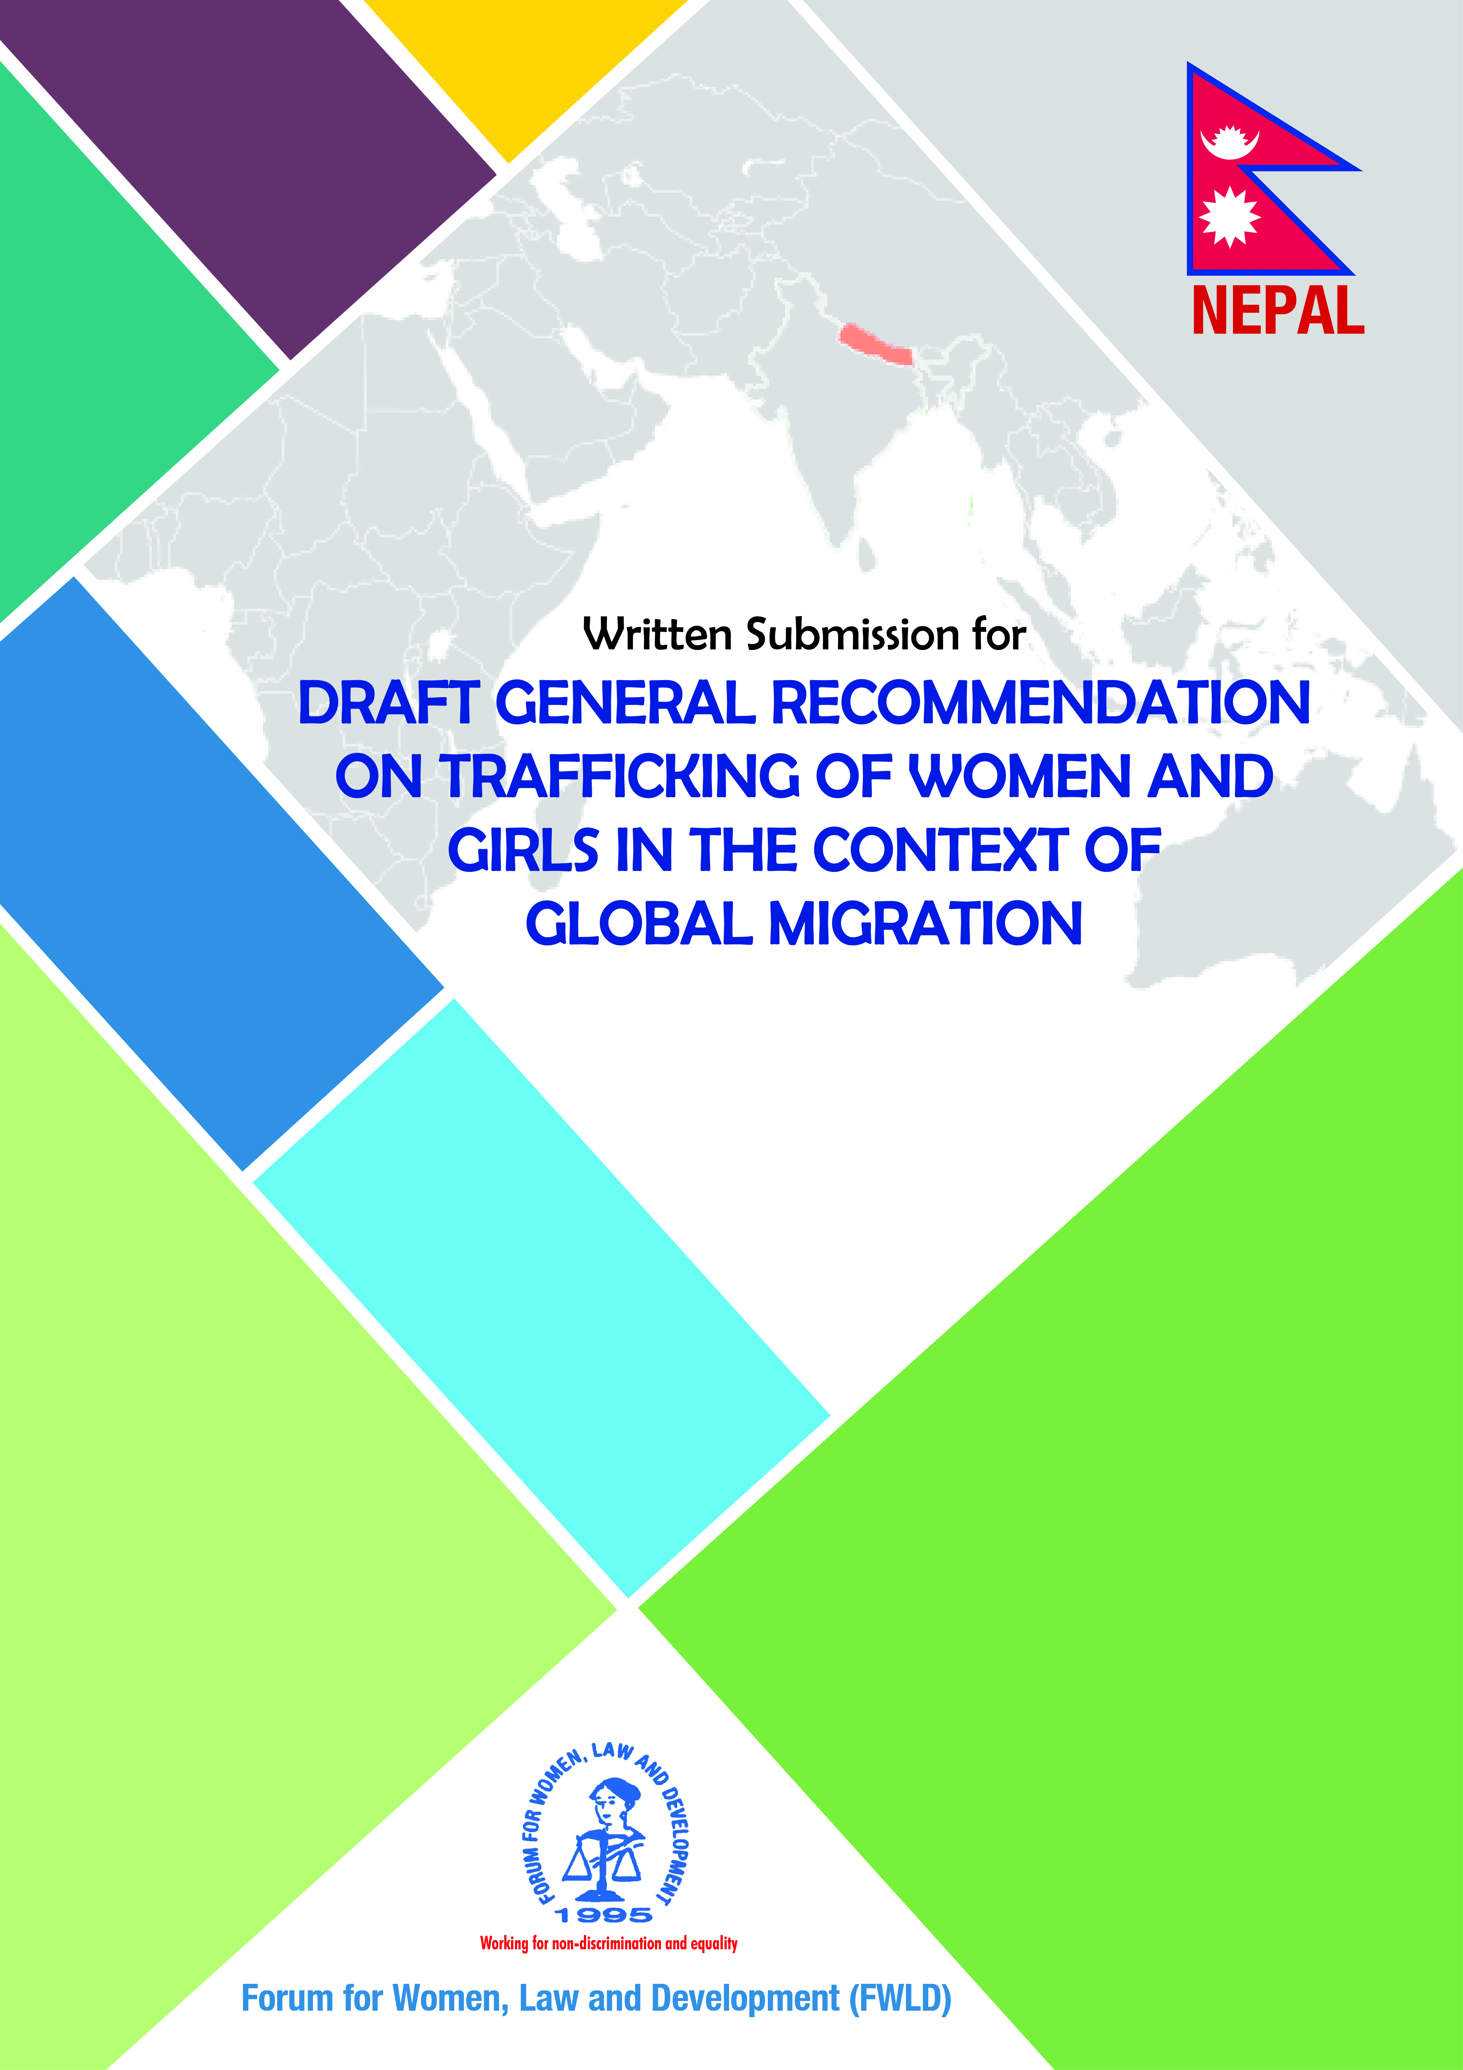
Introduction
Human Trafficking and Transportation is a grievous form of organized crime and serious violation of human rights. The heinous act against people’s human rights has been especially making women and children its victims along with other groups of people. Although the victims of human trafficking and transportation range from women, children to men, owing to the violent nature of organized crime, less number of male victims and the trend that shows less number of offences against male; it is evident that women and children are the prime target groups of human trafficking and transportation. There has been a drastic change in the present context of human trafficking in comparison to the previous situation where sexual exploitation was the main reason for trafficking and transportation of women and children. However, due to the effect of globalization, liberalization, end of cold war and free market system, the crime has been expanded to trafficking of women and children for labor exploitation, domestic work and transporting them in the name of adopted son and daughter as well.

Nexus between Human Trafficking and Foreign Labor Migration
There is an increasing and shifting trend in the number of cases where women and girls are subjected to human trafficking in the name of foreign employment as studies suggest that the many female domestic workers in Gulf region are in the state of forced labor situation mainly due to Kafala system – a system in which an employer has a complete control over a worker. Evidences of sexual abuse, assault, ‘forced acceptance of sex work’ and rape are widely reported.. In most of the cases, they become the victim of sexual and labor exploitation when they are transported as domestic workers or laborer in the name of foreign employment. Although the act of sending people for foreign employment is legal through following due procedures, the act of sending workers for different work than promised; committing labor and sexual exploitation and sending people through illegal channels are related to the crime of human trafficking and transportation. With the development in information technology, transportation and science, there has been increase in new organized forms of human trafficking and it has been difficult for the government to address the challenges in context to the current scenario.
In Nepal, there is very less understanding of trafficking beyond prostitution and sexual exploitation. The law, policy and enforcement mainly emphasizes on exclusively one purpose of trafficking i.e. sexual exploitation. In spite of its large contribution, foreign labor and migration has become one of the major areas for exploitation and trafficking, posing challenges for the protection of human rights of migrant workers. The major challenge has been the trafficking of the Nepali workers, mainly females, due to the close nexus between trafficking and migration. Among Women Migrant Workers (WMW) those who use informal channel and work in domestic sector are more vulnerable to trafficking as there are very little protection measures for informal and domestic migrant workers. A recent prominent feature of trafficking in Nepal is sending migrant workers, particularly women to work as domestic worker in the Gulf countries, via India without the knowledge or consent of the government. Let alone abroad, women are being trafficked within country to work in dance bars, restaurants, massage parlors and other entertainment sectors where they are susceptible to become the victim of sexual as well as labor exploitation.

The statistics of non-governmental organizations shows that approximately 5000 to 7000 women and children are sold in foreign countries every year in the same ways as mentioned above.As per the report published by International Labor Organization (ILO), In 2012, the ILO estimated that 20.9 million people are victims of forced labour globally, trapped in jobs into which they were coerced or deceived and which they cannot leave. Women and girls represent the greater share of total forced labour – 11.4 million victims (55%), as compared to 9.5 million (45%) men and boys. Children aged 17 years and below represent 26% of all forced labour victims (or 5.5 million children).. Drawing on the NGOs interventions including the rescue efforts of metropolice Crime Investigation Division of Kathmandu, Nepal Police and Foreign Embassies to Nepal, the estimated number of trafficking victims comes out to be about 23,200 in the FY 2015/16 in Nepal. It provides an estimate of 6,100 persons as trafficked; 13,600 persons as victims of attempt trafficking; and 3,900 persons remained missing. Of attempt to trafficking victims (13,600), 98 percent are females; 50 percent are children and 50 percent are adults. Of the trafficked persons (6,200), nearly 40 percent are males and the rest are females. Of the number of untraced persons (3,900), more than 70% are girls.
Case Story
Case
S.M.R (name changed) was lured in the name of foreign employment and sent to Bahrain by a relative named Kamala Rumba. S.M.R was taken to her workplace by Sunita Moktan, friend of her relative and Bahrain citizen Jafar. But S.M.R was forced to work as domestic labor instead of the work promised. She faced labor exploitation along with sexual exploitation from the sons of the owner of the house. However, she worked for two months with all those hardships expecting to get her salary. But when she asked for her money, the owner replied that her money was taken by the friend of her relative. Upon continuous request, she was placed in different house for her job. But, every time her salary would be spent by Sunita and S.M.R was forced to work for five more months with no salary and faced sexual exploitation. She was not able to make complain or call anyone during that period. One day she was taken to different house to work. The female owner of that house was kind and bought a plane ticket for her to return Nepal out of sympathy. After returning to Nepal, she filed complaint against Kamala Rumba and others under human trafficking and transportation despite she was sent to foreign employment by her consent. Makawanpur District Court in the case convicted the perpetrators under human trafficking and transportation as the case had element of recruitment, transportation, transfer, harboring, receipt of person and exploitation. (Source: Forum for Protection of People’s Rights, Nepal (P.P.R Nepal)

This case is a representative case of many women and girls who are being trafficked in the name of foreign employment. Also since Nepal has banned women of 24 years of age and lactating mother of 2 years old child from going into foreign employment, many women are using illegal channels from going to foreign land for employment. This discrimination is prevalent despite of Foreign Employment Act of Nepal clearly stating about no gender discrimination in foreign employment. The government has taken protectionist approach and hence has discriminated women instead of empowering them and making mechanisms and law for safe migration. A case was filed by FWLD along with other lawyers regarding the ban. However, the case has still not been resolved.
Nepal has Human Trafficking and Transportation (Control) Act 2007 to deal with crime of trafficking and also has Foreign Employment Act 2007 to cover the issues of foreign labor migration. However, both laws have not been able to interlink the concept of trafficking in the name of foreign employment. Human Trafficking and Transportation (Control) Act does not include labor exploitation as a purpose of trafficking. Similarly, Foreign Employment Act considers deception, labor exploitation or non-payment of wages as breach of agreement and provides compensation to victim. However, the Foreign Employment Act has not imagined the offence of trafficking through the channel of foreign labor migration. There are shifting trends and both the law must be able to cover the changing scenario and to prosecute and book criminals. The laws have not clearly defined on what to do in conditions where elements of human trafficking are found in foreign employment cases.
Recommendations
- State Parties should ensure that the legal provisions are clear enough to deal cases which have interrelation between human trafficking and foreign labor migration.
- Ratification of Palermo Protocol which obliges state to follow international standard in regard to protection of victims and to address the problems associated with the victims of foreign labor migration
- Ensure that the laws on anti human trafficking also define labor exploitation as the part of the organized crime.
- Make arrangements of interim relief in order to fulfill daily basic necessity of human trafficking victims during the proceedings of the case.
- Introduce and increase awareness programs for general public regarding the nexus between human trafficking and foreign labor migration
- Adopt and implement effective measures to encourage media to provide information regarding the risks of undocumented migration and nexus between trafficking and foreign employment.
- Ensure that the law enforcement mechanisms such as police have clear understanding of the nexus and laws in order to prosecute cases.
- Adopt effective measures to protect victims and witnesses during and after the proceedings of cases and ensure free legal assistance to indigent.
- Ensure that law enforcement mechanisms keep in mind the protection of security and confidentiality of the victim.
- Ensure coordination between concerned authorities to address nexus between human trafficking and foreign labor migration and deal with related problems.
- State Parties to maintain statistics on the human trafficking and to conduct adequate research to find out the interrelation with migration.
- Establishment of rehabilitation centers for the rehabilitation and reintegration programs for victims.
- Capacity Building and Conceptual clarity training to the judiciary, lawyers and other law enforcement officials regarding the shifting trends of human trafficking and the role of labor migration in it.
- Ensure that the diplomatic missions and the labor attaches are equipped enough with human, financial and intellectual resources to deal with cases of trafficking in the name of foreign labor migration.
- Majority of Women Migrant Workers are going as undocumented domestic workers which increase their vulnerability for the exploitation. Government should make law provisions to deal with problems of undocumented migrant workers. Similarly, Government should enforce legal provisions pertaining to the registration and operation of labor brokers proactively, and penalize those brokers who do not comply with it.
- To make clear legal provisions to punish the perpetrator and provide victim with adequate compensation on the basis of the nature of the offence.
- Ensure there is no any kind of discrimination between men and women going for foreign labor migration
- Remove age ban restricting women’s opportunity for labor migration ensuring safe mechanisms and legal channels.
- State Parties to formulate national policies against human trafficking, rescue and repatriation.

Trafficking in Persons National Report 2015/16, National Human Rights Commission (NHRC), p. 4
Training Manual on National and International Legal Measures for controlling Human Trafficking and Transportation and its effective implementation, UNDP/FWLD, 2061, p. 5
Commercial Sexual Exploitation and Trafficking of Children in a Nutshell – A Resource for Pacific Island Countries, International Labour Office, International Programme on the Elimination of Child Labour (IPEC) – Geneva: ILO, 2014, p. 3
Trafficking in Persons National Report 2015/16, National Human Rights Commission (NHRC), p. 1

