CEDAW General Recommendations Trafficking of Women and Girls
A Written Submission by the Humanitarian Organization for Migration Economics (Singapore), on Human Trafficking and Labour Migration
February 2019

About HOME
The Humanitarian Organization for Migration Economics (HOME; www.home.org.sg) is a non-governmental organization based in Singapore that serves the needs of the migrant community. Established in 2004, HOME has been granted United Nations ECOSOC status, and provides a range of services to thousands of migrant workers, including shelter, legal assistance, training, and rehabilitation programmes. In the last five years, HOME has provided shelter to approximately 3,500 migrant domestic workers. HOME also engages actively in research and policy advocacy for the advancement of migrant workers’ rights.

INTRODUCTION
While Singapore has enacted anti-trafficking laws, its anti-trafficking framework falls short of international standards as detailed in the UNODC Model Law Against Trafficking in Persons in significant ways. Core victims’ rights are not enshrined in law.

A core deficiency in the Singapore government’s anti-trafficking efforts is the lack of a strong labour protection regime. If the key purpose of human trafficking is exploitation, prevention efforts need to focus on combating exploitation, with clear and robust labour laws and strong enforcement of such laws. Managing the risks to forced labour and human trafficking are a vital aspect of anti-trafficking efforts: States must deal robustly with labour exploitation and the coercive mechanisms employed to induce it.

LABOUR MIGRATION IN SINGAPORE (WOMEN & GIRLS)
Singapore is highly dependent on migrant labour and there were close to 1 million low-wage migrant Work Permit (WP) holders as of June 2018, labouring in sectors such as construction, marine, manufacturing, service and domestic work. Women migrate to Singapore to work in the following sectors: service (including conservancy work, food and beverage, hospitality), domestic work, healthcare, entertainment, as well as sex work. This submission, however, focuses specifically on migrant domestic workers (MDWs).

Singapore is a key country of destination in the region due to its relative prosperity (and strong currency), demand for migrant workers to fill a wide range of jobs, and reputation as a ‘safe destination’. Other countries of destination in the region like Hong Kong and Taiwan offer higher wages and better labour protections for MDWs, and Singapore is sometimes seen as a ‘stepping stone’, a means to gain experience and save up the capital required to migrate to other countries. The monthly salary for a migrant domestic worker ranges, on average, from S$400 to S$600 (USD295 to USD 442) a month, depending on the nationality of the migrant worker: there is wage discrimination by nationality, and no minimum wage laws in Singapore (whether for locals or foreigners).

There were 250,000 migrant domestic workers in 2018. Source country restrictions stipulate which nationalities may work in which sectors, and migrant domestic workers come from countries in the region such as the Cambodia, Indonesia, India, Myanmar, Philippines and Sri Lanka. The State, meanwhile, does not reveal disaggregated data on migrant workers by nationality (it is considered ‘sensitive information’).

REGULATORY FRAMEWORK FOR MIGRANT DOMESTIC WORKERS
Migrant domestic workers are hired in Singapore on a specific category of work pass known as a ‘Work Permit’ (WP). It is a work pass issued to foreigners in low-wage sectors. The WP regime is an ‘employer-tied’ system, similar to the kafala system in the Gulf States. The key features that exacerbate the vulnerability of migrant domestic workers on WPs include:
- Highly restricted labour mobility: Under Ministry of Manpower (MOM) regulations, only MDWs who are held back as prosecution witnesses to assist in investigations may be granted permission to switch employers on a case-by-case basis (the employer’s consent is not required in this instance). Otherwise, it is entirely contingent on employers whether or not to allow MDWs to transfer to a new employer while in Singapore. This dependency on employers for their legal and employment status often induces compliance with exploitative conditions for MDWs who do not wish to lose their jobs and be sent back home. Even in instances where an employer may have mistreated the MDW, the employer retains the right to repatriate the worker and deny her the opportunity to seek a new employer if MOM does not require her as a prosecution witness.
- High level of deportability: An employer can unilaterally cancel a WP online without a migrant domestic worker’s knowledge or consent, and immediately repatriate the worker, without penalty.
- The S$5,000 security bond: The Singapore government imposes a S$5,000 security bond on employers for each WP holder they hire. This bond is liable to being forfeited if the foreign employee ‘goes missing’ or violates WP conditions. Employers’ anxieties about losing their security bond incentivizes the imposition of restrictions on domestic workers’ movements and communication, including the denial of rest days and confiscation of mobile phones. The widespread practice of withholding migrant workers’ passports is often rationalized by employers as ‘necessary’ because of this security bond requirement.
- Negative impact on future employment: The Ministry of Manpower maintains an online feedback system where employers are able to leave their contact details for prospective employers and agents. The former employer is then able to make unsubstantiated allegations against the domestic worker after she leaves the country, thereby jeopardizing her chances of being hired. This ability of employers to potentially ruin an MDW’s chances of returning to Singapore makes the threat of ‘blacklisting’ a powerful tool, one that employers and agents regularly and effectively wield to coerce workers into not making claims against them or into agreeing to unfavourable terms of employment.

While the domestic workers HOME assists are overwhelming documented workers, a caveat is necessary for Myanmar domestic workers. The Myanmar government has implemented a ban on Myanmar women going abroad to work as domestic workers. This has not, however, stopped women—and girls—from coming to Singapore to work: the ban is not enforceable here. The ban has been ineffective in preventing women from leaving, yet has had negative consequences: recruitment fees have increased to facilitate the payments required to leave the country, and recruitment activity in Myanmar has become more covert to avoid detection by the authorities. Additionally, MDWs who have suffered abuse and exploitation are often afraid to seek formal redress after returning to Myanmar, as they were not supposed to have been working overseas in the first place.

Underage MDWs
Currently, the minimum age requirement to work as a migrant domestic worker in Singapore is 23 years old. However, HOME continues to see underage domestic workers: this includes those who are under 23, as well as those below the ages of 18 (the international definition of a child). Child domestic workers tend to be from Myanmar, and they are especially susceptible to trafficking for forced labour (see HOME’s report on forced labour in the domestic work sector).

Under the UN’s Palermo Protocol, the presence of deception and coercion is not necessary to characterize a case as trafficking when it involves a child (anyone under 18 years old). However, there has to date not been a single case of any employers or recruiters being charged with domestic servitude involving underage girls under the PHTA. This despite well-publicized media reports on underage domestic workers being abused and exploited by employers in Singapore. There have also been reports of allegedly underage domestic workers falling to their deaths.

Last year, the Ministry of Manpower charged two employment agencies for recruiting two Myanmar girls who were only 13 years old of age to work as domestic workers in Singapore. One of the agency owners was given the maximum fine of S$5,000 in July 2018. The MOM has stated that MDWs who do not admit to being underage when they first arrive in Singapore, and are later discovered to be underage, face a permanent ban on working in Singapore.

Underage domestic workers are particularly vulnerable to threats of denunciation to authorities; these threats put them at risk not only of being blacklisted or repatriated, but also of being charged with violations of the law. Indeed, this is a jarring gap in the law as non-criminalization of victims for offences committed as a direct result of being exploited forms the cornerstone of victim protection.

In another underage domestic worker case, in which the MDW was sexually assaulted, criminal proceedings have halted as the domestic worker, who is currently back in her home country, is unable to travel back to Singapore to testify as a witness. Permission has not been granted for her to testify via video link. As the domestic worker was underage at the time of her working in Singapore, this had involved some falsifying of identity papers and there are concerns that if she returns to testify she may be detained for investigations into that offence. This has serious implications for the protection of underage victims of abuse, including underage victims of forced labour and trafficking, and their access to justice.

Lack of Legislative Protection
Domestic workers are excluded from the Employment Act, Singapore’s key labour law. This means MDWs lack basic protections in terms of limits on working hours, fixed hours of rest and rest days, stipulated notice periods and entitlements to annual leave, sick leave and hospitalization leave, among others. While the State’s response is that MDWs are covered by the Employment of Foreign Manpower Act (EFMA), the provisions do not provide equivalent protections. The language of EFMA is vague, in which employers are required to provide ‘acceptable’ accommodation, ‘adequate’ food, ‘adequate’ rest, and ‘reasonable’ notice of repatriation. The failure to clearly specify these terms leave the wellbeing and working conditions of MDWs largely dependent on the whims of employers and their interpretation of these regulations.

As the trajectory of Singapore’s complaints-based system of remedial justice rests largely on what is viewed as a legal infraction, being excluded from the Employment Act means many complaints of migrant domestic workers—including excessive overtime, emotional abuse, food deprivation, denial of rest days—may not be deemed ‘valid claims’ by individual mediating officers, unless they are egregrious enough to be considered criminal offences. This has material consequences for domestic workers, who are often denied transfers (i.e. livelihood alternatives) on the basis of their claims; without such guarantees, MDWs have little incentive to come forward to file complaints against abuse and exploitation.

MIGRATION & RECRUITMENT FEES: THE COERCIVE POWER OF DEBT
The indebtedness of migrant workers in Singapore is a significant factor in their compliance with deteriorating working conditions and increases their vulnerability to forced labour and trafficking. While Singapore’s Employment Agencies Act (EAA) limits agency fees to a maximum of two months fixed salary (for a two year contract), the Singapore government does not regulate training or agency fees paid in the home country; debts listed as ‘personal loans’ for fees incurred overseas are ‘allowable’ deductions. This regulatory loophole is easily exploited by employment agencies. Currently, many migrant domestic workers are required to pay fees ranging from S$1,200–$4,500 (USD887–3,327) to employment agencies (EA) for being placed in a job. Typically, the employer would make an upfront payment to the EA for this ‘loan’; the employer would then deduct an MDW’s salary each month until the amount is recovered. Depending on the MDW’s salary and the size of the ‘loan’, this could stretch up to six or eight months worth of salary deductions (see Appendix A for an example of a loan repayment schedule). MDWs often work for months either without any pay or with only a minimal monthly sum. Fearful that the MDW may ‘run away’ during this salary deduction period, employers may impose additional restrictions such as denying their workers their full complement of rest days and/or restrict their use of mobile phones. Domestic workers who wish to leave their placement are particularly vulnerable at this time; they often experience great difficulty in getting their recruitment agents to provide them with assistance, as agents often pressure MDWs to endure unfavourable working conditions until they have paid off their ‘loan’.

ANTI-TRAFFICKING MEASURES IN SINGAPORE

National Trafficking Referral Process: Lack of Transparency & No Appeal Mechanism
The government’s victim identification process lacks transparency and when referrals are made by NGOs, there is no explanation as to why they are/are not considered victims of trafficking. There is also no clear appeal process for trafficking referrals that are not deemed as trafficking: there needs to be a mechanism for appealing decisions.

Anti-Trafficking Legislation: Not Aligned with International Standards
Although the Singapore government enacted the Prevention of Human Trafficking Act (PHTA) in 2014 to tackle trafficking in persons, there are major weaknesses in the law that prevents individuals who have been trafficked from being identified. The PHTA’s definitions of key terms are significantly different from the UNODC Model Law Against Trafficking in Persons. At issue are definitions of ‘abuse of the position of vulnerability’, ‘coercion’, ‘deception’, exploitation’ and ‘forced labour’:
- Abuse of the position of vulnerability: The PHTA does not include abuse of vulnerability that preys upon addiction to substances; reduced capacity to form judgments by virtue of being a child; promises or giving sums of money or other advantages to those having authority over a person; and being in a precarious situation from the standpoint of social survival. We are concerned about these omissions as these vulnerabilities (social and economic weakness, payment of large sums of money, being underage) are common among the women our NGO assists.
- Coercion: The PHTA definition excludes ‘non-violent or psychological use of force of threat’, and omits psychological pressure as a means of coercion. This omission is concerning because psychological violence and harassment—emotional abuse, intimidation, threats, bullying—are frequently utilized as tools of coercion by employers and recruiters to induce women to stay in dangerous and unfavourable working conditions and/or not report violations.
- Deception is not defined in the PHTA. We recommend that deception be defined to include not just the nature of work and services but also the conditions under which the person is expected to perform such work (for e.g. hours of work, legality of permit and other forms of documentation, promises made regarding freedom of movement etc.).
- The PHTA does not have a definition of ‘exploitation’ that clearly defines the forms of exploitation involved in trafficking. In particular, ‘forced labour or services’ should be defined to criminalize all involuntary work or services extracted by the use of threats or penalties. This is of particular concern as we believe a significant number of complaints received by our NGO would qualify as strong indicators of forced labour and trafficking.

In HOME’s examination of over 800 domestic workers housed in our shelter last year, we found that the following indicators of trafficking and forced labour are the most prevalent among the residents: excessive overtime (between 16 to 20 hours a day), isolation (no days off, confiscation of mobile phones or severe restrictions on its use), verbal abuse (including name-calling, threats and intimidation), and salary-related issues (including the withholding of wages). There have also been a number of cases of wrongful confinement, though in HOME’s experience the authorities do not take action against employers for this. Additionally, based on our casework, attempted exploitation is not pursued under the PHTA. HOME has been told by government agents that intent to traffick does not constitute trafficking.

VICTIM DENTIFICATION, SUPPORT & PROTECTION

Lack of a Rights-Based Approach
Support measures for victims of trafficking are currently inadequate under the Act. Victims of trafficking still do not have a legally-mandated right to protection measures, including:
- Immediate authorization of temporary residency upon reporting to the authorities;
- The right to not be prosecuted for legal infractions committed while trafficked, including immigration offences (which may result due to workers being deceived about the legality of the permits they are issued);
- Informed consent to participation in investigations, protection and privacy;
- Legal assistance at no cost;
- The right to decent work opportunities, compensation, and a recovery period after reporting;
  - While the government has a Temporary Job Scheme (TJS) for migrants who are prosecution witnesses, whether a victim is allowed to participate in this scheme is not guaranteed. A worker who is disallowed from work cannot appeal the government’s decision in a court, tribunal or independent committee.
- Special support for victims who are minors are not clear.

Victim Identification
Front line officers are not adequately trained in identifying trafficked and forced labour victims. This is especially so for police officers, who have criminalized domestic worker victims of forced labour in their attempts to escape—see the case study on Rosa. (The case study can also be found in Chapter 4 of HOME’s recent report, Behind Closed Doors: Forced Labour in the Domestic Work Sector in Singapore.)
CASE STUDY: Rosa, Confined & Criminalized for Escaping
Rosa worked around 19 hours each day at her employer’s house (her working hours were 4 a.m. to 11 p.m.). She was not allowed to rest (or even sit down) during the day, except when having her meals, and even then she would be constantly rushed as she was eating. She had no rest days and was subject to seven months of salary deductions to repay her recruitment fees. Her mobile phone was confiscated by her employer. Rosa said she was constantly scolded by her employer and other family members, who would find fault with everything she did. Her passport was retained by her employer.

When Rosa asked her employer for a transfer, her employer refused and said she had paid a lot of money to hire Rosa and if she dared to leave she would be reported to the police. After Rosa asked for a transfer, her employer kept the house key on her person and did not let Rosa out of the house: not even to take out the trash. Meanwhile, the grilles to the front door were always locked. Feeling increasingly stressed about being confined in the house and not allowed to transfer, Rosa tried to escape from the bedroom window and fell from a height of several storeys. She ended up badly injured, with both legs fractured. The police then investigated Rosa for ‘attempted suicide’—a crime in Singapore—even though Rosa insisted she was trying to escape, not kill herself: Rosa was handcuffed while lying on the hospital bed with two fractured legs.

The police eventually issued a ‘stern warning’ to Rosa for ‘causing alarm or distress’ by her action of jumping out the window. It is unknown if any action has been taken against her employers for confining her in the house. Rosa has been told by the doctor it will take her at least a year to recover from her injuries.

Lack of Respect for Agency & Autonomy of Victim

Held back as State witnesses against their will
Women and girls who are identified as potential victims of crime, including trafficking, are being held back by the State as prosecution witnesses against their will. Our NGO regularly encounters women and girls who would rather not serve as witnesses and are desperate to return home, but their passports are confiscated by the State and their return home delayed indefinitely. Criminal cases are often protracted, and during these stays there are no guarantees of financial, legal and livelihood support. There are also inadequate assurances and clear processes in terms of ensuring the protection of witnesses and their families, both in Singapore and the country of origin. While in Singapore, the women and girls’ basic needs are also not adequate considered, including access to timely and adequate medical care.

HOME regularly encounters situations in which the police have held back women and girls who are victims of physical abuse against their will. Their passports were withheld yet provisions for their livelihoods were ill-considered; when healthcare needs emerged, the police tried to evade responsibility by insinuating it was outside of their purview. It is clear that the police do not have the capacity to adequately care for their witnesses, and without the capacity to provide substantive care for their witnesses, they should not be allowed to indefinitely detain people in Singapore.

RECOMMENDATIONS
Singapore’s anti-trafficking laws need to adhere to international standards. The PHTA should be coherent with UNODC Model Law, in particular the way it defines abuse of vulnerability, coercion, deception and forced labour. Victim identification processes need be benchmarked to international standards and strengthened with the deep involvement of CSOs.

Adopt a rights-based approach for victims of TIP. MDWs who are identified as potential victims of TIP should be given the full range of protections available under international law. Particularly, they should not be prosecuted for crimes committed while being a TIP victim, be given the right to decent work opportunities, and compensation.

Strengthen labour protection regime. A core deficiency in the Singapore government’s anti-trafficking efforts is the lack of a strong labour protection regime. Some recommended measures include:
- The Exmployment Act should be extended to MDWs so that basic labour rights, such as working hours, sick leave, limits on overtime and notice periods, among others, are regulated;
- MDWs should be allowed to switch employers freely, with clearly defined notice periods. MDW’s deportability and constraints on labour mobility are fundamental factors influencing MDWs’ decisions to stay in highly exploitative situations and to not report abuses and violations;
- The S$5,000 security bond conditions imposed by the Singapore government place an undue financial burden on employers of MDWs to ensure they ‘control and supervise’ their foreign employee. This responsibility incentivizes draconian control measures by employers, including the retention of passports, denial of rest days as well as restrictions on mobile phone use. These conditions should be abolished.

Strengthen cross-border cooperation to regulate working conditions in compliance with international labour standards. Labour migration is a transnational process, and TIP is a transnational crime. Bilateral agreements must align labour standards between origin and destination countries. Regulatory systems also need to be established to ensure effective cross-border monitoring and management of breaches.

Better transnational collaboration and regulation of recruitment practices. The indebtedness of migrant workers in Singapore is a significant factor in their acceptance of deteriorating working conditions. Efforts should be made by governments in countries of origin and destination to shift towards the International Labour Organization’s Fair Recruitment Initiative and adopt its key principles, which includes a ‘zero fees for workers’ model and advocates for greater transparency in recruitment processes.

Encourage capacity-building programmes for law enforcement officers and other relevant front-line responders. Frequent training programmes involving labour officials, the police and CSOs are necessary to ensure proper victim identification and cohesive efforts to combat labour exploitation and trafficking.

APPENDIX A: Salary/Loan Repayment Schedule of Indonesian Domestic Worker

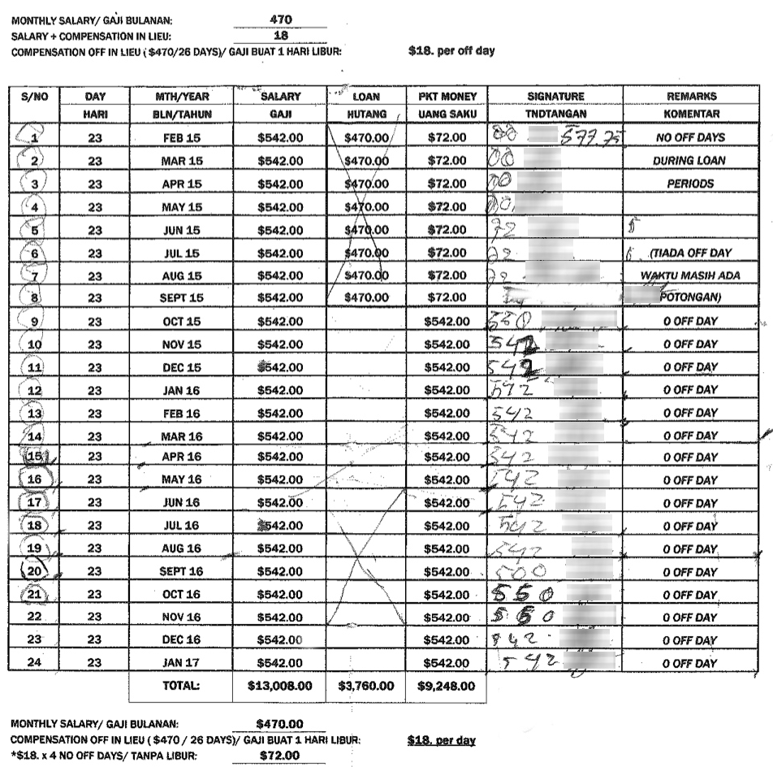

As can be seen in the salary schedule, the MDW has ‘no off days during loan periods’ and the total amount deducted is S$470 x 8 months = S$3,760. During those months, she is meant to receive ‘pocket money’ of S$72 a month. The ‘0 Off Day’ in the right column over a period of two years indicates the MDW is on a contract that does not allow her to take any rest days, with the rest day compensation factored into her monthly salary, thus making it S$542 instead of S$470 a month (after the 8-month salary deduction period).

According to the Ministry of Manpower, there were 966,200 Work Permit holders in June 2018. See Ministry of Manpower, ‘Foreign Workforce Numbers’, https://www.mom.gov.sg/documents-and-publications/foreign-workforce-numbers.
Anju Mary Paul, ‘Commentary: Improve Welfare of Foreign Domestic Workers to Prevent “Care Drain”’, TODAY, 7 May 2018, https://www.channelnewsasia.com/news/commentary/protecting-foreign-domestic-workers-maids-prevent-care-drain-10189326.
Ministry of Manpower, ‘Is There a Prescribed Minimum Wage for Foreign Workers in Singapore’, https://www.mom.gov.sg/faq/work-permit-for-foreign-worker/is-there-a-prescribed-minimum-wage-for-foreign-workers-in-singapore.
Ministry of Manpower, ‘Security Bond Requirements for Foreign Domestic Worker’, https://www.mom.gov.sg/passes-and-permits/work-permit-for-foreign-domestic-worker/eligibility-and-requirements/security-bond.
HOME & Liberty Shared, Behind Closed Doors: Forced Labour in the Domestic Work Sector in Singapore (Singapore: HOME & Liberty Shared, January 2019), https://tinyurl.com/forcedlabourHOME, 26.
Katie Arnold, ‘Myanmar Women Put in Danger by Ban on Maids Working Overseas’, 6 June 2016, The Guardian, https://www.theguardian.com/global-development/2016/jun/06/myanmar-women-put-in-danger-by-ban-on-maids-working-overseas.
Ibid.
Ministry of Manpower, ‘Foreign Domestic Worker Eligibility’, https://www.mom.gov.sg/passes-and-permits/work-permit-for-foreign-domestic-worker/eligibility-and-requirements/fdw-eligibility.
HOME & Liberty Shared, Behind Closed Doors, https://tinyurl.com/forcedlabourHOME, 50.
Liz Gooch, ‘Underage Maids From Myanmar Seek Help in Singapore’, Al Jazeera News, 7 August 2017, https://www.aljazeera.com/indepth/features/2017/08/underage-maids-myanmar-seek-singapore-170807072640035.html; ‘Maid in Singapore’, Al Jazeera, 101 East, 29 September 2016, https://www.youtube.com/watch?v=xQbd2XZGyXg.
Zaw Zaw Htwe, ‘Two Maids Die in Falls from High-Rises’, Myanmar Times, 4 December 2018; https://www.mmtimes.com/news/two-maids-die-falls-high-rises.html; Zaw Zaw Htwe, ‘Maid Jumps to Death in Singapore’, Myanmar Times, 1 March 2018, https://www.mmtimes.com/news/maid-jumps-death-singapore.html.
Shaffiq Idris Alkhatib, ‘Underage Maid: Agency Owner Fined $5,000’, Straits Times, 13 July 2018, https://www.straitstimes.com/singapore/courts-crime/underage-maid-agency-owner-fined-5000.
Yuen Sin, ‘More Underage Maids Spotted in Singapore and Sent Home’, Straits Times, 27 May 2018, https://www.straitstimes.com/singapore/more-underage-maids-spotted-and-sent-home.
See HOME & Liberty Shared, Behind Closed Doors, https://tinyurl.com/forcedlabourHOME, 36
‘The Current System is No Good’: The Challenges of Singapore’s Domestic Work Industry’, Asia Research Institute, Policy Briefing, September 2016, no.5, http://migratingoutofpoverty.dfid.gov.uk/files/file.php?name=rp08-mig-ind-mi-policy-brief-v9.pdf&site=354.
United Nations Office on Drugs and Crime, ‘Model Law Against Trafficking in Persons’, https://www.unodc.org/documents/human-trafficking/UNODC_Model_Law_on_Trafficking_in_Persons.pdf (accessed May 17, 2018), 9.
Ibid., p.12.
HOME & Liberty Shared, Behind Closed Doors: Forced Labour in the Domestic Work Sector in Singapore (Singapore: HOME & Liberty Shared, January 2019), https://tinyurl.com/forcedlabourHOME.
Under Section 41(a) of the Protection from Harassement Act, Chapter 256A.
HOME, ‘Enhancing Protection for Survivors of Abuse: Rights-Based Approach Needed’, 24 September 2018, https://www.home.org.sg/our-stories/2018/9/24/enhancing-protection-for-survivors-of-abuse-rights-based-approach-needed.

