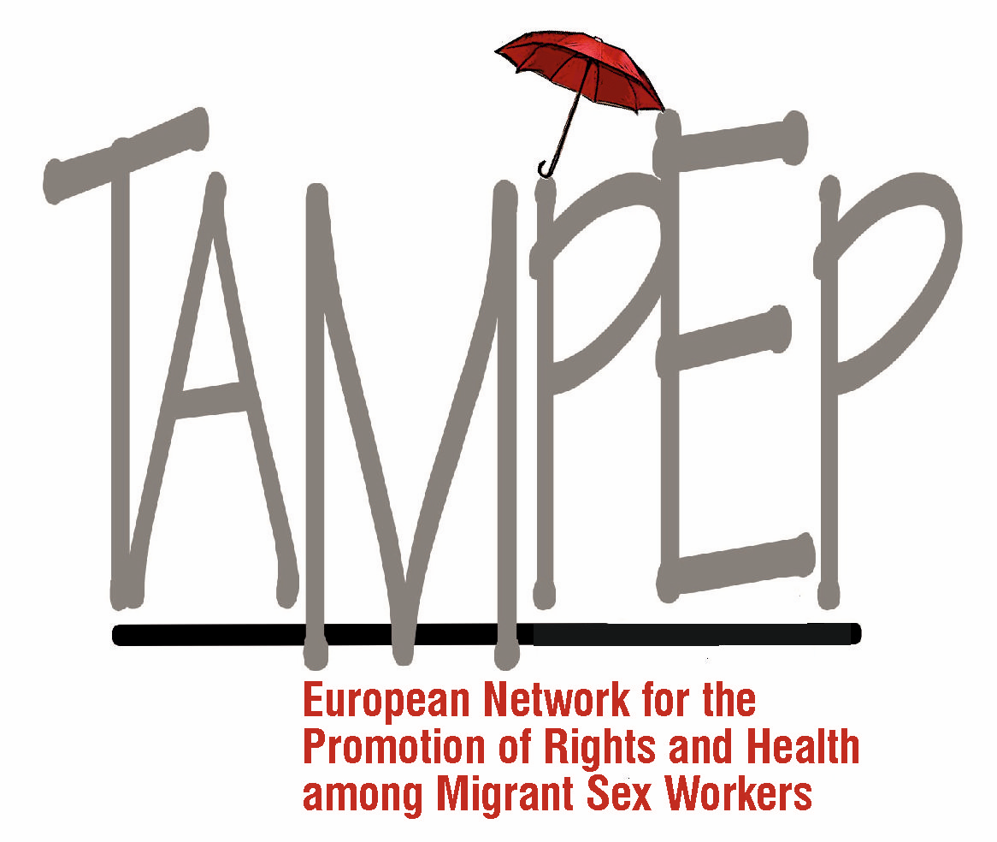

February 2019

Position Paper

Founded in 1993 in response to the needs of migrant sex workers, TAMPEP is a sex worker-led European network. It unites sex worker groups and allies in building stronger partnerships to advocate for the rights of migrant and mobile sex workers, who face multiple forms of discrimination and exclusion due to the convergence of repressive measures against migration and sex work.

TAMPEP developed a tripartite approach to human rights, advocacy and networking: the right to work, the right to health, and the right to move freely, with the diversity of migrant and mobile sex workers at its core.

We submit the following position paper in response to the Concept Note prepared for CEDAW on its elaboration of a General Recommendation on Trafficking in Women and Girls in the Context of Global Migration.
In the spirit of appreciation of the Committee’s efforts to provide clarity to CEDAW’s Article 6 and particularly the attention the Concept Note has drawn to the root causes of women’s vulnerabilities in the migration process, we request the Committee to consider the following when elaborating a General Recommendation on CEDAW Art.6.

T
he increase in international migration in the second half of the last century, primarily from less advantaged areas to more economically robust countries, came as a direct result of the changing global structure of society and increased opportunities for mobility. In addition, wars and civil unrest across many regions of the world have uprooted many peoples from their homes and contributed to hundreds of thousands of migrants and refugees, many of them coming to Europe.

WOMEN AND MIGRATION
The lack of social and economic opportunities in underprivileged countries has remained the primary cause of migration. Since the 1970s there have been significant increases in the number of women who migrate alone in search of new prospects for their own survival and to sustain their families in their countries of origin. This global trend of poverty amongst women has directly affected the "feminisation of migration".
A governmental approach that operates solely within the framework of "illegal immigration" offers no contribution to the welfare of migrant and trafficked people. It has resulted in increased vulnerability for everyone, regardless of how much agency they exercise in crossing borders or in choosing their employment. The inflexibility and harshness of recent immigration policies across Europe have exacerbated the potential for exploitation of migrant women, but failed to reduce either their influx, or their presence.
It is high time to recognise that migrant women are an integral part of the labour market, and for many of them, due to the language barrier, lack of professional training or work permits, sex work remains a practical solution to provide for themselves and their families.
As a “hidden in plain sight” international phenomenon, sex work issues have remained the same throughout its history: the rapid development and diversity of the industry, opportunities for both native and migrant people, high mobility of workers and the presence of criminal organisations that attempt to control the industry.

SEX WORK AND ITS SUPPRESSION
The traditional approaches to sex work have been to suppress or to control it, treating sex workers as objects rather than active agents, excluding them from social engagement as well as policy making. Health and social care cannot be effectively delivered within a repressive or judgemental framework, to people whose occupation is often perceived as illegal.
Legislation surrounding sex work in European countries falls into prohibitionist, abolitionist or regulatory models. None of these model gives sex workers adequate employment protections or labour rights.
Many laws force people selling sex to work on their own, which makes them more vulnerable to violence, and punishes sex workers and their families for attempting to improve their working conditions. Such dangerous attitudes directly impact on sex workers' perception of themselves, and on their lives.
A prerequisite of migrant sex workers' social inclusion is the recognition and implementation of their human rights: as women, as migrants and as workers.

MIGRATION AND SEX WORK
Migrant sex workers are forced into living and working in extremely disadvantaged circumstances and face even greater isolation, vulnerability and social exclusion than other sex workers. They are primarily dealt with and controlled through immigration legislation rather than sex work laws – while still being impacted by the policing of sex work, and both legally and socially disadvantaged as a result of their migrant status.

T
his makes political inclusion of migrant sex workers and those who have been trafficked for the purpose of sexual exploitation even more complex; these people often lack right of residence and therefore access to even the limited legal, social, and health care facilities available to resident sex workers.
TAMPEP supports the concept of a firewall – a clear separation between immigration enforcement and the provision of essential services. Putting the enforcement of immigration rules ahead of people’s fundamental rights prevents sex workers without regular status from accessing services, reporting crimes and getting protection.
Essential to the social and political inclusion of sex workers is the recognition of their needs and rights, via an on-going dialogue with sex workers - through sex worker-led organisations and non-judgemental service providers.
Some examples of such dialogue over the last two decades have resulted in the establishment of health and social care support services that work in partnership with sex workers to ensure their efficacy in responding to the reality of sex workers’ lives. Such interventions, in order to be successful, should be unaffiliated with any state authority, and operate within an ethical framework of the civil and human rights for all.

MIGRANT SEX WORKERS' NEEDS
In many Western European countries, migrant female sex workers constitute a significant number, in some cases as high as 70%, of all sex workers, but many health and social care services, often through restrictive regulations, are not equipped to respond to this reality.
Migrant sex workers should have their human and civil rights upheld, to reduce their vulnerability to exploitation, abuse and violence.
Police, social workers or immigration officials must not be the first port of call when engaging with migrant sex workers. Any service intended for their welfare should be independent of state and immigration authorities, and designed with active participation of sex workers.
It is essential that services for sex workers see them as whole human beings and go beyond focusing on them solely as vectors of sexually transmitted infections.
Responding holistically to the needs of migrant sex workers is the most effective instrument against their exploitation and therefore against trafficking.

TRAFFICKING IN THE EU POLICY
Both the European Union and the United Nations have highlighted that the sex industry is one of the areas in which trafficking in human beings occurs. Whether migrants engaged in sex work have been deceived or not, whether they work voluntarily or by force, they face extreme isolation, vulnerability and lack of access to rights and justice. Such social and political exclusion is one of the primary causes for the expansion of trafficking for the purposes of sexual exploitation, and for the impunity of traffickers.
One of the EU’s five priorities in relation to trafficking is stepping up the prevention of trafficking in human beings¹. Most policy makers have limited their interpretation of prevention as ending demand for services and goods by victims of trafficking. It is generally believed that ending demand for sexual services will end trafficking for the purpose of sexual exploitation. However, no measures are taken to discourage demand for services and goods by victims of trafficking in fishing and seafaring, the construction industry, agriculture, food processing, domestic labour, and care work. Nor have there been any attempts to use decriminalisation of sex work as a strategy to tackle trafficking and provide labour rights and protections to those selling sex in Europe.

D
espite evidence that trafficking and forced labour are fuelled by the demand for cheap, low-skilled and easily disposable labour, combined with increasingly restrictive immigration policies and lack of labour protections for migrant workers, policy makers are not seeking to tackle these structural determinants of trafficking and forced labour.
There is also a growing need for legislation that offers assistance to people who have been trafficked. They should be offered realistic opportunities for a safe environment, free from fear of further abuse and exploitation – instead of being deported after they testify against their traffickers.
However, the repressive legislation governing sex work thwarts the fight against trafficking for sexual exploitation, and restricts any positive social intervention that can encourage and support the victims.

Women’s migration must not be conflated with trafficking in women. However, trafficking in women is endemic within international migration.

CONFLATION OF SEX WORK AND TRAFFICKING
The common discourse tends to disregard the complexities of real life of migrant people and present trafficking in a simplified way, that zeroes in on sexual exploitation and ignores other forms of forced labour and servitude. In this approach, sex work is equated with sexual exploitation and thus with trafficking. Sex work is then portrayed as inherently violent, and sex workers – particularly migrant sex workers – as victims. The anti-trafficking legislation is therefore applied to the sex industry as a whole.
This attitude to trafficking, which has influenced EU policy, obscures both the relationship between immigration policy and ‘trafficking’, and that between sex work and forced labour in the sex industry. CEDAW can pursue the strategy of bringing up the inefficiency of the current legislation and lack in meeting victims’ needs and rights.
Failing to differentiate between the issues of sex work, migration and exploitation further validates approaches that perceive sex workers as pawns, and places the focus of governments and charitable resources on ‘rescuing’ them. Efforts to combat trafficking are essentially designed to combat sex work.

THE INSTRUMENTALISATION OF TRAFFICKING
To end the exploitation and abuse in the sex industry, governments have been using anti-trafficking legislation against sex work and migration, instead of creating a safe and supportive environment for sex workers to work, self-organize and demand good working conditions.
Dismantling the sex industry disrupts sex workers’ lives and work places, makes them dependent on third parties, and increases their isolation.
Victims of human trafficking become harder to find, and if they are found, their needs are rarely met in an effective way.
Conflation of sex work and trafficking results in ineffective policies aimed at all sex workers, and a complete disregard for the needs of sex workers that do not experience exploitation.
Migrant sex workers should be considered as part of the labour migration of women rather than victims of trafficking.
Instead of providing comprehensive rights and protection programmes for victims of trafficking, punitive measures against sex workers, in particular against migrant and mobile sex workers, are being implemented.
Such measures endanger the security and well-being of sex workers, compromise their health and working conditions, and precipitate more dependency and more exploitation.
TAMPEP consistently promotes the visibility of migrant sex workers as a way to dismantle victimisation theories and to raise awareness of the daily circumstances of sex workers in Europe.

RECOMMENDATIONS
Drawing from the 25 years of TAMPEP’s work and experience² in assessing migration and sex work in Europe, and in implementing programmes for protection of the human rights of migrant and mobile sex workers, the TAMPEP Network³ puts forward the following recommendations:
Acknowledge the intersection of sex work, migration and health policies and their impact on the living and working conditions of sex workers. Adopt a stance that is based on non-discrimination and inclusion.
Sex work and forced labour are two separate phenomena. Anti-trafficking laws must not be used to target sex workers, in particular migrant and mobile sex workers, and curtail their rights.
Respect and protect the human rights of migrant sex workers, including the rights
- to work
- to free choice of employment
- to just and favourable work conditions
- to freedom of movement and residence
- to equal protection under the law
- to the highest attainable standards of physical and mental health
Sex work policies should provide access to justice and legal protection.
Acknowledge the global reality of migration, including for sex work. Abolish laws and policies that criminalise both activities, and provide the possibility for migrant sex workers to obtain residence and work permits in order to increase their autonomy and independence, and to prevent exploitation.
Recognise and respect self-determination of sex workers.
Ensure the participation of migrant and mobile sex workers in the design, development, implementation and evaluation of migration and sex work policies. Use their cultural backgrounds and their vast experience of mobile work for finding just and sustainable policy making solutions.
Victims of trafficking must not be further exploited as witnesses. States should acknowledge their responsibility to assist and protect victims of trafficking – regardless of their ability or willingness to co-operate or testify in court proceedings.
Governments should address women's poverty, education for girls and the protection of women's rights as a global anti-trafficking strategy.
State bodies should recognise restrictive immigration legislation, and anti-prostitution policies as contributing factors to human trafficking and related abuses.

TAMPEP considers migrant sex workers to be agents of social change, and in doing so recognises their cultural identity and their right to contribute to the development of effective policies and services.

TAMPEP | European Network for the Promotion of Rights and Health among Migrant Sex Workers
network@tampep.eu
www.tampep.eu
@tampepnetwork
@tampepeu

¹ EU Directive 2011/36/EU, EU Strategy to the Eradication of Trafficking in Human Beings 2012-2016, http://eurlex.europa.eu/legalcontent/EN/TXT/PDF/?uri=CELEX:52012DC 0286&from=EN
² See TAMPEP publications under: https://tampep.eu/resources/
http://www.indoors-project.eu/
³ The TAMPEP Network: https://tampep.eu/members-and-allies/

