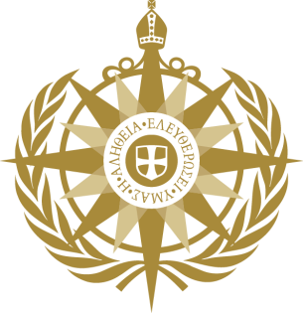
RE: United Nations Committee on the Elimination of All Forms of Discrimination against Women – Draft General Recommendation on trafficking of women and girls in the context of global migration

Oral Statement from the Anglican Consultative Council, February 2019

ANGLICAN CONSULTATIVE COUNCIL: Oral Intervention

Madam Chairperson and Committee members,
The Anglican Consultative Council, the legislative and policy-making arm of the worldwide Anglican Communion’s 85 million members across over 165 countries, welcomes the opportunity to participate in this important discussion.
Faith actors and leaders play a significant role in shaping values and norms of acceptable behaviours in society. Because of their global reach, churches and other faith actors should be key partners on tackling human trafficking, particularly in terms of exploring ways of building awareness and providing support for victims. A General Recommendation that encourages States parties to proactively partner with faith actors will support more effective compliance with their obligations to respect, protect and fulfil women’s human rights in the context of trafficking and global migration.
The activities that churches engage with around issues of trafficking are often shaped by applying a gender lens and the recognition of different gender dimensions in trafficking and modern slavery. In many of the examples given in our written statement, the support, counselling, resources and initiatives come with a gender sensitive approach. Anglican churches have also utilised existing networks to support a gender-based approach to care for female victims of human trafficking. Religious Orders of Women from the Anglican tradition as well as from other Christian denominations increasingly provide safe spaces, care and recuperation for victims.
As an institution located at the heart of local communities, churches can be key partners for States Parties in identifying trafficking victims and perpetrators. Our written statement provides a number of concrete and high-impact examples of this work. Additionally, churches have been vocal advocates for legislative approaches to tackle human trafficking. We would encourage all States Parties to commit themselves to passing legislation on this issue.
The Anglican Consultative Council would like to invite the Committee to:
- Make explicit reference in the General Recommendation to the role that faith-based actors, including churches, can and do play in
  - mechanisms and cooperation required to identify victims and perpetrators of trafficking
  - providing access to justice, as well as short and long-term assistance and services to victims of trafficking
  - ensuring accountability and responsibility of States Parties, in view of the Sustainable Development Goals, to address trafficking; and
  - offering gender-based approaches to combating trafficking

- Use this opportunity to encourage States Parties to partner with national churches to identify innovative and locally-grounded ways to combat the trafficking of women and girls in the context of global migration
Thank you.

Word Count: 407

