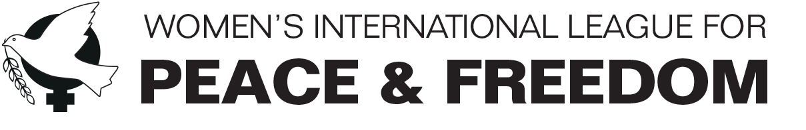

22 February 2019

Statement to the CEDAW Committee’s Half-day general discussion on trafficking in women and girls in the context of global migration

The Women’s International League for Peace and Freedom (WILPF) welcomes the opportunity to contribute to the CEDAW Committee’s elaboration of this draft general recommendation. In our written submission we have drawn particular attention to the critical impact that foreign military bases and military interventions have on trafficking of women and girls and which we hope the Committee will address. We submit that in developing this general recommendation, it is essential that the Committee reflects on what happens when human rights violations and foreign militarism intersect.

A foreign military presence, especially where there is low employment and high levels of migration, can exacerbate the risks of trafficking and forced prostitution. In many contexts in which they operate, foreign military bases provide a steady market for women, girls, and boys who are forced into sex work due to poverty or trafficking. We have seen time and again, from Bosnia and Herzegovina to Japan, to Djibouti, that wherever foreign militaries establish bases, sexual violence becomes part of the local landscape.

Demilitarisation and an end to foreign military bases is key. In the meantime, all states must fulfil their extraterritorial obligations in relation to their militaries or other presence in a third country. The CEDAW Committee has developed extensively the issue of states’ extraterritorial obligations in relation to human rights. It is important that this general recommendation continues to uphold and clarify further the application of this legal obligation and that, therefore, it addresses states’ extraterritorial obligations in relation to their military presences in other countries.

In our written submission, we have provided specific recommendations that the CEDAW Committee can address to States Parties in relation the impact of the presence of foreign military bases on trafficking in women and girls.

With regard to the impact of military interventions, we recall that it lasts far longer than the military operation itself. This is the case, for example, when military intervention is accompanied by provision of funding or other support to armed groups. In our submission, we have referred to developments following the military intervention in Libya in 2011. We have noted how support provided by the UK and other European States to non-state actors contributed to, among other things, a shift in power structures, which has had a disproportionately negative impact on women and girls, not least by creating an enabling environment for trafficking.

Moreover, through a combination of political pressure, financial incentives and military assistance, the EU has tried to induce transit countries in the Sahel to close their borders to Europe-bound migrants. Several countries, notably Italy with backing from the EU, have been outsourcing their border control to Libya by funding immigration detention centres under the pretext that such centres deter trafficking. However, evidence shows that these centres have been accommodating human rights abuses, torture, including torture of children, and gender-based violence. Deterring trafficking should be done through addressing its root causes rather than through aggressive and inhumane measures that foster human rights violations. Recommendations on this concern are provided in our submission.

