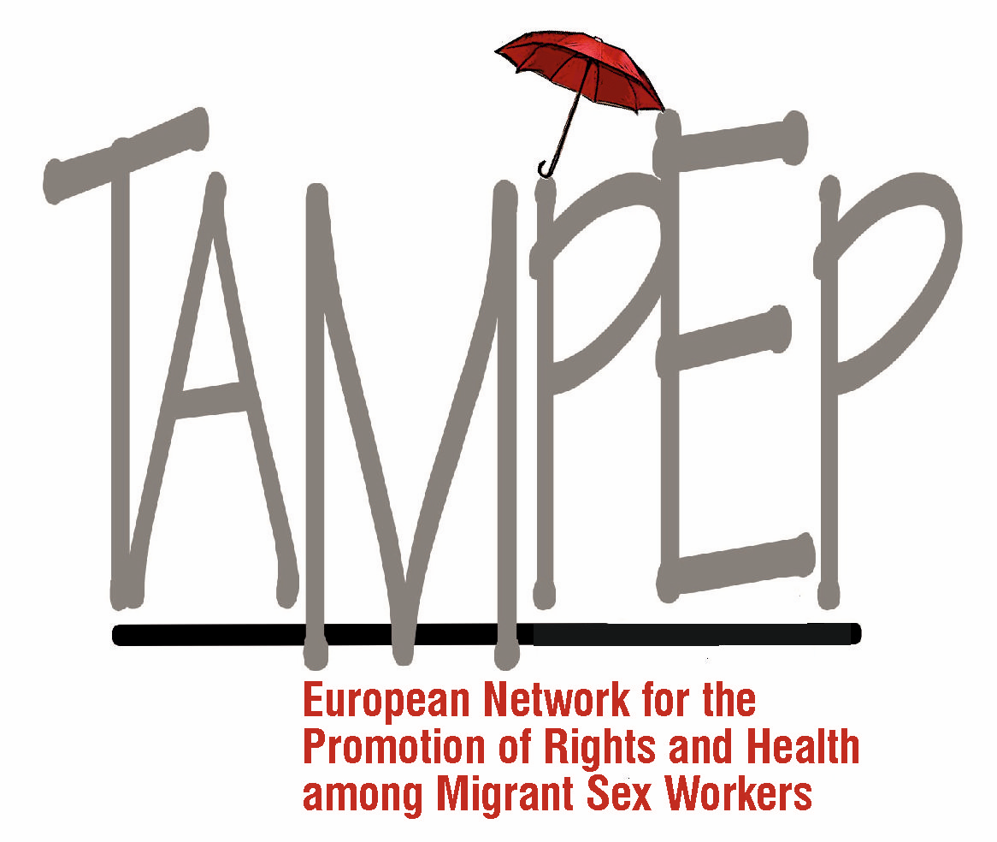

TAMPEP, The European Network for the Rights and Health of Migrant Sex Workers

Comments & Recommendations to CEDAW |
DRAFT General recommendation on Trafficking in Women and Girls in the Context of Global Migration

Founded in 1993 in response to the needs of migrant sex workers, TAMPEP is a sex worker-led European network. It unites sex worker groups and allies in building stronger partnerships to advocate for the rights of migrant and mobile sex workers, who face multiple forms of discrimination and exclusion due to the convergence of repressive measures against migration and sex work. TAMPEP developed a tripartite approach to human rights, advocacy and networking: the right to work, the right to health, and the right to move freely, with the diversity of migrant and mobile sex workers at its core.

We submit the following comments and recommendations in response to the draft General recommendation on Trafficking in Women and Girls in the Context of Global Migration prepared for Committee on the Elimination of Discrimination against Women (CEDAW). In the spirit of appreciation of the Committee’s efforts to provide clarity to CEDAW’s Article 6 and particularly the attention the Draft Recommendation has drawn to the root causes of women’s vulnerabilities in the migration process, we request the Committee to consider the following comments and amendments.

Throughout the Document

Replace the expression “sexual exploitation” by “forced labour in the sex industry”

- The expression “sexual exploitation” is problematic because it has no clear definition and thus states interpret in varying ways that then platform justification for legal frameworks and policies that conflate consensual sex work with forced labour in the sex industry, and at the extreme conflate these with trafficking. CEDAW has a responsibility to ensure language used cannot be misinterpreted by states, which in turn has proven to justify the adoption of further criminalization of sex work, via client criminalization, an approach that has shown to have detrimental effects to sex workers, including migrant sex workers and persons who are trafficked. UNODC reflected on the concept of ‘exploitation’ in the Trafficking in Persons Protocol, acknowledging that sex work must not be conflated with human trafficking. It also clarified that ‘sexual exploitation’ does not refer to all sex work: “When used in the context of the Protocol, this term could not be applied to prostitution generally as States made clear that was not their intention.”

Replace the expression “prostitution” by “sex work”

- The expression “prostitution” is stigmatizing and denounced by sex workers globally. It prevents the recognition of many forms of sex work and excludes sex workers from a labour rights framework that would allow protection against exploitation of that labour, including in cases of trafficking.

Section I. Introduction

Requested change (insertion of new paragraph)
- “According to the Committee on the Elimination of All Forms of Discrimination Against Women (the Committee), the phenomenon persists due to States parties’ failure to effectively address the root causes of trafficking in women and girls and to discourage the demand that fosters the exploitation of women and girls, which leads to trafficking” Insert: The intersectionality of the global demand for cheap and exploitable labour/workers without rights, is correlated with the gender-specific and unprotected informal labour that migrant women are frequently trafficked into, mainly in areas of reproductive labour – such as care-taking of the elderly and sick people, domestic work, marriage and entertainment industry
Section III Legal Framework

Requested change (insertion of new para 9):
- The 2010 Recommended Principles and Guidelines on Human Rights and Human Trafficking (E/2002/68/Add.1) elaborated by the Office of the United Nations High Commissioner for Human Rights further provides an important soft-law framework for integrating a human rights-based approach in all anti-trafficking interventions.

Insert:
- This especially pertains to paying attention to the Human Rights situation of persons working on their own will in the same industries, such as domestic and care workers, sex workers, and seasonal migrant agricultural workers.

Reason:
- Anti-trafficking interventions are evidenced to perpetuate harm to migrant sex workers as these often conflate migrant sex work with trafficking. A clear separation must be made that ensures all interventions are human rights based, which extends to other migrant workers in sectors working on their own will.

Section IV, e (title)

Requested change (deletion):
“Root causes of trafficking in women and girls and discouraging the demand that fosters their exploitation through trafficking”
Reason:
- “Demand” is a root cause of trafficking and should be subsumed within root causes, not placed alongside them, particularly since other root causes are not specified in this title.

Section IV, a, para 12:

Requested change (addition)
- “The Committee notes the limitations of existing data sets on trafficking. Sexual exploitation is the most commonly identified form of trafficking because it is more widely reported in comparison to other forms of exploitation such as forced labour or domestic servitude. Further, according the 2017 Global Estimates of Modern Slavery, of the 16 million people in forced labour exploitation, 57.6% were female.”
Reason: The GR is based on narrow UNODC data which fails to reveal the modern reality of the phenomenon of modern day slavery and human trafficking. UNODC also note the serious gaps and weaknesses in trafficking data, noting that the fact that sexual exploitation is the most commonly identified form of human trafficking, may be the result of statistical bias, “By and large the exploitation of women tends to be visible, in city centres, or along highways. Because it is more frequently reported, sexual exploitation has become the most documented type of trafficking, in aggregate statistics. In comparison, other forms of exploitation are under-reported: forced or bonded labour; domestic servitude and forced marriage; organ removal; and the exploitation of children in begging, the sex trade, and warfare.” ILO data found 38.2% of all victims of modern slavery are in the category of forced marriage. 11.9% fell into the category of “forced sexual exploitation / CSE of children”, while 49.9% of people in modern slavery were enslaved in other forms of forces labour.

Section IV, a, para 13:
Requested change (replacement):
The crime of trafficking is characterized by a complex web of perpetrator and victim profiles, as well as jurisdictions, often implicating private persons, corporations, State-mandated actors and officials. Trafficking and forced labour are fuelled by the demand for cheap, low-skilled and easily disposable labour, combined with increasingly restrictive immigration policies and lack of labour protections for migrant workers
Reason: The social determinants of trafficking and forced labour go beyond a simplistic frame of perpetrator and victim. Other fueling factors of trafficking and the exploitation of migrant workers must be acknowledged to platform a more nuanced national and international approach.
Section IV, d, para 18:
Requested change (insertion): including non-citizen, migrant, refugee, asylum-seeking and stateless women and girls, and women and girls with an irregular migration status and race, ethnic minority, gender identity status

Section IV, e, para 24:

Requested change (deletion):
- “In its general recommendation no. 34 (2016) on rural women, the Committee highlighted that the economic hardships of rural life including the negative effects of climate change, high levels of poverty, restricted access to State benefits, protection and services, resulting in, inter alia, low levels of education, and low awareness on how traffickers operate, render rural women especially vulnerable to exploitation, in particular in prostitution and as domestic workers and in conflict-affected regions.”

Reason: The references given to the Committee’s own documents [General recommendation No. 34 (2016) (CEDAW/C/GC/34), para. 26; CEDAW Contributions to the 2030 Agenda for Sustainable Development (2017 HLPF)] do not mention “prostitution” in any way that supports this focus. Indeed, only the former document contains a single reference to “prostitution”, and only in quoting the precise text of Article 6.

Section IV, e, para 27 (b):

Requested change (deletion):
“Where applicable, instituting penal legislation to sanction the users of goods and services that result from trafficking in persons”
Reason: This clause is a clear attempt to focus solely on buyers of sex work and push for the introduction of the Nordic Model that has immense adverse human rights impacts on sex workers, including those who are migrant who then work in greater fear of state surveillance leading often to arrest, deportation and greater future travel restrictions. This position is does not sit in line with CEDAW Committee’s existing body of work on Article 6 that rightly, does not indicate an equivocal espousal of client criminalisation strategies as an effective method to ‘discourage demand’. The CEDAW Concluding Observations on Article 6 have included recognising the adverse human rights impact of client criminalisation on sex workers and recommending implementation of labour frameworks to “prevent and combat other exploitative practices assimilated to trafficking”.

Section IV, e, para 27 (d):

Requested change (deletion):
- “Investigating, prosecuting and convicting all perpetrators involved in the trafficking of persons, including those on the demand side.”

Reason: The phrase ‘including those on the demand side’ is liable to be misinterpreted and/ or misapplied to target sex workers.

Section IV, e, para 32 (b):
Requested change (replacement):
- Allocate resources to ensure that human rights and women’s rights non-governmental organizations to ensure that NGOs advocating for human rights, women’s rights, workers’, migrants’ and sex workers’ rights are well informed, adequately consulted and play an active role in the initial and subsequent development of anti-trafficking strategies

Section IV, g, para 58 (a):
Requested addition:
- Introduce, strengthen, and enforce employment legislation designed to protect all migrant workers, irrespective of level of skill or the sector in which they work, duration of their employment, and to minimize the opportunities for exploitation by providing very clear protections, including minimum wage, overtime pay, health and safety, and decent working conditions, particularly in unregulated or unmonitored economic sectors that rely on migrant women’s labour, including domestic and care work, sex work, garment, construction, agriculture, food processing and fishing

Reason: Considering prostitution is referred to throughout the document as an industry that women and girls are trafficked into and forced to work, sex work must be included alongside industries where strengthening of employment legislation and worker protection is advocated

Section VI, a, para 92 ‘Adverse collateral effects of anti-trafficking efforts’:

Requested changes (additions):
- Clause b): “Ensure that raids conducted by law enforcement authorities with a view to dismantling trafficking networks do not justify or result in criminal prosecution or other coercive measures, including gender-based violence, abuse and harassment, against any group of women, particularly sex workers who are the group most often subject to such coercive measures;”
- Clause c): “Ensure that no group of women, is targeted for investigation or prosecution, discrimination, stigmatisation, or suffers from the lack of rights and protections, under the guise of combatting trafficking, including violations of their rights to movement, assembly, health and safety, to dignity and livelihood. This must include sex workers who are most often targeted, particularly migrant sex workers. States should cease such targeting and ensure these groups of women are afforded their full rights and protections;”
- Clause d): “Discontinue anti-trafficking measures that involve the apprehension, detention and involuntary rehabilitation of women, which are often experienced as antagonistic and traumatic. Sex workers, particularly migrant sex workers, are particularly targeted for such measures and this is an abuse of their human rights as well as an abuse of State powers;”
- Clause e): “Ensure that anti-trafficking efforts are not used as a means to deport migrant women with an irregular immigration status. Anti-trafficking efforts are often inappropriately used by States as part of a wider anti-migrant, and specifically anti-sex work, narrative. States much put clear measures in place to prevent this.”

Reason: We acknowledge and appreciate the Committee’s responsiveness to previous comments about the misuse by authorities of anti-trafficking legislation by authorities, and their recognition of sex workers as targets for this misuse, however we would urge more specificity to ensure clarity, and to measure States’ compliance and implementation of the General Recommendation.

Section VI, para 61
Requested addition:
- Conduct an impact assessment of anti-trafficking measures that are applied as anti-migration measures and policy

Reason: An impact assessment would ensure effectiveness but also more importantly highlight any, perhaps unintentional but equally harmful impacts of anti-trafficking measures applied as part of anti-migration measures and policies, which we see often play out in the lives of migrant sex workers.

NSWP, 2019, “Briefing Note: Sex Work is not Sexual Exploitation”.
https://www.nswp.org/sites/nswp.org/files/impact_of_anti-trafficking_laws_pb_nswp_-_2018.pdf
UNODC, 2018, “Global Report on Trafficking in Persons”.
ILO & Walk Free Foundation, 2017, “Global estimates of modern slavery: Forced labour and forced marriage”.
UNODC, 2009, “Global report on Trafficking in Persons”.
CEDAW/C/NOR/CO/9, para 28
CEDAW/C/CHE/CO/4-5, para 29

