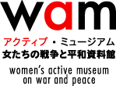

2-3-18, avaco bldg. 2F,
Nishi-Waseda, Shinjuku,
Tokyo 169-0051 Japan
Tel: +81-3-3202-4633
wam@wam-peace.org
May 11, 2020
Dear CEDAW Committee,
Thank you very much for the opportunity to contribute comments to the draft General Recommendation on trafficking in women and girls in the context of global migration.
The Women’s Active Museum on War and Peace (WAM) focuses on violence against women in war and conflict situations, particularly the issue of Japan’s military sexual slavery, or the so-called “comfort women” issue. We have submitted alternative reports on Japan’s military sexual slavery system to various UN human rights bodies, including ICCPR, CESCR, CEDAW, CAT, CERD, CED, CRC and UPR of the Human Rights Council over 15 years.
From our experiences, we have recognized that international law’s prohibition of slavery and of the slave trade, in all their forms, has obtained jus cogens status. The slave trade exists as an international crime, a humanitarian prohibition and as a human rights violation, whereas trafficking is a human rights violation and transnational crime.
The suggested modifications below aim to underscore that women and girls, regardless of their age, are afforded protection from acts of the slave trade as well as human trafficking rights violations.
Please extend attentive and kind consideration to the text highlighted in italics below that comprise the suggested modifications.
1. To paragraph 10, please consider adding the following sentence:
10. … Noting the distinctions between the international crime and human rights violation of the slave trade and that of trafficking in persons, the Committee recognizes that women and girls retain concurrent protections from all crimes and violations.
2. To paragraph 35, please consider adding the phrase “slave trading”:
35. … Forcibly displaced women are often subjected to gross human rights violations, including risks relating to trafficking for purposes of sexual or labour exploitation, slavery, slave trading and servitude, including the abduction or recruitment of women and girls into armed forces and groups.

Thank you very much, once again, for the opportunity extended to civil society to submit comments to the drafting committee. The CEDAW General Recommendation on trafficking in women and girls in the context of global migration will be an important instrument that will serve to ensure the human rights of women and girls.
Lastly, we would like to humbly request the committee to consider drafting the General Recommendation focusing more on sexual enslavement of women and girls in the context of war and conflict situations, in addition to the General Recommendation No. 30, to provide complete protection for women’s human rights under article 6 of the Convention.

Sincerely yours,
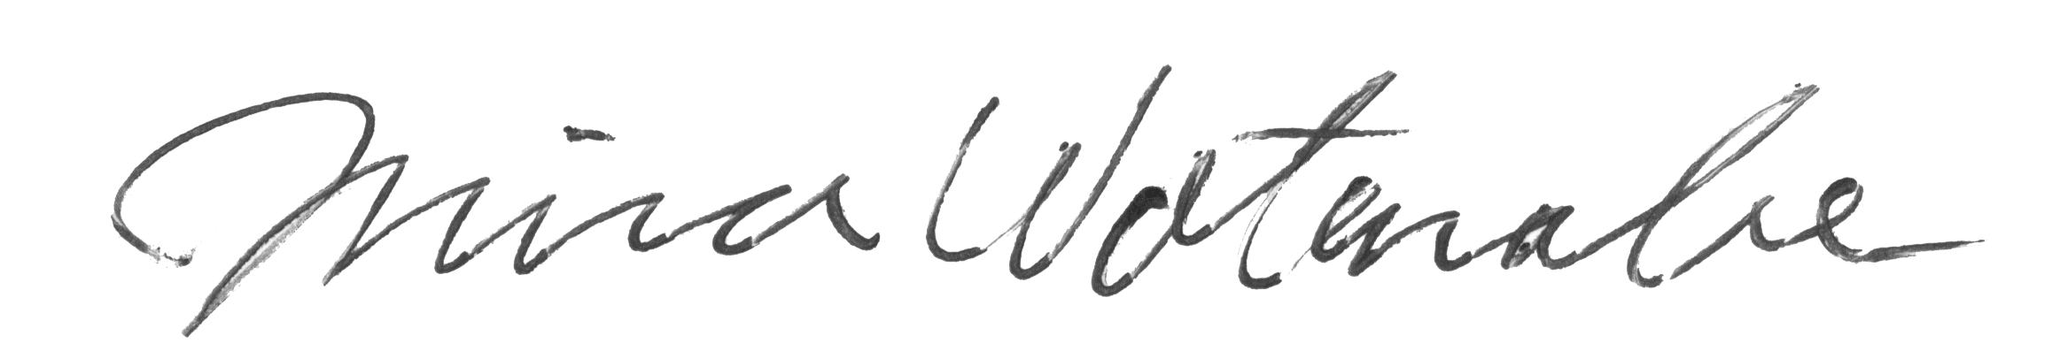
Mina Watanabe
Director, Women's Active Museum on War and Peace (WAM)

About Organization:
The Women’s Active Museum on War and Peace (WAM) holds exhibitions and educational events, conducts fact-finding projects, archives testimonials, and acts as an advocate for victims of Japan’s military sexual slavery. WAM is the main project of the Women’s Fund for Peace and Human Rights (WFPHR), a non-profit organization authorized by the Tokyo Metropolitan Government in 2003. WFPHR, which established WAM in August 2005 with donations from people in Japan and abroad, holds the ECOSOC Special Consultative Status since August 2019.

