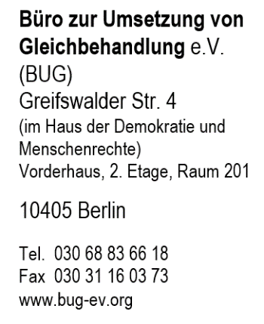
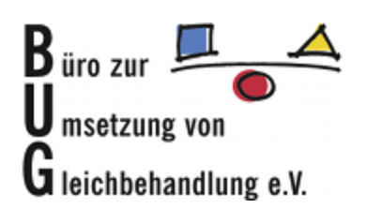
Berlin, 17.06.2019
To Whom It May Concern:
The Büro zur Umsetzung von Gleichbehandlung (the Bureau for the Implementation of Equal Treatment, BUG) thanks the Committee on the Elimination of Racial Discrimination (CERD) for the opportunity to contribute to General Recommendation No. 36 (Preventing and Combating Racial Profiling). BUG is dedicated to the active pursuit of a discrimination-free society in which all people are treated equally in all areas of life regardless of their ethnic origin, religion, gender, disability, age, or sexual orientation.
Since 2009, BUG has actively provided legal aid and counsel to those facing discrimination. As part of this, BUG has worked with victims of racial profiling. Currently, under German Police Code (Bundespolizeigesetz – BPolG), there are several provisions which allow for identity checks in police actions. Specifically, § 22 paragraph 1a and § 23 paragraph 1 of the BPolG allow for ‘stop and search’ procedures to be conducted by officers - independent of suspicious behavior. Furthermore, these checks can take place in any location of potential border traffic (for example, in airplanes and airports, trains and railway stations, as well as anywhere within 30 km of the national border). On the basis of this legislation, individuals of ‘non-German’ appearance are frequently the targets of racial profiling actions by police units. Prejudicial stereotypes about certain groups periodically equates to officers targeting individuals based on physical traits alone – generally, individuals who appear ‘non-German’ are singled-out for such ‘stop and search’ actions. Thus, in its pursuit of a discrimination-free society, BUG is especially interested in contributing to this Recommendation on preventing and combating racial profiling.
Based on our national experience, BUG suggests the following amendments to the Recommendation:
_____
Chapter VII, subsection A (Legislative measures), number 27
BUG strongly believes that concrete anti-racial profiling training and guidelines for law enforcement agencies should be provided. Though this is briefly mentioned in the final sentence of chapter VII, subsection A (Legislative measures), number 27, BUG suggests that this clause be amended to include the establishment of clear internal regulations for law enforcement agencies regarding ‘stop and search’ policies and the avoidance of racial profiling practices.
Provided that they contain clear and specific guidelines for law enforcement officers, internal regulations play a significant role in the prevention of racial profiling practices. Therefore, BUG suggests that ‘guidance for law enforcement’ (see the final sentence of chapter VII, subsection A (Legislative measures), number 27) be amended to include:
“The establishment of internal regulations for law enforcement agencies outlining guidelines on how to perform ‘stop and search’ functions in a non-discriminatory way.”
_____
Chapter VII, subsection F (Accountability), number 32
BUG supports the amendment of this section to address procedure when individual police officers perform ‘stop and search’ actions in a discriminatory way.
Therefore, following number 32 of chapter VII, subsection F (Accountability), number 32, BUG suggests that:
“Individual police officers should be held accountable in instances where the officer conducts a ‘stop and search’ action in a discriminatory way.”
Doing so ensures that direct consequences exist for individual police officers who engage in racial profiling actions. A reference addressing the need for such procedures specifically would pave the way for a more concrete policy for law enforcement agencies.
_____
BUG is grateful for the opportunity to contribute to CERD and believes that our suggestions will greatly increase the overall strength of this Recommendation. Attempts to counter racial profiling in Germany have been met with resistance in recent years. However, it is the firm belief of BUG that if this document – including our suggested additions - are implemented by policy makers, that significant progress will be made in the effort to end discrimination in police forces.

Sincerely,

Büro zur Umsetzung von Gleichbehandlung e.V.

