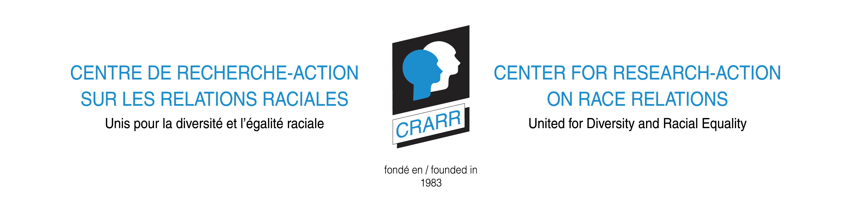

CRARR SUBMISSION TO THE UNITED NATIONS COMMITTEE ON THE ELIMINATION OF RACIAL DISCRIMINATION

DRAFT GENERAL RECOMMENDATION NO. 36: PREVENTING AND COMBATING RACIAL PROFILING

June 30, 2019

Montreal, QC

Canada

Final version

Submitted by

Center for Research Action on Race-Relations (CRARR)

460 Saint-Catherine Street West, Suite 610

Montréal, QC, CANADA H3B 1A7

www.crarr.org

- Information about the Organization
The Center for Research-Action on Race Relations (CRARR) is a Montreal-based independent, non-profit and non-governmental civil rights organization that was founded in 1983 with the mandate to promote racial equality and combat racism in Canada. As an issue-based organization, CRARR works with all sectors of society that share its values of equality and diversity, especially equality-seeking groups.
CRARR activities and services include:
- Advocacy and defense for victims of discrimination based on race, religion, ethnic or national origin, citizenship status and other characteristics as protected by different federal and provincial human rights legislation,
- Research and litigation on racial equality issues,
- Organizing conferences, consultations and seminars, and training sessions on different race relations and civil rights issues, and
- Interventions and advocacy before legislative, administrative, regulatory and judicial agencies.

- Comments and Recommendations
CRARR wishes to submit the following comments and recommendations on racial profiling to the Committee on the Elimination of Racial Discrimination (“the Committee”):

Section III Resources of the Convention
- That in this section as a whole, systemic racism be recognized more explicitly as an underlying notion of racial profiling, particularly in para. 14, where discrimination “through laws, policies and institutions” is recognized. The clear and explicit recognition of the systemic nature of racial profiling elevates the problem and practice beyond the individual law enforcement officer’s actions and conduct and defines the problem and necessary and applicable remedies in broader, institutionalized terms.
- That in para. 15, it be recognized that racial profiling also compromises the right to property ownership, a right recognized in art. 5(d)(v) of the International Convention on the Elimination of Racial Discrimination and others.
Section IV Defining and Understanding Racial Profiling
- That para. 16 recognize the common practices of escalation and use of excessive force in situations of racial profiling by law enforcement officers that often lead to serious injuries and fatality. Case law and social science data in Canada and other countries have begun to recognize the link between race and related grounds of discrimination and excessive force or police brutality.
- That para. 16 explicitly recognize the fact that racial profiling in education is a phenomenon and practice that involves school officials and private security guards and that exposes children and youth of color and those of Indigenous backgrounds to the corrosive effects of disproportionately negative sanctions ranging from suspension to expulsion. Racial profiling in schools, known in North America as the “school-to-prison pipeline” phenomenon, violates these children and youth’s right to education, among others.
Section V Consequences of Racial profiling
- That paras. 18 and 19 recognize the destructive economic consequences of racial profiling, notably biased policing, because they create disproportionate hardship on Black and Indigenous communities who are often more economically disadvantaged compared to the general population. Due to austerity measures in many jurisdictions leading to cuts to legal aid and limited access to adequate legal representation, the high costs of legal defense, lengthy criminal proceedings that are at times caused by prosecutorial racial bias, and the lack of judicial competency to address racial profiling that results in necessary appeals to name a few, victims of racial profiling who are charged with one or more criminal offenses, usually obstruction of justice, resisting arrest, and assaulting a police officer, often find themselves in dire financial straits. Furthermore, in many employment positions, even a pending criminal charge can result in job denial or termination.
Section VII Recommendations
- Legislative Measures
- That paras. 26 and 27 explicitly encourage states to add “racial profiling” as a prohibited practice in their respective human rights legislation. Most human rights laws explicitly prohibit discrimination and harassment; consequently, the addition of “racial profiling” will, among other things, help deter institutionalized denial of the problem since many authorities still consider racial profiling as a matter of “perception” or an “isolated incident”.
- That paras. 26 and 27 avoid restricting racial profiling to law enforcement agencies, since, from a systemic racism perspective, state prosecutors, the judiciary, school authorities, and private security agencies can also engage in racial profiling and need to undertake positive steps to deter and eliminate this form of discrimination in their practices and services.
- Human Rights Education and Training
- That, consistent with recommendation #7, state prosecutors, the judiciary, school authorities, and private security agencies be required to implement anti-bias training and training evaluations.
- Recruitment Measures
- That, in light of the Canadian experience in different federal and provincial jurisdictions, measures designed to diversify law enforcement agencies’ personnel in order to promote their reflection of and responsiveness to the communities they serve be legislated and made mandatory through effective enforcement mechanisms and that their implementation be monitored for both quantitative and qualitative results.
- Dialogue with Communities
- That para. 30 recognize the role of external and neutral (cultural) mediators, especially in situations of high tension and conflict with the police, to ensure effective and open dialogue
- Disaggregated Data
- That in para. 31, states are encouraged to adopt legislation on mandatory data collection on race, ethnicity, and religion where religion-based profiling is an issue for the purpose of adequate quantitative and qualitative documentation, monitoring, and analysis of law enforcement practices.
- That such data cover and include the nature of the criminal and penal offenses with which a person is charged and the judicial outcome related to said offenses (in Canada, criminal offenses are those prohibited by the Criminal Code of Canada, while penal offenses are violations of non-criminal laws such as Highway Safety Codes and city by-laws or ordinances).
- Accountability
- That para. 34 explicitly reaffirm the rights of victims of racial profiling and discrimination to effective protection provided by human rights mechanisms. Our experience in the Canadian province of Quebec demonstrates that legal protections guaranteed by the provincial human rights legislation do not lead to effective protection: excessive delays allow police respondents to challenge and defeat racial profiling cases on procedural grounds of unreasonable delays and lack of competency in assessing complaints of systemic racism and intersectional discrimination, among other things. It can take the Quebec Human Rights and Youth Rights Commission up to five years to render a decision on a complaint.
- That para. 24 affirm the requirement that independent civilian mechanisms to receive complaints from the public against police officers be equipped to assess complaints of racial profiling and to prosecute officers for racially biased and discriminatory conduct in an effective and rigorous manner. Our experience in Quebec has identified within the Police Ethics Commissioner’s office, a lack of competency in assessing complaints of systemic racism and intersectional discrimination, and in prosecuting violations of the code of conduct involving the practice of racial profiling.

