Contributions for the General Comment on the Rights of All Children in the Context of International Migration from the Casas de Acogida-Murcia (shelters) programme of the diocesan Caritas of Cartagena

1. Introduction
Via the Casas de Acogida-Murcia programme of the diocesan Caritas of Cartagena we offer a service specialised in the comprehensive reception of young people formerly under the guardianship of the authorities. Namely, minor immigrants who arrive in Spain unaccompanied and on reaching 18 years of age no longer have the right to benefit from the guardianship and protection provided by the authorities.

2. Background
The Immigrants Programme (currently the Casas de Acogida-Murcia Programme) of the diocesan Caritas of Cartagena has been providing comprehensive residential reception services to immigrants since 1991. In 2008, faced with the need to welcome young people who had to leave the Child Protection Centre on reaching the age of majority, Caritas fitted out an apartment to accommodate five persons, given that the circumstances and individual integration paths of these young people were different from the homeless people who traditionally took part in this programme. In 2011, as the demand from participants with this profile increased, a house with accommodation for 15 persons was fitted out, which currently has 20 places specifically for young people formerly under the guardianship of the authorities.

3. Scope of the General Comment
Regarding our work we may only refer to:
- minor migrants who are unaccompanied or separated from their parents (among other reasons, to seek employment, or who are victims of human of human trafficking, labour exploitation and child labour).

4. Contributions
Given General Comment no. 6 (2005) of the United Nations Convention on the Rights of the Child on the treatment of unaccompanied and separated children outside their country of origin, we may conclude that in the Autonomous Region of Murcia this is fulfilled in a literal way: namely, on the day minors reach 18 years of age many of the above-mentioned rights they previously benefited from no longer apply. Specifically:
4.1 IV. APPLICABLE PRINCIPLES c) Best interests of the child as a primary consideration in the search for short and long-term solutions (art. 3). Royal Decree 2393/2004, of 30 December 2004, approving the Regulations of Organic Law 4/2000, of 11 January 2000, on the rights and freedoms of foreigners in Spain and their social integration states in article 92.5: “In the case of minors protected by the competent child protection body who reach the age of majority without having obtained the above-mentioned residence permit and who have satisfactorily participated in the training initiatives and activities planned by said body to promote their social integration, it may recommend the granting of a temporary residence permit under exceptional circumstances, to which the provisions of article 40 j) of Organic Law 4/2000, of 11 January, will be extended”. In reality this means that young people formerly under the guardianship of the authorities may obtain a residence permit if specific requirements are met, but they may not be granted an initial temporary residence and work permit, which makes it difficult for them to enter the labour market and thus achieve independence as autonomous adults. The current employment situation in the Murcia region is marked by an overall unemployment rate of 23.5%, and an unemployment rate among under 25s of 51.2%, (National Statistics Institute data for Murcia, third quarter 2015). In this context, finding job offers that meet the necessary conditions for obtaining a work permit is very complicated (articles 36 to 43 of Organic Law 4/2000, of 11 January 2000, on the rights and freedoms of foreigners in Spain and their social integration). For example, 1-year contract, national minimum wage, etc.

4.2 IV. APPLICABLE PRINCIPLES d) The right to life, survival and development (art. 6). Resources available for unaccompanied minors who reach the age of majority are insufficient, so their development is not guaranteed. At Caritas we have tried to respond to this situation by using, in addition to the specialised resources for these participants, other (unfunded) resources from the entity, as shown in the chart below:
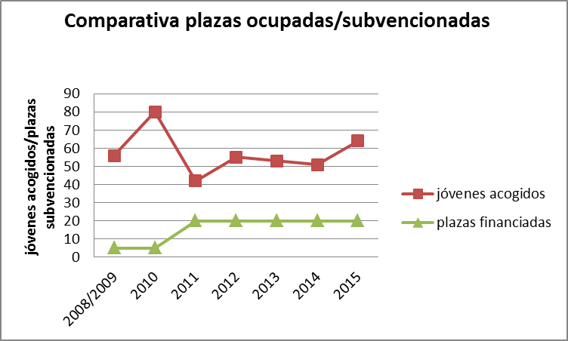
4.3 V. RESPONSE TO GENERAL AND SPECIFIC PROTECTION NEEDS f) Right to enjoy the highest attainable standard of health and facilities for the treatment of illness and rehabilitation of health (arts. 23, 24 and 39). In this regard, one of the requirements to obtain the above-mentioned residence permit under exceptional circumstances is national health coverage for the duration of the permit (this right is granted to them while they are minors) but Royal Decree Law 16/2012, of 20 April 2012, regarding urgent measures to guarantee the sustainability of the National Health System in Spain and improve the quality and security of its services, stipulates that they do not have the right to healthcare after reaching the age of 18, without prejudice to exceptions set out in the Regulations. Therefore, the majority of our participants welcomed as young people formerly under the guardianship of the authorities have to take out an expensive insurance policy for this purpose. This comprises a substantial obstacle for achievement of the short and long-term solutions mentioned in point 4.1., as our participants do not have enough money to meet this expense and thus be able to maintain their regularised status, and because without a residence permit they cannot access the mechanisms that would facilitate the process of gaining their complete autonomy.

Murcia, 8 January 2016

Antonio Murcia Moreno
Social worker at the diocesan Caritas of Cartagena (Spain)
Social action / Shelters

