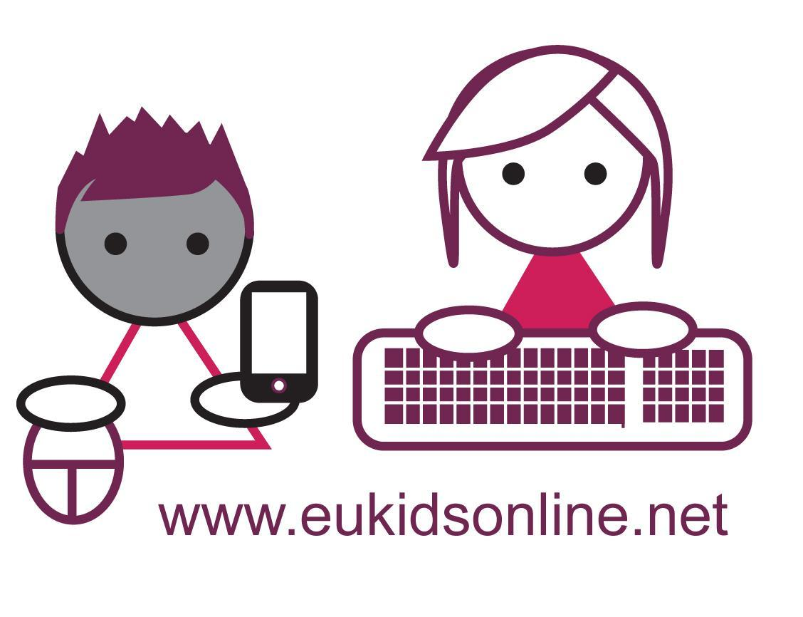

EU Kids Online: written submission to the

COMMITTEE ON THE RIGHTS OF THE CHILD

2014 Day of General Discussion

Digital Media and Children’s Rights

10 August 2014

The EU Kids Online network values the opportunity to contribute to this important discussion on the rights of the child in a digital age. EU Kids Online is a multinational research network which seeks to enhance knowledge regarding European children's online opportunities, risks and safety. It employs multiple methods to map children's and parents' changing experience of the internet. It also sustains an active dialogue with national and European policy stakeholders. It has been funded by the EC’s Better Internet for Kids programme.

First we note how children’s rights are specifically relevant to the digital age:

UN Convention on the Rights of the Child | Their specific relevance in the digital age
Protection against all forms of abuse and neglect (Art. 19), including sexual exploitation and sexual abuse (Art. 34), and other forms of exploitation prejudicial to child’s welfare (Art. 36) | Effort to prevent creation and distribution of online child abuse images, sexual grooming, online dimension of child trafficking
Protection from ‘material injurious to the child’s well-being’ (Art. 17e), ‘arbitrary or unlawful interference with his or her privacy, family, or correspondence, nor to unlawful attacks on his or her honour and reputation’ (Art.16) and right of child to preserve his or her identity (Art. 8) | Effort to prevent, manage and raise awareness of reputational risks, privacy intrusions, cyberbullying, pornography, personal data misuse (including identifying, location-based and financial information)
Provision to support children’s rights to recreation and leisure as appropriate to their age (Art. 31), an education that will support the development of their full potential (Art. 28) and prepare them ‘for responsible life in a free society’ (Art. 29) | Effort to provide educational technology, online information and creative resources, and promote digital skills in an equitable way (taking into account relevant languages, difficulties of access or conditions of disability or disadvantage)
Recognizing ‘the important function performed by the mass media’ encourages provision of diverse material of social and cultural benefit to the child (including minorities) to promote children’s well-being (Art. 17) | Effort to provide public and commercial educational, civic, science, cultural and heritage content online in an equitable way (as above)
Participation rights: ‘In all actions concerning children… the best interests of the child shall be a primary consideration’ (Art. 3), including the right of children to be consulted in all matters affecting them (Art. 12); see also child’s freedom of expression (Art. 13) and freedom of association (Art. 15) | Effort to include all children in diverse societal processes, including consulting them on matters of education, research and ICT governance

EU Kids Online’s evidence is pertinent to the DGD’s two questions.

(1) Children’s equal and safe access to digital media and ICT (or, in terms of the UNCRC articles, children’s rights to protection and provision):

- Although public concern over online sexual content is justified, the extent of children’s exposure should not be exaggerated, and nor should it be assumed that all children are upset or harmed by such exposure. Evidence suggests that popular discourses centred on teenage boys’ deliberate exposure to sexual content makes it harder for parents and others to recognise the distress that inadvertent exposure may cause girls, younger children and those facing psychological difficulties.
- In countries where there is more bullying overall, there tends to be more bullying online. Given the prior existence of bullying, as more countries gain internet access, cyberbullying is set to increase. Thus anti-bullying initiatives should accompany efforts to promote internet use. Further, evidence shows that online and offline bullying should be seen as connected, part of a vicious cycle in which perpetrators reach their victims in diverse ways and victims find it hard to escape. In other words, those who bully may also be vulnerable, and they are often victims themselves.
- It is important to distinguish making new contacts online – a common occurrence – from going to meet new online contacts offline. It is equally important to recognise that for the most part, meeting online contacts offline is harmless, probably even fun. However, for a minority of children, meeting online contacts offline is harmful, and these children tend already to be the more vulnerable.
- Policy makers need to be continually alert to new risks that affect children and young people, especially arising from peer-to-peer contact. This means that, as well as conducting representative surveys, qualitative work based on listening to children is vital to learn what new risks they are experiencing.
- While younger children have fewer resources to cope with online risk, they are also more willing to turn to parents for help. Meanwhile, teenagers face particular risks and they may struggle alone, so they need particular support.
- Industry needs to be much more proactive in promoting internet safety awareness and education. Evidence repeatedly shows that children struggle with user tools, safety devices, privacy settings and policies, reporting mechanisms. Independent evaluation of progress by the industry is crucial, to measure whether improvements have been made (against benchmarks) but more importantly, whether those improvements work - i.e. are they actually sufficient for children to manage their safety, privacy, identity and risk online?
- Awareness-raising in relation to online risks should be balanced and proportionate, and targeted at those most at risk of harm. Without being alarmist or sensationalist, parents need to be alerted to the nature of the risks their children may encounter online. Awareness-raising should try to encourage dialogue and greater understanding between parents and children about young people’s online activities. Increasing parental understanding of risks is particularly important in those countries where awareness of children’s risk experience is lowest.

(2) Children’s empowerment and engagement through digital media and ICT (or, in terms of the UNCRC articles, children’s rights to provision and participation):

- Children’s online opportunities and skills need human and financial investment. Not only do younger children and girls not progress as far up the 'ladder of opportunities' as teenagers and boys, many never reach the more advanced civic, creative or communicative activities at all. Promoting more creative and skilled applications is essential to ensure all children avail of online opportunities.
- Schools play a pivotal role in digital skills development, mitigating forms of digital exclusion. However, teachers are often inadequately resourced and trained to carry out the functions entrusted. Country differences in online skills point to the need for targeted educational interventions where there is evidence of a digital divide.
- Inequalities in digital skills persist – in terms of SES, age, gender and country so efforts to overcome these are needed.
- Encouraging children to do more online will also improve their digital skills as well as their overall confidence and/or increasing children’s beliefs in their abilities to use the internet. Similarly, teaching safety skills is likely to improve other skills, while teaching instrumental and informational skills will also improve safety skills.
- Since opportunities and risks online go hand in hand, efforts to increase opportunities may also increase risks, while efforts to reduce risks may restrict children’s opportunities. A careful balancing act, which recognises children’s online experiences ‘in the round’, is vital.

A wider analysis of the relation between evidence and policy suggests that:

- In debates over internet governance, the interests of children figure unevenly, and evidence shows that only very partial progress has been made in supporting children’s rights online globally.
- The UN Convention on the Rights of the Child is helpful in mapping children’s rights to provision, protection and participation as they apply online as well as offline. However, challenges remain.
- First, opportunities and risks are positively linked, policy approaches are needed to resolve the potential conflict between protection on the one hand and provision and participation on the other (especially as, when such conflicts arise, protection often wins out over participation).
- Second, while parents may be relied on to some degree to balance their child’s rights and needs, the evidence suggests that some parents are ill-equipped to manage this (related arguments can be made regarding reliance on schools and teachers, or other intermediaries such as youth or health workers, many of whom lack up to date training in digital matters).
- Third, resolution is needed regarding the responsibility for implementing digital rights, since many governments prefer self-regulation in relation to internet governance, partly for fear of ‘mission creep’ (if the means of protecting children online spread to forms of censorship).
- One solution would be to establish a trusted, efficient global governance body charged with ensuring the delivery of children’s rights.

Much of the foregoing reflects the European focus of the network’s research. However, the work of EU Kids Online has also been used to inform UNICEF’s unfolding global research agenda in relation to children’s rights in a digital age. There are some pressing challenges as internet use becomes more global. These include:

- The internet is not the cause of problems in children's lives but it certainly contributes to them. It is increasingly one of the 'places' where problems now occur (and this means child protection must encompass proprietary, globalised, difficult-to-regulate and fast-changing technological platforms and socio-technical practices).
- The affordances of the internet may amplify or otherwise complicate or worsen existing problems of abuse, violence or exploitation (because the internet enables rapid circulation of content that is difficult to erase, with little regard to child users in particular, and very hard to obtain redress).
- The internet also offers new ways of advancing positive provision for children, including opportunities for their greater participation and new pathways to opportunities to learn and grow. But just as technology is not by itself the problem, nor is it simply the solution. Everything depends on how it is used, by whom, and to what end.
- Since context is all, and context varies worldwide, the effects of internet use vary globally. To understand the harms and benefits associated with the internet, we need context-sensitive research and local knowledge, and this is lacking across much of the world.
- Until recently, the internet has been seen as a global north privilege, a symbol of affluence. But around the world, the global south is going online. This in itself is resulting in a step change in the number of child users.
- Relatedly, evidence shows that what internet use means is changing: (1) internet access is increasingly mobile first rather than desktop or workplace first, (2) in many countries there is more community provision than either home or school-based provision (both more common in the West, in the early days of the internet), (3) internet access and content is increasingly commercialised (often with little local, public or own-language provision), (4) internet access increasingly occurs in contexts of very low or sometimes-punitive regulation and insufficient mediation by bodies charged with child welfare or well-being.

Notes

As a major part of its activities, EU Kids Online conducted during 2010 a face-to-face, in-home survey of over 25,000 9-16 year old internet users and their parents in 25 countries, using a stratified random sample and self-completion methods for sensitive questions. Now including researchers and stakeholders from 33 countries in Europe and beyond, the network analyses and updates the evidence base to inform policy. See www.eukidsonline.net
Source: Livingstone, S., and Bulger, M. (in press) A global research agenda for children’s rights in the digital age. Journal of Children and Media.
For these and related points, see O’Neill, B., Livingstone, S. and McLaughlin, S. (2011) Final recommendations for policy, methodology and research. LSE, London: EU Kids Online. [Full text]
Livingstone, S., and O’Neill, B. (2014) Children’s rights online: challenges, dilemmas and emerging directions. In van der Hof, S., van den Berg, B., and Schermer, B. (eds), Minding Minors Wandering the Web: Regulating Online Child Safety (pp.19-38). Berlin: Springer. [Full text]
Livingstone, S., and Bulger, M. (2013) A Global Agenda for Children’s Rights in the Digital Age: Recommendations for Developing UNICEF's Research Strategy. Florence: UNICEF Office of Research. [Full text]

