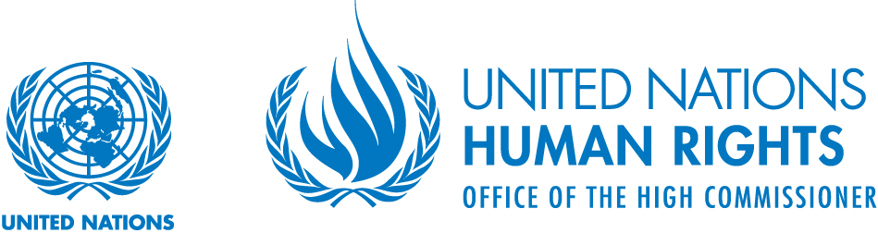

Statement of the Special Rapporteur on the implications for human rights of the environmentally sound management and disposal of hazardous substances and wastes at the
UN Committee on the Rights of the Child,
2017 Day of General Discussion

24 September 2016

Excellencies, distinguished delegates, friends and colleagues:

It’s a pleasure to be here with you today. As some of you are aware, last week I presented my second thematic report to the Human Rights Council, which examines the rights of child implicated by toxics and pollution.

In my thematic report, I argue that States have an obligation to prevent children from being exposed to toxics and pollution. Case after case has illustrated the myriad of rights violated when States and businesses fail to prevent the exposure of children to toxics and pollution.

Article 24 of the Convention of the Rights of the Child (CRC) recognizes the right of the child to the highest attainable standard of health. It explicitly requires States to take into account the risks of contaminated food and water as well as pollution in the realization of the right to health.

This explicit linkage between children’s rights, health, contamination and pollution in the CRC is powerful. And appropriately so.

Children are arguably the most vulnerable to toxics and pollution. For years, they are completely defenseless. They are impacted in ways in which adults are not. They are exposed at higher levels than adults, including to toxic chemicals found in their mother’s body. Numerous health impacts are linked to childhood exposure to toxics, such as cancer, developmental disorders, learning disabilities, and respiratory illnesses. Many of these diseases and disabilities do not manifest for years or decades after exposure.

Doctors refer to the present state of impacts on children’s health as a “silent pandemic.”

In one country, childhood cancer rates have increased nearly 20 percent over a twenty-year span. Types of diabetes are now seen in children that were previously only observed in adults. Rates of asthma, early puberty and birth defects have also increased dramatically. Most of these and other increases cannot be explained by lifestyle choices or genetics alone, and have come during periods of rapid industrialization.

Human rights are indivisible, interlinked and interdependent. A child’s right to health is closely linked to a child’s right to life, survival and development, and numerous other rights.

Latest figures from the World Health Organization estimate over 1.7 million children under the age of five, died prematurely from toxics, pollution and other exposures. This does not account for children who died after the age of five, or those who suffer from non-fatal diseases or disabilities.

The right to safe food, the right to safe water and sanitation, the right to adequate housing, the right to be free from the worst forms of child labor, have all been interpreted to require that States prevent exposure to hazardous substances.

A child’s best interests should guide the interpretation and implementation of the Convention on the Rights of the Child. The child’s best interests are best served through the prevention of exposure. Today, however, laws and polices around the world essentially permit children to be exposed to toxic chemicals and pollution.

Every child has a right to bodily integrity, which recognizes the autonomy of the individual, to be free from unwanted invasions of its body.

Yet, the child’s right to physical integrity is abused by an endless stream of exposure, by an invisible cocktail of dozens if not hundreds of hazardous substances, to which they are exposed before and after birth.

Sadly, pediatricians now refer to children as being born “pre-polluted.”

The inability to ensure a child’s views are heard before they are exposed to hazardous substances, and the impossibility to realize a truly effective remedy after exposure, strongly imply that States prevent exposure.

Children in low-income, indigenous, minority or otherwise marginalized communities bear a disproportionate burden of our inaction on toxic chemicals, implicating the human rights principles of dignity, equality and non-discrimination. In my view, the only solution to this injustice is the prevention of exposure.

The obligation of States to prevent childhood exposure to toxics and pollution lies at the nexus of these rights and freedoms. There too lies a corresponding responsibility on businesses.

Toxics and pollution are an insidious threat to human rights, with some of the gravest impacts on children.

However, this is a human rights issue where solutions are available to prevent violations. While considerable progress has been made by States to prevent exposure, some of which are described in the reports from visits to Kazakhstan, Germany and South Korea, much work remains to be done, which is also described in those reports.

To defend the most defenseless, our future generations, an effective framework is required. This consists of effective legislation, regulation and enforcement; ensuring businesses conduct human rights due diligence; realization of an effective remedy for violations; and international cooperation to address what is unquestionably a global problem.

Chair,

Over the past two years under this mandate, I have witnessed grave deficiencies in all of these aspects, in all regions and countries both rich and poor.

In one of the world’s wealthiest countries, 6,000-12,000 children were exposed to high levels of lead in their drinking water. The community of Flint Michigan is predominantly African-American, and nearly 30% live below the poverty line. Moreover, Flint is not an isolated case. Children in other minority, indigenous and low income communities around the United States & elsewhere also have, and continue to face, similar toxic threats from lead and other hazardous substances in the water they drink, food they eat, air they breathe, as well as their homes, schools and playgrounds.

During my visit to the Republic of Korea, the plight of over 1000 victims of an untested, under-regulated consumer product loomed large. Unknowingly, consumers added the toxic product to water tanks of humidifiers, hugely popular in Korea, which led to over 90 deaths. Among the dead, dozens of young babies and pregnant women whose bodies were especially vulnerable. The vast majority of the product was sold by the Korean subsidiary (Oxy) of an UK pharmaceutical company (Reckitt Benckiser) that certainly should have known the risks, regardless of the fact that it was in compliance with certain laws at the time.

During my visit to Germany, I learned of the case of a highly hazardous pesticide, which was banned in Germany but allegedly sold by a German company, Bayer, in Peru. The pesticide killed 24 school children and injured 26 others when they mistakenly consumed it as powdered milk. The victims and their families have had no semblance of a remedy for nearly 20 years. The case is emblematic of children regularly killed and injured by highly hazardous pesticides around the world.

These are but a few of the cases where the rights of children to life, survival, development, health, and other have been violated by the failure of States to prevent childhood exposure. However, the issue is not simply limited to these cases of poisonings. As I mentioned before, children are born pre-polluted in all countries, an abuse of the child’s right to physical integrity, and leading to the silent pandemic observed by pediatricians. States have a duty to prevent childhood exposure, and businesses a corresponding responsibility.
Thank you, Chair

