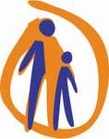
Child Rights Centre
Dobračina 29/3A
Belgrade, Serbia
Tel/Fax: +381 11 33 44 170
Email: office@cpd.org.rs
www.cpd.org.rs

DX Club submissions for the Day of General Discussion “Protecting and empowering children as human rights defenders”

In line with Guidelines for submissions to the Day of General Discussion “Protecting and empowering children as human rights defenders” the Child Rights Centre has supported children and young people to express their views and prepare submissions for the UN Committee on the Rights of the Child.
The Child Rights Centre is an association of citizens established in 1997 with the main aim of implementing child rights in Serbia in accordance with the Convention on the Rights of the Child. The main course of action of the Centre is aimed at creating a favourable social and legislative framework for the full achievement of child rights in Serbia through activities focused on the introduction and implementation of laws, policies and practices that enable the improvement of the welfare of the child, the protection of their rights and their full participation in society.
Child participation has a status of a principle in the work of our organisation and represents one of the main features of our activity. The Centre implements all of its activities in cooperation with children or for children. Through its work, the Centre provides support to independent and self-organised child and youth groups. In this regard, the continual support is offered to the group of children and youth at the Children's Information and Cultural Service (DX), which has been active in the Centre's programme activities since its establishment.
DX Club is made out of children and young people, from 12 to 18 years old. It’s a place where children and youth can get information about their rights in a language they understand. They can also join in club’s activities such as workshops, public debates, public manifestations, self-advocating activities, if they are interested in such.
The members of the club come up and organize the activities on their own with the support of the club’s coordinator, the facilitator of the activities. They went through training courses on child’s rights, so now they teach their peers about those rights. Besides that, they organize public activities, film short informative films and work on various other events to encourage their peers to advocate for the exercise of their rights.
More than 200 members of the club DX has participated in activities promoting the position of children and the youth in the Republic of Serbia. In cooperation with relevant institutions and international organizations the activities are implemented at the local, national and international level. Children and young people have so far participated in activities such as reports on exercising the rights of the child, creating a “child friendly” publication – written with the vocabulary that is comprehensible for children and numerous actions with the aim of their voice being heard, and the opinion respected.
Through learning about different cultures, their exhibitions, documentaries and other activities they inform their peers and the general public on the rights of the child, which are guaranteed by the Convention on the Rights of the Child.

In order to collect children’s views around the role, protection and empowerment of children as defenders of human rights in the period of March – June of 2018, workshops have been created and held with the children and the youth from Club DX. The results of the conducted workshops are presented in three drawings and they represent DX Club submissions for the Day of General Discussion “Protecting and empowering children as human rights defenders”.
The workshops were created with the help of Guiding Questions for facilitators, Child-Friendly Guidelines for Submissions to the DGD and the Concept note in order for children to become familiar with the concept of human rights defender, the topic of Protecting and empowering children as human rights defenders children, they have collected children’s opinions and attitudes for the creation of the motion for the Day of General Discussion. Besides participating in the workshops, the children expressed their opinion by drawing/writing on the drawings that will be delivered to the Committee on the Rights of the Child as DX Club submissions.
As the result of the conducted workshops, three drawings were created that reflect the opinions and attitudes of the children about:
- What do human rights defenders represent for them and how they differ from others children;
- What qualities do child defenders of human rights have;
- What kind of support is needed for child defenders of human rights.

I drawing – „What do human rights defenders represent for them and how they differ from others children?”
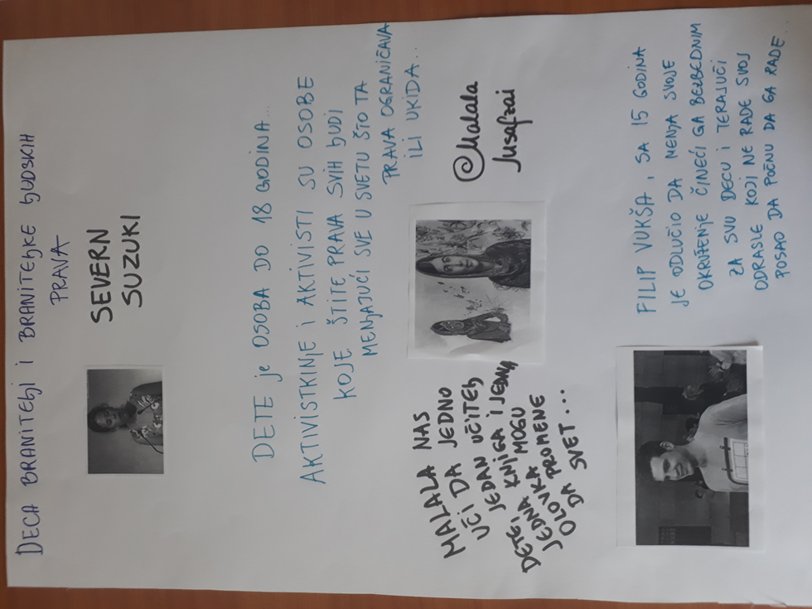

In order to gather the opinions of children and young people about who and what human rights defenders are and how they differ from other children, the members of DX Club have first themselves discovered the concepts of a human rights defender and examples from real life. For this purpose in the workshops they were shown, among other things, video materials with the examples of child defenders of human rights from around the world as well from the Republic of Serbia, such as Severn Suzuki, Malala Yousafzai and Filip Vuksa (Ekološka prava: Severn Suzuki https://www.youtube.com/watch?v=JZEpr5G1p1Y&amp;app=desktop Malala Yousafzai: Right on education for all https://www.youtube.com/watch?v=cHPyilPCPwI&amp;app=desktop Local one: Filip Vukša: safe environment for children and responsible public service Buđenje javnih institucija: Filip Vukša at TEDxNoviSad https://www.youtube.com/watch?v=kE-xAlsiA3w&amp;app=desktop).
After watching each attachment, it was discussed with the children which activities were initiated, the challenges that child defenders of human rights face, ageism they often encounter, the characteristics and the behaviour of child defenders of human rights, etc. The first drawing shows the mentioned prominent child defenders of human rights (Severn Suzuki, Malala Yousafzai, Filip Vukša) and the opinions of children and youth from the DX Club about them.
The children stated that Severn Suzuki argues that "a child is a person under 18, that activists are people who protect the rights of all by changing everything in the world that limits or abolishes these rights." That Malala Yousafzai teaches them that "One child, one teacher, one book and one pen can change the world," and that Filip Vukša, at the age of 15, decided to change his environment by making it safe for all children and making the adults who do not do their job start doing it.
II drawing – “What qualities do child defenders of human rights have”
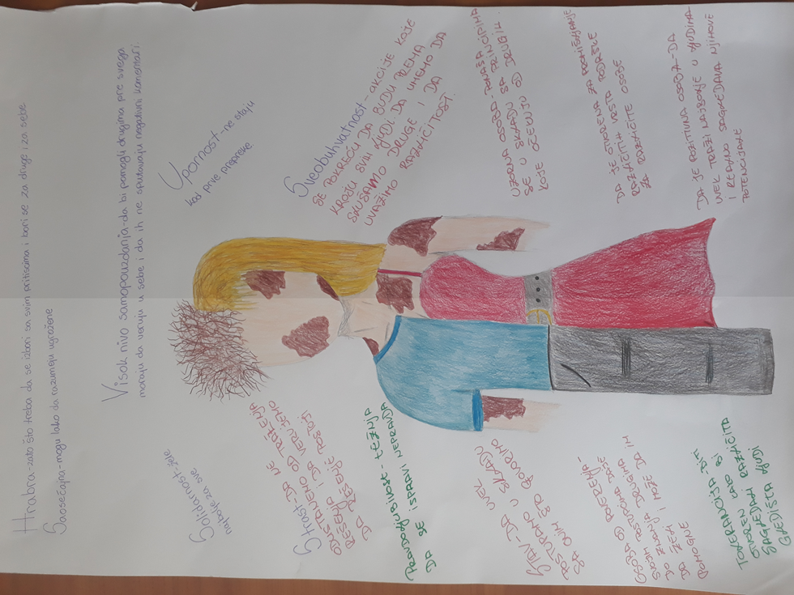
The second drawing represents the attributes that DX members think a child defender of human rights has or should have. The image itself is half a boy half a girl, and vitiligo indicates that, in the opinion of children, anyone can be a human rights defender regardless of sex, skin color, religion, health status, age, etc.
On the drawing itself are listed some qualities that child human rights defenders have:
- Brave - because they need to fight with all the pressures and fight for themselves and others;
- Compassionate - because they can easily understand the vulnerable;
- High level of confidence - to help others first and foremost they must believe in themselves and not let negative comments affect them;
- Persistence - to not stand at the first obstacle;
- Comprehensiveness – to include all in the activities they started. To be able to listen others and understand our differences;
- An exemplary person - acts in accordance with the principles they expect from others;
- That they are open to considering different kinds of support for different kinds of people;
- A positive person – to always look for the best in people and realistically look at their potential;
- Tolerance - to be open to consider different views;
- A person of trust – that by their actions they give others the knowledge that they wants and can help them;
- The attitude - to always act in accordance with what they say;
- Righteousness - the desire to correct injustice;
- Passion - not to give up seeking a solution and to believe that a solution exists;
- Solidarity - they want the best for everyone.

III drawing – “What kind of support is needed for child defenders of human rights”
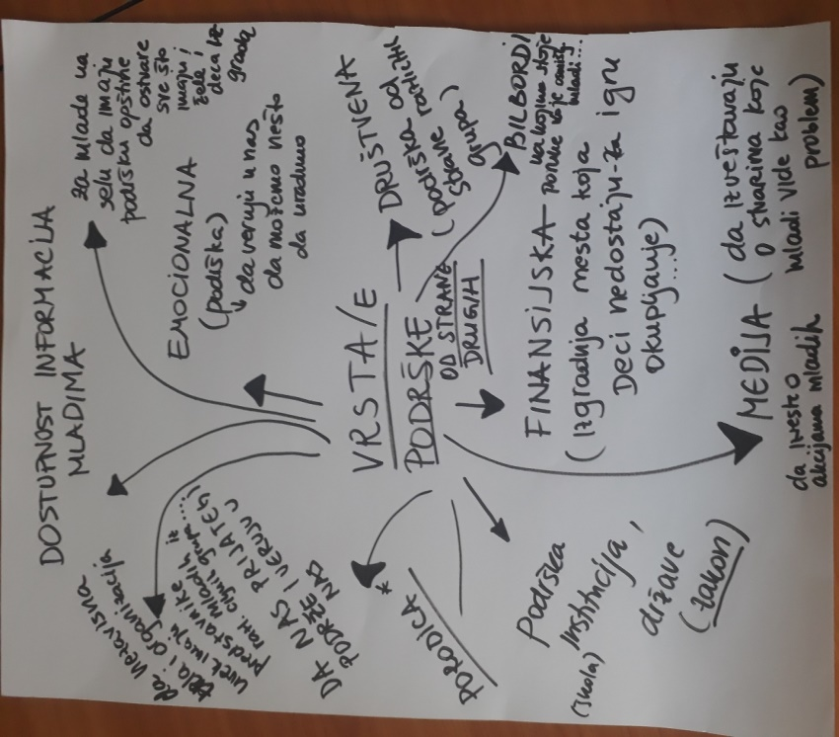
On the workshops it was discussed with children about what types of support should be initiated in communities all over the world so that children defenders are supported during their actions and protected while advocating in the environment in which they are located

During the workshop, members of the DX Club have come to a conclusion that all human rights defenders need the following types of support:

- The availability of information for the youth;
- For the youth in the villages to have support of their municipality to accomplish everything the children from urban cities can;
- Emotional (support) to believe in us that we can do something;
- Social (support by different groups);
- -Billboards on which the messages of young people are;
- Financial (building a place in the form of a large number of youth clubs that children lack for their games, get-togethers…);
- Media - to share their youth actions (to report on things that young people see as a problem);
- Support of institutions (schools), country (laws);
- Families-when they advocate the rights of certain groups that are stigmatized in Serbia (especially HIV + youth, LGBT+ youth, Roma, children with disabilities).
- That our friends support and believe in us;
- Independent bodies and organizations always have representatives (mostly youth) from different minorities.

The children point out that one of the best things about being a part of Club DX is meeting other Child defenders of human rights. The opportunity to create joint actions in the school that they come from in order to empower student parliaments, as well as actions in the local community also means a lot to children.
In schools human rights (and examples of violations of them) are talked about exclusively in civil education classes and parliamentary meetings. That's why children who are members of the DX club often suffer labeling by other children in schools when they promote the rights of certain social groups, who’s rights are violated, in Serbia because of the prejudices that exist about members of these groups. There is a need to work on changing the image of child rights defenders, as the bearers of changes in schools. Of the types of support that are especially missing in Serbia, members of the DX Club cited a lack of support from their peers and ageism-prejudice of adults towards young people as bearers of the changes in society.

Easy Read publications prepared in cooperation with children and youth

- "IT IS ABOUT YOU" - a book for children and young people to help them understand the recommendations of the UN Committee on the Rights of the Child
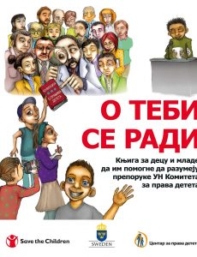

http://cpd.org.rs/wp-content/uploads/2017/10/centar_za_prava_deteta_O_tebi_se_radi.pdf

This child-friendly book covers topics related to children’s rights in Serbia, focused on: What Serbia is doing to respect the Rights of the Child What the Convention of the Rights of the Child is Information about Concluding Observations and Recommendation
Publication year: 2017 Publisher(s):Child Rights Centre

- "Nobody is Allowed to Hurt You": A book for children and young people to help them understand what abuse and neglect means
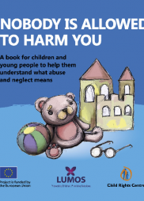

http://cpd.org.rs/wp-content/uploads/2017/11/niko_ne_sme_da_te_povredi_en.pdf

This child-friendly book has been developed by the Child Rights Centre to help children understand what neglect and abuse constitutes, as well as to provide guidance on what to do if they experience it first-hand, or witness another child being subject
Publication year: 2017 Publisher(s): Child Rights Centre

- “HRABRO U PROMENE - Veränderungen mutig begegnen”
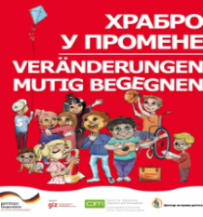

http://cpd.org.rs/nova-publikacija-centra-za-prava-deteta-hrabro-u-promene-2

This book gives children returnees and young people the opportunity to get to know some of the rights they have in Serbia, to find out who they can turn to for assistance and support when they need them, it gives advice that can help them understand the environment in which they are, as well as to encourage them to adapt more easily to the changes that have arisen in their lives.
Publication year: 2017 Publisher(s): Child Rights Centre

