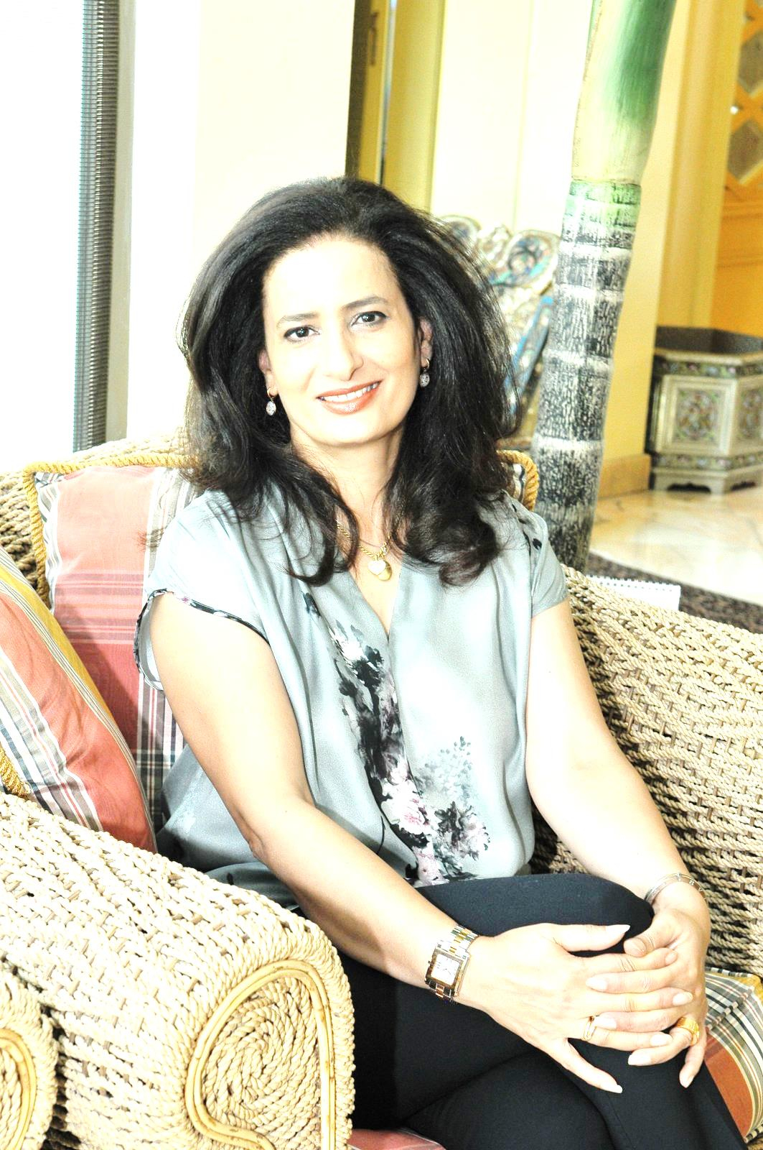
Aldoseri, Amal Salman
Kingdome of Bahrain

Current position/function:
- Member of the United Nations Committee on the Rights of the Child since 2013
- Vice- chairperson of the Committee, (Candidate for chairperson of the Committee in June 2014), member of the Bureau of the Committee
- Member of the Working Group on the 3rd Optional protocol on a communication procedures
- Member of the Arab Committee on the Rights of the Child, League of Arab States, Cairo
- Ex member and present resource person of the National Committee for Childhood, headed the team to draft the first National Child Strategy and plan of action.

Working languages:
Arabic, English, French and first certificate in German
Main professional activities:
- participated in developing 4 General Comments for the CRC: Harmful Practices (jointly with CEDAW), Children in Street Situations, Children’s rights in public spending, Children in Migration Situations (with CMW)
- member in the 25th anniversary of the CRC working group and participated in hangout meeting with children from different parts of the world
- participated in the preparation committee for the special session on children, New York 2001
- Headed a professional team to draft the “Child Law” in accordance with the CRC, which was adopted in August 2012.
- Manager of the first National Youth Strategy 2005-2009 and the update 2011-2015, including young people’s participation and rights.
- Manager of National Child Strategy in Bahrain and Action Plan 2012-2016.
- Manager of Situation Analysis (Sit-An) 2003 and 2011, focusing on the challenges facing the implementation of the Convention.
- Project Manager of Multiple Indicator Cluster Survey, in coordination with UNICEF.
- Main contributor in writing Bahrain’s initial, second and third periodic reports on CRC and member of the delegation for the dialogue with the CRC Committee, Geneva.
- Teacher, head of department, and then advisor on teaching methodology in the Ministry of Education
Educational background:
- B.A, double major English Literature and translation, Kuwait University
- Post-graduate Diploma in Education, Bahrain University
- Master in Education- Sheffield University UK,
- Course in “Innovation in Governance”, School of Government, Harvard University
Other main activities in the field relevant to the mandate of the treaty body concern:
- Initiated dialogue and lobbied to incorporate the CRC in the school curricula with Ministry of Education.
- Participated in the strategic planning for young people living in Bahrain in all fields, including human rights and civic participation.
- Founder of Bahrain Youth Parliament (age group 14-19 years).
- Founder of Y-PEER Education- Bahrain, the first and only in the region, in coordination with UNFPA to educate and train young trainers on sexual and reproductive health.
- Recognized trainer on capacity building and development of youth, children and women (UNDP, UNICEF, UNFPA, League of Arab States (LAS)
- Lead organizer of the Arab Child Festival.
- Launched Short Story Competition for Children to encourage writers and new young writers to produce story books for children.
- Lead organizer of the first Child Theatre Festival.
- Ex-Vice-president of International Council on National Youth Policy (ICNYP), Vienna.
- Ex -Board member of World Leisure Organization (WLO), USA.
- Member of non-profit Bahrain Society for Child Development, and member of Sultan Bin Abdulaziz Centre for speech and hearing, helping children with hearing disabilities.
List of most recent publications:
- “Child and Law in Bahrain”, 2003.
- “Children’s Books in Public Libraries”, survey
- “Children’s Programmes in G.C.C. Television Channels”, survey

