As of June 2017
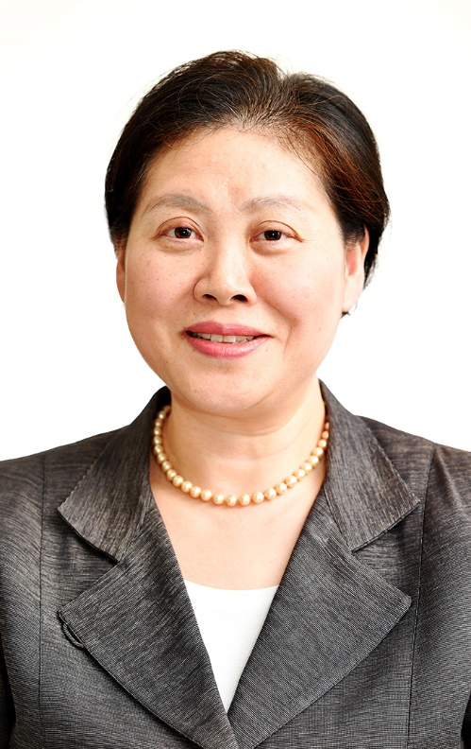

MIKIKO OTANI

Mikiko Otani is an international human rights lawyer based in Tokyo where practicing family law with focus on women’s and children’s rights. She is Member of the United Nations Committee on the Rights of the Child, Council Member of the International Bar Association’s Human Rights Institute and former Chair of the Committee on International Human Rights of the Japan Federation of Bar Associations. She is also the country representative of Japan for the Family Law and Family Rights Section of LAWASIA (The Law Association for Asia and the Pacific). The areas of her focus include human rights education, early childhood development, child participation, girl child, child marriage, human trafficking and migrant children.

As a leading woman lawyer representing civil society in Japan, Ms. Otani was an Alternate Representative of the Delegation of Japan to the 60th and the 61st UN General Assembly (Third Committee) (2005-2006) and an Advisor (NGO Representative) of the Delegation of Japan to the 53rd UN Commission on the Status of Women (2009). Ms. Otani has been actively involved with NGOs and professional organizations at the regional and the international levels, having served as a Regional Council member of the Asia-Pacific Forum on Women, Law and Development (2005-2014) and as Co-Chair of the Women Lawyers’ Interest Group of the International Bar Association (2013-2014).

Ms. Otani is also active in academic, research and teaching works. She is a Member of the Executive Council of the Japan Chapter of the Asian Society of International Law. She has been a lecturer on international human rights at Soka University Graduate School of Law. She was invited to give lectures at the training seminars for lawyers of Cambodia, Mongolia, Iraq, Iran and Malaysia on the international human rights law, women’s rights and children’s rights. She taught women and children’s issues in Japan and East Asia as a visiting professor at the William S. Richardson School of Law, University of Hawai`i at Manoa in 2011. She participated as an invited expert at the Ernst Strüngmann Forum on “Formative Childhoods: A Path to Peace?” in Frankfurt in 2013.

Ms. Otani was admitted to Tokyo Bar Association in 1990. She holds Bachelor of Law from Sophia University in Tokyo (1987), Master of International and Public Affairs from Columbia University in New York (1999) and Master of Law from University of Tokyo (2003).

Her publications include: Addressing Trafficking in Persons as Transnational Organized Crime, Hyu-rights Osaka (ed.), Asia-Pacific Human Rights Review 2006 (2006); Protection of Children from Violence, Kantaro Serita et. al. (ed.) “International Human Rights Law Making and Development, Lecture on International Human Rights Law, vol.2” (2006); Revisiting the Role of the International Human Rights Law: Review of and Challenges to the Human Rights Education in Japan, Hyu-rights Osaka (ed.), Asia-Pacific Human Rights Review 2007 (2007); Co-editor of “Handbook on Practice of International Human Rights Law”, (2007); Child Abduction in Japan, International Family Law Journal (2010); Committee on the Rights of the Child, Kentaro Serita et al. (ed.), “International Implementation of International Human Rights Law, Lecture on International Human Rights Law, vol.4” (2011); Practical Issues on Child Custody Involved in Separation/Divorce, Jurist, No. 1430 (2011); The Hague Convention on Child Abduction, Horitsu Jiho, No. 1040 (2011); International Issues on Child Custody: Internationalization of Families and Need of International Response, International Affairs, No. 607 (2011); Family Law: Jurisdictional Comparisons” (European Lawyer Reference) (author for Chapter on Japan) (2011).

…………

