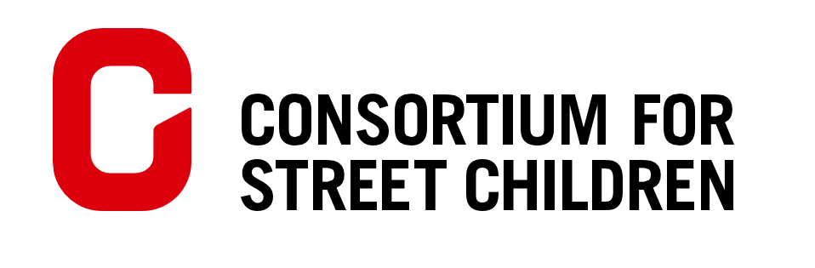
Submission on General Comment No. 24, replacing General Comment No. 10 (2007), on children’s rights in juvenile justice
08 January 2019
Introduction
The Consortium for Street Children (CSC) submits this joint contribution to the Committee on the Right of the Child regarding its draft General Comment No.24. CSC is a non-governmental organisation whose purpose is to defend the rights of children in street situations. CSC leads a global network of 100+ members working in 135 countries. The organisations Voice of Street, Toybox, Soeurs Salésiennes de Don Bosco, Don Bosco Fambul, Glad’s House, Save Street Children Uganda and Trace Uganda contributed their perspectives on juvenile justice for this submission.
The primary aim of this submission is to provide perspectives from advocates and practitioners working with one of the most vulnerable groups of children - children in street situations - on juvenile justice systems to highlight specific experiences from practice.
Minimum age of criminal responsibility
Members of the CSC network expressed a range of views regarding the appropriate minimum age of criminal responsibility based on their work with children in street situations, but every contributor was in favour of the minimum age of criminal responsibility being at least 14; the majority of respondents were in favour of a higher age of criminal responsibility of 16. Organisations felt that a higher age would allow for more supportive approaches that can influence the child’s well-being and positive potential for the future. Several contributors indicated that the child’s personal development by the age of 16 would be more advanced, giving them the maturity to understand and have control over their actions such that they could be held liable for offences committed from that age onwards.
CSC therefore recommends that the Committee requires a minimum age of criminal responsibility of 14, but goes further than to merely commend States adopting a higher minimum age, instead explicitly encouraging States to adopt a higher minimum age of criminal responsibility of 16 in paragraph 33.
Upper age limit of the juvenile justice system (criminal majority)
There were mixed views from the contributors to this submission regarding the issue of the upper age limit of the juvenile justice system. A minority favoured keeping the upper age limit at 18, in recognition of the widely recognised principle that adulthood begins at 18. The majority favoured an age of 21; the reasons for citing this age as an appropriate upper limit included the need for young adults to receive the higher level of support provided through the juvenile justice system rather than the adult justice system. In Glad’s House’s experience, generic adult services which have not been designed for young people often fail to meet their needs. For children in street situations, moving from childhood to young adulthood can be a particularly crucial time of transition during which they will need continued support and assistance.
CSC therefore supports the construction of paragraphs 40-42 and suggests that the Committee also include a recommendation that States adopt a restorative rather than punitive approach towards persons aged between 18 and 21 (in line with the principles of the juvenile justice system.)
Legal and other appropriate assistance
CSC and every CSC network member that contributed to this submission are supportive of the Committee’s recommendation in paragraph 62 that States should provide legal representation for all children who are facing charges in juvenile courts. Representation is a vital safeguard for all children, particularly those such as children in street situations who are especially likely to find the justice system complex and challenging to navigate without assistance.
Toybox reiterated that there must be efforts to ensure that legal representation, including State-funded or pro bono representation, is of sufficient quality. Evaluations and trainings of legal representation conducted on children’s behalf should take place regularly, and should permit the input and recommendations from children themselves on how the representation could be improved.
Don Bosco Fambul stressed the need for juvenile courts’ environments to be non-intimidating to children, both in terms of the physical set-up of the court and by ensuring that the professionals working in that setting have been sensitised to the specific support needs of children. CSC recommends the Committee includes this within paragraph 57.
In relation to paragraph 63, CSC recommends that the Committee asks States to implement a legal guarantee that children can have the assistance of ‘appropriate adults’ who are known to them when they are engaging with the juvenile justice system. Glad’s House further recommends that for children in street situations specifically, it would be preferable for the appropriate adult to be a specialist with experience of working with children who have connections to the streets. Vulnerable children often have large numbers of professionals coming in and out of their lives from the State and civil society, which can contribute to a lack of trust between children and professionals. Having an appropriate adult to work consistently alongside lawyers to support children and young people throughout the process would make their experience of the justice system more positive.
Deprivation of liberty
In respect of the recommended minimum age of deprivation of liberty in paragraph 101, the majority of contributors to this submission were in favour of a minimum age of over 16, with most recommending a minimum age of 18. Though there was not a consensus on this point, concern was widely expressed about the conditions of detention centres and prisons and the traumatising (rather than restorative) impact upon children and young people of being detained.
Glad’s House noted the reality that in many states, children are deprived of liberty in institutions without adequate facilities. Detention centres often lack adequate sanitation, beds, access to education, and trained staff; children experience infestations of bed bugs and epidemics of scabies, among other harms. These institutions can damage not only children’s physical wellbeing but also their mental wellbeing and health. Their life chances are significantly impacted as they miss big chunks of education and experience high levels of trauma. We recommend that the Committee states in paragraph 108 that these harms are unacceptable rights violations and that States that cannot provide adequate facilities that are safe and meet the needs of children being detained should not be depriving children of their liberty.
CSC suggests that paragraph 97 could be strengthened significantly: rather than deprivation of liberty being termed a measure of last resort, with this often not being reflected in practice, the Committee should require States to demonstrate that all reasonable alternatives in the circumstances for rehabilitating a child in conflict with the law into wider society have been attempted. Alternatives to detention recommended by CSC network members include: employment training and skills development; diversion towards counselling and rehabilitation; family mediation and reintegration; therapeutic support for individuals, groups and families; restorative justice; early intervention; and programmes challenging community stigma around drug use, sexual activity and truancy. Trace Uganda has found it particularly effective to work hand in hand with probation officers and lawyers to support children in conflict with the law, and civil society can be an important source of support and expertise for professionals working with marginalised and vulnerable children.
Support for children released from detention
CSC recommends that the Committee takes the opportunity to give more clarity in paragraph 99 about the support needs of children who are released from detention. It is important that they are given extra support with their reintegration into wider society, including through work with families and community leaders to reduce any associated stigma. CSC suggests that the Committee includes a requirement for States to provide services such as counselling, support with accessing education, employment (where appropriate) and vocational skills placements and longer-term professional assistance (e.g. through street workers, special educators and psychologists) to children released from detention.
Often children are returned home without any risk assessment or family mediation, which can mean that the situations that pushed children into conflict with the law (and sometimes onto the streets) are not resolved. This can lead to children moving onto or returning to street situations with increased experiences of trauma. CSC recommends that the Committee requires States to ensure appropriate care and protection placements and safe care plans for all children entering and exiting the juvenile justice system in paragraph 99.
Additional suggestions of points for inclusion
Status offences
Paragraphs 10 and 11 discuss status offences; General Comment No.21 describes these offences as directly discriminatory (paragraph 26) and adds that States have an obligation to respect the dignity of children and their right to life, survival and development by decriminalising survival behaviours and status offences (paragraph 32). Though this is applicable for all children, the criminalisation of status offences has a disproportionate impact upon children in street situations, as recognised in General Comment No.21. This General Comment is an opportunity to reflect that there has not yet been sufficient progress globally towards the decriminalisation of status offences and survival behaviours by children and to reinforce the message that this is a State obligation that must be fulfilled.
CSC recommends that the Committee strengthens paragraph 10 by noting with concern the widespread non-compliance with this obligation and informing States that the decriminalisation of status offences is an urgent priority. This could be supported by a cross-reference to the aforementioned paragraphs in General Comment No.21.
Police accountability
The CSC network has repeatedly raised the urgent need for police round-ups and targeted violence towards children in street situations to be put to an end. Save Street Children Uganda referenced incidents of police physically assaulting children in the process of rounding them up, causing multiple violations of their rights. Toybox noted this as a priority issue facing children in street situations, adding that there is a need for more information on police round-ups and negative police treatment; that police should be trained about children’s rights and held accountable for any violations and that children should be able to provide feedback and complain about treatment that violates their rights.
Members of the police and security forces must be held accountable for violations of children’s rights. Authorities who violate the rights of children should be subject to appropriate disciplinary action and should also be held accountable through the criminal justice system where their conduct amounts to a criminal offence. Where abuses of power occur, effective follow-up action should be taken to identify how policing systems and procedures can be improved to prevent or limit any further re-occurrence of those abuses. CSC recommends that the Committee makes these accountability mechanisms an explicit requirement for States in paragraph 15.
Glad’s House further expressed concern about the encouragement or ordering of round-ups by politicians. The Committee could also use paragraph 15 to remind Government representatives of their responsibility to respect, protect and fulfil the rights of all children, including often-stigmatised populations such as children in street situations.
Institutionalisation
In many countries, child rights or juvenile justice laws give children in street situations the status of being “in need of care and protection”. These laws can sometimes link closely with status offences – a child found begging, running away from home or ‘loitering’ in public spaces may result in a child being deemed a child in need of care and protection. These laws can authorise children being placed in residential care institutions, such as children’s homes, orphanages and specialised boarding schools.
The Committee has recognised in the past that deprivation of liberty is never a form of protection for a child. Institutions are residential care facilities that segregate children away from local communities and parental care, and which do not make a parallel effort to reintegrate the child into their family or find suitable alternative care for them (whichever is in their best interests). Institutionalisation disproportionately impacts street children and children with disabilities. CSC requests that the Committee reiterates the need for States to set up de-institutionalisation programmes and develop and strengthen alternative care options, such as family and community-based care, in paragraphs 93-94.
Suitable alternatives to institutionalisation recommended by CSC network members focused on family-based care and long-term support. These include family tracing, family reunification, family support, adoption, fostering and follow-up services such as child and family empowerment programmes (Don Bosco Fambul, Save Street Children Uganda, Trace Uganda). Glad’s House stated:
“The most helpful alternative is identifying each child as an individual and recognising that every intervention should look different - one size does not fit all. A holistic model of response based around the child's needs created with the child […] is the only successful way to work with children, particularly if they have a high level of needs or complex issues that need supporting.”
_________________________________________________________________________
Stacy Stroud at Consortium for Street Children (CSC) authored this submission with the input of the below contributors. Queries in relation to the submission can be directed to Stacy@streetchildren.org.
CSC sincerely thanks the network members who contributed to this submission for giving their time and expertise:

Voice of Street
Devendra Kumar Gurung

The Toybox Charity
Al Richardson

Glad’s House
Vicky Ferguson

Save Street Children Uganda
Iryne Marunga Banoba

Soeurs Salésiennes de Don Bosco
Johanna Denifl

Don Bosco Fambul
Samuel Thomas Bojohn

Trace Uganda
Kisakye Francis

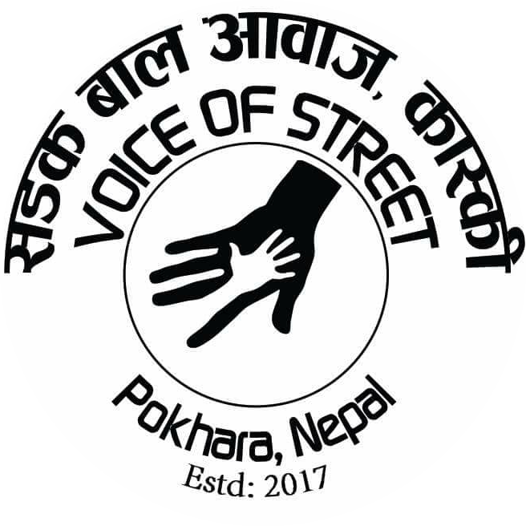
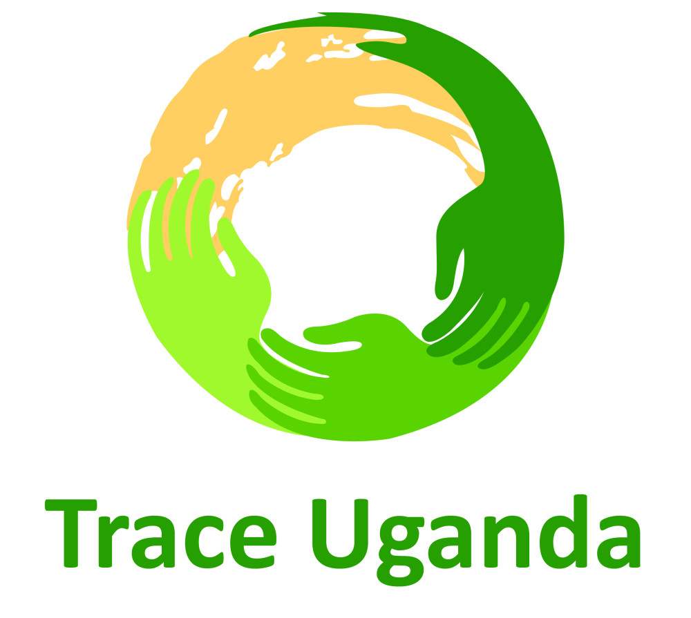

Voice of Street works in Nepal. The Toybox Charity (‘Toybox’) works in Bolivia, El Salvador, Guatemala, India, Kenya and Nepal. Soeurs Salésiennes de Don Bosco works in Benin and Côte d'Ivoire. Don Bosco Fambul works in Sierra Leone. Glad’s House works in Kenya. Save Street Children Uganda and Trace Uganda work in Uganda.
CSC submitted a joint contribution with its network members to the UN Global Study on Deprivation of Liberty about children in street situations’ experiences of round-ups and detention, which is publicly available here.
UNCRC, General Comment No. 21 (2017), para 44.
UNCRC, General Comment No. 9 (2006), para 49.
UNCRC, General Comment No. 21 (2017), paras 44-48.

