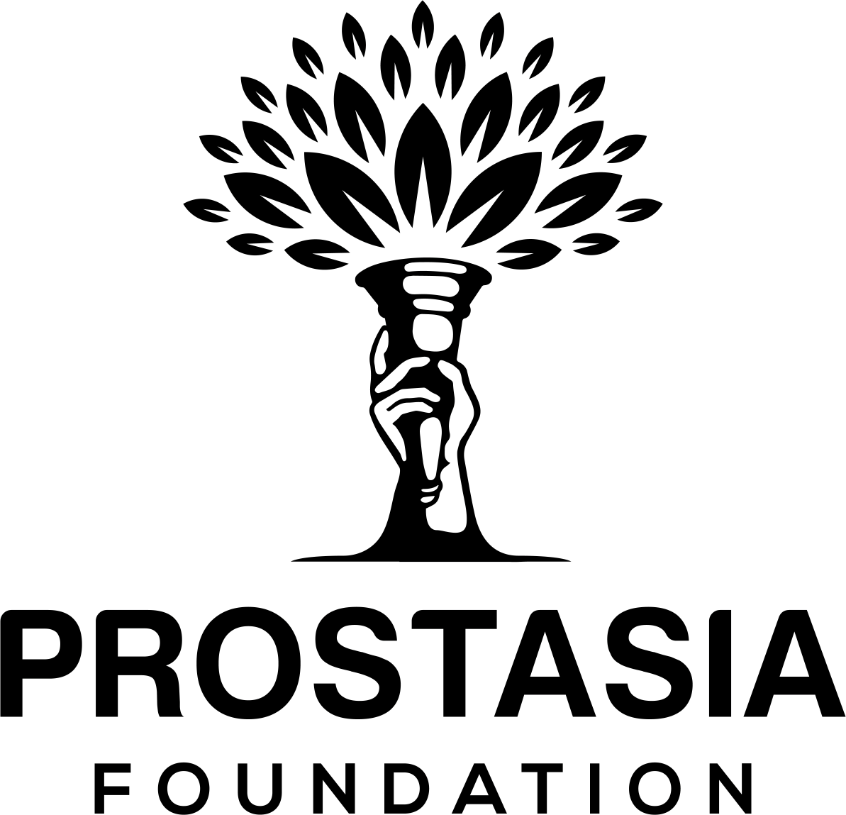
Prostasia Foundation
18 Bartol Street, #995
San Francisco, CA 94133

info@prostasia.org
+1 415 650 2557
https://prostasia.org

Submission to the UHCHR on General Comment on
children’s rights in relation to the digital environment
3 November 2020
Prostasia Foundation is a child protection organization dedicated to taking an evidence-based, prevention-focused approach to protecting children, which upholds Internet freedom, sex-positivity, and human rights. Our mission is to ensure that the elimination of child sexual abuse is achieved consistently with the highest values of the society that we would like our children to grow up in.
Below we offer our paragraph-level comments on selected sections of the draft General Comment on children’s rights in relation to the digital environment.

B. The best interests of the child (art. 3, para 1)
We support the intent of this section of the General Comment, which is to ensure that the best interests of the child are taken into account in actions concerning children that relate to the provision, regulation, design and management of the digital environment. However, we are concerned that the framing of this obligation in the General Comment departs significantly from its source material in the Convention on the Rights of the Child (CRC). The draft General Comment states in paragraph 13:
States shall ensure that in all decision-making regarding the provision, regulation, design and management of the digital environment that may impact children’s rights, the best interests of the child shall be a primary consideration.
It continues in paragraph 14 by providing that in regulating the digital environment, the best interests of the child should be not merely a primary consideration but, even more strongly, “the determining principle.” This is not merely a commentary upon but a significant expansion of the text of CRC Article 3, which relevantly states:
In all actions concerning children, whether undertaken by public or private social welfare institutions, courts of law, administrative authorities or legislative bodies, the best interests of the child shall be a primary consideration. [emphasis added]
The provision, regulation, design and management of the digital environment is not (generally) undertaken by public or private social welfare institutions, courts of law, administrative authorities or legislative bodies, but by private enterprise. Although a broad range of decisions that these private actors take “may impact children’s rights” to some degree, this alone does not make them “actions concerning children” in the sense referred to in CRC Article 3.
This much is made clear by General comment No. 14 (2013) on the right of the child to have his or her best interests taken as a primary consideration, which affirms that “not… every action taken by the State needs to incorporate a full and formal process of assessing and determining the best interests of the child,” but rather only decisions that will “have a major impact on a child or children” [emphasis added]. This same nuance is absent from the present draft General Comment.
Treating any and all decisions taken in relation to the provision, regulation, design and management of the digital environment as requiring the best interests of the child to become a primary consideration—let alone the determining principle—does not accord with the recognition that the best interests of the child is (as the General Comment acknowledges) a dynamic concept.
As such, the stipulation as expressed in the draft General Comment that “best interests of the child” is always the correct and determinative test, is incompatible with CRC Article 3. Such a stipulation could easily be misused by regulators to justify over-extensive Internet regulations that emphasize platform regulation as a solution to the problem that general Internet platforms can be misused.
It diverts attention away from the fact that often the best interventions to ensure that children are protected from the potential harmful impacts of online content are not technological, but educational. For example, including porn literacy in sex education curricula may be a better approach than censorship to ensure that children are equipped to address the potential harms of early exposure to such material online.
To accord with the intent and the historical interpretation of the CRC, and to avoid over-emphasizing the role of private Internet companies, we recommend that the words “that may impact children’s rights” be replaced by “that have a major impact on a child or children” in paragraph 13 of the draft General Comment, and that the words “and shall apply the best interests of the child as the determining principle” be deleted from paragraph 14.

General measures of implementations by States (art. 4)
Under point I, “The Business Sector,” paragraph 37 recommends:
States should require businesses to prevent their networks or online services from being misused for purposes that threaten children’s safety and well-being…
Although well-intended, this language is unworkably broad. The fact is that it is impossible to prevent all networks and online services from being misused for purposes that threaten children’s safety and well-being, without placing those services under constant surveillance and/or severely constraining how they may be used.
To give one example, this paragraph of the draft General Comment could be read as prohibiting businesses from providing services or networks that are end-to-end encrypted, since such services, if they exist at all, can always be misused for illegal purposes. Yet the right to secure encrypted communications has been recognized by the United Nations Special Rapporteur on the promotion and protection of the right to freedom of opinion and expression, and is also put forward elsewhere in the General Comment (paragraph 72) as a privacy-by-design feature for services that impact on children.
As such, the General Comment should recognize that the safety of online services involves a careful balancing of rights and interests, and that a simple mandate requiring that they be made impossible to misuse is overbroad. Instead, the General Comment should encourage appropriate and proportionate steps to be taken to limit the misuse of such services, without laying down an inflexible mandate. We recommend that the words “should require businesses to prevent” in paragraph 37 should be replaced with “should require that efforts are made to prevent,” which borrows language from elsewhere (eg. paragraph 43) in the draft General Comment.
Similarly, under point K on Remedies, paragraph 47 contains the injunction that “States should guarantee non-recurrence of violations, including by reform of relevant law and policy and their effective implementation.” Clearly, there is no way that States could possibly provide such a guarantee, without potentially creating other human rights violations in the process, for example by imposing proactive monitoring obligations. We recommend that “States should guarantee non-recurrence of violations” in paragraph 47 should be replaced by “States should require that efforts are made to prevent recurrence of violations.”

Freedom of expression (art. 13)
Freedom of expression includes not only the communication of opinions, but also the communication of ideas in the form of artistic and literary works. Increasingly, the exercise of this right by children has been subject to challenge by states, businesses, and civil society actors alike. This is particularly the case in relation to sexual speech by children, which is frequently censored even when it is developmentally normal and age-appropriate.
To give one recent example, in 2019, a 17 year old girl from Costa Rica was arrested for publishing sexualized cartoons on her blog, under a Costa Rican law that makes it unlawful to publish any representation of a minor engaged in a sexual situations, including in illustrated form. Such laws should not be used to criminalize young people for their creative expressions, by conflating these with real images of child abuse.
In the Committee’s 2019 consultation on Draft Guidelines on the implementation of the Optional Protocol to the Convention on the Rights of the Child on the sale of children, child prostitution and child pornography, many respondents pointed out that representations of youth sexuality in fiction and art are not inherently abusive, nor do they necessarily reveal pedophilic mindset on the part of either the creator or consumer of such works.
Over 17 thousand individuals signed a petition, organized by Prostasia Foundation, urging the Committee not to accept any “recommendation that state parties censor or criminalize artistic or literary representations of imaginary or fictional children,” because there is no evidence that such representations result in harm to real children.
Scholar Anna Madill, writing about the criminalization of representations of queer youth sexuality in cartoon form in the United Kingdom, warns that:
well-meaning efforts to protect children will potentially criminalize a sexually benign youth demographic, most of whom are teenage girls and young women, literate with the conventions of explicit romance in which the protagonists are, to many of them, age-appropriate boys and youths.
The criminalization of such representations, especially those created by children, is stigmatizing and harmful. In some jurisdictions, children as young as 10 years old can be listed on sex offense registries for creating or sharing such images, with dire long-term consequences for their health and wellbeing, their familial and dating relationships, and their future employment and housing. Given the lack of evidence of harm caused by such representations, there can be no justification for children being held criminally responsible for them.
We recommend that in paragraph 61, “Children should not be prosecuted for expressing their opinions in the digital environment” should be amended to “Children should not be prosecuted for exercising their freedom of expression in the digital environment.”

UN Committee on the Rights of the Child (CRC), General comment No. 14 (2013) on the right of the child to have his or her best interests taken as a primary consideration (art. 3, para. 1), 29 May 2013, CRC /C/GC/14, available at: https://www.refworld.org/docid/51a84b5e4.html [accessed 3 November 2020]
Special Rapporteur on the promotion and protection of the right to freedom of opinion and expression, Report on encryption, anonymity, and the human rights framework, 22 May 2015, A/HRC/29/32, available at https://www.ohchr.org/EN/Issues/FreedomOpinion/Pages/CallForSubmission.aspx [accessed 3 November 2020]
Petition to the Committee on the Rights of the Child on Draft Guidelines on the implementation of the OPSC, 31 March 2019, available at https://www.ohchr.org/Documents/HRBodies/CRC/Guidelines/Prostasia.docx.
Madill, Anna. “Boys’ Love Manga for Girls: Paedophilia, Satirical, Queer Readings and English Law” in Renold, Emma et. al. (eds) Children, Sexuality and Sexualization. Palgrove MacMillan, London, 2015, 273, 285.

