Comment on Concept Note for a General Comment on children’s rights in relation to the digital environment by the UN Committee on the Rights of the Child

I am writing as a Commissioner working directly with children of the Global South.
As South Australia’s Commissioner for Children and Young People, my mandate under the Children and Young People (Oversight and Advocacy Bodies) Act 2016 (the Act) is to advocate for the rights, interests and wellbeing of all children and young people in South Australia. It is also my role to ensure that the State, at all levels of government, satisfies its international obligations under the Convention on the Rights of the Child (CRC).
During my 2017 Listening Tour I asked children and young people across South Australia what was most important to them. On the basis of their responses I included the ‘engagement and empowerment of young digital citizens’ in my five year strategic plan: all children and young people in SA should be able to engage with the digital world, access its benefits equally, be digitally included and have their rights protected. This agenda has informed much of the work undertaken in the past 14 months as set out by way of case study throughout this comment.
Online is simply another place
One of the resounding things young people told me is that the online world is part of their everyday life. It is one place they frequently visit in the same way they go to school, to their friend’s home or to their local sports’ field. The online world is simply another ‘place’.
Provision and participation are neglected
We know the tenants of the ‘3 P’s’ of the generational contract within the CRC are provision, protection and participation. There is an evidential trend of giving disproportionate emphasis to ‘protection’ when it comes to the online space. Compounding this disparity, children and young people are telling me they want the tools to feel empowered when navigating this space. Much of the work I am doing therefore centres on building tools for children and young people to feel empowered, and on developing ways to encourage and assist young people to participate in the rich opportunities enabled by the online environment.
COMMENTS ON THE POSSIBLE STRUCTURE AROUND KEY GROUPS OF RIGHTS
Access to information and freedom of expression and thought
My conversations with children, families and schools around South Australia have shown that basic access to digital technology is not a given for many. Aside from concerns about Australia’s notably slow home broadband internet speeds, there are those with poor access in remote regions, in poorer schools and those with access to devices but limited online connectivity associated with location and/or economic situation. Industry programs have started to roll out connectivity to remote communities but the issue of practical access to this connectivity remains. My Youthful Cities Report identifies young people’s desire for shared spaces in South Australia that are neutral, communal and owned by young people. These ‘youth hubs’ must also have interconnectivity, Wi-Fi and phone charging stations, with access to high-quality Wi-Fi seen as essential.

Right to education and digital literacy
My work around the provision of digital literacy uses a two-tiered approach. I have been working to both encourage schools and educators reticent about digital learning to embrace free quality step-by-step resources that already exist and have incorporated unplugged digital thinking activities for those lacking devices or online connectivity. I have also focused on emphasising the role of broader community and family in the delivery of education. This is to promote the understanding that education is all around us and is not an activity confined to school.
Case study - Commissioner's Digital Challenge
In 2019 I introduced my year-round recurring Commissioner’s Digital Challenge to engage and empower young digital citizens through inclusive digital opportunity. This learning in my region is vital as demonstrated by the low proficiency standards demonstrated in the Australian NAP Sample Assessment ICT Literacy Years 6 and 10 (November 2018).
To create and implement the Challenge, my office worked in consultation with state government, a cross section of education providers, community and industry to curate and host a balanced range of free quality digital learning resources, including curriculum approved options and options for those lacking digital devices. This material was wrapped into a challenge with group digital rewards to encourage engagement and participation.
In its first year the Challenge’s focus is digital thinking (coding and computational thinking) and it’s designed to expand across core areas of the digital learning journey over time including design thinking, systems thinking, digital literacy and digital citizenship.
Almost 30% of primary and combined schools in South Australia are already taking part in the Challenge in its pilot year and dozens of libraries are running holiday and afterschool programs.
The Challenge is also offered in the broader community to underline the importance of community involvement in education and, on a practical level, to reach children who are not at school or who attend schools that are not engaging in digital learning. This was done in partnerships with public libraries of South Australia (20% of public libraries are running Challenge programs), Scouts, Girl Guides and Children’s University Adelaide.
I am just about to roll out my Early Learning Unplugged Edition designed in partnership with the Australian Computing Academy with activities specifically for 3-5 year olds that teach computational thinking through exploration and dance.
My design thinking challenge in 2020 will enable all children in SA to create solutions for life in space using 3D printing software. Entries will be judged by a panel of space experts with winning designs being 3D printed from plastic filament sourced from plastic waste polluting Australian oceans and publicly exhibited. The idea being to get children, and the adults in their lives, genuinely excited and hands-on about learning real and transferrable digital skills.

Family environment, parenting and alternative care
I believe it is important to raise awareness around healthy internet use with parents, carers and families via the promotion of active shared family screen time. This is about promoting safety by emphasising positive and empowering ways to interact online.
I’ve included the option for children to take the Commissioner’s Digital Challenge at home with their families to promote the thinking that education does not stop outside the school-gate: learning is something that’s taking place wherever we are, every day.

Right to culture, leisure and play
I have formed the view that, in the current day, digital play is a core part of ‘play’ for children and young people so I have been running consultations with young people and their families in SA around issues arising around gaming and e-sports.
I have partnered with High School Esports League (HSEL) to work with industry and others to develop a child centric ethical framework that includes information to enable young people to make informed and safe choices about games and gaming. This partnership is part of my overall strategy to take a comprehensive approach to gaming. By gathering information around who, how and when esports are being played across our high schools, we will gain insight into this growing sector and the role government and schools can play in ensuring the necessary policy and planning tools are used to ensure positive outcomes for young people.
A recurrent theme young people have talked about with me is that balance is the key ingredient to healthy online engagement and that when the right balance is struck, gaming can be a practical tool to help alleviate other wellbeing issues young people may face in areas such as mental health and social interaction.
Young people told me that gaming provides a mirror to the issues that a person would experience offline. For example, if problems with addictive behaviours, violent tendencies or bullying exist offline, they may also take place online. On the other side of the coin, I was told by many young people that gaming could provide a solution to many problems experienced in the offline world. Young people who may struggle to form friendships offline might enjoy the benefits of an active and uplifting social life in the online environment while gaming.

One young person told me that online friends can sometimes be more important than we (as adults) might imagine. Another said that, when he was nine years old, he didn’t have any friends and said: “online friends replaced friends [and] gave me a social aspect that I was lacking at school”. They also told me that they wanted to know how to engage in an empowered way in this world. Findings from my gaming conversations will be consolidated and published in due course.

Protection of privacy, identity and data processing
Oversharing
One of the most consistently occurring breaches of privacy for children and young people can come from those who care about them the most – their friends and family ‘oversharing’ on social media – a practice sometimes referred to as ‘sharenting’. Public opinion needs to shift around ‘sharenting’ as it can be harmful on many levels. A compelling way to reshape public opinion could be through promotion of real stories from young people who are creating their first social media account only to find they already have an extensive and revealing digital footprint. The sense of betrayal and compromise that can arise with this discovery can be profound.
Facial recognition technology and Article 16
To uphold Article 16, and for reasons of basic safety, it will be crucial that cohesive regulation and practical measures are implemented to prevent mass consolidation of facial recognition data from being made publicly accessible.
Facial recognition technology can already identify and collate the faces of children in the background of photographs with apps such as Google Photos for a user to view within their own private library. The technology is so advanced that they can pick up photos of the same child taken years apart, from different angles and in the background of an image. As this technology is currently in use within private users’ accounts, the core technology is at risk of being made available for public use – for example, an image of a child could to be uploaded to Google Images search function to return every single public image that includes that same child using facial recognition technology, even if in the background. The ‘sharenting’ trend further impacts this risk, so the potential for an array images to be circulating about any one child is now staggering.
This means ensuring behemoths such as Facebook, Apple and Google are bound by tight regulations when it comes to facial recognition technology to confine its use to positive application.
Case study - Mechanisms of Trust
I have been speaking with children and young people about feedback mechanisms and characteristics that are important to them. One of the early themes to emerge from these conversations has been the issue of trust in technology companies. These organisations are early service providers for children and young people. As such, their engagement with young people through genuine customer service is important for building trust and laying the foundations for young people to develop understanding of how to best engage as customers on a range of topics including safety and privacy. Findings from these conversations will be released later this year.

Case study – Challenge where young people set a design challenge for adults and judge the solutions
The results of my public polling with 13-17 year olds has informed the framework of my upcoming face to face consultation with a focus group of young people to unpack what they believe to be the single most pressing online rights-based issue: feeling they can trust the sites they visit to not try to take advantage of them.
The results from the polling and consultation is to form the basis of a challenge problem for the South Australian Department of Premier and Cabinet’s Information and Communication Technologies and The Office of Digital Government’s D3 Challenge in partnership with AustCyber in mid-2019. D3 is a digital design challenge to engage and enable adult innovators and entrepreneurs to create and implement practical digital solutions to real life problems.
Later in the D3 process, young people will advise and inform me, along with a panel of industry experts, to determine which three potential digital solutions will receive funding for prototype, and which of the tested solutions will receive significant partnership funding to become a reality.
This approach respects the real views of young people, informs solutions that young people actually want and believe will be effective, and is likely to reduce prevailing communication barriers between adults and young people around issues of ‘online safety’.
My poll asked children aged 13-17 which of the following 5 questions (loosely based on the 5 categories of rights identified by 5Rights Foundation) were most helpful to them:
- Knowing what your data is being used for
- Being able to use, and make things for, the online world
- Being able to take down anything you put online
- Feeling you can trust sites you visit to not try to take advantage of you
- Having simple ways to get support for upsetting or troubling things (not only illegal things)
The results were as ranked in order of importance as follows:
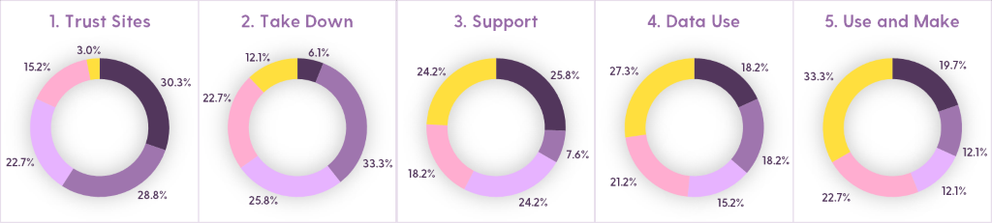
Protection from violence, sexual exploitation and other harm
A separate area of my agenda centres on prioritising young people in South Australia who are doing it tough with part of this work around bullying.
Case study – Bullying Project
I ran extensive bullying consultations around South Australia in 2018. In these consultations children and young people did not differentiate between online and offline bullying and considered one to be an extension of the other so the solutions provided in the report are for both. Please refer to my report: The Bullying Project.
Health and wellbeing
Case study – Online Polling
During Youth Week 2019 I ran a series of public polls with young people in South Australia aged 13-17 years asking them to rank the following issues as a ‘legit problem’, ‘sort of an issue’ or ‘not an issue’:

- Online addiction
- Bullying online
- Copying dangerous behaviour seen online
- Seeing inappropriate things online
- Reputational damage online
- Lack of real-life social interaction

- Parents oversharing online
- Online gaming causing violent behaviour
- Online gaming wasting your time
- Spending money on online games
- Creepy Adults

These were the results of the three most important issues identified and the breakdown:
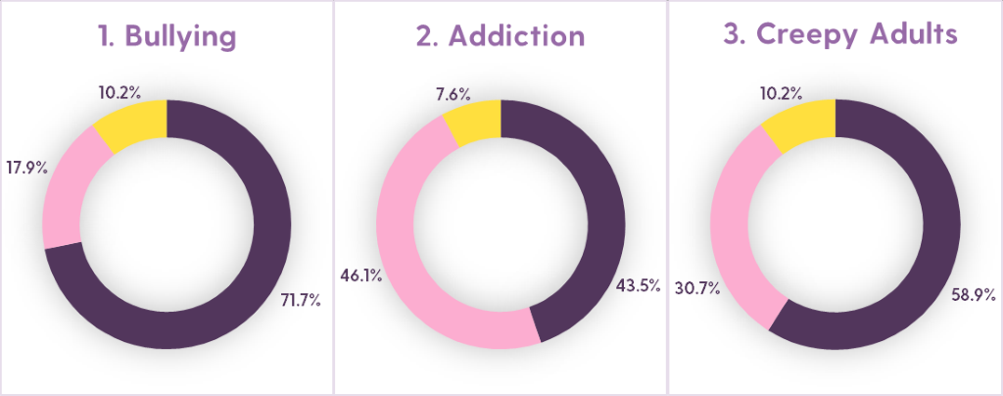
⬛ ‘Legitimate Problem’
⬛ 'Sort of an issue’
⬛ 'Not an issue’

OTHER QUESTIONS FROM THE COMMITTEE
How can children’s views and experiences be expressed and taken into account when formulating policies and practices which affect their access to and use of digital technologies?
My Front and Centre Agenda (Strategic Plan) is about putting children and young people front and centre in our thinking and to include them in shaping and contributing to the services that impact them. I do this by consulting with children and young people directly on decisions that impact their lives. In many other areas this is now the norm, e.g. health carers give feedback on health systems and companies invest in market research and focus groups before any product launch.
In the same way, my work encourages government and industry to regard children and young people as stakeholders and to put into place mechanisms for them to actively participate in decision-making in the areas of health, education, protection and justice. For more information about our approach, please refer to:
- Our approach to participation and engagement
- Our approach to advocacy
- Our approach to engaging with SA business
- Our approach to engaging with community organisations
How can discrimination (offline or online) be effectively addressed to ensure all children have their rights realised in a digital world?
My legislated role specifically requires me to consult with and engage children and young people in the performance of my functions under the Act, and to seek to engage those groups of children and young people whose ability to make their views known is limited for any reason. So when I consult with young people I seek out the voices of those living in remote regions, those attending schools ranked low on the index of socio-economic advantage, those belonging to cultural groups subject to discrimination with special emphasis on Aboriginal and Torres Strait Islander children, and those who may be otherwise underrepresented. If all decision-making affecting children and young people takes this approach, it would be a step in the right direction.
How should the General Comment treat the role of parents and other caregivers?
Government, industry and community groups should be provided with a structure for systemic improvement. From this, the broad messaging of the General Comment can be simplified and shared as part of a high impact general public awareness campaign to shape public opinion, belief and narratives and to create expectations on these institutions.
In terms of active positive and negative obligations on caregivers, their value as ‘first educators’ facilitating everyday education, the importance shared family screen time, and of children having agency in what is posted online about them are a few of the many topics that deserve attention.
How should the practices of businesses operating in the digital environment support the realisation of children’s rights?
By giving young people a significant role in influencing business at a leadership and decision-making level. This is a progressive approach that recognises that young people are not only our future leaders – they are leading today.
As one of the many ways my office is working to engage with South Australian business, I am pioneering a child-led award to recognise businesses that are getting it right in the online world. The parameters for the award are loosely based on the Committee of the Rights of the Child’s General Comment 16 (2013) on State obligations regarding the impact of business on children’s rights – the criteria asks businesses to demonstrate how they most respect:
- The right to non-discrimination of children and young people
- The best interests of children and young people
- The right to life, survival and development of children and young people and
- The right of children and young people to be heard
Young people will design the award, judge the winners and present the award in partnership with an established business awards program.
Is the realisation of children’s rights in the digital environment necessary to realise children’s rights in other environments?
Yes, absolutely - although universal, human rights arise from the individual - not from their surrounds. As such the provision, protection and participation around children’s rights in the online space must be advanced to avoid undermining, and potentially violating, children's integral human rights. Young people in South Australia speak about the online world as just one more environment in their day. The online world is simply another room – another playing field – another library – another ‘place’.
Helen Connolly
Commissioner for Children and Young People
Adelaide, South Australia

Gaming in the sense of playing computer games including online games – no reference to gambling.
Sample size: 66 young people in South Australia aged 13-17 years
Sample size: 39 young people in South Australia aged 13-17 years

