Submission on Guidelines on the implementation of the Optional Protocol to the Convention on the Rights of the Child on the sale of children, child prostitution and child pornography
29th March 2019

Introduction
Consortium for Street Children (CSC) is an international network of over 100 organisations, researchers and practitioners working to defend the rights of children in street situations. This submission aims to provide perspectives on the sale of children, child prostitution and child pornography as it applies to children in street situations. The organisations Cities for Children, StreetInvest and Zambuko House contributed their perspectives for this submission.
Understanding the sale of children, child prostitution and child pornography in street situations
The UN Committee on the Rights of the Child’s General Comment No. 21 on Children in Street Situations recognises that children living on the street “are particularly vulnerable to sexual violence and exploitation”. The very nature of life on the streets, with or without spending intermittent time in often poor quality, unregulated child care institutions, exposes children in street situations to a high risk of sexual violence and exploitation. As such, CSC welcomes the Committee’s inclusion of children in street situations in their recommendation for States to identify, support and monitor children at risk of falling victims of the offences covered by the Optional Protocol on the sale of children, child prostitution and child pornography (OPSC) as well as to strengthen prevention programmes in Section IV of the Guidelines.
CSC wants to emphasise the importance of recognising the unique situation of children in street situations that makes them vulnerable to or forces them to engage in prostitution or other forms of sexual exploitation. Some girls in street situations engage in prostitution to fund basic necessities and to avoid being raped when they are sleeping on the streets at night:
“I will be tempted to join girls in sex work. When I should go to sleep in front of shops I may be raped; so the best option for me would be to join my friends in sex work”
“If I don’t go to work in the night as a sex worker I will not get money for food”
Recent developments
CSC appreciates the Committee’s acknowledgement in paragraph 4 of the draft Guidelines of the recent increase in migrant and refugee children who are vulnerable to sexual exploitation. Children are more vulnerable to sexual exploitation when they are removed from their communities and traditional support networks. Recognising that the nature of global displacement is becoming increasingly urban, this vulnerability is further compounded if migrant and refugee children find themselves living in street situations once they are on the move.
CSC, therefore, recommends that the vulnerability of refugee and migrant children is emphasised in a standalone paragraph acknowledging the connection between migration, forced displacement, street connections, and vulnerability to sexual abuse and exploitation, urging states to take a targeted approach that takes into account their unique situation and needs.
Prevention
CSC suggests that State parties need to look beyond the root causes of the sale and sexual exploitation currently indicated in paragraph 33 of the draft Guidelines, to the causes that lead to the emergence of marginalised groups that are particularly vulnerable to sexual abuse and exploitation, such as children in street situations. Preventing the emergence of these marginalised groups will lead to reduced numbers of children with heightened vulnerability to sexual abuse and exploitation. In turn, sexual abuse and exploitation can contribute to the emergence of children in street situations, as children seek to escape situations of sexual abuse, perpetuating the cycle of vulnerability.
CSC, therefore, recommends that the Committee strengthens paragraph 33 by highlighting these interlinkages, and urging State parties to pay attention to and take targeted measures to address the root causes that lead to the emergence of marginalised groups that are particularly vulnerable to sexual abuse and exploitation.

Criminalisation
CSC welcomes the Committee urging State parties to ensure that national legislation does not criminalise child victims of sexual abuse, sexual exploitation and trafficking in paragraph 18. In many countries, children in street situations are criminalised for survival behaviour, including prostitution. The risk of such behaviour being criminalised it that it becomes more hidden and invisible, further increasing the children’s vulnerability.
CSC, therefore, recommends that the Committee not only urge State parties not to criminalise child victims of sexual abuse, exploitation and trafficking, but also urge State parties to decriminalise any offences that make children more vulnerable and push exploitation further into hidden domains.
Data collection
CSC supports the Committee’s push for reliable and accurate data that is disaggregatable to account for vulnerable groups in order to ensure the effective implementation of the OPSC in paragraphs 20-22. CSC is, however, concerned, that children outside traditional households are likely to be left out of such data collection exercises. Most official data collection takes place through household surveys, or use sampling methods not suitable for adequately identifying and including children outside traditional households. As such, children in street situations, among others, are often excluded from data collection exercises, which only serves to perpetuate their marginalisation.
CSC, therefore, recommends that paragraph 21 is strengthened to urge States to make specific provisions to collect data on children living outside of traditional households, including children in street situations, taking into account the guidance on data collection in UN CRC General Comment no. 21. CSC further recommends that the Committee specified in paragraph 21 (a) that data should also be disaggregated for children’s living situations, whether this is in a traditional household, on the streets, in informal settlements, care institutions or jail.
Dissemination and awareness raising
CSC welcomes the Committee’s recommendation to disseminate information about the OPSC to children outside formal education in paragraph 29 (d). Children in street situations are often not enrolled in formal education, and won’t receive information through such channels. To further reduce the vulnerability of children in street situations, non-governmental organisations, social workers and street workers should be informed about the provisions of the OPSC also, as these stakeholders are often the primary caregivers or educators for these children.
CSC, therefore, recommends that the Committee in paragraph 29 (b) includes non-governmental actors, and in particular non-governmental street workers and social workers, among those to whom States should disseminate information on the provisions of the OPSC.
Training
CSC commends the Committee’s guidance in paragraph 30 (a) for States to incorporate the training of all relevant professionals within national policy, including foster child- and gender-sensitive approaches. Noting the unique and complex context of children in street situations, CSC recommends paragraph 30 (a) includes training on approaches for addressing the unique situations and needs of child victims and survivors in street situations. CSC recommends that this training should be developed in collaboration with those who work with children in street situations, including experts, NGOs and street workers in line with UN CRC General Comment No.21.
Children exploited in prostitution
CSC is in favour of the Committee’s development in terminology in paragraph 55, and suggests that the term “child prostitution” in paragraph 53 should also be replaced with “children exploited in prostitution”.
CSC is in agreement with the Committee that children exploited in prostitution “must never be considered liable for their exploitation”. It is particularly pertinent to children in street situations, who are often stigmatised and unnecessarily criminalised.
CSC, therefore, recommends that paragraph 54 should make explicit that children should never be criminalised for their “involvement” in prostitution, and to encourage states to review existing legislation to this end and decriminalise any offences that make children more vulnerable or push exploitation further into hidden domains.
CSC welcomes the inclusion of commodified “relationships” as a form of exploitation in prostitution in paragraph 58. Testimonies gathered from children in street situations during the consultations for UN CRC General Comment No.21 highlighted their particular vulnerability to commodified “relationships”:
“You cannot get water at [X] if you have no money and you cannot have money if you don’t prostitute yourself. If you have no money they may even ask to have sex with you in order to have water to wash your body with.”
CSC, therefore, recommends that paragraph 58 emphasise the vulnerability of children in street situations to commodified “relationships”, as well as reiterate that children should never be criminalised for this type of ‘survival behaviour’.
Sexual extortion
CSC welcomes that paragraph 75 of the draft Guidelines acknowledges the vulnerability of children to sexual extortion. CSC is particularly concerned about sexual extortion by individuals in caregiving or law enforcement roles. Children in street situations are particularly vulnerable to this type of sexual extortion. General Comment No.21 highlights that they can often face sexual extortion from government authorities, in particular from police.
“The police are the people who are supposed to protect you. But when you meet him on the street at night, he is the first to ask you for fucking you…If you refuse they threaten to rape you. Thus you are obliged to ‘let them have what they need’ so as not to be arrested. Then you wonder, ‘are the police for protecting people or what?’”
CSC, therefore, recommends to strengthen paragraph 75 by urging States to urgently criminalise the sexual extortion of children, inclusive of government authorities, and ensure prosecution of perpetrators.
Age of consent
Noting that paragraph 77 recommends State parties to criminalise all offences covered by the OPSC committed against any child up to the age of 18, CSC urges the Committee to specify that States should be encouraged to review their laws, and decriminalise offences that are currently able to hold children criminally liable for prostitution or other acts that they are unable to consent to.
The child victim’s right to assistance and protection in legal proceedings
CSC welcomes the elaboration on States’ obligation towards children’s right to access justice in situations of sexual violence and exploitation in Section VIII. Children in street situations are, however, at risk of being left out, as they often do not have legal identification documents which can prevent them from accessing services, including accessing assistance and protection in legal proceedings.
CSC, therefore, recommends that the Committee emphasise explicitly in Section VIII that all provisions regarding the child victim’s right to assistance and protection in legal proceedings should apply to children who are not citizens of the state they are residing, or who have no birth registration or legal identity documents.
The child victim’s right to recovery, family and social reintegration and compensation
In terms of family and social reintegration addressed in paragraph 106, it is important to acknowledge that some children do not have families or cannot be reunited with their families due to an ongoing abusive or unsafe environment within the home. In such cases, it is important that decisions on where the child will live or receive care from should always be taken together with the child, in line with UN CRC General Comment no. 21.
CSC, therefore, recommends that the Committee in paragraph 106 (b) urge Sates to engage children in all decisions about their care, seek appropriate care in line with par. 44 of UN CRC General Comment No. 21, and not force children to accept care placements against their will.
Mutual legal assistance and international cooperation
CSC welcomes the mention of cooperation between countries for repatration and reintegration in paragraph 115. CSC is, however, concerned that children who lack legal identity documents or were not registered at birth are at risk of being left out.
CSC, therefore, recommends that the Committee elaborate on the repatriation for children trafficked to a different country, urging State parties to provide special support for children who lack legal identity documents, and that appropriate care is provided in consultation with the child upon return in line with our recommendation regarding paragraph 106 above.
Queries in relation to the submission can be directed to advocacy@streetchildren.org.
With sincere thanks to the network members who contributed to this submission for giving their time and expertise:
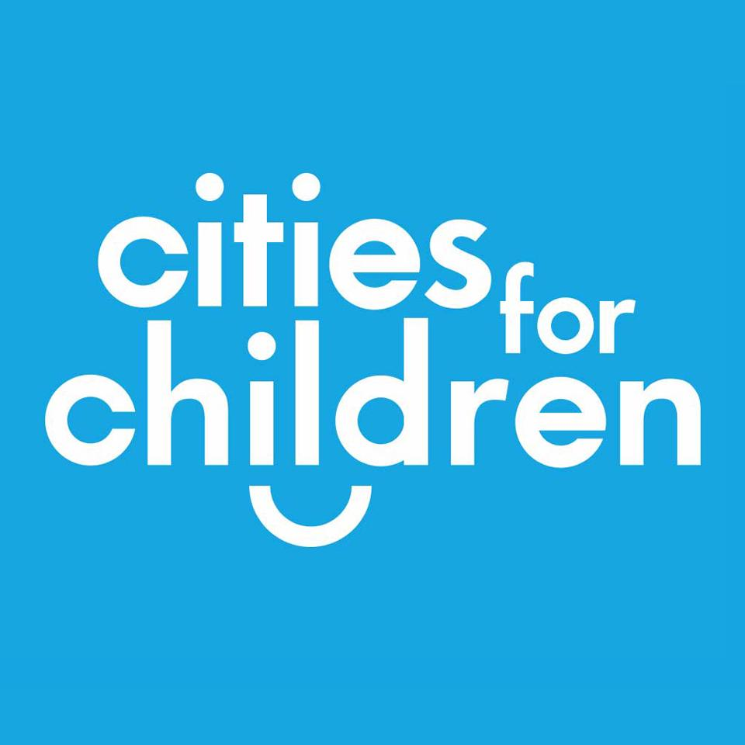

UN CRC, General Comment No.21 on Children in Street Situations, 21 June 2017, UN Doc. CRC/C/GC/21, para 58.
Quote from a street child/youth participating in the consultation held in Accra, Ghana between 4th and 6th March 2016 by Consortium for Street Children and Growing Up on the Streets.
Quote from a street child/youth participating in the consultation held in Accra, Ghana between 4th and 6th March 2016 by Consortium for Street Children and Growing Up on the Streets.
Draft OPSC Guidelines [para. 33]
GC No.21 Chapter IV.23
UN GC No.21 Chapter IV.18
Quote from a street child/youth participating in a consultation held in Bukavu, DRC, 23-25 February 2016, informing the UN CRC General Comment No. 21, organised by Consortium for Street Children and Growing Up on the Streets.
UN GC No.21 para 60
Quote from a street child/youth participating in a consultation held in Bukavu, DRC, 23-25 February 2016, informing the UN CRC General Comment No. 21, organised by Consortium for Street Children and Growing Up on the Streets.

