ECPAT Sweden’s comments on the Draft Guidelines on the implementation of the Optional Protocol to the Convention on the Rights of the Child on the sale of children, child prostitution and child pornography.

Stockholm, Sweden, 29th of March 2019

- Introduction

1.1 ECPAT Sweden

ECPAT Sweden welcomes the possibility to comment on the current draft of the Guidelines on the implementation of the Optional Protocol to the Convention on the Rights of the Child on the sale of children, child prostitution and child pornography, hereafter the “Draft Guidelines”.

ECPAT Sweden is a child rights organisation working to prevent sexual exploitation against children in Sweden and by Swedish offenders abroad. ECPAT Sweden contributes to preventing and counteracting all forms of sexual exploitation of children through awareness-raising, advocacy and lobbying efforts. ECPAT Sweden is a member of the global ECPAT network.

1.2 Methodology

ECPAT Sweden gathers information on sexual exploitation of children in Sweden, and exploitation which is linked to Sweden. ECPAT Sweden acquires facts and figures of exploitation through first-hand information, reports, research, dialogue with experts - foremost individuals working directly with the issues such as law enforcement representatives, decision-makers at various levels (local, regional, national, global), private sector representatives in the tourism-, transportation-, IT- and finance industries, and through direct information as acquired through the ECPAT Hotline.

- ECPAT Sweden’s comments

Para 7. Luxemburg guidelines
ECPAT Sweden believes that communication is critical when working for protection and implementing the rights of the child for instance regarding the gravity of the crimes in the OPSC. ECPAT Sweden welcomes the Committee´s encouragement to State parties regarding the use of the Luxemburg guidelines. However, the terminology used in the Draft Guidelines is not in line with the Luxemburg guidelines and therefore ECPAT Sweden strongly recommends the Committee to revise the Draft Guidelines so that the terminology used is guided by the guidelines to make sure that the Committee itself does not risk trivialise the sexual exploitation of children.

Para 10, 15. ECPAT Sweden welcomes that the present Draft Guidelines on the implementation of the OPSC are the result of a process of consultation, and the remarks on the importance of child participation. In this regard, ECPAT Sweden assumes that children themselves have been actively involved in planning and drafting the Draft Guidelines and we encourage the Committee to clarify this within the Draft Guidelines.

Para 12, 29. ECPAT Sweden welcomes the Draft Guidelines and agrees on the urgent need for an interpretation of the CRC and its provisions in the light of the rapid development and spread of Information Communications Technology (ICT). However, ECPAT Sweden questions the legal status of the Draft Guidelines and the obligation of the States to report on this document. ECPAT Sweden would like the Committee to clearly state which article in the CRC or the OPSC that entitles the Committee to produce guidelines that are legally binding for the State and how the Draft Guidelines will relate to the General Comments produced by the Committee.

Para 21 c), 35, 38 d) ECPAT Sweden welcomes the recommendation for collection of data for reported cases and prosecutions. ECPAT also welcomes a requirement to screen any person applying for work in which they would be in direct contact with children, where such a requirement does not already exist. However, ECPAT Sweden is concerned by the absence of preventive measures for adults with a sexual interest in children such as treatment programs for paedophilia and anonymous helplines in order to prevent sexual abuse of children before it occurs. The treatment should be easy to access throughout the member states and scientifically proven to help individuals. ECPAT Sweden questions the recommendation for States to register convicted sex offenders without references to evidence-based research that states that registering sex offenders will have positive affects for the child’s right to protection from sexual exploitation. ECPAT Sweden advises against arbitrary infringement of human rights when there is no evidence-based research that measures such as sex offender registers, exchange of information, and travel restrictions, will have a positive outcome for the rights of the child.

Para 29 d) ECPAT Sweden welcomes the recommendation for ensuring that the OPSC is included in the school curricula but would like the Committee to encourage states to highlight the ICT’s positive effects for children seeking information, which encourages a healthy sexuality and relationships online. Sexual education that focuses on protecting the child as s/he explores their sexuality in a non-judgemental way can strengthen the child’s protection from risks of sexual exploitation. ECPAT Sweden also encourages the Committee to recommend that adults actively involve themselves in the child’s use of ICT in order to support the child as s/he develops their abilities. ECPAT Sweden acknowledges the importance of providing parents and/ or caregivers information about the safe use of ICTs and the child’s right to sexual education. However, ECPAT Sweden recognises the risks of involving parents´ or caregivers’ views in the child’s right to sexual education since adults´ views may infringe on the child’s right to information. It is important that the child is protected when participating in sexual education in school and not restricted from involvement due to the views of his/her parents.

Para 30 c), 68. As a non-governmental organisation and provider of an online Hotline, ECPAT Sweden would like to stress the necessity of education and training on the CRC and OPSC for NGO’s. There are many NGOs working for children, providing health, legal and psychological support without a child rights-based approach. ECPAT Sweden recommends that the Committee reminds states of the importance of a child rights perspective when selecting NGOs for cooperation and strategic partnerships.

Para 38 The Code constitutes one alternative for awareness and advocacy actions within the travel and tourism industry. ECPAT Sweden encourages the Committee to acknowledge that there are other alternatives for States.

Para 38 (c) ECPAT Sweden would recommend that the Committee includes the banking and finance sectors, apart from the ICT sector in the recommendations.

Para 42, ECPAT Sweden encourages the Committee to ensure that the recommendations in this paragraph are revised to reflect the States´ obligation to protect the child from sexual abuse from family members and persons within the child’s inner circle. As it stands in the current recommendations, this is not reflected.

Para 43, ECPAT Sweden welcomes the recommendation that State parties should ensure that internet service providers control, block and remove online child sexual abuse material as soon as possible, but urges the Committee to consider that the scope of responsibility is broadened and includes all entities providing online services.

Para 53, ECPAT Sweden recognizes a risk of defining sexual activities even at a minimum, since it may not include all sexual abuse of a child. Therefore, ECPAT Sweden suggests that the Committee may consider reframing the recommendation in a way that defines the minimum of activities but at the same time clearly states that the list is not exhaustive. ECPAT Sweden recommends that focus should be on the sexual violation of the child in each specific case.

Para 61 – 63, Sweden has made a reservation for 2 c in the OPSC and therefore ECPAT Sweden will not comment on these recommendations.

Para 91, ECPAT Sweden would like to stress the importance of the Committee clearly stating that the gravity of sexual exploitation of children online and offline is equally severe and to encourage states to enforce legislation, which does not differentiate between “hands on” acts and exploitation using ICT. From a child’s rights perspective documentation and dissemination of images of the abuse online can be more severe for the physical wellbeing of the child.

Para 103 d), ECPAT Sweden questions the suggestion that placing a screen between the alleged offender and the child is by any means adequate and contributes to not aggravating the trauma for the child. ECPAT Sweden therefore encourages the Committee to revise the recommendation and suggest other efforts to support child victims in a court process.

If the intention of the recommendation is that the child and the perpetrator are placed in separate rooms, with the child being filmed and the image presented on a screen, ECPAT Sweden would like the Committee to clarify this in order to avoid misunderstanding.

Para 111, ECPAT Sweden would like to point out the need for the Committee to also encourage State parties to establish a system for victims to receive compensation from offenders in other countries. The system needs to be victim-centric and take inter alia transparency and anti-corruption measures into account.

Sincerely,
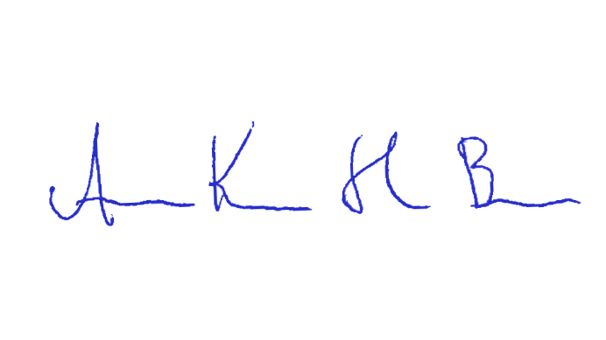
Anna Karin Hildingson Boqvist
Secretary-General ECPAT Sweden

