Days of general discussion of the Committee on the Rights of the Child:
Child-friendly guidelines for the participation of children

What is a DGD?
Visit the Committee’s DGD webpage to learn about DGDs that occurred in the past!
- A DGD (day of general discussion) is a public event on a specific topic related to children’s rights. During the event, children and adolescents, the Committee, Governments, the United Nations, civil society organizations, national human rights institutions, and experts on children’s rights share their opinions and ideas on how to make the situation of children and adolescents better.
- A DGD usually takes place every two years, in September, in a big conference room and several smaller conference rooms at the United Nations in Geneva, Switzerland.
- A DGD lasts for one day and is usually a large group discussion (in “plenary”) and two or more small group discussions on specific areas of focus related to the discussion topic. Exhibitions, performances, discussions, movie viewings or other events are held during lunchtime.
- After the DGD, the ideas that were discussed are summarized in a report that gives recommendations to Governments, the United Nations, the Committee, civil society organizations, businesses, adults and children defending children’s rights to undertake specific activities to improve the situation of children. For example, you can read the ideas on children as human rights defenders from the 2018 DGD here.
Did you know? A “child” is as any person below the age of 18 years. This includes adolescents and teenagers.

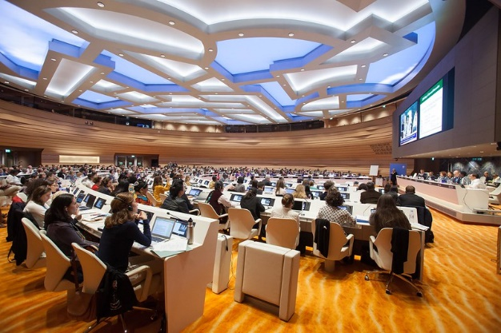
Why should you participate in a DGD?
- All children and adolescents have the right to express their opinions or ideas on all decisions that affect them, and adults should listen to them and take them seriously. It is the right of every child and adolescent, without exception.
- The DGD provides an opportunity for children and adolescents to express their opinions or ideas in discussions on children’s rights at the international level. This document is a child-friendly version of the Committee’s working methods on the participation of children in DGDs.
Did you know? The last DGD in 2018 was about protecting and empowering children as Human Rights Defenders. 400 participants, including 67 children, took part in the DGD in Geneva, and 800 via the Internet. There were also small group discussions on the challenges faced by children who defend human rights, like on the environment and climate change. Read about the 2018 DGD here.
- By participating in a DGD, you can express your opinions or ideas on the rights of children and adolescents but you can also learn more about their human rights and how to mobilise your friends in order to campaign for things that should be changed.

How can you participate in a DGD?
- Suggest a topic of discussion
Each DGD focuses on a specific topic that is selected by the Committee more than a year in advance. You can make suggestions on what the topic of a DGD should be.
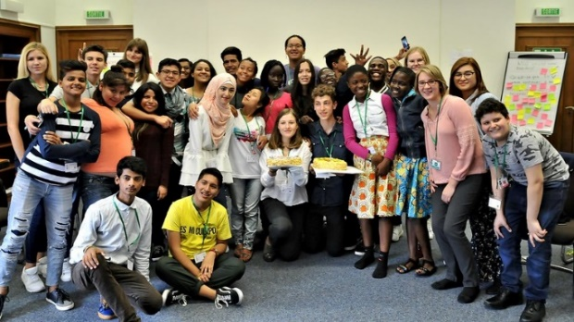
- Support all steps of the preparation and organization of a DGD
The Committee and civil society, together with children and adolescents, are involved in the planning and preparing a DGD. You can share your ideas on the programme and format of the DGD, so that the event is relevant and interesting for both children and adults. You can also support the Committee in sharing information on the DGD, and in organizing exhibitions, performances and other events. The organizers establish an advisory group of children that regularly shares their opinions and ideas on the preparation, organization and follow-up to the DGD. Some organizations meet with children and adolescents in their countries or communities.
Child Advisors should represent all ages, sexes, countries, backgrounds and ethnicities. Read more about the Children’s Advisory Team for the 2018 DGD!
- Send information to the Committee on the discussion topic
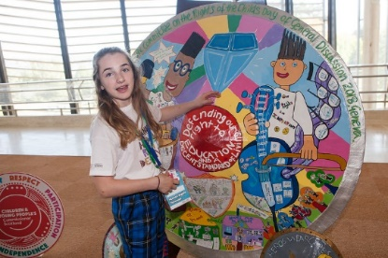
You can work with other children or adolescents to send reports, photos, art, videos or other materials on your opinions, experiences, ideas and recommendations on the discussion topic of the DGD. These materials, known as submissions, should include up to five recommendations on the topic and will contribute to the discussion during the DGD, the report on the DGD and the recommendations endorsed by the Committee.
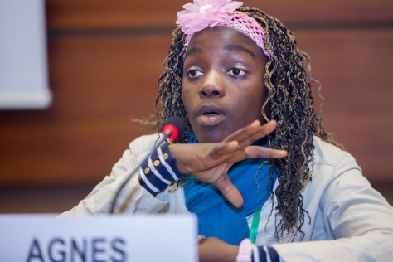
- Attend the DGD
You may choose who in your group of children and adolescents will participate in DGDs; this is not a decision that should be made by adults. The selected child(ren) or adolescent(s) can attend the event in person as speakers, moderators and/or participants, and participate in related side events. All other children and adolescents can follow the discussion online, such as through social media or online surveys.
You can be invited to participate in DGDs as speakers, moderators and/or participants.
- Meet with Committee members
If you participate in DGDs in person, you can meet informally with members of the Committee to share your opinions or ideas on the discussion. This meeting is private and is reserved exclusively for children and adolescents.
- Participate in follow-up and evaluation
You should receive information on how your opinions or ideas have influenced the DGD and follow-up activities. The organizations that supported your participation should also support you to organize and take part in follow-up activities that aim to improve the situation of children and adolescents based on the discussion at the DGD. Adults should also collect feedback from you on your experience and your ideas on how children can be better supported to participate in future DGDs.

What do you need to know if you participate in a DGD?
- It does not matter who you are or where you come from, you can participate in a DGD.
- You have the right to express your opinions or ideas and to participate in DGDs, whether online or offline.
- Your knowledge, abilities, opinions, experiences and ideas can contribute to the DGD.
- Everyone should respect your opinions and ideas.
- Adults should support you to share your opinions, experiences and ideas and to participate in the DGD. This includes creating safe and inclusive spaces for you to share your opinions.
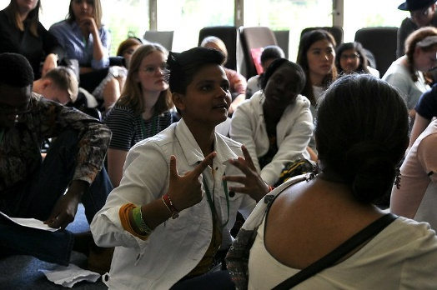
- You decide whether you want to express your opinions or ideas, and others cannot influence what you say. You can stop participating whenever you want.
- No one should make you feel afraid, unsafe or uncomfortable about expressing your opinions or ideas, and you should know where you can receive help if someone makes you feel this way.
- Materials on DGDs must be in formats and languages you understand.
You have a right to be heard, but participating in DGDs is a choice.
- You may be filmed or photographed during a DGD, because DGDs are open to the public and are filmed, and a recording is posted online. In order to participate, you need to give your consent.
- You have a right to know how your opinions and ideas influenced the DGD.

How can you prepare for a DGD?
- Even though the DGD lasts for one day, the preparation takes much longer and requires a lot of work. Adults should help you prepare for your role in a DGD, such as by organizing trainings and sharing with you the information and materials you need to prepare.
- Learn more about the Committee and its previous DGDs! Visit the Committee’s child-friendly webpage or read about previous DGDs.

