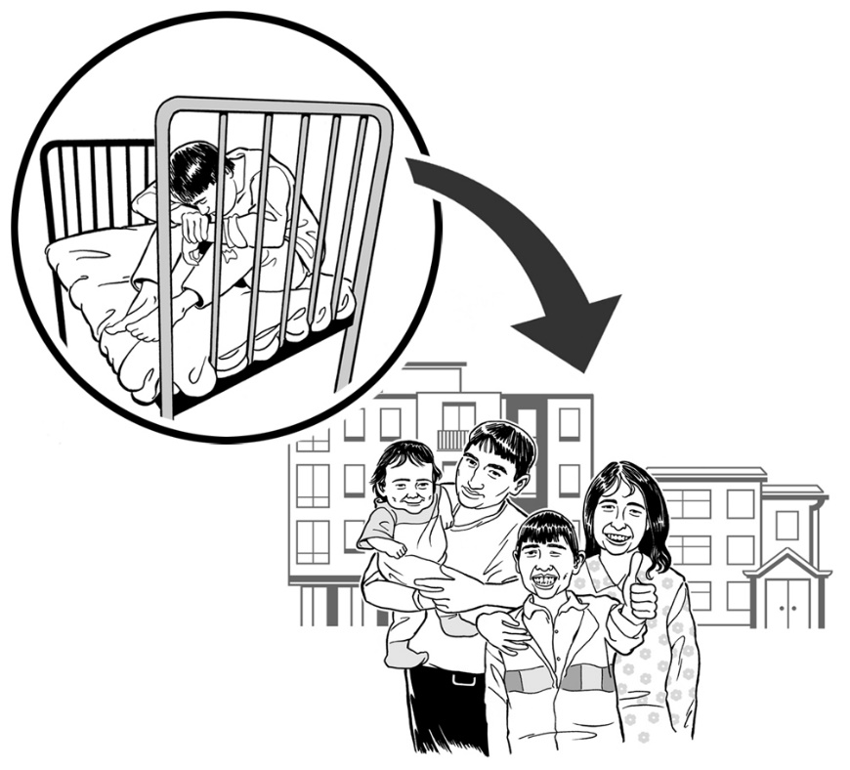
Committee on the Rights of Persons with Disabilities

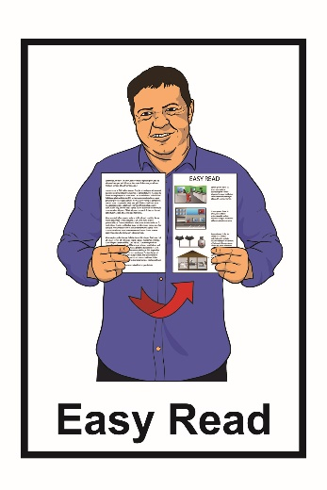
Asia Pacific region:
online consultation about what needs to happen so people with disabilities can live good lives in the community

What you will find in this document

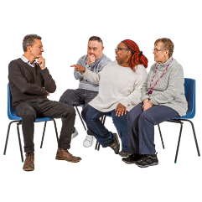
What is a consultation? 3
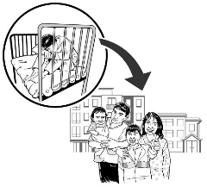

What is this consultation about? 6
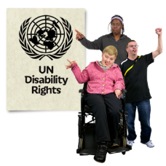

Who is running this consultation? 11

Why is this consultation
happening? 13
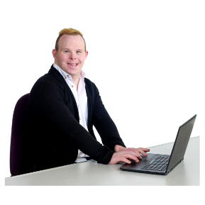

How can I register? 25

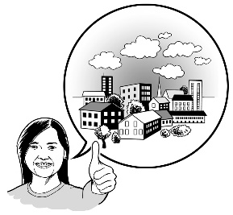
What should I talk about
in my statement? 32
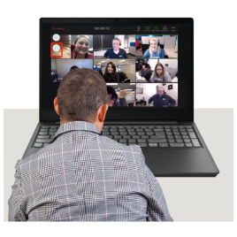

How will the consultation
happen? 45

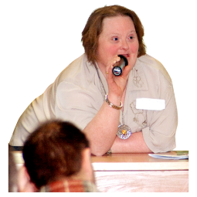
Other ways to give information
to the committee 47

Countries in the
Asia Pacific region 49

What is a consultation?
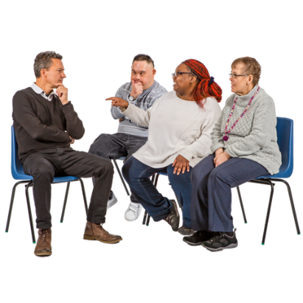

A consultation is a meeting where people share what they know and think.
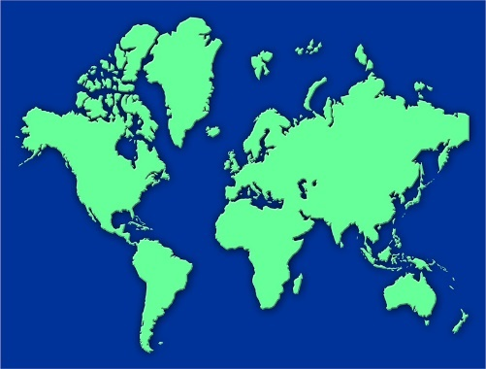

There are consultations happening for the different regions of the world.

This consultation is only for people in the Asia Pacific region.

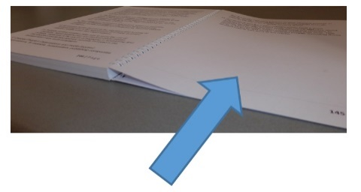
You can see the list of the countries that are part of the Asia Pacific region on pages 49 to 52.

This consultation will take place on:
Wednesday 12 May 2021 at 2pm Australian Eastern Standard Time.

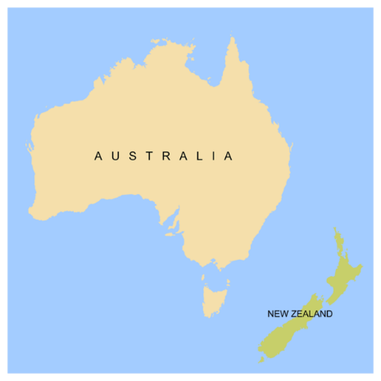
Australian Eastern Standard Time is the time zone that includes:
- Sydney
- Melbourne.

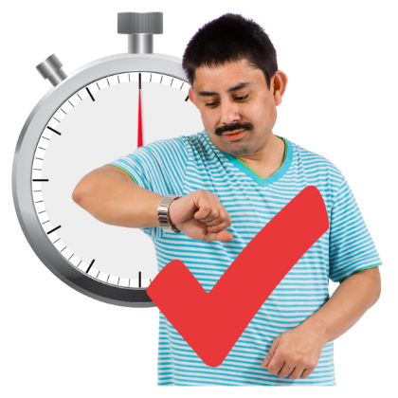
The time may be different for you because of your time zone.

Please check what the time of the meeting will be in your local time.

You can find out more about timezones at:
https://www.timeanddate.com/
worldclock/converter.html

What is this consultation about?

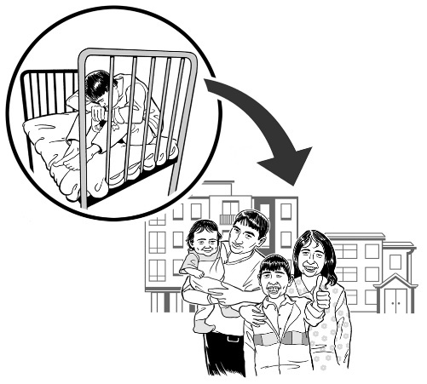
The consultation is about deinstitutionalisation.

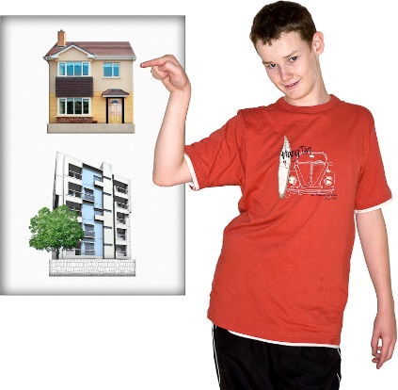
Deinstitutionalisation means people with disabilities have their rights to:
- make their own decisions and choices
- have control over their own lives
- live where they want to
- live with people they want to
- move from institutions to homes of their choice in the community.

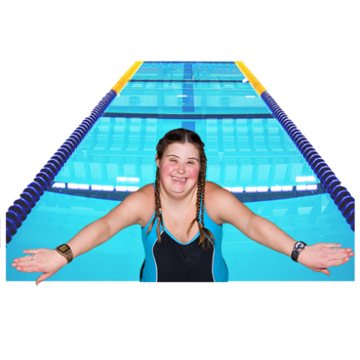
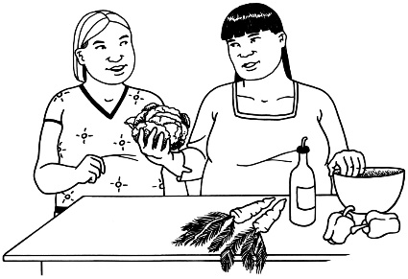
Deinstitutionalisation also means people with disabilities have their rights to:
- have disability services and support
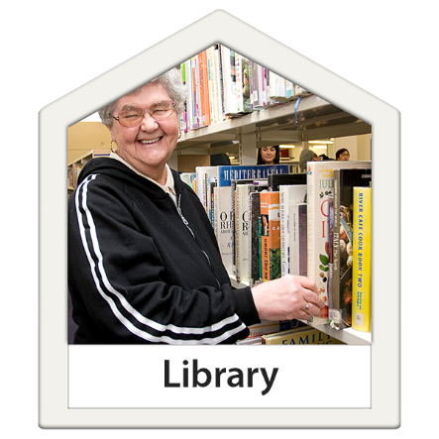
- be able to use everyday services in the community
- live the life they want to live.

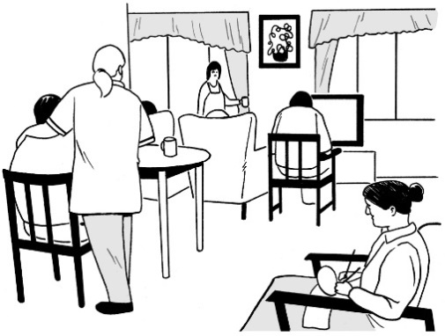
Institutions are places some people with disabilities have to live in or be part of.

Institutions are places like:
- large disability services
- special schools
- group homes.

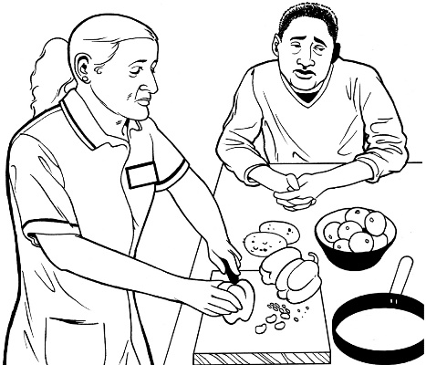
When people with disabilities are in institutions other people:
- make decisions
- and are in control.

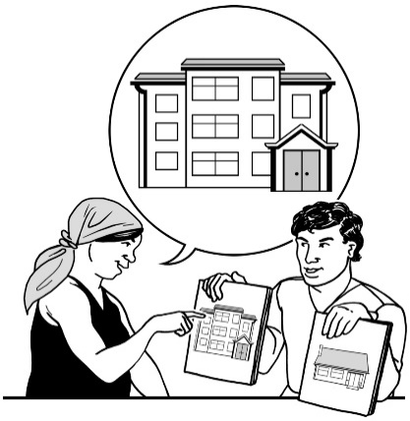
People with disabilities in institutions do not have much choice about things like:
- who they live with
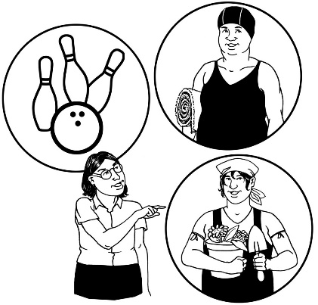
- where they live
- what they do with their day

- how they live their life.

Lots of people with disabilities used be in institutions.

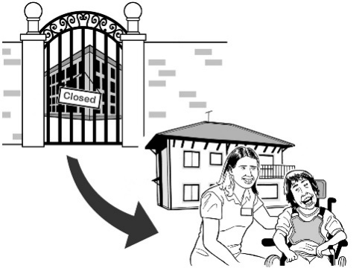
Now some people with disabilities have:
- more choice about where they live
- have the life they choose.

The committee will be looking at things like:
- what makes deinstitutionalisation hard
- how deinstitutionalisation can work well.

Who is running this consultation?

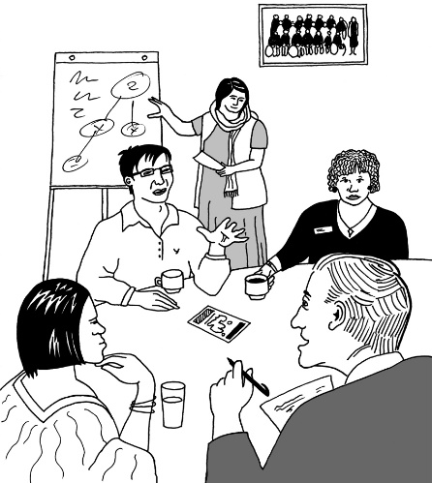
The consultation is run by the Committee on the Rights of Persons with Disabilities.

We will call the Committee on the Rights of Persons with Disabilities the Committee.

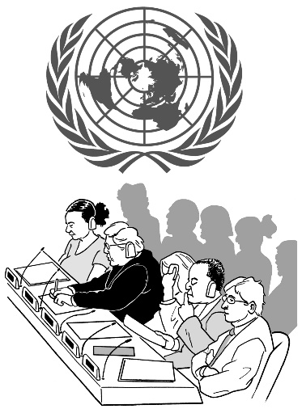
The Committee is a group of experts from different countries who check on how the United Nations Convention on the Rights of Persons with Disabilities is happening in different countries.

The United Nations Convention on the Rights of Persons with Disabilities is an agreement between lots of countries.

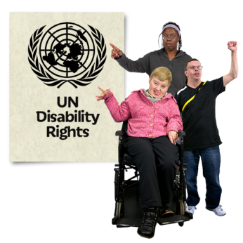
It says what governments must do to make sure people with disabilities get the same rights as everybody else.

The United Nations Convention on the Rights of Persons with Disabilities is also called the UNCRPD.

Why is this consultation happening?

The COVID-19 pandemic has changed things for a lot of people.

COVID-19 is a virus that has made people ill in a lot of countries.

Some people have died because of COVID-19.

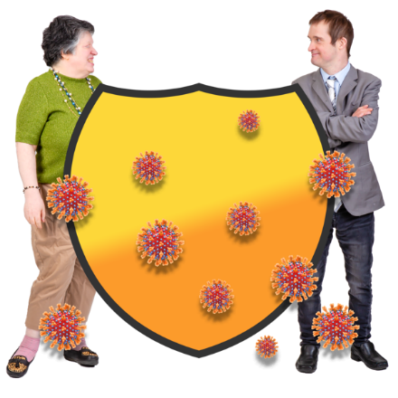
Many countries changed a lot of things to stop COVID-19.

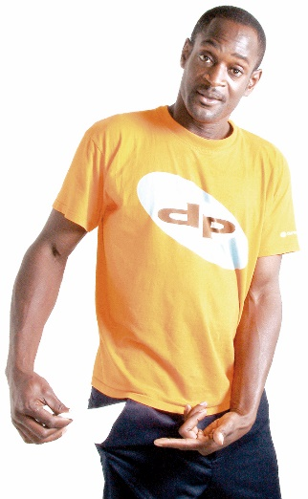
This has meant many people with disabilities have a higher chance of:
          - losing the money they live on
          - losing other benefits they get like health insurance
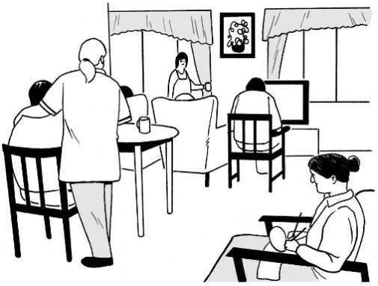
          - having to live in institutions
          - being stopped from going outside home
          - being isolated.

Isolated means being cut off from:
- other people like friends
- the community.

COVID-19 has made things worse for a lot of people.

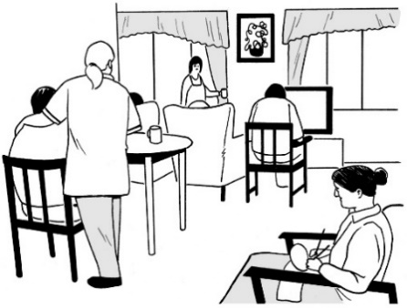
Things are worse for some groups of people with disabilities like:

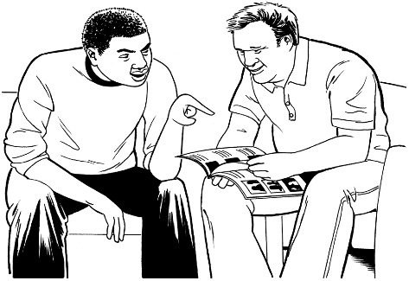
- people who still live in institutions
- people with intellectual disabilities
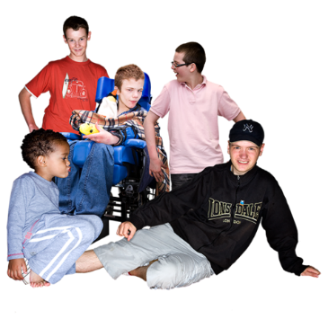
- people with psychosocial disabilities
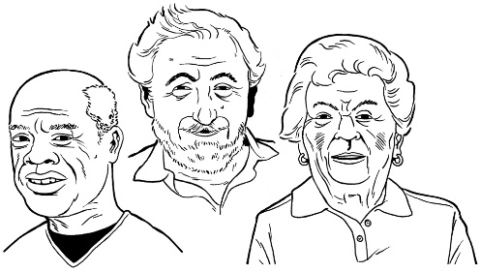
- children
- older people
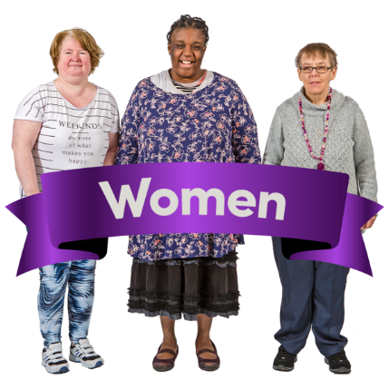
- women.

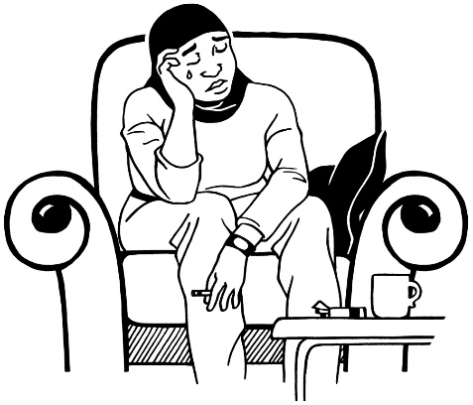
Things are also worse for people with disabilities who experience other kinds of discrimination.

This discrimination might be because of things like their:
- age
- gender
- place of birth.

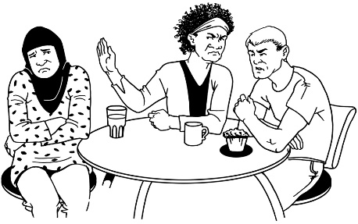
Discrimination is when people are treated differently because of something like:
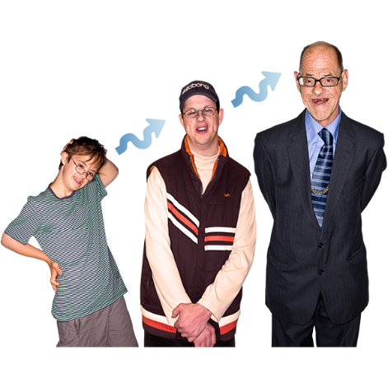
- having a disability
- their gender
- where they are from.
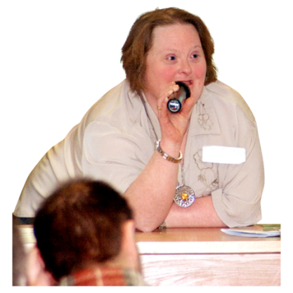
This consultation is a chance for people with disabilities to share their ideas on how to change things.

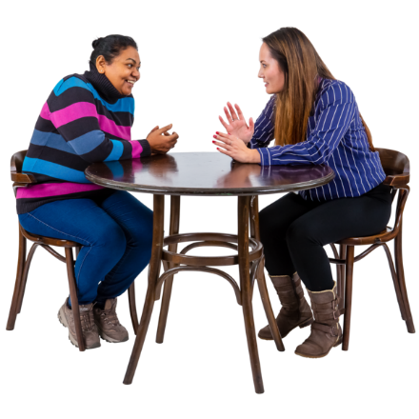
It is also a chance for people from different places to share what has worked well where they live.

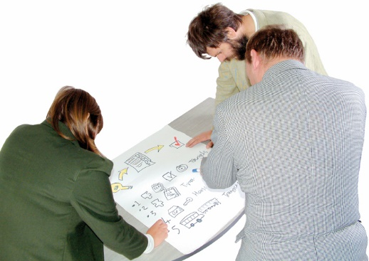
After the consultation has happened the Committee will use the information it has found out to write a document.

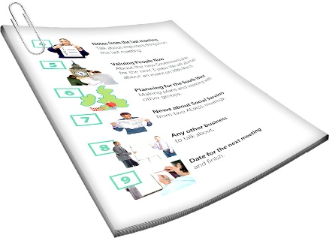
The document will be called:
Draft Guidelines on Deinstitutionalisation.

The document will have ideas for countries to make the rights in the UNCRPD real.

Who is the consultation for?

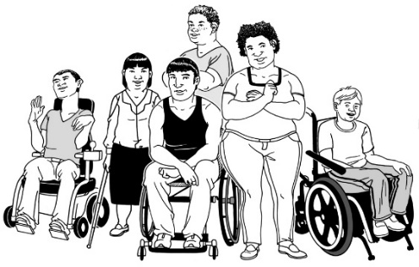
The Committee wants to hear from people with disabilities from the Asia Pacific region.

The committee wants to hear from people who they do not usually hear from.

The people that the committee wants to meet fit into 5 groups.

Group 1

Group 1 is:
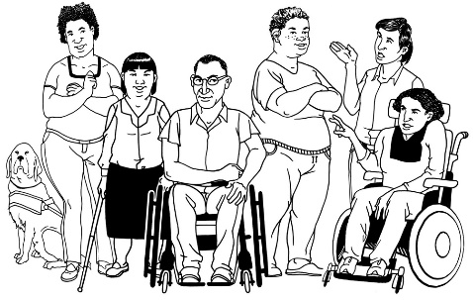
- people with disabilities
- organisations of people with disabilities.

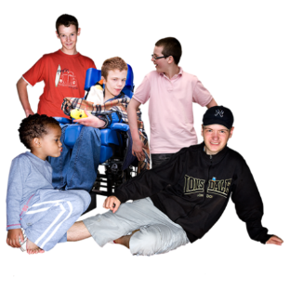
Organisations of people with disabilities include:
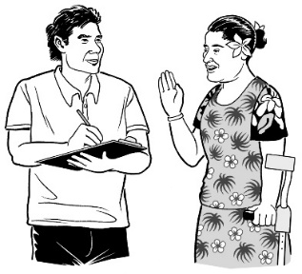
- organisations of children and young persons with disabilities
- self-advocacy organisations
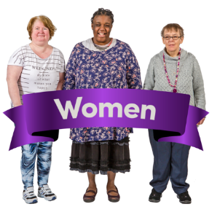
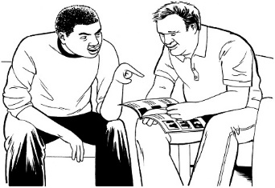
- organisations of people with intellectual or psychosocial disabilities
- organisations of women with disabilities.
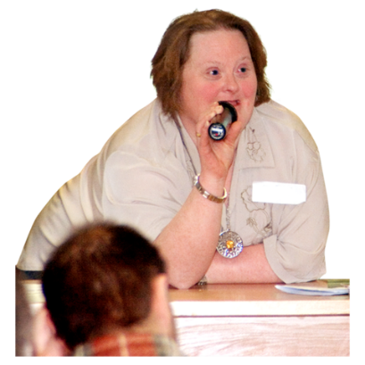
People in Group 1 will have 4 minutes each to speak in the consultation.

Group 2

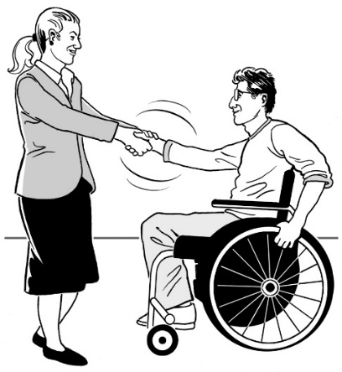
Group 2 is coalitions of organisations of people with disabilities.

A coalition means 2 or more organisations working together.

Each coalition can have 1 or 2 people speak.

The coalition can speak for no more than 6 minutes.

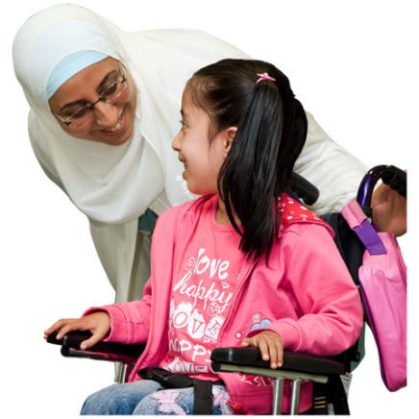
Group 3

Group 3 is for people with disabilities working together with organisations of parents of people with disabilities.

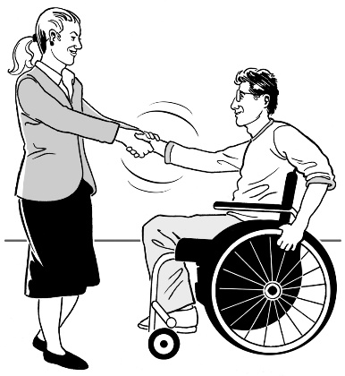
There can be two people working together.

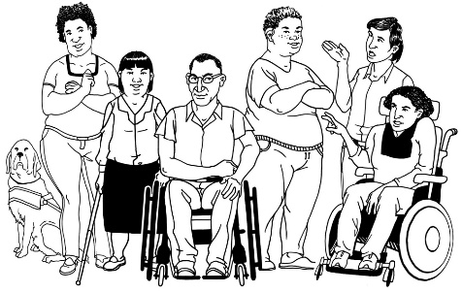
One person must be a person with a disability.

They can speak for 3 minutes between them.

If an organisation of parents does not have people with disabilities to speak with them then the organisation:
- can watch the consultation
- cannot speak at the consultation.

This is called being an observer.

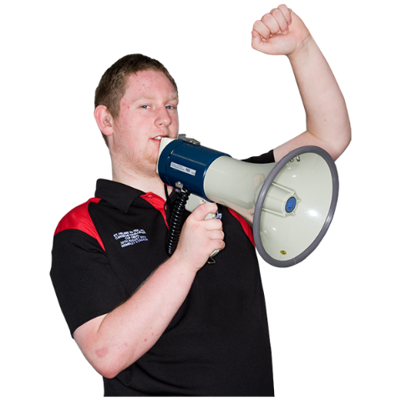
Group 4

Group 4 is for organisations that work so:
- there are no institutions

- more people with disabilities can live independently.

Speakers in Group 4 can speak for up to 2 minutes if there is time.

Group 5
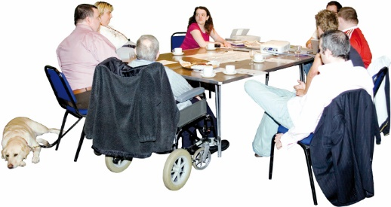

Group 5 is for other organisations.

These organisations can watch how things go.

They cannot make a presentation to the committee.

This is called being an observer.

How can I register?
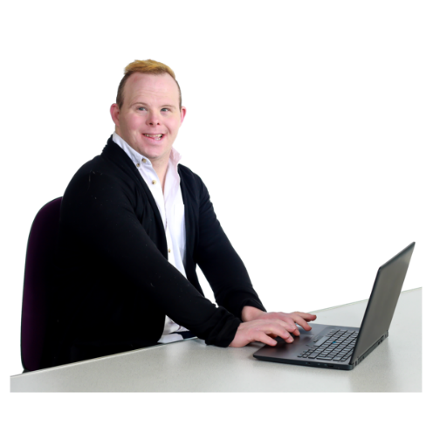

You need to register to speak at the consultation.

You can register by sending an email to hfuentes@ohchr.org

The subject of your email should be:
Regional consultation Asia Pacific.

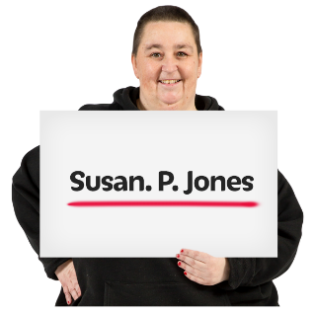
In your email please tell us the:
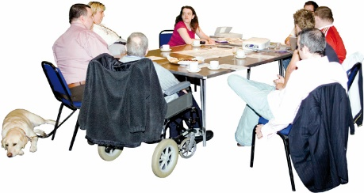
- full name of the person who will speak at the consultation
- the name of your organization
- the country where your organisation works or is from.

If you are not sure how to register ask someone you trust to support you

Attach your statement to the email.

Your statement is what you want to say at the consultation.

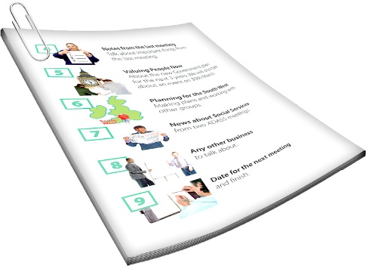
Your statement needs to be written:
- in English
- as a Word document
- have no more than 5 hundred and 20 words
- Be double spaced
- in 12 point font.

If you are not sure how to write your statement ask someone you trust to support you.

You have to register by 20 April 2021.

Information that is shared during the consultations will be used to help write the draft guidelines.

Your information will be kept confidential.

Confidential means we not say what you said at the consultation

The consultation is only for 2 hours.
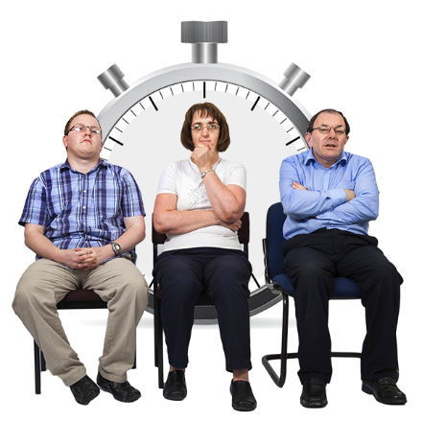

This means if lots of people want to speak it may be hard to fit everyone in.

After you register for the consultation the Committee will make a list of speakers.

The consultation is only for people who get an invitation.
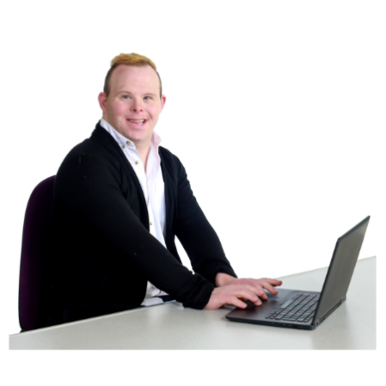
When making the list of speakers the committee will check if you or your organisation:
- sent what you want to say in writing
- are a person with disabilities or a member of an organisation of persons with disabilities
- speak up about and works to assist:
  - people with disabilities moving from institutions
  - people with disabilities right to live in the community.

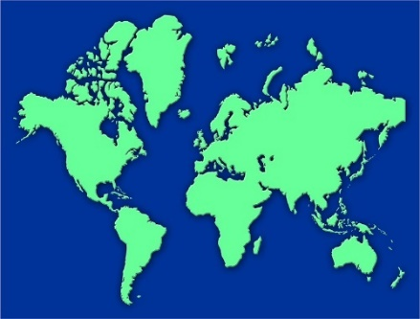
The Committee also wants to hear ideas from people from the different countries in Asia Pacific region.
We will send you an email to confirm you will speak as part of the consultation.

We will send you a link to join the Zoom meeting on 12 May 2021.

We will also send you a list of all the speakers that show what order they will speak in.

What should I talk about in my statement?

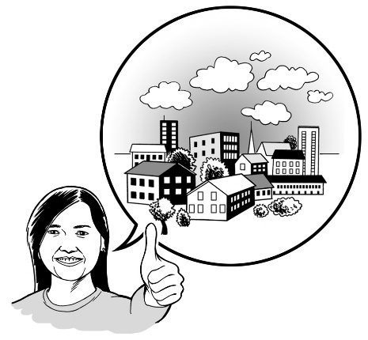
We want speakers to give us ideas about ways more disabled people can live:
- independently
- where they choose to
- as part of a community

Here are some questions to think about when you are writing your statement.

How are people with disabilities in the Asia Pacific region:
- kept in institutions
- kept away from non-disabled people
- not allowed to do the things
non-disabled people can
- isolated?

How can we stop these things happening?

How do we make sure that people with disabilities still get to make their own decisions when there is an emergency like COVID-19?

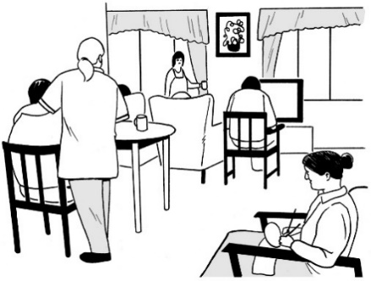
How can we make sure that people with disabilities do not go back to institutions or to smaller institutions?

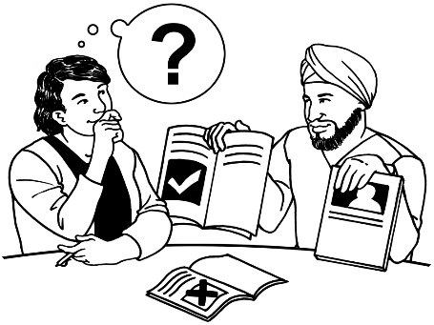
When people with disabilities are moving from institutions how should they be supported to:
- make their own decisions
- communicate what they want?

Sometimes people with disabilities are put and kept in institutions:
- by laws
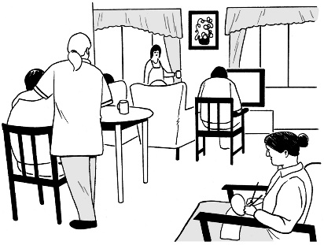
- through the education system such as special schools
- through services such as group homes.
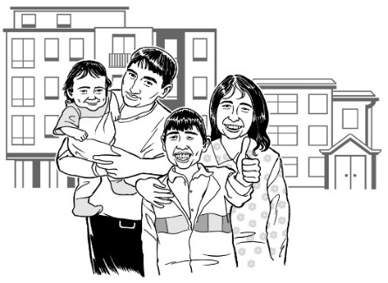

How can we stop this happening?

How can we make sure that all people with disabilities get their rights?

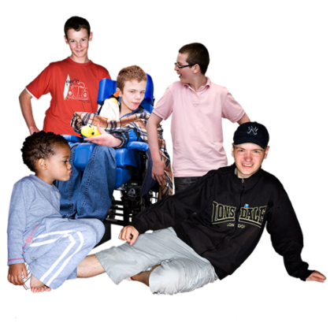
People with disabilities who need to get their rights include:
          - children with disabilities
          - young people with disabilities
          - older people with disabilities
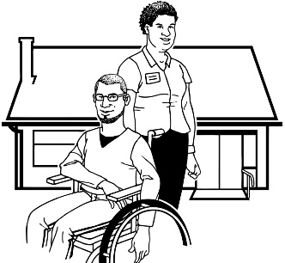
          - people with disabilities who need high levels of support
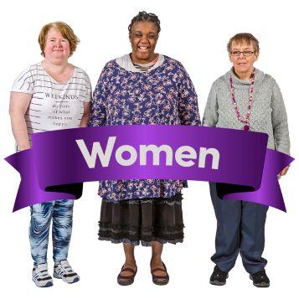
          - women with disabilities
          - people with intellectual disabilities
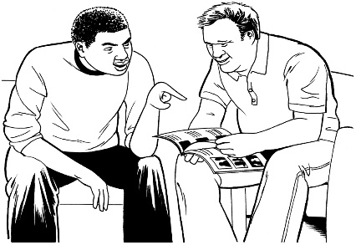
          - people with psychosocial disabilities

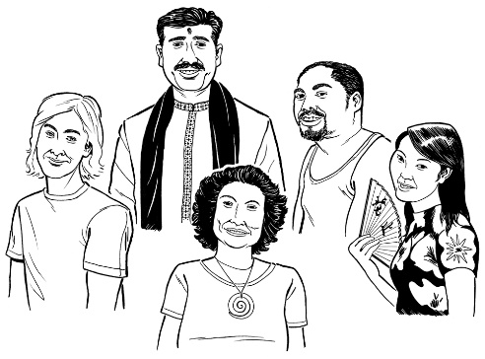
How can we make sure people with disabilities who are indigenous or from minority communities get their rights?

Indigenous people are people who were the first people to live in a country.
Indigenous people include:
          - Māori
          - Aboriginal and Torres Strait Islanders
          - Ainu
          - Malay Singaporeans.

Minority communities are a group of people from the same:
- race
- culture
- religion.

They live in a place where most of the people around them are of a different:
- race
- culture
- religion.

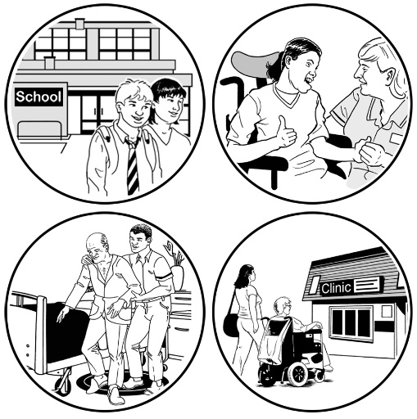
What support do people with disabilities need:
- to live in the community:
      - to move from institutions to a place they choose in the community

      - to be able to live the life they want in the community
      - when something big happens like the COVID-19 pandemic?

What can make things better for people with disabilities who used to be in institutions?

How can we make sure people with disabilities have their rights to:
- make their own decisions and choices
- have control over their own lives
- live where they want to
- live with the people they want to
- move from institutions homes of their choice in the community
- have disability services and support
- be able to use everyday services in the community
- live the life they want to live?

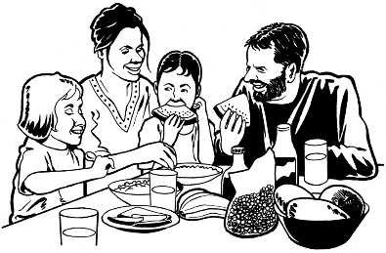
How can others support people with disabilities to live in the community?

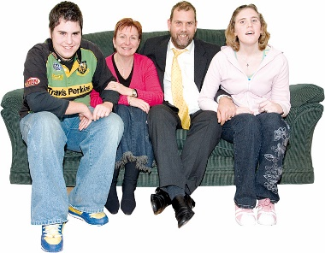
Others such as:
          - families
          - organisations
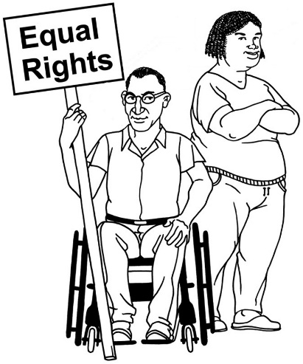
          - human rights groups

          - private companies or businesses.

Can you tell us anything to do with moving people with disabilities from institutions to living in the community that has been done well where you live?

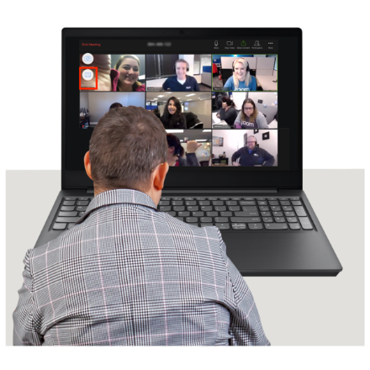
Can you tell us about any meetings or consultations about living in the community that you have been part of where you live?

How will the consultation happen?

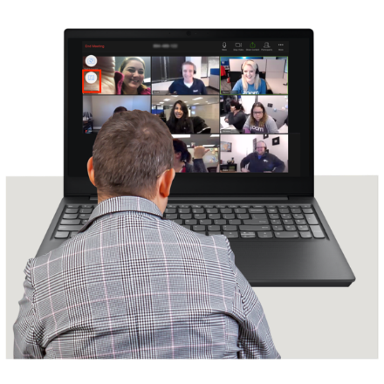
The consultation will be online.

We will meet through Zoom.

The consultation will last 2 hours.

We will hear from different speakers in the Asia Pacific region.

The consultation will be in English.

When you are on the online meeting you can turn on captions in English.
These are captions

Captions mean that the words that are being said will be written on the screen.

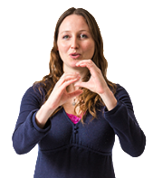
There will also be translation into International Sign.

Other ways to give information to the committee

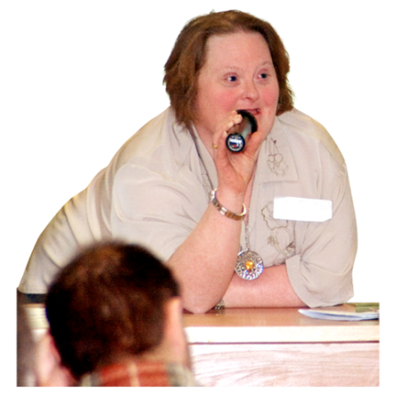
If you cannot be part of the online meeting there are other ways to be part of the consultation.

You can send us:
- a video message of no more than 4 minutes
- a voice recording of no more than 4 minutes
- a written statement.

You can use WeTransfer to send one of these to hfuentes@ohchr.org.
You can find out more about WeTransfer at: https://wetransfer.com/

If you send us a written statement should be:
- no more than 5 hundred and twenty words
- double spaced
- in 12 point font.

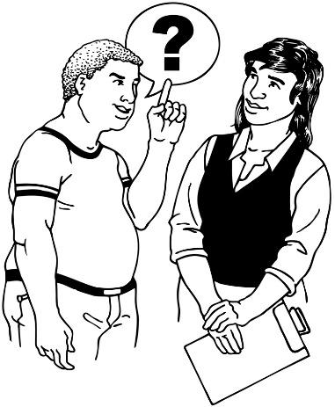
If you are not sure how to make a video or write your statement ask someone you trust to support you.

The countries in the Asia Pacific region

Here are the countries in the Asia Pacific region:
- Afghanistan
- Australia
- Bangladesh
- Bhutan
- Brunei Darussalam
- Cambodia
- China
- the Cook Islands
- the Democratic People's Republic of Korea
Here are some more of the countries in the Asia Pacific region:
- Federated States of Micronesia
- Fiji
- India
- Indonesia
- Islamic Republic of Iran
- Japan
- Kiribati
- Laos
- Malaysia
- Maldives
- Mongolia
Here are some more of the countries in the Asia Pacific region:
- Myanmar
- Nauru
- Nepal
- New Zealand
- Niue
- Pakistan
- Palau
- Papua New Guinea
- Philippines
- Republic of Korea

Here are some more of the countries in the Asia Pacific region:
- Republic of the Marshall Islands
- Samoa
- Singapore
- Solomon Islands
- Sri Lanka
- Thailand
- Timor-Leste
- Tonga
- Tuvalu
- Vanuatu
- Vietnam
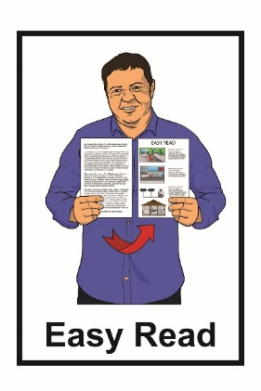
This information has been translated into Easy Read by the Make It Easy service of People First New Zealand Inc. Ngā Tāngata Tuatahi.
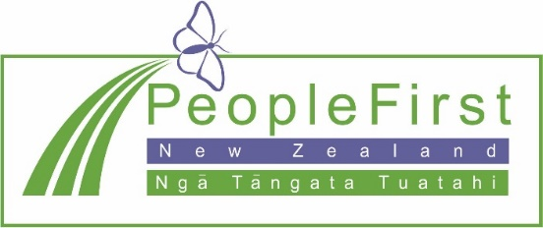
The ideas in this document are not the ideas of People First New Zealand Ngā Tāngata Tuatahi.
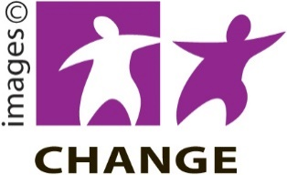
Make It Easy uses images from:

- Changepeople.org

- Photosymbols.com
- Sam Corliss

All images used in this Easy Read document are subject to copyright rules and cannot be used without permission.

