Den 30 06 2017
D.nr .329757
Sagsbeh. tg_lev

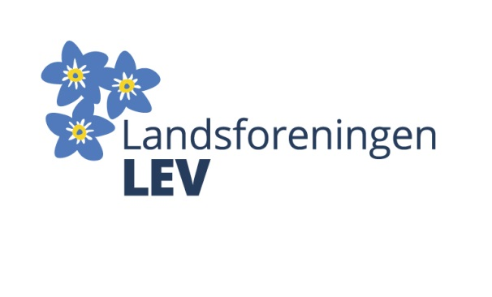

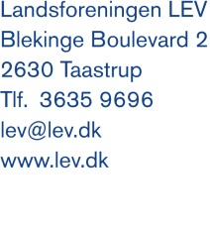

Submission to the draft General Comments No 5 on Article 19: The Right to Live independently and Being included in The Community

About LEV
The National Association of LEV (LEV) is the nationwide association for people with disabilities and their relatives. LEV has about 10,000 members and also has a number of affiliated associations, including The National Organization of People with Learning Disabilities (ULF), which is the national self-advocacy organization for people with intellectual disabilities. LEV works for people with intellectual disabilities interests in Denmark, and our work is based on the principles of the UN Disability Convention.

General comments
LEV would like to express our gratitude for the Committee to prioritize the drafting of General Comments regarding Article 19.

We share the draft's very precise designation of Article 19, as one of the central cornerstones of the Convention. Not least because we currently are experiencing that the rights stated in article 19, in these years are under significant pressure in Denmark.

In the decades since the mid-1970s, there was a significant - though gradual - de-institutionalization of housing conditions for people with intellectual disabilities in Denmark. Many of the very large total institutions that were established in the latter half of the nineteenth and first half of the twentieth century were gradually settled. People with disabilities gained stronger legal rights, including to meaningful employment outside the institution, support for participation in local communities, etc. In many cases the large institutions with more than 100 inhabitants were replaced by smaller and more including small group homes with 3-8 inhabitants and with far better and more home-like physical characteristics (kitchen, private toilet and bath facilities etc.). Many institution-like features survived this transition, especially regarding service provision, but many also diminished or disappeared. The development was clearly toward less institution, more home and more independent living and inclusion in the local community.

This development changed course from around 2007 onward. Here, Denmark went through a comprehensive municipal reform, which meant that the municipalities, among other things, was assigned total responsibility for support measures and housing for people with disabilities, including full financial responsibility. The reform was followed by an economic crisis clearly reflected in the municipal budgets.

The consequence of this decentralization was a significant weakening of disability policy insight and awareness among political and administrative decision makers as well as a short-term focus on economic optimization, including a naive belief in economies of scale in managing institutions compared to independent and community living schemes.

In recent years we have seen a highly problematic regeneration of large-scale institutional construction in Denmark. These projects are initiated by the municipalities, and almost exclusively intended for people with intellectual disabilities, especially persons with complex support needs. The operation of these new institutions (allocation of assistance between residents, etc.) is done in traditional institution-fashion fare from any independent living perspective.

The Danish case shows us that de-institutionalization is a vulnerable process that can run off the track. It is crucial that constant efforts are made to maintain political and administrative consensus on the de-institutionalization process and the right to independent living.

In LEV we regard the draft as an important element in this important effort. We welcome the draft in its whole. The following remarks and recommendations express the wish to contribute to further clarification and unfolding of thie General Comment.

Comments regarding specific paragraphs

Paragraph 15 c
The definition in paragraph 15 c seems to assimilate large scale institutions with small group homes. In LEV we share the analysis that small group homes also can be characterized by the same institutional features as large institutions. On the other hand, we find that it is relevant to clarify that the risk of intense institutionalization of the residents' life - all in all - is less and more preventable in small group homes than in large institutions. By emphasizing this point, it is stressed that ‘size means something in itself’, which is important. Particularly in relation to the gradual transition from institutions to independent living in the community, which in practice could be needed in many cases, where people with disabilities have lived in institutions for many years (as stated in paragraph 28 in the draft).

We would also recommend that paragraph 15 c of the draft (in line with paragraph 35) clarifies the institutionalizing and stigmatizing effect of gathering many people in an institution or a specific area/neighborhood in a community. These effects arise regardless of whether a building is designed as a cluster of a large number of self-contained homes on a landmark or in the case of more classical institutional building under the same roof. One could talk about a kind of ghetto effect, which in itself constitutes an obstacle to inclusion in the community - despite the fact that most of new ‘institutions’ contains two room flats with private bath and kitchen etc. The resident can be said to have a modern flat, termed as a “golden cage”..

Paragraph 16
LEV acknowledges that it is relevant that the draft emphasizes that residential service can not in itself be a guarantee for independent and community living. Over the past few decades, Denmark has progressively developed towards residential housing service, where the tenant obtains rental-rights in line with other tenants of a dwelling. This right is significantly stronger than the right to residence in an institution.

However, LEV's documented experience is that this formal characteristic (tenant rights) does not in itself preclude institutionalization of the housing. The vast majority of newer homes built in Denmark for people with disabilities are listed as rented accommodation. However, this does not mean that the basic institutional characteristics are reduced. Several of the newer building-projects in this area, are designed with 40 – 100 people under the same roof and with significant institution-characteristics.

Paragraph 25
Based on LEV's experience in Denmark, it is relevant to add local authorities to the listing of parties who act as substitute decision-makers in practice. LEV thus has several examples of local authorities, without legal basis, initiate the replacement of people with disabilities from their homes to another, without their consent, and the government rarely intervenes or speaks out criticism.

Final comments
As mentioned above, LEV is grateful for the Committee's prioritization of work on a General Comment on article 19. In conclusion, we would like to emphasize that the draft’s clarification of the state party's obligations in relation to the implementation of Article 19 are of particular importance in a Danish context. This applies not least to the obligation to draw up binding action plans for the progressive realization of de-institutionalization and the involvement of representative organizations in this work.

Anni Sørensen
Chairman

