Check against delivery

The Committee on the Rights of Persons with Disabilities

Day of General Discussion on the Right to Education of Persons with Disabilities

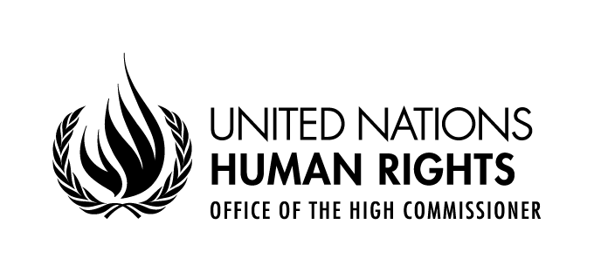

Opening Address by

Mr. Ibrahim Salama
Director
Human Rights Treaties Division

Representative of the Secretary-General

Palais des Nations, Room XVII
Wednesday 15 April 2015, 10.00 a.m.
Madame Chair, Ladies and gentlemen,
It is my pleasure to be with you this morning and to welcome you on behalf of the High Commissioner for Human Rights, Zeid Ra’ad Al Hussein, to today’s Day of General Discussion on the right to education of persons with disabilities, organized by the Committee and OHCHR in partnership with our UN partners, notably UNICEF.

I think you will all agree that the attendance here this morning is very impressive. It underscores the importance of the issue of inclusive education to us in the human rights community and beyond. Moreover, when I last checked the website of your Committee, over 80 written submissions for today’s event had been received. This is an extraordinary level of engagement, and bodes very well for a dynamic discussion today. Let me extend a particular welcome to Mr. Moreno, the Special Envoy of the Secretary General on Disability and Accessibility, Mr. Cardona from the Committee on the Rights of the Child, Ms. Bailey from CEDAW and the UN Special Rapporteur Ms. Devandas. We know from experience that active cooperation between the various mechanisms is a sure path not only towards outcomes that are soundly grounded, but also towards greater jurisprudential coherence across the system. Let me also commend the generosity of the donors who financed the attendance of many participants.

Today’s event is part of the process of elaborating a CRPD General Comment that will provide authoritative guidance to States parties and other stakeholders on implementing the right to education of persons with disabilities. OHCHR is very happy to support this event and the broader process, particularly through the provision of the expertise of our staff working on the rights of persons with disability and on the right to education. Our support dovetails with our work in support of other treaty bodies (notably the current drafting of a general recommendation of CEDAW on the right to education of girls and women), as well as to the Human Rights Council and in particular the 2013 OHCHR report on the right of persons with disabilities to education.
As authoritative guidance, general comments resonate well beyond Geneva, as you know. For us working in the Office, it is crucial to have as sound and as implementable a general comment on inclusive education as possible. For our colleagues - particularly those working in our 66 field presences - the Committee’s principled, pragmatic and pertinent advice on the application of Article 24 of the CRPD will be a touchstone for our future work on inclusive education. It will allow us and our partners to be more effective in our work: in increasing awareness on the issue, in lobbying for change in laws, policies and practices, and in seeking accountability in the case of violations.

In the room today we have a good percentage of the world’s experts on the issue of inclusive education. I will end here to give as much time as possible to you to discuss the very real challenges persons with disabilities face in claiming their right to accessible, acceptable, and quality education. And I hope that your discussions will move beyond the challenge and begin to draw the broad lines of some durable, rights-based solutions.
Thank you

