Submission

by Bundesarbeitsgemeinschaft Inklusionsfirmen (bag if) for the General discussion on the right of persons with disabilities to work and employment (Art 27 CRPD) organized by OHCHR

Content:

1. Introduction: Objectives of this document 2

2. Who we are 2

3. The model of inclusive enterprises in Germany 2

3.1. Historical development and current status 2

3.2. Data and facts 3

3.2.1. Inclusive enterprises and their jobs 3

3.2.2. Business sectors 4

3.3. Key elements of inclusive enterprises 5

4. The added value of inclusive enterprises 5

4.1. Added value for people with disabilities 6

4.2. Added value for enterprises 7

4.3. Added value for state and government 7

4.4. Added value for society 7

5. Preconditions for success 7

5.1. Market orientation 7

5.2. Compensation for disadvantages 8

5.3. Networking 8

6. Conclusion 8

Introduction: Objectives of this document
With this document, the Bundesarbeitsgemeinschaft Inklusionsfirmen – bag if (Federal Association of Inclusive Enterprises), as the umbrella organisation of inclusive enterprises in Germany, aims to present the model of inclusive enterprises as a "lighthouse model" for the implementation of Article 27 of the UN Convention on the Rights of Persons with Disabilities. Inclusive enterprises represent full compliance with the obligations to respect, protect and fulfil the human rights of persons with disabilities with regard to Article 27 of the Convention.
The inclusive enterprise model exists, with some differences in the framework conditions, in many countries in Europe and the world. All these models pursue one goal: the right of persons with disabilities to work, on an equal basis with others; this includes the right to the opportunity to gain a living by work freely chosen or accepted in a labour market and work environment that is open, inclusive and accessible to persons with disabilities (Art.27 UNCRPD).
Therefore, we appeal to the United Nations to support this inclusive enterprise model and to include it as a best practice model in the policy recommendations on employment models that respect UN CRPD Article 27.

Who we are
The German umbrella organization Bundesarbeitsgemeinschaft Inklusionsfirmen (bag if) represents the interests of inclusive enterprises in Germany. Together with our regional associations (lag if), we form a nationwide network of inclusive enterprises and advocate for the interests of people with severe disabilities in working life. We support, strengthen and promote social entrepreneurship in which economic action is guided by a sense of social responsibility.
bag if represents the interests of around 1,000 inclusive businesses and 30,000 employees at national and international level. We lobby in the political arena, negotiate with payers and decision-making bodies and participate in legislative processes. We advise companies, authorities and service providers on all relevant issues concerning the employment of people with severe disabilities. We inform, support and interlink inclusive enterprises with the aim of shaping inclusive participation in Germany in sustainable ways. As founding members of the European organisations Social Firms Europe - CEFEC and EuCIE - European Confederation of Inclusive Enterprises, we are committed to the fulfilment of Article 27 of the UNCRPD at European level. Our vision is an inclusive labour market that recognises people with disabilities as an indispensable resource in the corporate diversity strategy.

The model of inclusive enterprises in Germany

Historical development and current status
Since 2001, inclusive enterprises in Germany have been legally anchored in the Social Code IX (today §§ 215 ff. SGB IX). However, so-called "self-help companies" were already founded in the 1980s with the aim of offering rehabilitation and employment opportunities on the regular labour market under working conditions that were as realistic as possible to disabled people with significant vocational integration problems.
The starting point for these activities were mostly the de-hospitalisation measures initiated in the course of the nationwide psychiatry enquiry and necessary outpatient services for people with mental health problems. Accordingly, the target group of self-help companies consisted for a long time predominantly of people with mental health disabilities, and only to a small extent of people with intellectual, learning, physical or sensory disabilities.
Nowadays, inclusive enterprises employ people with all forms of disability, but especially people who would otherwise have no chance of employment in the general labour market due to their disability.
Taking into account the UN Convention on the Rights of Persons with Disabilities and the inclusion mandate enshrined therein, inclusive enterprises are more relevant than ever. In the last 30 years, inclusive enterprises have proven that it is possible to employ or train people in an inclusive way who would otherwise not be able to work in the labour market due to their severe disability. Inclusive enterprises are positive examples of inclusion in practice and are committed to implementing the UN Convention on the Rights of Persons with Disabilities. Inclusive enterprises are positive examples of inclusion in practice and are committed to implementing the UN Convention on the Rights of Persons with Disabilities. In the sense of "more normality", they represent an alternative to the sheltered workshop for many severely disabled people and, through special support services, enable them to work together with their non-disabled colleagues and, above all, with pay that is in line with collective agreements/local/sectoral standards and is the same for all employees.

Data and facts

Inclusive enterprises and their jobs
Today there are around 1,000 inclusive, enterprises, companies and departments in Germany.
These are companies in the general labour market, with one important special feature:
They employ a high proportion of persons with severe disabilities (at least 30%), by employment contract, with a collectively agreed or local wage, which in many cases is higher than the statutory minimum wage; the employees have all the rights and obligations of an employee. Most employment contracts are open-ended.
In 2019, a total of 29,866 people were employed. The number of employees with severe disabilities was 13,550. The employees from the target groups employed in the inclusive companies are people who would otherwise have no or very few opportunities on the labour market due to their disability, but who prove in the inclusive enterprises that they can develop in inclusive structures in the workplace and contribute to the economic success of their companies.
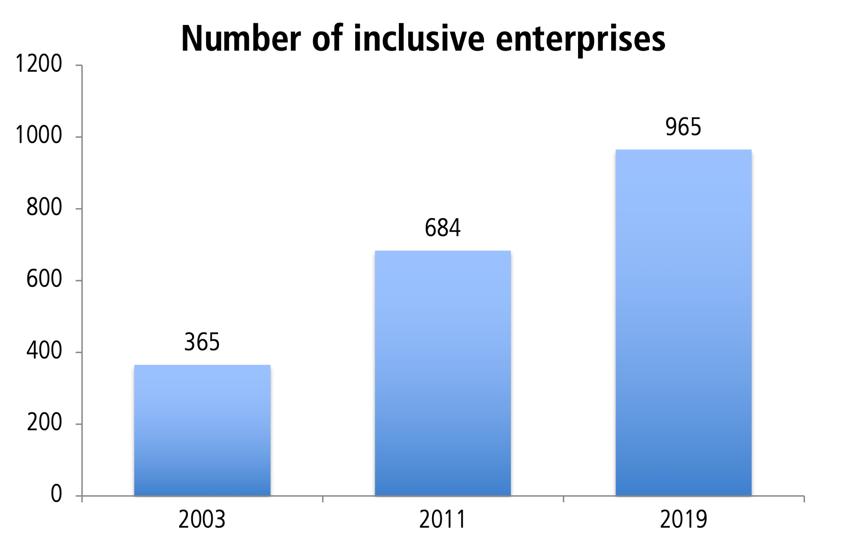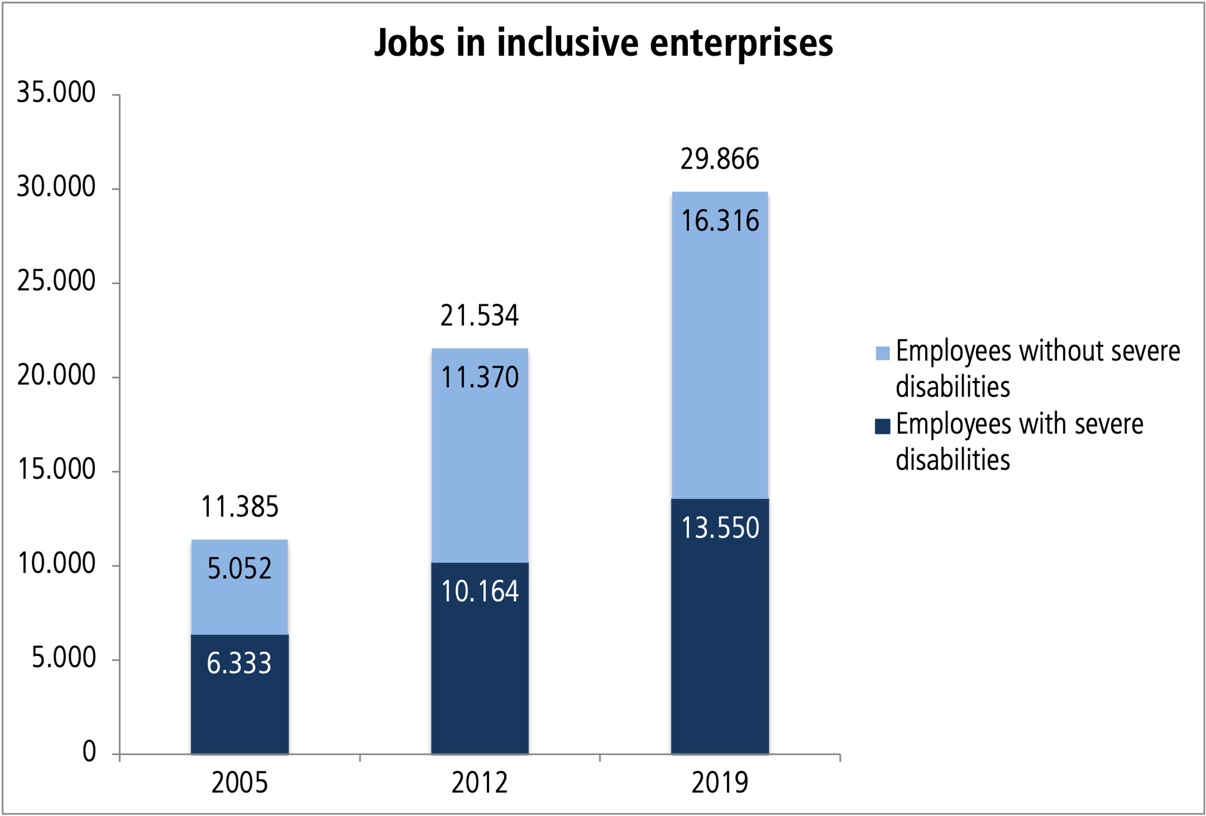

Inclusive enterprises are "specialists" for inclusive employment and training of special groups of people, for example people with mental and emotional disabilities, and can be an employment alternative for many people with disabilities in sheltered workshops.

Industries and sectors
Inclusive enterprises are represented in almost all industries and sectors. (School) catering as well as facility management, hotels and food markets are among the emerging sectors.
There is a slight increase in companies in the sectors of gardening and landscaping, agriculture and nature conservation, office and IT-supported services as well as logistical services and removals.
Inclusive enterprises are predominantly active as service providers in the broadest sense.
At the end of 2020, the following nationwide sector distribution was to observe (source: FAF company statistics).
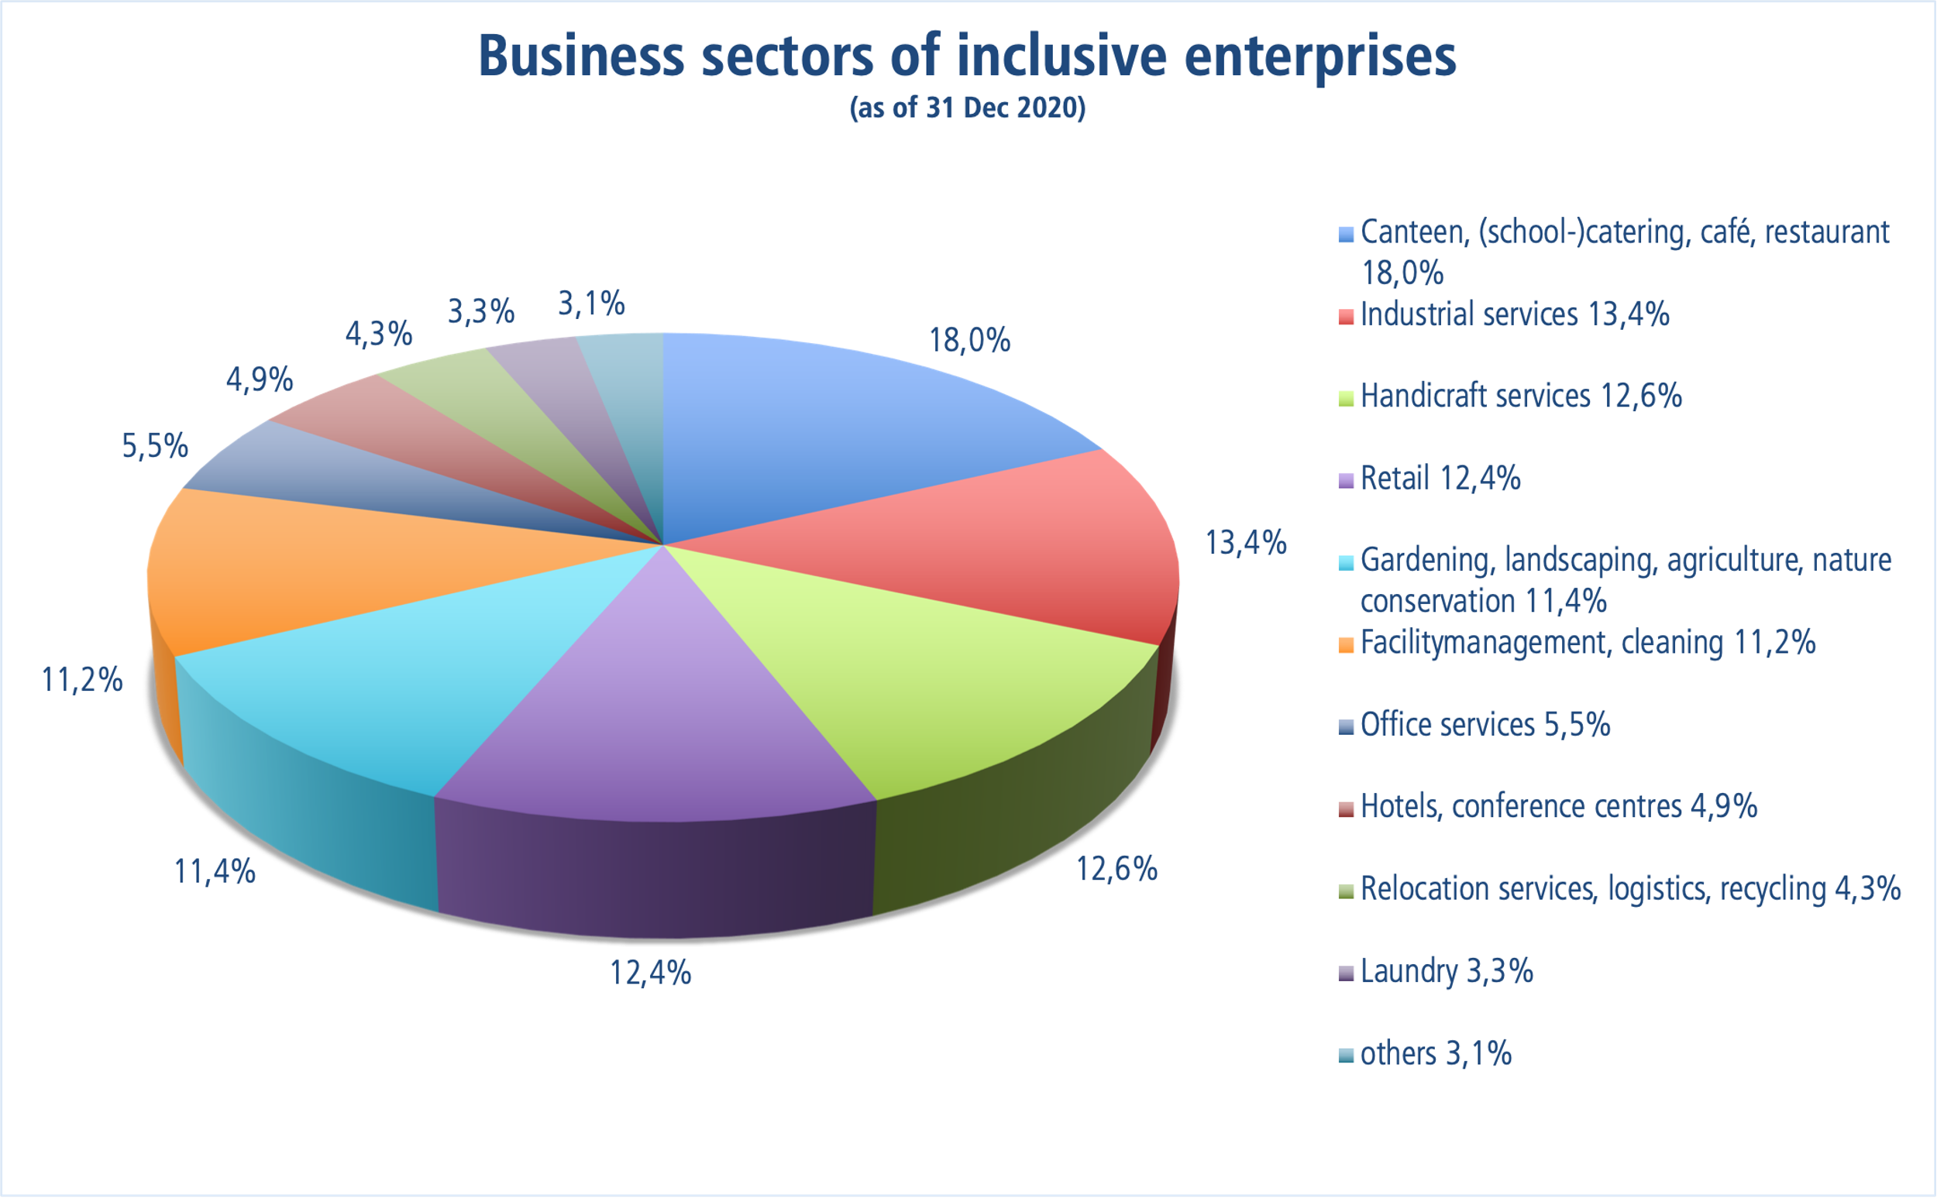
Exact statistical data has not yet been collected: Many inclusive enterprises are active in two or sometimes more sectors; the above figures refer to the number of business units; they do not reflect the turnover or the number of jobs in the sectors. The research of more precise data is reserved for an inventory to be carried out.

Key elements of inclusive enterprises
Inclusive enterprises, like no other model, stand for the free access of persons with disabilities to an open labour market accessible to all, in accordance with Article 27 CRPD.
They are characterised by the following key elements:
- Inclusive enterprises are businesses in the general labour market with a commercial purpose, which are operated by their owners under their own entrepreneurial responsibility. Their costs are essentially financed through the sale of products and services on the market.
- Inclusive enterprises are market-oriented and also fulfil a social mission.
- Inclusive enterprises are designed for the long term. This objective also applies to their workplaces.
- All employees have regular employment contracts.
- All employees - with and without disabilities - are paid according to the same industry-standard, labour law and collective agreement regulations.
Due to the above-mentioned key elements, inclusive enterprises are not a special or sheltered labour market but are embedded in the competitive order of our normal economic system. They are therefore exemplary for a "social market economy" in the truest sense of the word and can serve as an example for all companies in the private sector.

The added value of inclusive enterprises
Inclusive enterprises are characterised as social enterprises by the fact that they use entrepreneurial methods to generate added value for society and do not primarily or exclusively pursue a profit orientation. The success of the past 30 years confirms the sustainable impact of inclusive enterprises on the employment and training situation of people with disabilities.
With their sustainable corporate goals and values, they also make a significant contribution to the implementation of the United Nations Sustainable Development Goals.
Goals 1-NO POVERTY, 2-ZERO HUNGER, 4-QUALITY EDUCATION, 8-Decent Work and Economic Growth, 10-Reducing Inequalities, 11-Sustainable Cities and Communities and 17-Partnerships to Achieve the Goals specifically call for the inclusion of persons with disabilities. Inclusive enterprises fulfil these objectives.
The major added value of the inclusive business model is evident at several levels.

Added value for people with disabilities
- People with disabilities have unrestricted access to the general labour market.
- People with disabilities have a regular employment contract.
- People with disabilities receive a regular statutory or collectively agreed wage.
- People with disabilities receive social security benefits, unemployment pension, old-age pension.
- People with disabilities are provided with an adapted workplace and adapted qualification opportunities.
- People become independent of social benefits and can live self-determined lives.
- People with disabilities are strengthened in their self-confidence and become full members of our society through employment in an inclusive enterprise.

Added value for enterprises
- Employees with disabilities are characterised by high motivation and willingness to work.
- Employees with disabilities often have undiscovered resources that need to be utilised.
- Employees with disabilities contribute to diversity in the company. And diversity increases the company's success.

Added value for state and government
The state shapes the framework conditions for inclusive enterprises by
- Investment subsidies
- Wage subsidy to compensate for the reduced performance or the necessary support of employees with disabilities
- Tax relief due to the high employment rate of people with disabilities
- preferential consideration in the awarding of public procurement contracts
In return the state receives
- Less expenditure on state social benefits
- Tax and social security revenue from employees
- More purchasing power through employees

Added value for society
By participating in the general labour market, in all sectors, as a matter of course, people with disabilities become "visible". Their abilities and resources are recognised, prejudices are reduced and they are thus a natural part of our society. Inclusive employment creates encounters and encounters enable people with and without disabilities to understand each other. In the long run, inclusive employment leads to an inclusive society.

Preconditions for success

Market orientation
The prerequisites for the success of inclusive enterprises are above all the orientation of the companies towards successful market segments and professional business management. Inclusive enterprises must cover the majority of their running costs by generating revenue on the market.

Compensation for disadvantages
Inclusive enterprises need state support for the high employment rate of persons with disabilities in order to adapt their operational structures to the needs of employees with disabilities and to compensate for reduced work performance with additional staff.
The state can strengthen the special and inclusive business model through tax breaks and a special design for awarding public procurement contracts.

Networking
Inclusive enterprises work together on site in a network with other organisations and institutions of vocational rehabilitation, placement and participation, especially in the search for and preparation of severely disabled employees.
In addition, they need a network on national and international level to advance the successful model and to know best practice examples and learn from each other. This is what we stand for as the Bundesarbeitsgemeinschaft Inklusionsfirmen (bag if).

Conclusion
The UNCRPD is a human rights convention. The States Parties have undertaken to adopt state measures to ensure these rights. The United Nations and the Committee on the Rights of Persons with Disabilities pursue the goal of realising an inclusive labour market in the sense of the UNCRPD and to monitor and support the States Parties in the implementation of the goals and measures.
The aim of the General Discussion is to provide guidance to States Parties on what measures they should take to fully implement their obligations to respect, protect and fulfil the human rights of persons with disabilities with regard to Article 27 of the Convention.
Therefore, through this document, we offer the Committee on the Rights of Persons with Disabilities at the United Nations to use the inclusive enterprise model as a reference model to enable persons with disabilities to earn a living through work in an inclusive and accessible labour market.
By implementing inclusive employment policies, States Parties have great opportunities to achieve the goal of inclusive participation in working life for persons with disabilities. Inclusive employment offers persons with disabilities economic independence, social participation and a self-determined life. Inclusive enterprises are the innovative, but proven, way forward.

