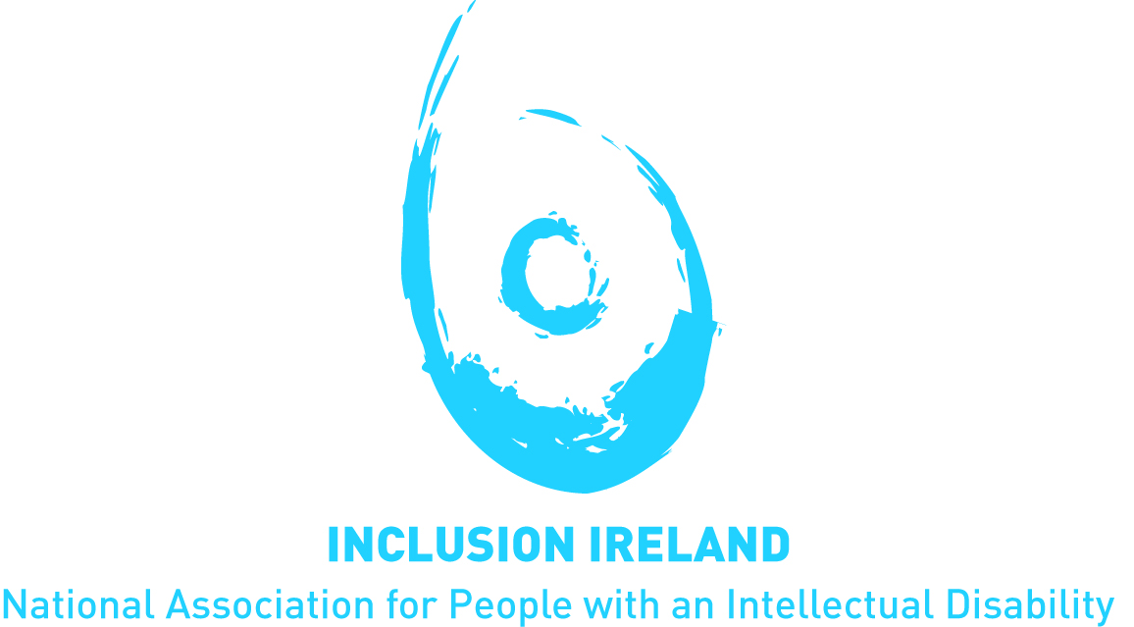

Employment for People with Intellectual Disabilities in Ireland
Submission for the UNCRPD Committee General Comment on Article 27.

March 2021

This document is written in font 12 Verdana in line with Inclusion Ireland plain English guidelines

Key Messages
- The Government must continue to invest in and promote inclusive education and provide career guidance services to all students with intellectual disabilities.

- Day services need to be reformed in line with New Directions and developed to provide more opportunities for people with intellectual disabilities.

- The Government must engage in a public awareness campaign on reducing the stigma around disability with a particular in relation to opportunities in employment.

- Continue investment in Supported employment initiatives beyond 2024. Provide funding for long term projects so people with intellectual disabilities of all ages have opportunities in employment.

- Provide Information in accessible formats to people with intellectual disabilities about employment and benefits and how it all works.

- Provide awareness training to employers so they can raise their expectations of what people with intellectual disabilities can do in the workplace.

- Ensure that people with intellectual disabilities are vaccinated for Covid 19 at the earliest opportunity so they can go back to work safely.

- Continue to develop schemes and supports both for employers and for people with disabilities can continue to access employment initiatives. Aim to support people in the open labour market as much as possible.

- Improve access to transport for people with disabilities so they can get to work easily and safely.

Easy to Read Summary

Inclusion Ireland is the National Association for People with an Intellectual Disability in Ireland.

We use the UNCRPD in all our work. We are happy to make this submission to the UNCRPD Committee on Employment. Ireland ratified UNCRPD in 2018.
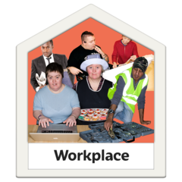

We know that people with intellectual disabilities find it difficult to get and keep jobs.

Attitudes towards disability make it hard for people to get jobs. We need attitudes to get better. There needs to be a public awareness campaign so that everyone can learn about disability
People with disabilities are not always included in education. More inclusive education will help people with intellectual disabilities to be included in the workplace. We also need to work on making Day Services better
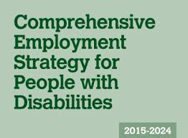
In Ireland the Government made the Comprehensive Employment Strategy 2015-2024 to make employment and work better for people with disabilities in Ireland. We need to continue work on this plan.

We know there are barriers to employment in Ireland- some of the barriers and solutions to them are below

Covid 19 has caused many people to lose their jobs. People with intellectual disabilities are called vulnerable, so many have had to stay at home.
The government need to make sure that people with intellectual disabilities get the vaccine soon so they can go back to work safely.

People with disabilities worry about losing their social welfare, disability allowance and other benefits if they work too much.
We need to make sure people are paid for the work they do but also have the support they need.

We need to keep spending money on projects that support employment like the Ability projects. These projects need to last for a long time so that lots of people get a chance to try them. We need to spend money on supported employment, job coaches and long term support.

We need to raise awareness for people with intellectual disabilities and with employers about schemes and supports available for employment.

We need training for employers in the private and public sector to encourage them to employ people with intellectual disabilities

We need to make accessible information for people with intellectual disabilities about all the supports around employment so they understand what support they can have.

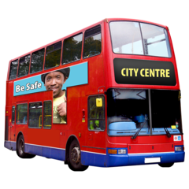

We need to make transport more accessible for people so they can get to work.

Introduction

Established in 1961, Inclusion Ireland is a national, rights based advocacy organisation that works to promote the rights of people with an intellectual disability.
The vision of Inclusion Ireland is that of people with an intellectual disability living and participating in the community with equal rights. Inclusion Ireland’s work is underpinned by the values of dignity, inclusion, social justice, democracy and autonomy and we use the United Nations Convention on the Rights of Persons with Disabilities (UNCRPD) to guide our work.
Inclusion Ireland Welcomes the opportunity to make this submission to the UNCRPD Committee on Article 27 Employment. There are many issues about employment that are very important to people with intellectual disabilities in Ireland

Statistics on Employment in Ireland

According to recent statistics 36% of people with disabilities of working age (age 20-64 years) are in employment, compared to 73% of the general population. Employment rates are lower among those with intellectual disabilities: 17% of those with an intellectual disability are in employment.
Statistics published in 2017 show us that less than 1% of people registered with the National Intellectual Disability database are in open employment. If those in supported employment or an enclave within open employment are included, the figure rises to 4%.

Attitudes towards people with intellectual disabilities
One important aspect to consider on this issue is that of attitudes towards people with disabilities in Irish society. The National Disability Authority (NDA) Public Attitudes to Disability Survey in 2017 has shown that while positive attitudes towards people with disabilities and mental health difficulties is improving, there is still cause for concern with the general public’s attitudes towards people with disabilities .
The survey shows that adults who have an intellectual or emotional disability are more likely to receive negative treatment in the workplace compared with people with physical disabilities.
Overall, only 18% of respondents believed that people with disabilities receive equal opportunities in terms of employment. This means that 82% of respondents said that they believe people with disabilities do not receive equal opportunity in the workplace.
When asked about their level of comfort working with people with disabilities, respondents reported highest comfort levels for working with people with physical disabilities (8.9 out of 10), and the lowest comfort levels for working with people with mental health difficulties (8.2 out of 10). Nevertheless, positive attitudes towards all, including people with mental health difficulties, have increased when compared to previous years. These findings are encouraging however if people cannot or do not work with people with disabilities because of low representation, good attitudes are wasted.
The Government should engage in a public awareness campaign on reducing the stigma around disability, with a particular focus on inclusion and opportunity in the workplace.

The importance of inclusive education
Separation is common in the Irish disability sector. People with intellectual disabilities have traditionally been segregated from their peers, starting at a young age in the education system, before this segregation manifests itself in other ways, such as in housing, employment or in health and social care services.

In Ireland, there are currently over 16,000 students educated in either a special class or a special school. There are 1,620 special classes in the country and 8,400 students educated in special schools throughout Ireland. The way in which children with additional needs are separated from their peers within the education system facilitates a culture where children with intellectual disabilities are treated as “others” by their peers, teachers, and by the system itself. This leads to further separation when people try to enter the world of work.

There is extensive research into the education of students with disability that has overwhelmingly established inclusive education as producing superior social and academic outcomes for all students and consistently found that academic and social outcomes for children in fully inclusive settings are without exception better than in the segregated or partially segregated environments.

To achieve inclusive education, the Government will need to invest heavily in teachers, teacher training, school buildings and allied health professionals over a sustained period. It will not be a quick fix but requires a multi-year implementation plan, fully financed with the appropriate legislative and policy backing. Inclusive education also needs to include good planning for the future.
In Ireland, there is no career guidance in special schools. There is an expectation that people with intellectual disabilities automatically transfer to Health Service Executive Day Services when they turn 18 years. A Government report on guidance by Indecon proposed a separate guidance system for children in special schools of an inferior level to their peers in mainstream schools. This needs to change so young people have guidance and support to move on from education to employment. The number of young people with disability failing to engage with further education and training or employment requires attention, and therefore addressing engagement before age 21 is important.
A policy of New Directions (2012) was published to change how Day services are provided. Progress is slow in this regard and we are now in a situation where there is lack of action in Day services and they are in need of urgent reform. New Directions needs to be fully implemented and further opportunities of exploring employment offered to as many individuals as possible. Many day service initiatives are targeted at young people so there is a significant cohort of people who miss opportunities because they are too old.

Key Policy in Employment in Ireland
Ireland has a commitment 3% of employees in the public service at the moment and has made a promise of 6% by 2024. Ireland has a Comprehensive Employment Strategy 2015-2024 to which aims to improve employment for people with disabilities in Ireland. There are 6 priority areas of the strategy. These are:
- building skills, capacity and independence;
- providing bridges and supports into work;
- making work pay;
- promoting job retention and re-entry into work;
- providing co-ordinated and seamless support;
- engaging employers.
Progress in these areas are happening, even if it is slow, it will make a difference.
One of the most prominent and significant barriers to employment in Ireland is an over reliance on benefits and the fear surrounding losing benefits if one goes to work.
In 2017 A Make Work Pay report set out the key things needed for people with disabilities to be in work and earn money but also have the supports they need. Now the situation around benefits, like disability allowance and working as well as having other benefits has improved. There is still more work to do. There needs to be awareness campaigns for people with intellectual disabilities to understand the supports and measures that are available. There will also be a need for initiatives to continue beyond 2024 so that people have continued opportunity into the future.

Other key Barriers to Employment
It is important to highlight that Covid-19 has had a huge impact on employment in Ireland. Like most of the world Ireland has been experiencing repeated lockdowns since March 2020. People with disabilities and especially those with an intellectual disability have been disproportionately affected by Covid -19 and the State’s response. This has caused many to lose their jobs, to be cocooning or shielding at home. This is a significant barrier to progressing employment initiatives, including supported employment, work experience, part time and full-time positions.
Ireland has a scheme called Employability which supports people with disabilities to enter the world of work. However, to avail of this service, a person must be ready for work. If a person is not “job ready” and they need a bit more support, they do not qualify for this scheme. This means a lot of people, especially people with intellectual disabilities are falling through the cracks.
People with disabilities are still exiting school earlier than their nondisabled counterparts.

Many employers have a particular view of what people with intellectual disabilities can do in employment. There are traditional jobs and tasks that people with disabilities are offered and supported in. There is a need for more awareness for employers about how a small amount of support can really help to support the potential of many people in employment.
A lack of access to transport causes people with intellectual disabilities to be unable to get to work. Rural Ireland suffers from a lack of transport infrastructure. Even in urban settings people can find it difficult to navigate and understand the system. Many people with disabilities have free travel but if they cannot access it, or understand it then schemes and benefits are no longer effective.

Good practice in employment
Ability projects
Ability at work is a rights based supported employment service for young people with disabilities funded by the Irish Government and the European Social Fund. There are 27 Ability Projects funded in Ireland from 2018-2021 Job coaches provide training, upskilling and on the job support to job seekers to help them enter the labour market and to stay there. Ability@Work at Cope Foundation in Cork was recognised as one on the UN Zero Projects in 2021. July 2021 the funding will come to an end. This needs to be extended, it is working well. The Ability projects have still continued throughout Covid 19 as far as possible. The projects are a good example of efforts to meet the priorities of the Comprehensive Employment Strategy.
Another example of good practice is from The Irish Association of Supported Employment (IASE). This organisation runs a Job Shadow Day each year when people with disabilities can join someone in their workday to learn about what they do. This encourages people to think about careers and also engages employers in a very meaningful way.

Ireland’s Census 2016
Ireland’s Health Research Board
NDA (2017). Public Attitudes to Disability Survey
Barr JJ, Bracchitta K (2015) Attitudes Toward Individuals with Disabilities: The Effects of Contact with Different Disability Types, Current Psychology, 34 (2), 223–238
NCSE (2019). Policy Advice on Special Schools and Classes. An Inclusive Education for An Inclusive Society?
http://allmeansall.org.au/research/

