General Comment on article 4.3 and 33.3 of the convention on the participation of persons with disabilities in the implementation and monitoring of the Convention - Hft response

Compiled by Billy Davis- Public Affairs & Policy Manager – May 2018

About Hft

Hft is a national charity that provides specialist care and support to over 2,500 adults with learning disabilities in order to live with as much independence, choice and control as possible.

We were founded in 1962 by a group of families who believed that, with the right support, their relatives were capable of more than society expected of them.
Today, we still share that same vision. We support people to live independently in their homes through our Supported Living services, alongside Residential Care, and Short Break services. We empower people to make their own choices, including finding a job, building friendships and relationships and taking part in activities.

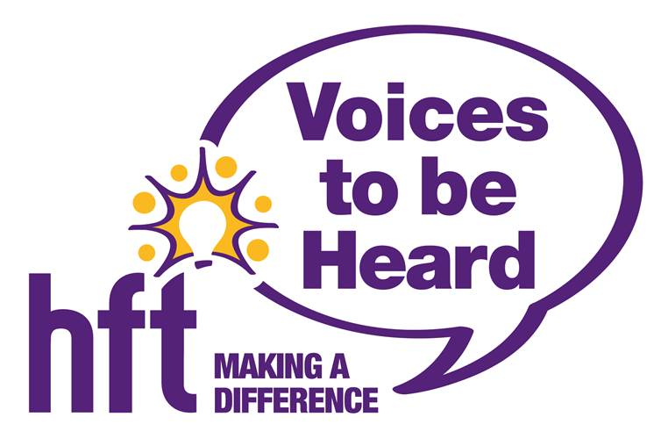
We operate in sites across England from Newcastle to Newquay.

About Voices to be Heard (VtbH)
True involvement means providing opportunities to recognise and grow people’s capabilities, and actively support them to put these skills to use in their lives.
That’s why Hft has developed ‘Voices to be Heard’; forums recognised and valued across the whole organisation. Our Voices to be Heard group was formed in 2014 when the Speak Out groups from both the heritage Self Unlimited and Hft parts of our organisation came together. The group advises Hft on what needs to be changed and has worked on specific projects requested by the management team, aiding the development of Hft.
Every Hft region has at least one Voices to be Heard group and each of these elect representatives to attend Divisional meetings. One representative from each Divisional meeting is then also nominated to attend the National meetings and in

this way everyone supported by Hft has a voice which is heard by the Operations Directors when they meet twice a year. Through “Voices To Be Heard @ Council”, a branch of Hft’s Board of Trustees, the voice of the people we support helps shape Hft’s strategic direction and ensure that the voice of adults with learning disabilities is heard in Hft’s external public affairs and advocacy activities.
About the Fusion Model of Support

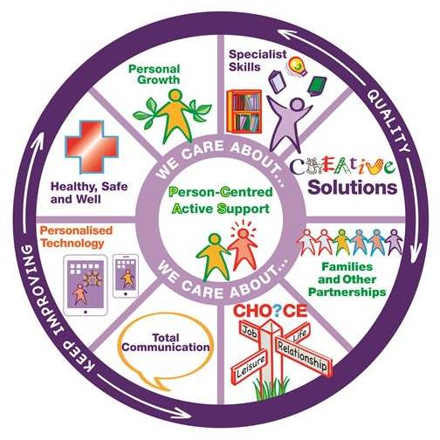
Hft’s Fusion Model of Support is a different way of supporting someone with a learning disability. The model puts the emphasis on how we provide support, not what support we provide. It contains all of our strengths and all of the elements that we believe are essential to providing high quality, person-centered services. When all of these elements come together, a ‘fusion’ is created – this is when Hft is working at its best.
At the centre of our model, and because they are at the centre of everything we do, are the people we support. Surrounding them are eight segments that reflect all of the specialist skills that we believe are necessary to provide excellent support. These segments also include some of the ethical and moral considerations we take into account when providing services.
Surrounding these segments are three supporting themes: ‘care about’ runs through everything we do, ensuring we provide ‘quality’ services that are ‘continually improving’.
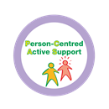
- Person-Centred Active Support (PCAS)
PCAS is a way of supporting people so that they are engaged in meaningful activity and relationships as active participants, exercising more control over their lives and experiencing greater levels of inclusion, independence and choice.
- Specialist Skills
Specialist Skills means using proven expert knowledge and best practice to support people.
This includes providing support with physical, mental, emotional and social needs and also meeting syndrome and time of life specific needs.

- Creative Solutions
Creative Solutions means thinking openly and using imaginative and original ideas to find practical solutions to enhance the lives of the people we support.

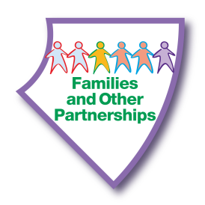
- Families and Other Partnerships
This means helping the people we support to develop and maintain positive relationships with families, friends and other partners involved in their lives.
It means having the skills and understanding of how important it is to work in partnership with the people we support and those involved in their lives. This includes welcoming and valuing what families contribute to giving the best support.

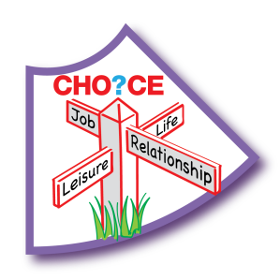
- Choice
Choice means enabling the people we support to have a greater awareness of the range of options available to them, so they can make the choice or decision that is uniquely right for them. This means people are more empowered to make informed decisions, even if these decisions may be considered ‘unwise’ by others.
- Total Communication
Total Communication means that all forms of verbal and non-verbal communication are thoroughly explored and embraced for each individual. This includes all body language, facial expressions, gestures, signing, verbalisation, intonation, photographs, drawings and symbols, written words, objects of reference and access to appropriate technology.

- Personalised Technology
Personalised technology means any technology which enhances the lives of the people we support. This includes specialist technology such as telecare, environmental controls and prompting devices, as well as

mainstream technology such as quick cooling hobs and mobile phone technology.

- Healthy, Safe and Well
Healthy, Safe and Well involves all aspects of a person’s life including their physical, mental, emotional, social, cultural and spiritual needs. It is a positive concept and means we will proactively work with each individual to find out what this means for them so we can help them to live more fulfilled lives.
This also means that, when necessary, we will support them to take risks to get the lifestyle they want, while also safeguarding them from harm.

- Personal Growth
Personal growth means the people we support will be helped to take control of their lives so they can continue to develop as individuals. This includes embracing new skills and knowledge, widening interests and having new experiences. Everyone we support will have the confidence to express their thoughts and ideas, increasing their self-esteem

Executive Summary

1. As an organisation which both gave evidence, and supported individuals to attend the CRPD inquiry into the Government of the United Kingdom in Geneva, Hft welcomes the provisions laid out in article 4.3 and 33.3 on the participation of persons with disabilities in the implementation and monitoring of the Convention. The CRPD was a landmark in international disability rights, and it is absolutely right and proper that disabled people are at the forefront of ensuring the rights of the Convention are enjoyed across Member States and that they are provided a special place within the convention, as part of a commitment to the Human Rights Model of Disability.

2. However, Hft has concerns that the definitions outlined in the General Comment are too restrictive, and could potentially exclude so-called “speak out” groups, such as Hft’s “Voices to be Heard” group from the category of “self-advocates” and instead categorise them under “organisations for disabled people”. We believe that do to so would be erroneous and underestimate the genuine impact such groups can have both internally and externally of the organisations that support them.

3. With domestic legislation in the United Kingdom increasingly calling for the inclusion of service users within the decision-making process of the organisations that support them, Hft believes that the Convention, and by extension the Committee, should be supporting these fledgling speak out groups on their path to becoming self-advocates.

II. Normative content of articles 4.3 and 33.3; 1. Definition of ‘representative organisations’

4. The CRPD is widely regarded “not only the exemplar, but the most advanced human rights treaty” in terms of disability rights and, in particular, its “groundbreaking provision” of explicitly including disabled people in the monitoring and implementation of the articles of the Convention.

5. In August 2017, Hft was delighted to be able to assist two of the individuals that we support to attend a meeting of the Committee of the Rights of Persons with Disabilities to discuss the Government of the United Kingdom’s implementation of the CRPD, where they were able to give evidence, based on their lived experience,

of the impact of government austerity policy on their ability to enjoy their rights under Article 19 of the CRPD.

6. For this reason, Hft is concerned about the descriptions of organisations as provided in the General Comment. Paragraph 14d identifies self-advocates as organisations “comprised of and represent[ing] persons with intellectual disabilities, autistic persons or persons with psychosocial disabiltiies” and notes that while “appropriate, sometimes extensive support” may be needed, it is “important to ensure that persons with disabilities are and remain in full control”.

7. By contrast, Paragraph 15 differentiates between DPOs and so-called “organisations for persons with disabilities” which provide Paragraph 16 confirms “neither CSOs nor NGOs should be considered to be DPOs/OPDs”. While it is proper that the voices of disabled people, and the organisations who represent them, the prescriptive nature of these groups means that it fails to take into account the emergence of speak out groups amongst the learning disability sector.

8. User involvement in a social care context in England began in earnest with the Children Act (1989) and the National Health Service and Community Care Act (1990), which established in law a right to comment, complain and have a say in the management or running of services. In more recent times, CQC, the regulator of social care has devloped a rights-based approach to social care and, upon its foundation in 2010 stated its first prioirty as “ensuring care is centred on people’s needs and protects their rights”. In August 2017, CQC also published updated guidance on its human rights approach to regulating social care.

9. A significant part of this has been placing user involvement at the heart of service improvement. Recent guidance from CQC says that providers “must actively seek the views of people who use the service”. Those seeking an “outstanding” rating must also be commited to “find innovative and creative ways to enable people to be empowered and voice their opinions. They and staff are actively encouraged to discuss any concerns. There are high levels of open engagement when they do”. Updated NICE guidelines also call for those with learning disabilities to have a greater say in the services provided to them.

10. Such a change has been a paradigm shift for the learning disability sector, with even a leading organisation like Mencap stating it found the rise of self-advocacy within its services to be a “challenge”. Previously, providers had relied on advocacy groups controlled by parents or professionals. At Hft, this was historically run through our “Friends of Hft” groups, or our Family Carer Support Service, which was founded in 1989, and still exists today, although its focus is much more on supporting Carers to exercise their rights and provide information on employment, welfare and other such matters.

11. Although speak out groups had existed in Hft services for several years, in 2010 Hft founded its National Speak Out Group, where representatives from the services met nationally to discuss issues of common interests, and make recommendations on what Hft could do better. Following a series of mergers, in 2013 this became rebranded as “Voices to be Heard” (V2BH). Since 2014, “Voices to be Heard @ Council” has been a formal part of our Executive structure, as part of our Council of Trustees. Here, the people we support have a direct say in steering the organisational direction of the charity, as well as having a meaningful platform to engage on external issues as the national and local level.

12. Although Hft believes it is rather ahead of the curve in including the people we support at an Executive level, the emergence of speak out groups within services and organisations is becoming increasingly commonplace. However, we do not believe that this occurrence has been accounted for in the current descriptions of organisations as currently provided in the General Comment.

13. While speak out groups such as V2BH form part of Hft’s governance, members are independent from the guidance of Hft, and can, for example, be criticial of the support Hft provides or its way of working. Far from being tokenistic, V2BH has helped implement real change, such as taking the lead in revising our staff smoking policies. Members have also actively participated in Hft campaigns such as It Doesn’t Add Up and presenting evidence at the United Nations. However, as V2BH is a formal part of the charity structure, they would receive more support than,

say, an entity like People First. Furthermore, charities are ultimately run by the Executive Board and the CEO, meaning that V2BH would currently qualify as an “Organisation for Disabled People”, despite V2BH being an autonomous advocacy group, separate from Hft’s own public affairs and policy function.

14. While Hft recognises that, historically, disabled voices have been either dismissed or appropriated by “those of representatives of ‘organisations for persons with disabilities’ and other groups of ‘experts on disabilities”, we do not share the dismissive tone of such organisations raised in the text [Paragraph 6]. Indeed, such organisations should never be paternalistic in their support; rather their evidence and knowledge should be supportive and supplementary to the evidence being provided by the persons with disabilities. For example, when Hft submitted evidence to the Committee, the lived experience of the people we support was at the forefront of this, with our provider knowledge providing a sector and policy context to the concerns raised.

15. This is particularly important when charities are finding it increasingly restrictive to engage in advocacy in England. In the area of social care, providers in the sector are especially dependent on government money. The social care market has been described as “the classic definition of a monopsony – a market with one buyer and many sellers”. With local authorities being the major commissioner of social care (whilst there are some individual funders, this pales into insignificance compared to local authorities). Charities are unduly affected, with 18% of registered charities in England listing “social services” as their primary activities, more than any other activity. As local authority expenditure on social care has decreased, the sector has found itself in a funding crisis. This has led to concerns of charity’s altering their charitable missions to fit criteria for funding, or the impartiality of research and advocacy from organisations which receive monies from government bodies.

16. The Lobbying Act, which places restrictions about what NGOs can say up to a year before a general election, is having a “chilling effect” on many charity’s advocacy activities, and led many to inadvertently fall foul of the legislation when it was

backdated after the call of an unexpected Snap Election in 2017. More recently, it was revealed that charities selected to help deliver the government’s Work and Health Programme had signed contracts with clauses that meant they were required to “pay the utmost regard to the standing and reputation” of the Department of Work and Pensions and the Work and Pensions Secretary, Esther McVey. For many, the clause preventing criticism of McVey was seen as particularly worrying, as the Minister’s previous voting record on welfare has been widely regarded as problematic.

17. With such restrictions being placed upon charities to advocate, it is more important than ever that the right support is given to speak out groups within charities as they embark on their journey to self-advocacy. We would therefore call on the Committee to make provisions for such organisations within their definitions, and implore State Parties and other organisations to cultivate and nurture such bodies to ensure they move from tokenistic consultation to true, independent self-advocacy.

C. Article 33.3: The involvement of Civil Society

18. The involvement of civil society groups in helping to monitor and implements the articles of the CRPD at the national level is something that has been widely documented and should be warmly welcomed by all stakeholders.

19. In Paragraph 28 of the General Comment, the Committee reminds State Parties that they are obliged to “support and fund the strengthening of capacity building within civil society to ensure that DPOs/OPDs cam effectively participate in the process of implementing and monitoring….and ensuring that….accessibility requirements for various disabilities are taken into account”. Hft believes that, in the spirit of the CRPD, and the letter of Article 33, such funding should be made available to fledgling groups, such as Speak Out Groups within social care settings, along with established DPOs. By nurturing these emerging groups, the diversity of

voices heard in the monitoring and implementation of the Convention will be increased, and a wider range of sectoral representation will be included in the process.

IV. Relationship with other provisions in the Convention

20. In Paragraph 51 of the General Comment, the Committee notes that Article 3 of the Convention includes provisions for the “full and effective participation and inclusion in society” of people with disabilities, and the Committee asserts that this “means the participation of persons with disabilities, through their DPOs/OPDs, cuts across the entire text and applies to the whole Convention”.

21. As stated in our previous responses, we believe that, by categorising Speak Out Groups as “organisations for disabled people”, the Committee is inadvertently preventing those with learning disabilities from participating in monitoring and implementing the Articles of the CRPD in an established forum within an organisation and support network that they are already familiar with.

22. We believe that a more inclusive definition, reflecting changes in UK legislation, will allow Speak Out Groups to play a greater role in the monitoring and implementing of the conversation, similar to fully-formed Self Advocacy Groups and other DPOs.

“Hft pair give evidence at UN on disability rights”, Hft, URL: https://www.hft.org.uk/blog/hft-pair-give-evidence-un-disability-rights/
Lewis Clarke, “Henry speaks out on austerity at UN”, Tiverton Post, 29 August 2017, p.9
Matt Bass, “Woman with learning disabilities speaks at UN committee meeting”, Stroud News & Journal, 30 August 2017, p.17
Stephen Meyers, NGO-ization and Human Rights law: The CRPD’s Civil Society Mandate, Laws (2016), 5, 21, p. 2
Ibid.
Peter Beresford, “Service user involvement n social work and beyond; exploring its origins and destinations”, p.13
Tony Prosser, The Regulatory Enterprise: Government, Regulation and Legitimacy, Oxford University Press: Oxford (2010), p. 129.
“Our human rights-based approach to social care”, CQC, URL: http://www.cqc.org.uk/guidance-providers/all-services/our-human-rights-approach
Reg 17: Good Governance -HSCA 2008 (Regulated activities) Regulations 2014 (Part 3), paragraph 17(2)a.
“Key lines of enquiry, prompts and ratings characteristics – adult social care services”, CQC, P.59
“Learning Disabilities and Behaviour That Challenges: Service design and delivery”, NICE guideline NG93, March 2018, paragraph 1.2.2
Barry Gray and Robin Jackson, Advocacy and Learning Disability, Jessica Kingsley Publishers: London (2002), p.11
Gabor Petri, Julie Beadle-Brown and Jill Bradshaw, “More honoured in the Breach than in the Observance” – Self- advocacy and Human Rights”, Laws, 2017, 6, 26, p. 3
Bill Peck, A History of the Home Farm Trust 1962-2008, Home Farm Trust Limited: Bristol (2008), pp. 87-114
Ibid, pp. 115-118
“Family Carer Support Service”, Hft, URL: https://www.hft.org.uk/our-services/family-carer-support-service/
Welcome to the National Speakout Group [DVD], Hft: Bristol, 2010
“Involvement at Hft”, Hft, URL: https://www.hft.org.uk/our-services/empowering-individuals/involvement-at-hft/
“Petition to protect vulnerable lives presented to government”, Charity Today, 7 December 2016, URL: https://www.charitytoday.co.uk/petition-protect-vulnerable-lives-presented-government/
“Hft pair give evidence at UN on disability rights”, Hft, URL: https://www.hft.org.uk/blog/hft-pair-give-evidence-un-disability-rights/
Ingrid Koehler, Paying For It: The human cost of cut-price care, LGiU, p.4
House of Lords Select Committee on Charities, “Stronger Charities For A Stronger Society”, HL Paper 133, March 2017, p.7
Celine Chew and Stephen P Osborne, “Strategic Positioning in UK Charities that provide public services: Implications of a New Integrating Model”, Public Money & Management, October 2008, p. 286
Sarah M Lyness and Jim McCambridge, “The alcohol industry, charities and policy influence in the UK”, European Journal of Public Health, Vol 24, No.4, 2014, pp. 557, 559, 560.
Fiona Harvey & Anushka Asthana, “’Chilling’ Lobbying Act is stifling democracy, charities tell party chiefs”, The Guardian, 6 June 2017, URL: https://www.theguardian.com/politics/2017/jun/06/chilling-lobbying-act-stifles-democracy-write-charities-party-chiefs
Matthew Taylor and Sandra Laville, “Charities may face criminal sactions after ‘gagging law’ backdated before election”, The Guardian, 21 May 2017, URL: https://www.theguardian.com/environment/2017/may/21/charities-may-face-criminal-sanctions-as-gagging-law-backdated-before-election
John Pring, “Charities delivering DWP’s work programme ‘must promise not to attack McVey’”, Disability News Service, 19 April 2018, URL: https://www.disabilitynewsservice.com/charities-delivering-dwps-work-programme-must-promise-not-to-attack-mcvey/
Steven Hopkins, “9 reasons campaigners are concerned at Esther Mcvey’s return to the DWP”, Huffington Post UK, 9 January 2018, URL: https://www.huffingtonpost.co.uk/entry/esther-mcvey_uk_5a5495b3e4b01e1a4b19269d
Esther McVey’s voting record on welfare and benefits, TheyWorkForYou, URL: https://www.theyworkforyou.com/mp/24882/esther_mcvey/tatton/votes#welfare
Arlene S. Kanter, The Development of Disability Rights under International Law: From Charity to Human Rights, Routledge: Oxon (2015), pp. 5, 44, 50, 86, 88, 91, 204

