Check against delivery

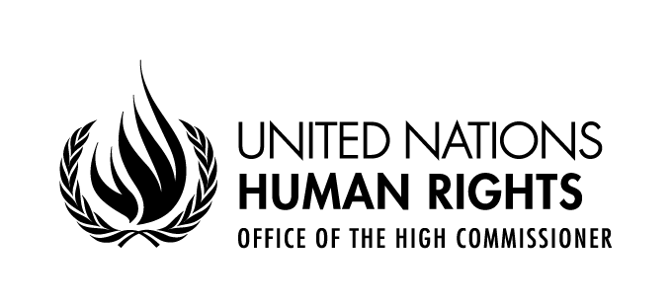

Committee on the Rights of Persons with Disabilities
18th session
14 August – 31 August 2017

Day of General Discussion on Equality and Non-Discrimination

Opening address by

Gianni Magazzeni, Officer-in-Charge

Human Rights Council and Treaty Mechanisms Division

25 August 2017
Madam Chair,
Distinguished members,
Ladies and Gentlemen,

I am pleased to extend a warm welcome on behalf of the Office of the High Commissioner for Human Rights to today’s General Discussion of the Committee on the Rights of Persons with Disabilities on equality and non-discrimination. I thank you for your presence and look forward to a fruitful assessment of the progress made regarding implementation of the Convention on the Rights of Persons with Disabilities. We hope this event shall provide further clarity to ensure the compliance of domestic laws and practices with requirements under the Convention, particularly with regard to its article 5.
Indeed, equality and non-discrimination are at the core of international human rights law. Freedom from any form of discrimination is a fundamental human rights principle upheld in the International Bill of Rights. Article 5 of the Convention on the Rights of Persons with Disabilities on ensuring equality and non-discrimination in the enjoyment of rights did not create new rights. The principles of equality and non-discrimination are included in all the core United Nations human rights treaties.
All persons, without distinction, are entitled to enjoy all human rights, including being equal before and under the law and the right to equal and effective legal protection against discrimination on all grounds, including disability. The high number of countries that have ratified the Convention on the Rights of Persons with Disabilities provides testimony to the international community consent to this basic premise.
In spite of this, however, persons with disabilities continue to face disproportionately high levels of discrimination in the civil, cultural, economic, political, and social fields of life, including access to birth registration, education, employment, access to justice, and access to services on an equal basis with others. Our communities are, to different extents, inaccessible both indoors and outdoors, and the constant obstacles in physical environments, transportation, communications and information, continue to make it difficult, or at times impossible, for persons with disabilities to carry out basic daily activities such as leaving their homes, moving around freely, obtaining an education, seeking employment, or receiving information about public services. Furthermore, the attitudinal barriers leading to discrimination and social stigma against persons with disabilities including by family, caretakers, civil servants, and the community at large, hinder the full and effective participation in society of persons with disabilities, particularly women and girls with psychosocial and intellectual disabilities. Indeed, much work remains to be done to meet the goal of ensuring equality for all, particularly regarding the consistent implementation of the Convention.

Madam Chair,
Distinguished members,
Ladies and gentlemen,
From its very beginning, as stated in its Charter, the United Nations determined as one of its aims “to reaffirm faith in fundamental human rights, in the dignity and worth of the human person”. As reiterated in the 2017 position paper by the United Nations System Chief Executives Board for Coordination entitled “Leaving No One Behind: Equality and Non-Discrimination at the Heart of Sustainable Development”, the United Nations system has a standing legal mandate and a central duty to promote the respect for human rights. In turn, our Office, as the lead United Nations entity for human rights, has a long history and extensive experience in the anti-discrimination field. Enhancing equality and countering discrimination is at the core of our priorities. The Office gives precedence to achieving increased compliance of national laws, policies and institutions with international human rights standards and to enhancing equality and countering discrimination, including discrimination based on disability. Within this broad framework, the Office, with its comprehensive mandate to promote and protect human rights, works with States, legislatures, courts, national institutions, civil society, regional and international organizations and the United Nations system, to advocate for and build capacity to protect the human rights of persons with disabilities. We equally do so in the context of the 2030 Agenda and the Sustainable Development Goals, to support their implementation by Member States in order to transform existing social structures that perpetuate discrimination and inequality, including against persons with disabilities.
I would now like to share with you some initiatives of the Office of the High Commissioner for Human Rights relevant to today’s General Discussion. One is the annual study on the rights of persons with disabilities on equality and-non-discrimination further to article 5 of the Convention, published in December 2016, at the request of the Human Rights Council in its resolution 31/6. In consultation with over 70 States and other relevant stakeholders including national human rights institutions and representative organizations of persons with disabilities, this report notes good practices in the implementation of the Convention on the Rights of Persons with Disabilities, including regarding the implementation of article 5. Nevertheless, among the findings of the report, there is also the continuing systematic exclusion in laws and policies against persons with disabilities. I hope this Committee will consider this report and the written submissions received in response to the Office’s consultation to be useful tools for its work towards drafting a related general comment.
Another initiative is the joint EU-OHCHR project entitled “Bridging the Gap” on the development of indicators for the Sustainable Development Goals based on the CRPD Convention. At the heart of the whole 2030 Agenda is a commitment to achieve “universal respect…for equality and non-discrimination”. As part of our work to ensure that strategies and policies to implement the 2030 Agenda for Sustainable Development are human rights-based, this project aims to provide tools and guidance to accomplish two main objectives. The first is to seek to strengthen the implementation and monitoring of the CRPD through the elaboration of human rights indicators and guidance on data sources. The second is to support implementation of the Sustainable Development Goals guided by the CRPD Convention. In general, public policies worldwide insufficiently address the rights of persons with disabilities for a number of reasons, including the lack of disaggregated data, a lack of consultations with representative organizations of persons with disabilities, and the absence of policymaking that explicitly promotes their rights and inclusion. The Convention can guide the implementation of the Sustainable Development Goals and action towards the Goals, in turn, can substantially contribute to realizing the rights of persons with disabilities. Only through concrete tools such as human rights indicators and human rights-based approaches to disaggregated data and statistics on the most disadvantaged groups and those groups affected by discrimination, including persons with disabilities, can efforts to ‘leave no one behind’, be truly successful.
Through these and other initiatives, the Office of the High Commissioner for Human Rights is committed to making international human rights laws and standards a reality. The Office will continue to raise awareness, understanding and recognition of disability as a human rights issue, and to promote coordination and partnerships within and outside the United Nations system to expedite the removal of obstacles and support appropriate enabling environments for guaranteeing equality and non-discrimination of persons with disabilities in society.
Finally, let me emphasize the fact that the just started third cycle of the UPR offers another opportunity to ensure follow up action at country level with respect to recommendations received by Member States from all HR mechanisms, including the CRPD. As the Secretary-General states in his recent Report to the General Assembly on the Work of the Organization:
“The Human Rights Council’s universal periodic review process is now entering a new cycle, with every Member State scheduled for a third round of scrutiny. We will work to strengthen the relevance, precision and impact of the Council’s recommendations, including by providing better support to Member States in implementation, stronger collaboration with United Nations country teams and the establishment of national mechanisms for human rights reporting and follow-up to link the universal periodic review to the implementation of the Sustainable Development Goals...."
I wish you, on behalf of the Office of the High Commissioner for Human Rights, a rich and thought-provoking discussion.

Thank you.

___________

