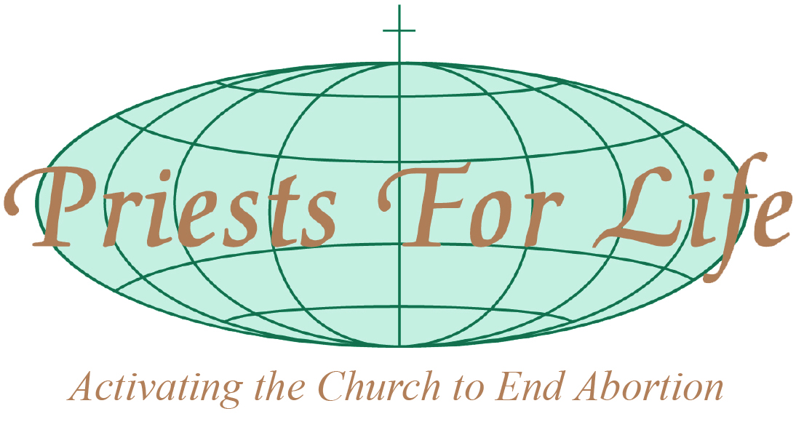

Committee on the Rights of Persons with Disabilities
Draft General Comment on the right of persons with disabilities to equality and non-discrimination (article 5)
Submitted by Priests for Life (PFL), a non-governmental organization in special consultative status with the Economic and Social Council

Priests for Life works to ensure that human dignity and the fundamental right to life for all is respected during all stages of life from conception to natural death, without exception, and is applied equally without discrimination including during the prenatal and neonatal periods. Priests for Life welcomes the opportunity to submit its observations on the draft General Comment on Equality and Non-discrimination (Article 5).

Prenatal screenings for impairment
Priests for Life concurs with the Committee on the Rights of Persons with Disabilities (the Committee) when it states in the introduction to General Comment (GC) that it “notes with concern” the remaining challenge “regarding the persistence of disability-based discrimination” by Member states that have ratified the Convention. Priests for Life observes that such discrimination is evident in State-sponsored maternal health programs that emphasize prenatal screenings for impairment followed by abortion when there is possibility of disability, especially when Down syndrome is suspected.

The failure of Member states to embrace unborn children with disabilities and to offer special assistance to their mothers and fathers rather than elimination of the child is incompatible with the Convention. The continued casting by governments of preborn children who are impaired as burdens to families and society jeopardizes efforts to overcome the prejudice, stigma and negative stereotypes against persons with disabilities.

Priests for Life observes that when States applaud the fact that in their countries there are nearly zero births of infants with Down syndrome they are reinforcing a fatal discrimination that selectively ends the lives of children with trisomy 21 and perpetuates negative stigma against an entire group of people.

The increased use of technology for prenatal searches to identity the possibility of impairment followed by destruction of the supposedly afflicted child reveal a discrimination that affords the right to life only to those children deemed perfect and bolsters the idea that individuals with an impairment are ‘unworthy of life’.

Priests for Life recommends that the Committee address this specific discrimination in the GC.

PFL believes that such reckless disregard for the lives of society’s weakest members subjectively denies a human being her or his right to life and perpetuates the perception that life is only for the perfect and that society is intolerant of those with an impairment regardless of their age, condition of dependency or disability.

Prenatal sex selection
Prenatal discrimination that results in denial of the right to life also manifests in sex determination that leads to fatal discrimination against girls. The girl-child in utero faces deadly discrimination when sex determination techniques identify her presence and result in her death. The Beijing Platform of Action opposed this discriminatory practice in paragraph 38 stating “Discrimination against women begins at the earliest stages of life and must therefore be addressed from then onwards.” However, fatal sex selection practices are remain rampant in select countries and cultures.

The Platform also recognized that son preference not only discriminates against girls and limits access to food, education and health care but to “even life itself”. While efforts to ensure girls’ access to food, education and health care have benefitted by nearly universal agreement since Beijing, endeavours to ensure that girls have universal access to “life itself” have been stymied by a global failure to embrace consistent non-discriminatory protection of girls beginning “at the earliest stages of life”.

Failure to protect girls in law from prenatal sex selection as recommended to governments in paragraph 283d of the Platform—“Enact and enforce legislation protecting girls from all forms of violence, including female infanticide and prenatal sex selection”—begins the discrimination and disempowerment which perpetuates throughout the life cycle and renders the worth of a girl contingent upon subjective views of wantedness and utility. The girl child becomes a commodity, devoid of innate dignity and value, subjected to deadly discrimination.

In General Comment No.7, the Committee on the Convention on the Rights of the Child identified selective abortion as discrimination against girls stating, “Discrimination against girl children is a serious violation of rights, affecting their survival and all areas of their young lives as well as restricting their capacity to contribute positively to society. They may be victims of selective abortion...”

Priests for Life urges reference to this discrimination in the GC.

Neonatal discrimination
“Equal and effective legal protection against discrimination” as stated in the GC is critical to ensure that impaired newborns do not become the victims of infanticide or abandonment but are afforded the same medical care as non-impaired newborns as well as given critical life-saving treatments when needed. Protocols that seek to impose euthanasia on impaired newborns are in conflict with the Convention as they abandon the needs of the infant while pursuing the discriminatory taking of a human life based on physical affliction.

We believe that euthanasia of newborns needs to be strongly opposed by the Committee in the GC to ensure that all acts of discrimination against children with disabilities are addressed.

Prenatal Protection
Priests for Life notes that the Preamble of the Convention on the Rights of the Child (CRC) reminds us that “the child, by reason of his physical and mental immaturity, needs special safeguards and care, including appropriate legal protection, before as well as after birth"; a majority of Member states restrict access to abortion.

We note that Article 2 of the CRC instructs State Parties to “respect and ensure the rights set forth in the present Convention to each child within their jurisdiction without discrimination of any kind, irrespective of the child's or his or her parent's or legal guardian's race, colour, sex, language, religion, political or other opinion, national, ethnic or social origin, property, disability, birth or other status.”

Priests for Life believes that the act of abortion is by its very nature an act of fatal discrimination that denies a child in the womb his or her right to life. The rights of each child should be respected regardless of the subjective views of his or her mother or father, social and economic condition, sex, or the presence or suspicion of a disability.

Subjective discrimination for any reason negatively impacts respect for the right to life and renders the human dignity and worth of a human being contingent upon the opinion of others.

Equal worth and dignity
The Committee states in #7 of the GC that “the term ‘dignity’ appears in the CRPD more often than in any other human rights convention of the United Nations, starting in the preamble where the principles proclaimed in the Charter of the United Nations are recalled, which “recognize the inherent dignity and worth and the equal and inalienable rights of all members of the human family as the foundation of freedom, justice and peace in the world”.

Priests for Life wishes to highlight that fact that the inherent dignity and worth of all members of the human family was ‘recognized’ in the Charter of the United Nations, an acknowledgement that international bodies and governments neither bestow nor remove human dignity but can only recognize inherent God-given human dignity and inherent rights.

Governments exist to preserve and protect inherent rights beginning with the right to life, beginning when life begins—at conception—and ending at natural death, and extending to all human beings.

Laws to remove the most basic right—the right to life—to allow abortion, including in the case of suspected physical impairment, and to allow infanticide of impaired newborns discriminate against members of the human family.

Measures to stop discrimination

Families of children living with impairment, and the children themselves, are the best advocates and defenders of all individuals living with disability. Priests for Life recommends the Committee listens to their voices and learns about the laws that they have helped to enact to help stop discrimination against children with disabilities. One example is 14 year old Chloe Kondrich from the U.S. state of Pennsylvania who has Down syndrome and who successfully lobbied for the Down Syndrome Prenatal Education Act, also known as Chloe’s Law. The law is designed to help parents learn about the facts about children with Down syndrome in order to overcome the stigma, fear and ignorance that surrounds a diagnosis of trisomy 21. Next on Chloe’s list is helping lawmakers in Pennsylvania pass legislation “Celebrating People with Down Syndrome & Denouncing Selective Abortion

Conclusion
Priests for Life believes that true equality and non-discrimination require ensuring that no human being, from conception to natural death, is denied their right to life. This includes unborn children who, as the youngest and most vulnerable members of the human family, are the most at risk group in the world today while preborn children with impairment are in particular danger from a discrimination that seeks their elimination through abortion.

Priests for Life urges the Committee to recommend Member states embrace the lives of all children, regardless of sex, age, stage of development, condition of dependency or disability. Such action is needed if the vision of the 2030 Agenda to “leave no one behind” is to be achieved.

