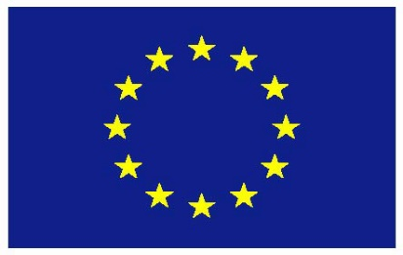

UNITED NATIONS
HUMAN RIGHTS COUNCIL
Intersessional meeting on human rights and the 2030 Agenda
Building Back Better: Integrating Human Rights in Sustainable and Resilient Recovery from the COVID-19 pandemic

14th of January
EU Statement
Thank you Mr. Chair,
The COVID pandemic has proven to be a real test for our societies. As stated by the UN Secretary General “The pandemic is more than a health crisis. It is fundamentally a human crisis that has laid bare severe and systemic inequalities”.
The Human Rights Council has time and again underscored the importance of adopting a human rights-based and gender responsive approach to the implementation of the 2030 Agenda. In assessing synergies between human rights and sustainable development it is important to recognize the interdependence and interrelatedness of human rights. COVID-19 illustrated this very clearly: ensuring the right to life and highest attainable standard of physical and mental health calls for investments in safe drinking water and sanitation, adequate housing, social protection, food safety and a healthy environment. Civil and political rights continue to be equally important in times of crisis - any restrictions to the enjoyment of human rights must be necessary, proportionate, temporary, non-discriminatory and in full compliance with the State’s obligations under applicable human rights law. The EU stresses that a holistic human rights and gender responsive approach is a prerequisite for building back better in the aftermath of the pandemic. The Treaty Bodies, Special Procedures and the OHCHR have provided us with clear recommendations and check-lists in this regard.
One thing is clear, there is no place for discrimination of any kind in the response to COVID-19 or in the implementation of the SDGs. To make headway on inclusive and fair development we need informed decision-making based on disaggregated data as appropriate and participatory processes that highlight the needs and risks faced by those that are marginalized. The role of civil society and human rights defenders is more important than ever to help us recover better and faster after the pandemic.
Excellency,
While the pandemic is a challenge for the implementation of the SDGs, it also provides us with tremendous opportunities in ensuring that the voice, rights and agency of people are at the centre of our national and collective efforts. The EU supports the UN Secretary-General’s Call to Action on Human Rights as well as his leadership in placing human rights at the core of the response to the pandemic. We underscore that a transformative recovery process aimed at achieving fairer, greener, more resilient and inclusive societies will require investing in human rights, democracy, enabling civic space and the rule of law. The EU undertakes to ensure that our response promotes the human rights of all without discrimination of any kind. No one should be left behind, no human right ignored.
Thank you.

