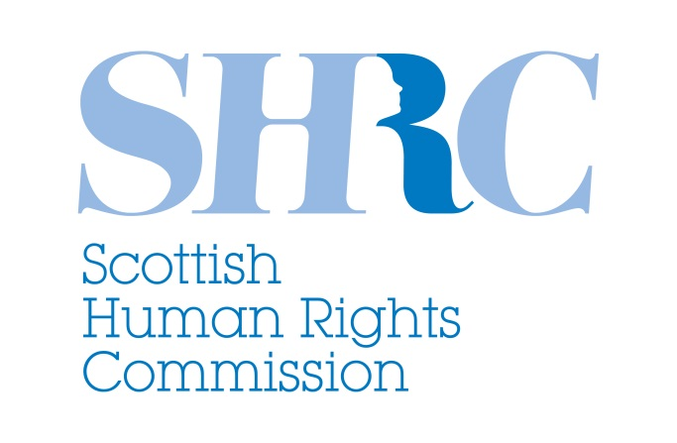

QUESTIONNAIRE RESPONSE:
THE CONTRIBUTION OF DEVELOPMENT
TO THE ENJOYMENT OF ALL HUMAN RIGHTS

Questionnaire for National human rights institutions
November 2017

The Scottish Human Rights Commission was established by The Scottish Commission for Human Rights Act 2006, and formed in 2008. The Commission is the national human rights institution for Scotland and is independent of the Scottish Government and Parliament in the exercise of its functions. The Commission has a general duty to promote human rights and a series of specific powers to protect human rights for everyone in Scotland.

QUESTION 1
Please provide examples of best practices such as policies, action plans and any other measures undertaken by your organization and/or entity in support of the national sustainable development agendas that promote and realize all human rights including the right to development for all?

Since 2015 The Scottish Human Rights Commission (the Commission) has been actively engaged with the Post 2015-Sustainable Development Goals, with a particular focus on the human rights relevance and linkages between the two frameworks. The Commission was keen to ensure that the SDGs were reflected within the measurement framework for Scotland’s First National Action Plan for Human Rights (SNAP), and the timescale (2013 to 2030) and content of SNAP’s long term 2030 Outcomes were consciously influenced by the SDG Agenda.

One of SNAP’s medium term outcomes is to embed human rights within national measurement frameworks. Following the Scottish Government’s commitment to the SDG Agenda, the Commission, therefore, began work to support the Government, both to embed human rights and reflect their SDG obligations within their own National Performance Framework (a framework with targets, outcomes and indicators that measure national progress across a wide range of areas). This work is on-going in the form of a small working group lead by the Commission and involving the Scottish Government leads for the SDGs, National Performance Framework and Human Rights. The work was also brought within the Scottish Government’s Open Government Partnership Action Plan (Action 2).

As part of this work the Commission undertook a review of the indicators and data currently used to measure progress in Scotland and compared this the SDG Global indicator set in order to identify the gaps between the two measurement frameworks. The Commission continues to work with the government in developing their new indicator set (due April 2018) as well as encouraging those responsible for data creation and/or collection to improve the availability of disaggregated data.

The Outcomes-based approach adopted by the National Performance Framework has now been embedded within legislation via the Community Empowerment (Scotland) Act, and must be reviewed at least once every five years. The Commission will, therefore, continue to work with the Scottish Government during each cycle of the NFP review to ensure that human rights and the SDGs are reflected within the way Scotland measures its progress. The Commission will also work to encourage cross-party support within the Scottish Parliament and across civil society to ensure the focus on human rights and the SDGs does not change with any changes to subsequent administrations.

At the time of writing, SNAP is reaching the end of its first four year cycle and is currently undergoing a process of external evaluation as well as a participatory evidence gathering review to determine future priorities and action. As part of this evidence review, the Commission has performed a triangulation analysis of the evidence of issues gathered through the participation process, with all outstanding conclusions and recommendations from all UN Treaty Bodies (including the UPR process), and the SDG Goals & Targets. This will ensure that the next iteration of SNAP is grounded in the SDG agenda.

In addition to this work related to SNAP, the Commission is also in the process of undertaking an internal review of strategic and operational work through an SDG lens and the SDG goals and targets will be considered within future strategic & operational planning in years to come. This will also support planned future work by the Commission to support rights holders, civil society groups, and government to draw direct links between SDGs and international human rights obligations through human rights treaty reporting and parallel reporting processes.

Over the last two years, the Commission has also systematically included, where relevant, reference to the SDGs within its policy and legislative consultation submissions to Government and Parliament.
For some examples please see:
- A New Future For Social Security Social Security in Scotland (2016): http://www.scottishhumanrights.com/media/1508/shrc-submission-on-a-new-future-for-social-security-271016.docx
- Child Poverty (Scotland) Bill 2017: http://www.scottishhumanrights.com/media/1596/child-poverty-scotland-bill-submission-mar-2017.pdf
- Guidance on engaging communities in decisions relating to land: http://www.scottishhumanrights.com/media/1684/shrc-guidance-on-engaging-communities-in-decisions-relating-to-land.pdf

The Commission has also taken the time to share good practice from its work on SDGs with the wider international human rights and SDG communities – in order to encourage a better understanding of the relevance of human rights within the SDG agenda and vice versa. This engagement has included:

- Publication of a blog for the Journal of Health and Human Rights (March 2016) entitled “Contributing to the Accountability Web: The Role of NHRIs and the SDGs”: https://www.hhrjournal.org/2016/03/contributing-to-the-accountability-web-the-role-of-nhris-and-the-sdgs/
- Participation in research by the European Network of NHRIs (ENNHRI) on HRBA to poverty measurement under SDGs: http://ennhri.org/IMG/pdf/poverty_and_sdgs__tor_20171027_fin.pdf
- Providing good practice information for the Global Alliance of NHRIs (GANHRI) publication: National Human Rights Institutions engaging with the Sustainable Development Goals (SDGs) (2017): https://www.humanrights.dk/sites/humanrights.dk/files/media/dokumenter/sdg/ganhri_nhris_engaging_with_the_sdgs.pdf
- Participation at the Global Alliance workshop on Peaceful, Just and Inclusive Societies, Presentation on “Use, analysis and visualization of data and reporting mechanisms for SDG Goal 16+” (2017) https://sdgresources.relx.com/ga https://sdgresources.relx.com/sites/default/files/annotated_agenda_final.pdf
- Participation at the Regional Consultation, Europe and Arab States hosted by ENNHRI, Arab Network for NHRIs (ANNHRI) and UNDP - Presentation entitled : “The role of NHRIs in monitoring and accountability (‘reporting’)” (2016)
  - Conference information: http://ennhri.org/IMG/pdf/agenda_nhris_and_sdgs_01122016.pdf
  - Conference report: http://www.eurasia.undp.org/content/rbec/en/home/library/democratic_governance/Role-of-National-Human-Rights-Institutions-in-implementing-the-2030-Sustainable-Development-Agenda-and-the-Sustainable-Development-Goals.html
- Presentation and participation at the Council of Europe Workshop on National Action Plans for Human Rights June 2017, at the invitation of Nils Muižnieks. Discussion focus: What are the opportunities for renewing NAPs? (including alignment with the UN Sustainable Development Goals (SDGs).
- Contributing to the Danish Institute Publication – Human Rights and Data (2017): https://www.humanrights.dk/publications/human-rights-data

Finally, the Commission is a member of the newly created ENNHRI SDG working group.

QUESTION 2: What are the main challenges or obstacles your organization and/or entity face in supporting the national sustainable development agendas that promote and realize all human rights including the right to development for all?

A key challenge that the Commission has and continues to face, is that of a lack of awareness and understanding about the SDG agenda.

First, there is relatively low awareness and understanding of the SDGs and the SDG Agenda more generally amongst Scottish civil society, public bodies and SNAP partners. Second, there is a low but growing awareness and understanding about the SDGs and their relevance in terms of human rights within human rights organisations both domestically and internationally. Third, there is a low but growing awareness and understanding by many who are engaged in the SDG agenda, about the key role of human rights within the SDG agenda. For example, awareness was relatively low at the Global Alliance meeting in September 2017 (noted in response to question). Indeed, that was one of the reasons the Commission was asked to speak about its work.

Finally despite the public commitment to the SDGs by Scotland’s First Minister Nicola Sturgeon in 2015, there remains an institutional lack of knowledge about the SDG Agenda and especially the interconnection between the SDG and Human rights agendas. Work has progressed through the Commission’s working group (as noted in answer to Question 1) on supporting the development of a National Performance Framework that will both embed human rights and address the SDGs. However, there has been much conflation in public statements by government officials that this measurement framework is also an implementation framework (which it is not) and as such the Scottish Government is yet to develop an ‘Implementation Framework’ or ‘Action Plan’ for the SDGs. The development of such an Action Plan would be welcomed by the Commission and there would most likely be a role for integrating some actions within the next iteration of SNAP. As it stands, this remains a challenge in supporting a national sustainable development agenda.

In terms of the Commission itself, a key obstacle to furthering its work on the SDGs has been resource and capacity. Engagement with the wider SDG agenda followed the development of the Commission’s most recent strategic plan and therefore had no dedicated resource or capacity allocated to it. All of the work that the Commission has developed and costs incurred in this area has been in addition to an already full Strategic Plan. However, although the next Strategic Plan is not due until 2020, the Commission will be able to consider some resource and capacity at an operational level 2018-2020.

End.
Scottish Human Rights Commission
For further information please contact alison.hosie@scottishhumanrights.com

