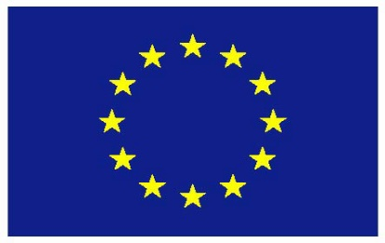

UNITED NATIONS
HUMAN RIGHTS COUNCIL
25th Session of the Advisory Committee
16th of February
EU Statement
Item 3 (f) Women’s representation on HR organs and mechanisms

Thank you Chair,
The EU welcomes this discussion on the draft report on current levels of representation of women in human rights organs and mechanisms such as the Advisory Committee, requested through HRC resolution 41/6.
Equality and non-discrimination are foundational values of the EU. We remain strongly committed to promoting women’s and girls’ full enjoyment of human rights, gender equality and the empowerment of women and girls in all areas of our action and engagement – this was yet again reaffirmed in our updated Action Plan for Human Rights adopted last year. Through our robust equal treatment legislation and jurisprudence, the EU has made significant progress in addressing inequalities in the last decades. Having said this, challenges remain and we are committed to scaling up our own action, as well as to working with partners to do the same.
The guidance produced by the UN’s human rights machinery is a key element in guiding States on how to meet their obligations with respect to women’s and girl’s rights. Women should not be treated as a homogenous, vulnerable group, but must be acknowledged as right-holders that have suffered long-standing multiple and intersecting forms of discrimination. It is fundamental that the voices, expertise and experience of women themselves be incorporated into international human rights mechanisms in order to change the narrative and have concrete and targeted recommendations for the elimination of gender stereotypes and structural inequalities.
Unfortunately, the statistics available show that more needs to be done in ensuring gender parity in the human rights mechanisms. The EU reiterates that States have a particularly responsibility when it comes to promoting greater gender party across and within the respective Treaty Bodies and the Advisory Committee. We encourage States to nominate more women for these positions and to consider the use of special measures, such as quotas, both in nomination and election processes.

We would also like to recall the recently adopted working methods for the Consultative Group, which outline that due consideration should be given to gender balance in the selection processes of special procedure mandate holders, in addition to the general criteria and the technical and objective requirements.

The EU is committed to working towards women’s full, equal, effective and meaningful participation in all spheres and levels of public and political life, including multilateral fora. The EU reiterates that the gender-specific threats and violence against women human rights defenders and women in politics must be addressed. This is an essential precondition for women to be able to claim their rightful place in public life.

Taking a firm stance against the current backlash against women’s and girls’ rights and promoting their equal and full enjoyment of all human rights is not just a task for CEDAW, CRC and the gender specific Special Procedures. While we look forward to the views by the Advisory Committee on how to increase the percentage of female members on human rights bodies, we would also welcome concrete suggestions on measures that could enhance a gender- responsive approach throughout the work of the UN human rights mechanisms. This can be done by the Advisory Committee itself more systematically applying a gender lens to its thematic studies and advice, such as those on racial equality in the world and new and emerging digital technologies and human rights being discussed in this session.

I thank you.

https://undocs.org/A/HRC/AC/25/1/Rev.1
By way of example, the overall percentage of female members of the treaty bodies is at 38.3 per cent discounting the female representation in CEDAW. For the Special Procedures the gender balance has remained just above 40%.

