ITALY

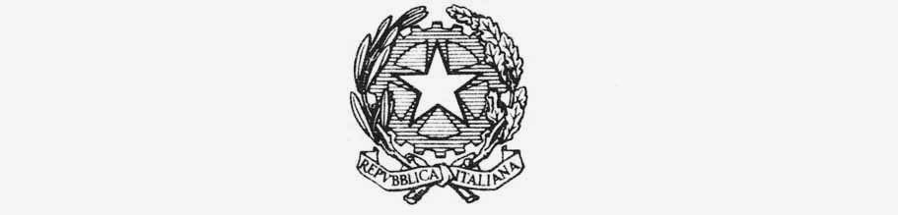

MINISTRY OF FOREIGN AFFAIRS AND INTERNATIONAL COOPERATION

inter-ministerial committee for human rights

ITALY’S REPLY TO ADVISORY COMMITTEE QUESTIONNAIRE ON GENDER PARITY
HRC Resolution 41/6

November 21, 2019

ITALY
hrcadvisorycommittee@ohchr.org
Further to your query, we are in a position to provide the following, for your information only:
Reply to questionnaire on current levels of representation of women in human rights organs and mechanisms

- Do current processes in the State allow for, or encourage, a consideration of gender balance when nominating, electing and appointing experts for human rights organs such as the Advisory Committee and treaty bodies? Do these processes ensure publicity, transparency, and participation by civil society organizations and/or other actors? Yes, they do.

- Does the State take into account the gender composition of the treaty bodies or the Advisory Committee at the time of nomination or election? Yes, we do.

- Does the State have any good national practices related to the nomination, election and appointing processes for human rights organs such as the Advisory Committee and treaty bodies? Do these processes take into account gender when nominating, electing, or appointing? Please refer to our reply to Q. No. 1.

- How does the State take into consideration its obligations concerning non-discrimination and women’s right to equal access to participation, as well as its obligations under Article 8 of CEDAW to ensure women’s equal participation in the work of human rights organs when nominating or appointing candidates for those organs and mechanisms? As for representation of women in Parliament, the last national elections’ round marked an increase to 35,4%. (Source: last periodic report to CEDAW). By Act 215/2012, establishing “Provisions to promote gender balance in local governments and regional councils. Provisions on equal opportunities in the composition of selection boards for competitions in the public administrations”, municipal statutes shall include provisions to ensure equal opportunities between women and men within councils and non-elective collective bodies of municipalities and provinces, as well as of agencies, businesses and institutions depending from them. At the electoral level, for Municipalities with less than 5,000 inhabitants, to be valid, candidates’ lists must include both sexes. For the Municipalities between 5,000-15,000 inhabitants, in addition to the above quota - by which none of the two sexes can exceed of 2/3 the other one -, the gender preference has been added. As for the selection boards to positions in Public Administration, at least 1/3 is reserved to women. The same purpose is under Act 65/2014 on the election to the EU Parliament: from 2019, women must represent 50% of the candidates’ list. Plus, the first two candidates of each list have to be of different sexes. In the event of two or more preferences by the voter, they are valid only if reflecting the gender balance principle. (….). At the EU Parliament elections-2014, the increase in women amounted to 39,7% (compared to the initial 19.3% when women were 18). (..) Women’s under-representation is mainly a cultural problem. Therefore, multi-annual training projects, entitled “Women, politics and Institutions - educational processes for a gender and equal opportunities culture”, have been developed with a view to disseminating a gender-sensitive culture and allowing women, of every age, workers or not, to approach politics and promote their success and their participation in the national political and social life. Within We-Women for Expo 2015 - an initiative launched by EXPO Milano 2015, in collaboration with the Ministry of Foreign Affairs and the Mondadori Foundation, several actions aim at strengthening women’s participation as driving forces for the future of the planet. In terms of women’s participation in diplomacy, as at December 31, 2014, 17 women out of 215 (on a total of 932 diplomats) were at the level of either Ambassador or Minister Plenipotentiary. Within Penitentiary Police, more than half of the personnel are women (3369 out of 6067), with 114 female Directors of Penitentiary Institutes (out of 197 Institutes). Additional data are reported in the revised NAP1325, 2014-2016. More specifically, as for women in top positions (2013): Women Prefets were 38%; Executive physicians of complex facilities, 14,7%; High-ranking magistrates, 2,6%; First grade Executives of Ministries, 32,3%; School principals, 61,6%; Armed forces high-ranking officers, 11,7%. In 2014, women represent 41.9% of the employed; and 24.5% were among top management, legislators and senior officials (ISTAT data annexed - Table 4.12). Specifically, positive trends refer to women prefects and school principals”.

- How many women has the State nominated to human rights organs and mechanisms in the last five years (such as the Advisory Committee or treaty bodies)? With specific regard to Treaty Bodies and Special Procedures, mention has to be made of four ladies.

- Does the State take any action to publicize and encourage women to apply for the special procedures mandate-holders vacancies? As a way of examples, in addition to ads., vacancies are shared during working meetings.

- What are the main challenges within your country in tackling the issue of gender balance when nominating and electing candidates for human rights organs and mechanisms such as the Advisory Committee, treaty bodies and the special procedures? No specific challenge.

- Are there good practices by the State or other stakeholders that ensure gender parity? If yes, could you please share these practices? N/A.

- Are there recommendations directed to States, international bodies, or other entities, that you wish to make in order to strengthen and inform this report? Women’s meaningful participation and representation are key issues and components of all processes, as evidenced by the Mediterranean Network of Women Mediators launched at the Ministry of Foreign Affairs and International Cooperation of Italy in October 2017 within the framework of the National Action Plan on Women, Peace and Security, in accordance with UNSCR 1325(2000).

Two candidates can be indicated but they have to be of different sex, otherwise the second choice will not be valid.
In the previous round, they were 15.
Various are also the initiatives undertaken by CSOs: the relevant political school organized by Sturzo Institute; and the new course on Women, Peace and Security, including the e-course by VIS.
http://www.2015.org/it/progetti/we-women-for-expo
The limited presence of women in the Armed Forces is due to the late women’s access to this sector.

