|  |  |  |  |
| --- | --- | --- | --- |
|  | United Nations | A/HRC/46/54 | |
| United Nations logo | **General Assembly** | | Distr.: General  21 January 2021  Original: English |

**Human Rights Council**

**Forty-sixth session**

22 February–19 March 2021

Agenda item 4

**Human rights situations that require the Council’s attention**

Report of the Independent International Commission of Inquiry on the Syrian Arab Republic[1]*, [2]**

|  |
| --- |
| *Summary* |
| In its resolutions 43/28 and 45/21, the Human Rights Council requested the Independent International Commission of Inquiry on the Syrian Arab Republic to present its findings and analysis of key recurrent human rights concerns over the course of the conflict and continuing trends. As the conflict nears its tenth grim anniversary, the Commission presents its analysis covering the period from March 2011 to 24 December 2020. |
|  |

I. Introduction

1. The present report complements the report of the Independent International Commission of Inquiry on the Syrian Arab Republic[3] on arbitrary imprisonment and detention[4] and is based on 21 mandate reports, 12 conference room papers, nine Arria formula briefings to the Security Council, two briefings to the General Assembly, 27 briefings to the Human Rights Council and dozens of other publicly available documents.[5] In order to meet its standard of proof, the Commission primarily drew on the 7,874 interviews conducted between the establishment of the Commission by Human Rights Council resolution S-17/1 of 23 August 2011 and the time of submission of the present report.[6]

2. Despite the formal and informal requests and resolutions of the General Assembly and Human Rights Council, the Government of the Syrian Arab Republic has continued to refuse the Commission and its staff access to its territory.[7]

II. Findings of the Commission of Inquiry

A. Evolution of the conflict

3. Amid unrest that started across several countries in the Middle East and North Africa, in February 2011, Syrians began protesting rural poverty, corruption, the detention of political prisoners and the lack of freedom of expression and democratic rights.[8] In March, Syrian security forces detained and tortured a group of Syrian children accused of painting anti-government graffiti in Dar’a, prompting further peaceful protests in the city.[9] After families recovered the mutilated bodies of Thamir Al Sharee, 14 years of age, and Hamza Ali Al Khateeb, 13 years of age, detained in a separate incident, protests spread across the Syrian Arab Republic.[10] The Government reacted with widespread arrests during ground operations and at checkpoints[11] and with targeted attacks on demonstrators in many locations, prompting numerous domestic, regional and international responses aimed at both fact-finding and mediation. While the Government announced limited reforms in the spring of 2011, it continued its brutal repression of demonstrations and non-violent activists. The ensuing defections from the military and security forces fuelled the emergence of anti-government armed groups and an increase in their organizational and logistical capacity. By that time, the Commission had already documented gross violations of human rights and crimes against humanity perpetrated by government forces and a range of human rights abuses by non-State armed groups.[12]

4. The intensity and duration of the conflict, combined with the increased organizational capabilities of anti-government armed groups, met the legal threshold for a non-international armed conflict as of February 2012.[13]

5. Despite a fleeting effort at a ceasefire and the brief deployment of a United Nations monitoring mission in the second and third quarters of 2012, the conflict continued to intensify, with widespread arrest and detention campaigns conducted by government forces, the formation of more armed groups and the imposition of sieges. Member States and private individuals provided support to various armed groups with competing interests and ideologies, funnelling funds, weapons and materiel to divergent actors and encouraging the fragmentation, competition and shifting alliances and enmities among armed groups. Similar support from external parties to the Government’s military and security apparatus likewise encouraged the continuity of the militarization of the crisis. Artillery and aerial bombardment of civilian populated areas increased, with the first use of barrel bombs reported in August 2012 in Homs city.[14]

6. As armed groups, and later United Nations designated terrorist groups, gained control over increasing numbers of Syrian population centres between 2012 and 2016 (see annex II), the Government imposed sieges and bombarded areas of suspected opposition activity, including densely populated civilian areas. Initially, the entry into the conflict of Iranian Republican Guard forces, Lebanese Hezbollah and Iraqi Shi’a militias in support of the Government failed to alter the conflict’s trajectory. Armed groups and entities took control of eastern Aleppo city, parts of Homs, Idlib, Raqqah, Dayr al-Zawr, and Dar’a and numerous areas in Rif Damashq, including eastern Ghutah, among many other cities and towns with significant populations. Armed groups also fought among themselves, with shifting alliances and changing names and formations. Government forces largely withdrew from the north-eastern Syrian Arab Republic in the middle of 2012, retaining certain military and civilian structures, but ceding temporary authority to the Kurdish People’s Protection Units, which then became the primary armed actor in that region, at least until the emergence of Islamic State in Iraq and the Levant (ISIL).

7. Jabhat al-Nusra,[15] which had emerged in 2012 as an offshoot of Al-Qaida in Iraq, split off in April 2013, operating independently while coordinating with other armed groups. ISIL meanwhile consolidated control in the eastern Syrian Arab Republic in particular and rapidly expanded, proclaiming itself a “caliphate” in June 2014.

8. In September 2014, the United States of America announced the formation of an international coalition to fight ISIL.[16] Initially focused on combating ISIL in Iraq at the request of the Government of Iraq, the coalition, although not all of its members, has also conducted operations against ISIL in the Syrian Arab Republic, which continue to date. Both the Russian Federation and Turkey would also invoke combating terrorism as the rationale for their interventions, at the invitation of the Government and on the basis of self-defence, respectively.[17]

9. A massive attack with sarin-filled rockets on eastern Ghutah in August 2013 killed, maimed, injured and terrorized Syrian civilians. The Syrian Arab Republic became a party to the Convention on the Prohibition of the Development, Production, Stockpiling and Use of Chemical Weapons and on Their Destruction shortly after the attack, averting a possible military intervention by the United States. In November 2020, the Organisation for the Prohibition of Chemical Weapons noted that there were still outstanding issues related to the compliance of the Syrian Arab Republic with the treaty.[18] The documented use of chemical weapons would continue, with the majority of incidents attributed to Syrian government forces (see section II.B below).

10. Due to the deteriorating humanitarian situation, in particular for besieged and hard-to-reach civilians, the Security Council adopted resolution 2165 (2014) authorizing the use of four international border crossings for humanitarian aid. By July 2020, the number was reduced to only one crossing in resolution 2533 (2020), despite the continuing dire humanitarian situation. Administrative restrictions imposed by the Government continued to hinder access to humanitarian assistance for populations throughout the Syrian territory, in particular for civilians in recaptured areas.[19]

11. A coalition of non-State armed groups captured Idlib city in March 2015, prompting the displacement of a large part of the civilian population. Following the commencement of Russian airstrikes in support of the Government in September 2015, the Government of the Syrian Arab Republic began to recapture more territory in the country, and Idlib Governorate increasingly became a refuge for Syrians unable to remain in recaptured areas and a hub for opposition armed groups. Idlib Governorate would increasingly, but not exclusively, become dominated by Hay’at Tahrir Al-Sham and would remain largely outside of government control as of the time of reporting.

12. In the north-east of the country, the Kurdish People’s Protection Units, with the support of the international coalition, captured large amounts of territory from ISIL. In 2015, the “Syrian Democratic Forces” were formed as an alliance primarily comprising forces of the Kurdish People’s Protection Units and including their allies among Arab and Assyrian armed groups and other opposition groups. By late 2015, they controlled an increasing expanse of territory in the north-east and along the border with Turkey, including Ayn al-Arab (Aleppo) and Tall Abyad (Raqqah).

13. In what would be the first of four major, named operations carried out by Turkey, in August 2016, Turkish troops and affiliated Free Syrian Army groups pushed through predominantly ISIL controlled areas of northern Aleppo Governorate as part of the cross-border Operation Euphrates Shield.[20] By 30 March 2017, the Turkish armed forces and Free Syrian Army groups controlled an area from I’zaz to Jarabulus and extending down to Bab.

14. The Government’s recapture of eastern Aleppo city in late 2016 marked another significant shift in the conflict.[21] In mid-December, after much of eastern Aleppo city had been destroyed by government shelling and airstrikes, government forces and armed groups reached an “evacuation agreement”.[22] The last remaining fighters, their families and other civilians were transported on government buses to Idlib Governorate. Aside from the significance of regaining complete control of the city that had been the most populous and an economic hub of the country before the war, it also ushered in a period of government consolidation of control and the use of “reconciliation agreements” to move fighters, their families and civilians from other locations in the Syrian Arab Republic primarily into Idlib Governorate throughout 2017 and 2018.

15. Although chemical weapons would be used periodically throughout that period, the attack on Khan Sheykhun (Idlib) with sarin in April 2017, killing 83 people, including 28 children and 23 women, and injuring another 293 persons, including 103 children,[23] prompted the first direct airstrikes on Syrian government facilities by the United States, joined by France and the United Kingdom of Great Britain and Northern Ireland.

16. An agreement concluded in May 2017 in Astana (now Nur-Sultan) between the Islamic Republic of Iran, the Russian Federation and Turkey established a cessation of hostilities and “de-escalation zones” in four areas. The de-escalation agreement temporarily reduced violence in Idlib, western Aleppo and Dar’a, while eastern Damascus and northern Homs remained volatile. By the end of 2018, each area of the de-escalation zone would be recaptured by the Government, except Idlib and western Aleppo, with fighters and civilians either signing oaths of loyalty[24] and reconciling with the Government or being forced to relocate to Idlib Governorate under “reconciliation agreements”. While armed groups in Dar’a capitulated through negotiations and reconciliation, the Government recaptured eastern Ghutah in 2018, ending a five-year siege.[25]

17. Also in 2017, the Syrian Democratic Forces, backed by the United States-led international coalition, encircled and captured Raqqah city, the de facto“capital” of ISIL, destroying significant parts of the city in the process and causing thousands to flee.[26] It marked an accelerated decline for ISIL’s territorial control, with the last ISIL stronghold of Baghuz captured by March 2019. Following the capture of that area, tens of thousands of predominantly Syrian and Iraqi nationals, along with thousands of other foreigners, the majority of whom were women and children, would end up interned in camps. Most of them remain deprived of their liberty there as of the time of reporting. More than ten thousand suspected ISIL fighters were imprisoned by the Syrian Democratic Forces.

18. Although the Syrian Democratic Forces made gains against ISIL in that period, it also lost control of the Afrin subdistrict and town, following Operation Olive Branch, another cross-border operation launched by Turkey and backed by the newly consolidated “Syrian National Army”,[27] in fighting from January to March 2018. Following an announcement by the United States that it was moving its forces away from the Syrian border with Turkey, Turkish forces backed by the Syrian National Army launched Operation Peace Spring in October 2019, capturing the Syrian territory between Tall Abyad and Ra’s al-Ayn along the border.[28] Simultaneously, the Syrian Democratic Forces agreed to Syrian government forces returning to the area and being deployed outside the main urban areas.

19. Despite the presence of observation posts that were established under the agreement concluded in Astana in order to monitor the Idlib de-escalation zone (see annex II), fighting erupted in late 2019 and in the first quarter of 2020, with pro-government forces[29] advances, preceded by airstrikes and artillery and resulting in the displacement of 960,000 civilians towards northern Idlib and Aleppo Governorates. In February 2020, Turkey launched Operation Spring Shield, all but halting the Government advance and leading to a ceasefire on 5 March, brokered by the Russian Federation and Turkey, that has largely held as of the time of reporting.

20. Prior to the conflict, the Syrian Arab Republic had an estimated population of more than 22 million persons.[30] As of the time of reporting, on 7 January 2021, more than half of the pre-war population had been displaced, with 6.2 million people internally displaced and 5.3 million registered as refugees, primarily in neighbouring countries but increasingly as a global diaspora.[31]

21. On the cusp of the eleventh year of the conflict, the Syrian State authorities and associated militias, with the support of Iranian and Russian forces, have regained significant territory. Large swaths of the country remain out of their control, however, with Turkey and the United States backing different coalitions of anti-government groups. Israeli airstrikes on purported Iranian or Lebanese Hezbollah-linked targets occur with increasing frequency. Patrols of Russian and United States forces test the limits of their deconfliction mechanisms. While the Russian Federation and Turkey have avoided most direct confrontations, they remain aligned behind diametrically opposed forces on the ground. Although the March 2020 ceasefire still largely holds, the Syrian Arab Republic remains a tinderbox, with five foreign militaries active therein. Without concerted, immediate action to further a permanent ceasefire and a good faith Syrian-led peace process, the conflict may yet descend to new levels of inhumanity.

B. Conduct of hostilities

22. The Government has long claimed combating terrorism as a justification for its military action, without distinguishing between United Nations-designated terrorist groups and other armed groups, however. The Commission has repeatedly recalled that, while States have an obligation to defend their citizens from terrorism, they must do so in full compliance with international human rights law and, if applicable, international humanitarian law.

23. The Government has consistently failed in its obligations in that regard. From the end of 2011 through the end of 2020, its army and air forces have used artillery and airstrikes in a clearly indiscriminate manner. Such use of heavy weapons in civilian populated areas, which killed and injured civilians, in the period prior to the start of the armed conflict amounted to clear violations of the right to life.[32]

24. From the outset of the armed conflict, government forces have indiscriminately bombarded civilian populated areas and deliberately targeted protected objects, in particular hospitals and medical facilities, and what are clearly civilian locations, including markets, bakeries, schools and civilian neighbourhoods.[33] Protected religious sites have also been struck in indiscriminate attacks.

25. In addition to the widespread commission of those war crimes, there are also reasonable grounds to believe that Government and pro-government forces, on multiple occasions, have committed crimes against humanity in the conduct of their use of airstrikes and artillery shelling of civilian areas.[34] In most instances documented by the Commission, witnesses denied the presence of any military target, while the Governments of both the Russian Federation and the Syrian Arab Republic declined to provide responses concerning the specific incidents concerned.[35]

26. Pro-government forces used air-delivered cluster munitions in civilian populated areas on multiple occasions, and the Commission has documented the use of ground-to-ground artillery shelling with cluster munitions by Syrian ground forces. The Syrian Air Force also deployed barrel bombs, improvised explosives dropped by helicopters, on densely populated civilian neighbourhoods where such munitions could not be accurately targeted. The use of such weapons in civilian populated areas was inherently indiscriminate and amounted to war crimes.[36]

27. Both the Syrian military and the Russian air force attacked civilian neighbourhoods, including crowded markets during the day, with explosive bombs with wide-area effects, killing and injuring civilians in attacks that amounted to war crimes.[37]

28. Although in some instances the Commission could not make the determination that specific attacks were unlawful, it documented a systematic failure to take any precautions to spare civilians from harm,[38] in violation of international humanitarian law, and numerous instances of the war crime of launching indiscriminate attacks causing civilian deaths and injuries and the commission of multiple instances of the war crime of the deliberate targeting of protected objects.[39]

29. The Commission notes the abhorrent, established pattern of pro-government forces targeting hospitals and clinics, clearly documented beginning in 2012[40] and accelerating in 2016.[41] Those attacks deprived countless civilians of access to health care and amounted to the war crimes of intentionally targeting protected objects and medical personnel and transport.[42]

30. Likewise, armed groups, including ISIL, Hay’at Tahrir Al-Sham and the Kurdish People’s Protection Units, also conducted indiscriminate attacks using mortars and rockets, as well as improvised munitions. Such attacks rarely appeared to target, or to be able to target, military objectives, with armed groups committing numerous instances of the war crime of launching indiscriminate attacks causing civilian deaths and injuries in the Syrian Arab Republic.[43] The Commission has likewise documented the indiscriminate use of improvised explosive devices by numerous actors in civilian populated areas, amounting to war crimes, most recently in the north-eastern part of the Syrian Arab Republic.[44]

31. The United States-led coalition also conducted airstrikes documented to have caused civilian casualties, failing to take all feasible precautions to avoid and minimize incidental loss of civilian life, injury to civilians and damage to civilian objects,[45] in violation of international humanitarian law. The conduct of the aerial campaign to retake Raqqah city damaged or destroyed up to 80 per cent of buildings there,[46] reportedly killing and injuring thousands of civilians and leaving parts of the city uninhabitable, displacing nearly the entire population and raising concerns that the widespread destruction wrought upon Raqqah city included indiscriminate attacks.[47]

32. Syrians also endured the resurgent use of chemical weapons. The Commission documented 38 separate instances of the use of chemical weapons, of which 32 met its standard of proof for attribution to Syrian government forces and 1 to ISIL. In the remaining 5 instances, the Commission could not attribute responsibility.[48] Each such use of a chemical weapon amounts to a war crime.

33. In its reports, the Commission has detailed how different weapons and weapons systems have been used to kill and maim civilians, commit international crimes and contribute to the deterioration of the overall human rights situation. Such weapons included improvised weapons, such as “hell cannons”, barrel bombs and improvised explosive devices that were inherently indiscriminate as constructed or as used. Such weapons also included those manufactured in third-party countries and either sold or provided to the conflicting parties. Neither the Syrian Arab Republic nor the major third-party States providing support to the Government of the Syrian Arab Republic or to groups opposed to the Government are party to the Arms Trade Treaty, which imposes specific restrictions on the transfer of arms on the basis of respect for international humanitarian law and international human rights law.[49] All States, however, have obligations under article 1 common to the four Geneva Conventions, to respect and to ensure respect for those Conventions in all circumstances, which requires States to refrain from encouraging, aiding or assisting other parties in the commission of violations of international humanitarian law, including through the provision of funding and arms.[50]

C. Violations of human rights beyond the front lines

34. While front-line violence in the Syrian Arab Republic was characterized by the heavy bombardments, the initial phases of the crisis and conflict involved massive arrest and detention campaigns, particularly those undertaken by government security forces, which are addressed in detail in the report of the Commission dedicated to arbitrary imprisonment and detention.[51] In the context of detention, Government forces, ISIL and Hay’at Tahrir Al-Sham have all committed crimes against humanity,[52] and all parties have perpetrated war crimes and violations and abuses of human rights law.

35. The Commission also documented the mutilation and murder of *hors de combat* fighters and military personnel, including by pro-government forces,[53] armed groups[54] and ISIL.[55]

36. Protests and demonstrations were regularly targeted, primarily by government forces, but subsequently by multiple parties to the conflict as they gained control.[56] Journalists and media workers, and their activities, were targeted, threatened, harassed, arrested and murdered by Government elements, as well as by armed groups and terrorist groups. Attacks on journalists and the pressure placed on the media also compounded the difficulties of documenting violations and abuses. Sources in areas under the control of the Government, ISIL, Hay’at Tahrir Al-Sham or the Syrian Democratic Forces were reluctant to report on violations by the entities controlling the territory, owing to the risk of reprisals.[57]

37. Pillage and looting was another mainstay of the conflict, with government forces, pro-government militia, ISIL, Hay’at Tahrir Al-Sham[58] and other armed groups all implicated in their commission after taking control of territory.

38. While attacks on cultural heritage in the course of the conflict have largely been associated with ISIL and their destruction and pillage of archaeological sites, the Commission also documented attacks carried out by Ahrar al-Sham on the thirteenth century citadel in the old city of Aleppo and the bulldozing, looting and destruction of archaeological sites and Yazidi shrines and graves by the Syrian National Army in Afrin.[59]

39. Syrians across the country also suffered violations of the rights to health, food and an adequate standard of living, due to the imposition of sieges, the denial of access to humanitarian aid, the destruction of medical facilities and the resulting lack of access to basic medical care, the denial of access to housing and education and the decimation of the Syrian economy.

40. The combination of the deliberate targeting of medical facilities, hospitals and medical workers by government forces and the incidental damage to such facilities – at one point rendering approximately half of all medical facilities damaged or destroyed – in addition to the flight of health workers, further imperilled Syrian’s access to health care.[60] Further endangering already vulnerable populations, in 2020, the coronavirus disease (COVID-19) pandemic spread to the Syrian Arab Republic, with 11,890 reported cases, including 610 deaths, in government-controlled areas at the time of reporting.[61] An additional 20,500 cases have been reported in the north-western Syrian Arab Republic, and 8,153 cases in the north-eastern Syrian Arab Republic.[62] With a medical sector vastly diminished by the conflict across the country, the actual numbers are likely significantly higher than acknowledged figures, and the impact greater.

41. According to a World Bank study, by 2017, 60 per cent of Syrians were living in extreme poverty, with 6.1 million Syrians out of work, school or any formal training, and the cumulative loss in gross domestic product (GDP) at the time already amounted to $226 billion, which the World Bank calculated as four times the GDP of the Syrian Arab Republic in 2010.[63] Those indicators and the resulting impact on Syrians’ rights to an adequate standard of living and access to food, education and health care were felt across Syrian society, particularly among displaced Syrians. The 2019 financial crisis in neighbouring Lebanon and the ensuing currency crisis further aggravated the economic outlook, and, by 2020, a staggering 9.3 million Syrians were food insecure.[64]

42. In addition to the economic harm associated with the conflict, a number of countries imposed unilateral coercive measures on the Syrian Arab Republic, increasing the economic devastation inflicted upon regular civilians.[65] While most such sanctions were targeted at specific individuals and institutions, their impact was likely felt across the Syrian economy, including among the most vulnerable. The Commission previously observed that, in some areas, the impact of unilateral sanctions has further weakened the ability of humanitarian actors to deliver assistance, owing to increased prices and the reduction in the availability of crucial items in local markets and overcompliance.[66] In the light of the economic crisis, the situation of food insecurity and the COVID-19 pandemic, all obstacles to humanitarian aid should be removed, including those unintentionally caused by sanctions that have overly cumbersome humanitarian exemption procedures. At the onset of the global COVID-19 pandemic, the Secretary-General encouraged Group of 20 members to waive sectoral sanctions imposed on countries in order to ensure access to food, essential health supplies and COVID-19 medical support.[67]

43. More than 11.5 million people have been displaced thus far by the conflict in the Syrian Arab Republic, with many of their homes damaged or destroyed.[68] In its most recent public update, in 2016, the United Nations Human Settlements Programme (UN-Habitat) placed the number of damaged housing units in Syrian cities at 760,000. In 2017, the World Bank estimated that 7 per cent of the housing stock had been destroyed and 20 per cent damaged,[69] and, in a survey conducted in 2019 of conflict-induced damage covering 16 cities and towns, more than 125,000 damaged or destroyed buildings were identified.[70] In addition to the displacement and destruction, Syrians are routinely denied return to their places of origin, notably due to restrictions on access placed by the Government and fear of arrest in retaken and formerly besieged areas, in particular in Rif Damashq, Daraa, Quneitra, Homs, Hama and Aleppo, as well as in areas controlled by the Syrian National Army and the Syrian Democratic Forces in the north-eastern Syrian Arab Republic.

44. Lack of security of housing, land and property rights for the millions of affected Syrians was further deliberately compounded by legislation, policies and practices. At least 40 laws relating to housing, land and property have been passed since 2011, indicating a systematic push to reorganize the management of property rights in the Syrian Arab Republic, while raising concerns regarding the ability of all Syrians with property interests, in particular the displaced and refugee populations, to secure their rights. Many families lack security of tenure in rural areas, while many others who moved to Syrian cities and towns during the rapid and informal urbanization in the second half of the twentieth century lack formal deeds. The lack of access to housing, land and property rights across the Syrian Arab Republic has also been noted as a key driver of the conflict, with the housing, land and property framework having required reform even prior to the current conflict.[71]

D. Impact of sieges

45. Sieges were mostly carried out by the Government and its affiliates, but also by armed opposition groups and terrorist organizations. Government sieges included those in: Daraya (2012–2015); eastern Ghutah (2013–2018); Yarmouk (2014–2016); Al-Waer district (Homs) (2014–2017); Madaya and Zabadani (Rif Damashq) (2015–2017); and eastern Aleppo city (2016).[72] Armed groups and Hay’at Tahrir Al-Sham besieged Nubl and Zahra in northern Aleppo between 2012 and 2016, until defeated by a government offensive. Similarly, armed groups primarily under the Jaish al-Fatah (Army of Conquest) laid siege to the predominantly Shi’a towns of Fu’ah and Kafraya from 2015 until the last 5,000 civilians were evacuated in April 2017. ISIL also besieged the densely populated Government-held neighbourhoods of Dayr al-Zawr city from 2014 until 2017.

46. Such sieges lasted months and often years. In some instances, shortages of food, water, and medicine – often due to the Government’s deliberate obstruction of aid access – led to acute malnutrition and deaths among vulnerable groups, including children, the elderly and the infirm. Besieged armed groups confiscated or hid food items, distributing them on a preferential basis within their circles.[73] In other instances, those in control of besieged areas prevented civilians from leaving by using them as human shields. Throughout the Syrian Arab Republic, the use of siege warfare also breached numerous tenets of international human rights law, including the right to life, the absolute prohibition on torture and cruel, inhuman or degrading treatment, the right to freedom of movement, the right to an adequate standard of living, including adequate food, clothing and housing, and the right to essential primary health care, including essential medicine.

47. Sieges were often concluded through the use of “evacuation agreements”, negotiated by parties to the conflict, concerning the removal of fighters, their families and civilians of dissenting opinions from besieged areas. Often, no reconciliation possibility was offered to health-care personnel or activists.[74] The Commission found that, for each civilian who was unable to freely decide on his or her movement or destination, the use of such agreements amounted to the war crime of the forced displacement of civilians.[75]

E. Gender-related impact of the conflict

48. Civilians’ experiences in the conflict in the Syrian Arab Republic have been deeply gendered. Sexual and gender-based violence against women, girls, men and boys has been documented by the Commission since 2011.[76] While the immense suffering induced by those practices affected Syrians from all backgrounds, women and girls were disproportionally affected and victimized on multiple grounds, irrespective of the perpetrator or geographical area.

49. Syrians faced divergent and gendered impacts with regard to freedom of movement in particular. The most severe restrictions were imposed on women and girls living in areas under ISIL control, who were largely restricted from venturing outside in the absence of a male relative and from taking part in public life. Similar restrictions were also enforced by Hay’at Tahrir Al-Sham and other armed groups. Likewise, men and boys were often unable to move freely in areas controlled by government forces or the Syrian Democratic Forces, fearing forced conscription or arrest.[77]

50. Government forces and associated militias perpetrated rape and sexual abuse against women and girls, and occasionally men, during ground operations aimed at arresting opposition activists and house raids to arrest protestors and perceived opposition supporters and at checkpoints. In detention, women and girls were subjected to invasive and humiliating searches and raped, sometimes gang raped, whereas male detainees were most commonly raped with objects and frequently subjected to genital mutilation and sexualized torture. Those acts amounted to crimes against humanity and the war crimes of rape and other forms of sexual violence, including torture and outrages upon personal dignity.

51. Armed groups also committed the war crimes of rape and other forms of sexual violence, including torture and outrages upon personal dignity.

52. Throughout areas under its control, Hay’at Tahrir Al-Sham[78] caused severe psychological and physical harm to women, girls, men and boys, by imposing religious dress codes and, in the case of women and girls, denying their freedom of movement without a male relative. Edicts formally delivered to populations residing under Hay’at Tahrir Al-Sham control disproportionately affected women and girls and evinced discriminatory treatment on the basis of sex, in breach of international human rights norms. Unauthorized “courts” established by Hay’at Tahrir Al-Sham and various armed groups imposed death sentences that amounted to the war crime of murder and were used to impose such groups’ draconian social strictures, in particular against women and sexual minorities, including men accused of homosexuality. Armed groups seriously contravened international human rights norms, including the right to life, liberty and security of person, the right to freedom from torture and other forms of cruel, inhuman or degrading treatment and the right to the highest attainable standard of physical and mental health.

53. ISIL systematically discriminated against women, girls and sexual minorities as a matter of policy. ISIL members subjected Yezidi women and girls to enslavement, torture, inhuman treatment, murder and rape, including through sexual slavery, as part of their genocidal campaign.[79] The stoning of women and girls on charges of adultery and the executions of homosexuals were also recurrent in areas under ISIL control, as were forced marriages to fighters. ISIL’s rule placed women and girls under the control of male relatives, effectively restricting their freedom of movement and removing them from public life. Those found to violate ISIL’s strict dress code, most commonly women and girls, including those as young as 10 years of age, were punished with lashings. Those acts constituted the war crimes of torture, cruel or inhuman treatment and outrages upon personal dignity against women. Executions further constituted the war crime of murder and also amounted to serious breaches of international human rights norms, including denial of the right to life and the right to be free from discrimination. Furthermore, the well-documented crimes of ISIL and their terrorizing of the civilian population in Raqqah and Dayr al-Zawr Governorates formed part of a widespread or systematic attack directed against a civilian population. By targeting sexual minorities and depriving them of their fundamental rights, ISIL also perpetrated the crime against humanity of persecution.

F. Children’s rights

54. Since the start of hostilities, Syrian children have been victimized in numerous ways and left to endure multiple violations of their rights by all parties.[80] While the Government bears the primary responsibility for the protection of the rights of children, armed groups were nevertheless obligated to respect fundamental human rights norms, which form part of customary international law in territory where such actors exercised de facto control.[81]

55. Robbed of their childhood and forced to participate in a brutal war, children were killed and maimed by parties across the conflict.

56. In addition to intentionally targeting children with sniper fire, pro-government forces deployed cluster munitions, thermobaric bombs and chemical weapons, often against civilian objects such as schools and hospitals. Government forces also detained boys as young as 12 years of age, subjecting them to severe beatings and torture and denying them access to food, water, sanitation and medical care. In detention centres, but also more broadly, rape and sexual violence was used against boys and girls as a tool to punish, humiliate and instil fear among affected communities. Such acts resulted in movement restrictions on girls, with many being removed from school, and compelled families to relocate abroad.

57. Armed groups carried out attacks on areas under government control, causing scores of casualties among children. Children were detained and used to extract ransom or as bargaining chips to initiate prisoner swaps with government forces and affiliated militias. In some cases, boys were forcibly recruited as fighters by armed groups, including the Kurdish People’s Protection Units, while in others, the dire economic situation, the death or disappearance of breadwinners or the lack of educational opportunities pushed children to join such groups.[82]

58. ISIL subjected girls as young as 9 years of age to sexual slavery and other forms of sexual violence and systematically recruited and used children for direct participation in hostilities. The group also launched indiscriminate attacks on towns and villages that killed and injured scores of children. Most emblematically, children were both victims of public executions and forced into the role of executioner by the group.

59. In areas under the control of the Hay’at Tahrir Al-Sham terrorists, many girls were prevented from attending school and boys were recruited for combat roles.

60. The impact of those violations on children has been extremely severe. As many as 2.6 million girls and boys have been internally displaced from their homes.[83] The mental health of many Syrian children has been, and will continue to be, deeply affected by the conflict’s brutality. Due to attacks on civilian infrastructure, physical health has also been acutely affected, in particular for those children suffering from disabilities caused by warring parties.

61. Children also face considerable obstacles related to identity documentation. As noted by the Office of the United Nations High Commissioner for Refugees and the Ministry of the Interior of the Syrian Arab Republic, without a completed birth registration, a child may not be able to prove its Syrian nationality,[84] increasing the risk of that child becoming stateless. They remain vulnerable to exploitation through child labour or child marriage, often as a result of the death or disappearance of male parental figures. Crucially for their long-term prospects, millions of children have missed out on years of education, with 2.8 million currently out of school.[85] That status quo will affect the ability of boys and girls to exercise their basic rights in innumerable ways as they grow older.

G. Right to recognition before the law and civil documentation

62. The challenges facing Syrians, especially those who are displaced, in retaining and keeping up to date their basic civil documents – including identity cards, birth, marriage or death certificates and property records left behind, lost or destroyed – have only grown as the conflict continues. That prevents them from gaining access to essential governmental services, such as health care, education, social benefits or humanitarian aid. It also puts them at risk of being deprived of their basic rights, including to identity and movement, and to their property.

63. The lack of official vital records poses problems for Syrians living outside of government control, in particular those living in situations of displacement or those who only possess documentation produced by non-State entities. In areas recaptured by government forces, Syrian authorities do not recognize civil documentation issued by armed groups.

64. While lack of documentation affects all Syrians, the gendered harms are also starkly manifested. Female-headed households have been rapidly increasing because of the widespread and systematic arrests and disappearances of men and boys, primarily by pro-government forces.[86] The death of many men and boys has gone undocumented. Without an official death certificate, women have been unable to move forward with the legal aspects of the deaths, which, in turn, has impeded inheritance and custody rights and severely restricted freedom of movement, in particular travel abroad with minor children.[87]

65. Syrian women moreover have faced difficulties in registering their children, as Syrian nationality is conferred to a child through his or her Syrian father.[88] Despite some limited exceptions to that rule in certain circumstances, for example for children born out of wedlock and in cases of rape,[89] they appeared to be utilized rarely, likely owing to social norms and the stigma attached.

H. Rights of displaced persons

66. Many of the more than 6.2 million displaced persons in the Syrian Arab Republic were victims of the crime against humanity of forcible transfer, the war crime of ordering the displacement of the civilian population, or both.[90] Even absent crimes committed for the purpose of displacement, the commission of multiple war crimes and violations of international humanitarian law by parties in the course of the conflict prompted many millions to flee internally or to seek asylum abroad. Many of the actors controlling territory were, and remain, poorly equipped to respond to the needs of displaced persons, with internally displaced persons forced to seek shelter in overcrowded camps and abandoned buildings and at times to sleep out in the open.

67. Camps for displaced persons, such as Rukban next to Tanf, have become notorious for malnutrition and a host of human rights failures, while camps such as the Al-Hawl camp have become internment camps, where tens of thousands are unlawfully deprived of liberty, including foreign children and women who remain there due to the unwillingness of their home countries to repatriate them. The massive displacement of 1 million people prompted by the government offensive in Idlib in the fourth quarter of 2019 led to the deaths of children by exposure. Displacement across the country has been characterized by denial of access to the rights to food, water, health, education and an adequate standard of living. For those in areas outside of government control, a complex web of actors bear the responsibility for those denials.

68. While much attention has been paid to the dire situation of persons in displacement in areas outside of government control, 3.8 million people are also internally displaced within government controlled areas, often in protracted situations.[91] While the cross-border aid mechanism aims to reach those in need in areas outside of government control, access to humanitarian aid in areas within government control is subject to the approval and priorities of the Government.

III. Accountability

69. The scale and gravity of the myriad violations and abuses of international humanitarian and human rights law committed by the parties to the conflict since March 2011 have generated forceful and persistent demands for accountability. From the onset of the crisis, in its resolution S-17/1 establishing the Commission, the Human Rights Council mandated it to identify perpetrators with a view to ensuring that perpetrators were held accountable.

A. Individual perpetrators and perpetrator entities identified by the Commission of Inquiry

70. Since the commencement of its work, the Commission has compiled confidential lists of alleged perpetrators of violations and crimes in the Syrian Arab Republic from among all parties to the conflict, on the basis of the interviews it has conducted. Although in the investigation and review process it uses human rights investigation methodologies and standards, the confidential alleged perpetrator lists are compiled and updated to assist future credible criminal investigations by competent authorities.

71. To date, the Commission has compiled initial information on more than 3,200 alleged individual perpetrators. Of those individuals, the Commission was able to determine that it had sufficient credible information on the involvement in the commission of a crime or violation to meet its standard of proof for 121 of those individuals. That includes individuals from all sides of the conflict, including government forces, anti-government armed groups, including the Kurdish People’s Protection Units, and United Nations listed terrorist organizations Hay’at Tahrir Al-Sham and ISIL. The Commission has also gathered information linking dozens of State and non-State entities with varying levels of detail to the commission of violations in the Syrian Arab Republic through the course of its public reporting.

72. The existence of information pertaining to alleged individual perpetrators, and the preservation of the substantiating information and evidence, serves as a reminder that, while the conflict continues, so too does documentation. While some have called for a public release of those names, the Commission considers it improper to do so,[92] and the lists of names, and more importantly the substantiating information and evidence, are continuously put to use to assist international and third-party State accountability processes, including the International, Impartial and Independent Mechanism to Assist in the Investigation and Prosecution of Persons Responsible for the Most Serious Crimes under International Law Committed in the Syrian Arab Republic since March 2011.

B. Lack of domestic accountability

73. Initially, the Government of the Syrian Arab Republic appeared to recognize the need to investigate allegations of criminal conduct and hold accountable perpetrators, when it formed its independent special legal commission to investigate all cases pertaining to events that had taken place since March 2011.[93] The Government further indicated that it might engage with the Commission after its own special legal commission had concluded its own work.

74. To date, however, the Commission has not received any information concerning the investigation, prosecution, conviction or acquittal of any Syrian military, security forces or government personnel for any criminal violations of international human rights or humanitarian law by the Government.

75. In addition, for the past nine years, the Commission has consistently found that Syrian national courts are not an effective mechanism through which to pursue justice. The Commission has yet to identify evidence that Syrian courts have either the will or the capacity to fulfil international obligations to prosecute the perpetrators of serious international crimes. To date, there have been no developments towards lifting the immunity of security and intelligence forces who continue to enjoy immunity from prosecution under Legislative Decrees No. 14/1969 and No. 69/2008. In addition, for crimes and violations committed by non-State armed groups and terrorist entities, the counter-terrorism court, regular criminal courts, ad hoc military field courts and various local religious courts in areas controlled by the Government appear to operate in an arbitrary manner without fair trial guarantees. The Commission remains concerned that the Syrian criminal justice system currently violates international rights to due process and a fair trial, exacerbating and compounding the suffering of victims of the armed conflict.

76. With the exception of information received from the “Syrian interim government”[94] in relation to two specific instances of extrajudicial executions, the Commission has yet to receive information concerning non-State armed groups holding their own forces to account in specific cases of alleged violations or abuses committed against Syrians in relation to the conflict since March 2011.

77. The Commission is aware of investigations conducted by certain third-party State Governments in relation to the potentially unlawful conduct of their own forces, but none have resulted in prosecutions for the documented war crimes and violations of international humanitarian law committed through aerial bombardment or any other acts. The United States-led coalition has made public its own information concerning civilian deaths and injuries in the conduct of its own airstrikes but has not yet acknowledged a single incident in the Syrian Arab Republic that amounted to a violation of international humanitarian law.[95] While such measures are a first step towards transparency, they fall far short in terms of accountability. In correspondence with the Commission in the fourth quarter of 2020, most States that had been active militarily inside the Syrian Arab Republic either reported no violations attributed to their forces or had not yet responded at the time of reporting.[96]

C. International efforts to seek accountability

78. The need for accountability for crimes committed in the Syrian Arab Republic at the international level quickly became apparent after the start of the conflict. In its final communiqué, issued on 30 June 2012 (referred to as the Geneva communiqué), the Action Group for Syria stressed the need for accountability for acts committed during the crisis as part of their principles and guidelines to meet the aspirations of the Syrian people.[97]

79. As the conflict increased in severity in 2013, Switzerland, joined by 56 other States, petitioned the Security Council to refer the situation in the Syrian Arab Republic as of March 2011 to the International Criminal Court,[98] a call echoed by the United Nations High Commissioner for Human Rights when briefing the Security Council on 18 January 2013.

80. Although primarily focused on the elimination of the chemical stockpile of the Government of the Syrian Arab Republic, Security Council resolution 2118 (2013) also fully endorsed the Geneva communiqué in its entirety and called for the individuals responsible for the use of chemical weapons in the Syrian Arab Republic to be held accountable.

81. More than a year later, the Security Council recognized, in its resolution 2139 (2014), the need to end impunity, and reaffirmed that those who had committed or were otherwise responsible for such violations and abuses in the Syrian Arab Republic should be brought to justice. The resolution, adopted unanimously in February 2014, was followed just four months later by the veto by China and the Russian Federation of a draft resolution to refer the situation in the Syrian Arab Republic to the International Criminal Court.[99]

82. Faced with inaction at the domestic level and the inability to refer the situation to the International Criminal Court, the international community turned to other forums to press for accountability for the ever-increasing crimes committed in the Syrian Arab Republic. Judicial authorities of third-party States initiated investigations into war crimes committed in the Syrian Arab Republic, leading to the first such conviction in 2016 (see sect. D below). The Commission initiated cooperation with such national jurisdictions in 2014 and set out its policy on such cooperation in 2015.[100] In March 2016, the Human Rights Council endorsed its approach.[101]

83. By its resolution 71/248, the General Assembly created the International, Impartial and Independent Mechanism to closely cooperate with the Commission of Inquiry to collect, consolidate, preserve and analyse evidence of violations of international humanitarian law and human rights violations and abuses and to prepare files in order to facilitate and expedite fair and independent criminal proceedings, in accordance with international law standards, in national, regional or international courts or tribunals that had or might in the future have jurisdiction over those crimes, in accordance with international law (para. 4). The Commission has since transmitted the vast majority of its evidence to the International, Impartial and Independent Mechanism, pursuant to a mutual agreement of March 2018, subject to the informed consent of the sources, and continues to regularly transfer information and evidence. The Commission has also provided the information underlying its lists of individual perpetrators to the International, Impartial and Independent Mechanism and continues to update and consolidate that information following each mandate extension.

84. Although primarily dealing with supporting domestic efforts in Iraq to hold perpetrators accountable, the Security Council also established the United Nations Investigative Team to Promote Accountability for Crimes Committed by Da’esh/Islamic State in Iraq and the Levant, in its resolution 2379 (2017). Given the cross-border nature of ISIL and its territorial presence on Syrian territory until 2018, however, its establishment is still relevant to the overall accountability landscape for the Syrian Arab Republic.

D. Third-party State national jurisdictions

85. In the absence of avenues to hold perpetrators accountable in the Syrian Arab Republic at present and the failure of the international community to refer the situation to the International Criminal Court, the only avenue to hold perpetrators to account in courts that uphold basic fair trial and due process guarantees has been through the use of third-party State national jurisdictions exercising some form of universal jurisdiction.

86. Although numerous States have convicted individuals for terrorism-related offences linked to the conflict in the Syrian Arab Republic, relatively few have sought to investigate and prosecute individuals for international crimes committed against Syrians, with the bulk of the public investigations and convictions at present concentrated in a small number of Western European States, including Austria, France, Germany, Sweden and the Netherlands.

87. The vast majority of cases involve the presence of alleged perpetrators on the territory of the State concerned, such as the recent arrest of Islam Alloush, formerly of the armed group Jaysh al-Islam (Army of Islam), by French authorities in January 2020 in relation to the disappearance of four prominent Syrian activists in December 2013. Courts have also issued arrest warrants for individuals outside their territory, including French warrants for three high-level Syrian government officials, Major General Ali Mamluk, General Jamil Hassan and General Abdel Salam Mahmoud, a director in air force intelligence, in relation to the disappearance of dual French-Syrian nationals. In February 2019, Germany formally requested the extradition of General Jamil Hassan from Lebanon, where he had gone for medical treatment, although the extradition did not occur.

88. In addition, efforts have been undertaken to hold corporations, and executives thereof, liable for complicity in crimes against humanity in relation to their operations in the Syrian Arab Republic during the conflict, although to date no such corporate convictions have been secured.

89. Since the start of its work, the Commission has provided information directly to the national prosecution authorities of third-party State national jurisdictions for over 60 national criminal investigations in support of efforts to hold perpetrators accountable, in line with its mandate, comprising more than 300 discrete requests – from those for information on specific individuals to those for contextual information to those to liaise between potential witnesses and national authorities. In addition to that direct support, the Commission’s reports have also been used as evidence in numerous other proceedings, including most recently in the ongoing trial in Koblenz, Germany, where three of the Commission’s reports were read into evidence.[102]

90. Supplementing such efforts, non-governmental organizations and strategic litigation groups have spearheaded additional efforts to bring some form of accountability, through the representation of victims and their families in strategic litigation. One such public instance includes the effort to hold the Syrian Arab Republic accountable under the Foreign Sovereign Immunities Act of the United States, filed on behalf of family members of Marie Colvin, a journalist killed by government shelling in Homs in February 2012, for which a default judgment was ordered in January 2019 against the Government of the Syrian Arab Republic.[103] Related litigation is ongoing in France.

91. In addition to the direct provision of information to national jurisdictions, the Commission has also provided information in support of other efforts at strategic litigation spearheaded by non-governmental organizations. It did so where such efforts were non-duplicative of national jurisdictions’ efforts and presented potentially novel ways of opening pathways to accountability, including through civil litigation, and where requisite consent to share such information had been obtained from the sources.

92. Although complete justice-related statistics concerning the criminal and civil efforts to hold perpetrators accountable for international crimes and violations and abuses of international human rights law are difficult to obtain, the Commission is aware of more than 100 criminal investigations in 10 countries, including some that overlap with the more than 60 processes indicated above, and 3 processes in relation to civil litigation.[104]

93. The numerous efforts by victims’ and family associations, dedicated national authorities and strategic litigation entities comprise an essential effort to hold perpetrators to account. At the same time, such efforts are inherently incomplete, given that jurisdiction depends on the requirements of individual legal systems, including in many cases the physical presence of perpetrators on the national territory of the State concerned.

E. Other forms of justice for Syrian victims and survivors

94. As the Commission has previously indicated, victims’ demands for justice and accountability are a central component of any negotiated settlement and any durable peace solution, and there can be no trade-off between that goal and a political solution. Beyond prosecutions, there are a number of restorative justice measures that the Commission first enumerated in its fifteenth report, but which remain both relevant and unfilled. They include: the need for a mechanism to coordinate, consolidate and transmit information concerning the estimated 100,000 missing and disappeared persons; the unilateral and unconditional release of all persons arbitrarily detained by any entity; the immediate and unfettered access of independent international monitors to all places of detention; a comprehensive countrywide moratorium on executions; the introduction of identity determination procedures that rely on simplified procedures for those who do not possess vital official civil documentation; and the removal of obstacles to sustainable returns, including the ability of displaced Syrians to reclaim their property.

IV. Conclusions

95. Over the past 10 years, parties to the conflict have perpetrated the most heinous violations of international humanitarian law and violations and abuses of international human rights law. Such violations and abuses have included acts that are likely to constitute crimes against humanity, war crimes and other international crimes, including genocide.

96. Pro-government forces, but also other warring parties, resorted to methods of waging war and used weaponry that minimized risks to their fighters, rather than those minimizing harm to civilians. They consistently focused on the acquisition and control of territory, at the expense of the rights of the civilian population. Syrians have suffered vast aerial bombardments of densely populated areas; they have endured chemical weapons attacks and modern day sieges in which perpetrators deliberately starved the population along medieval scripts and indefensible and shameful restrictions on humanitarian aid – both cross-line and cross-border, the latter even with the approval of the Security Council. The horrors of the conflict have left no Syrian family untouched.

97. Despite knowing the scale of the violations committed in the Syrian Arab Republic from an early stage, influential States acted with equivocation in their efforts to extinguish the conflict in the Syrian Arab Republic. While supporting the need for a political solution, some simultaneously deepened their military involvement, accentuating the internationalization of the conflict and flooding warring parties with money, fighters and weapons – notwithstanding the violations being enabled. Former Joint Special Envoy of the United Nations and the League of Arab States to Syria, Lakhdar Brahimi, concluded that: “Everybody had their agenda, and the interests of the Syrian people came second, third or not at all.”[105] The assault on Syrian civilians has also been an assault on the fundamental norms of human rights and humanitarian law.

98. A sufficient framework for negotiations has been in place since the issuance of the Geneva communiqué in 2012 and the adoption of Security Council resolution 2254 (2015). That framework must be strengthened and updated and must reflect what is immediately achievable now to rebuild confidence in the momentum for a negotiated peace on a realistic timetable.

99. For 10 years, the massive crimes, violations and abuses have gone unpunished, and perpetrators have not been held to account; yet, despite inaction at the Security Council, gains in terms of criminal prosecution have been made through the creation of the International, Impartial and Independent Mechanism and, more practically, by the use of universal and other forms of jurisdiction to prosecute perpetrators globally for crimes committed in the Syrian Arab Republic. The time is long overdue for similarly innovative initiatives to fill gaps in other areas of justice, including by identifying the missing and disappeared, working towards universal release of the arbitrarily detained, supporting the families of victims and survivors, providing reparations to victims, demobilizing fighters, in particular children, providing holistic psychosocial support, in particular for children and victims of sexual violence, and collating, preserving and authenticating civil documentation records and housing, land and property records. All such processes should be led by representative groups of Syrians, with technical support as requested from the international community.

100. Processes to incentivize the full range of security sector and governance reforms, including vetting, and the use of a truth and reconciliation mechanism should be explored and the groundwork necessary for their introduction should be laid.

101. Over the course of its 33 reports, the Commission has made hundreds of recommendations – to parties to the conflict, to the international community and to international organizations. In the present report, which provides an overview of the main trends and efforts to support justice and accountability, the Commission reiterates those recommendations in full and makes one overarching recommendation: immediately institute a permanent ceasefire, endorsed by the Security Council and enforced by the key Member States supporting the Government and armed groups. Such a ceasefire must be genuine, and safeguards should be put into place to ensure that it is not simply used as a means to prepare for fresh offensives, but instead provides the space for Syrian-led negotiations and for the restoration of the basic human rights that have been so long denied.

Annex I

Map of the Syrian Arab Republic[106]

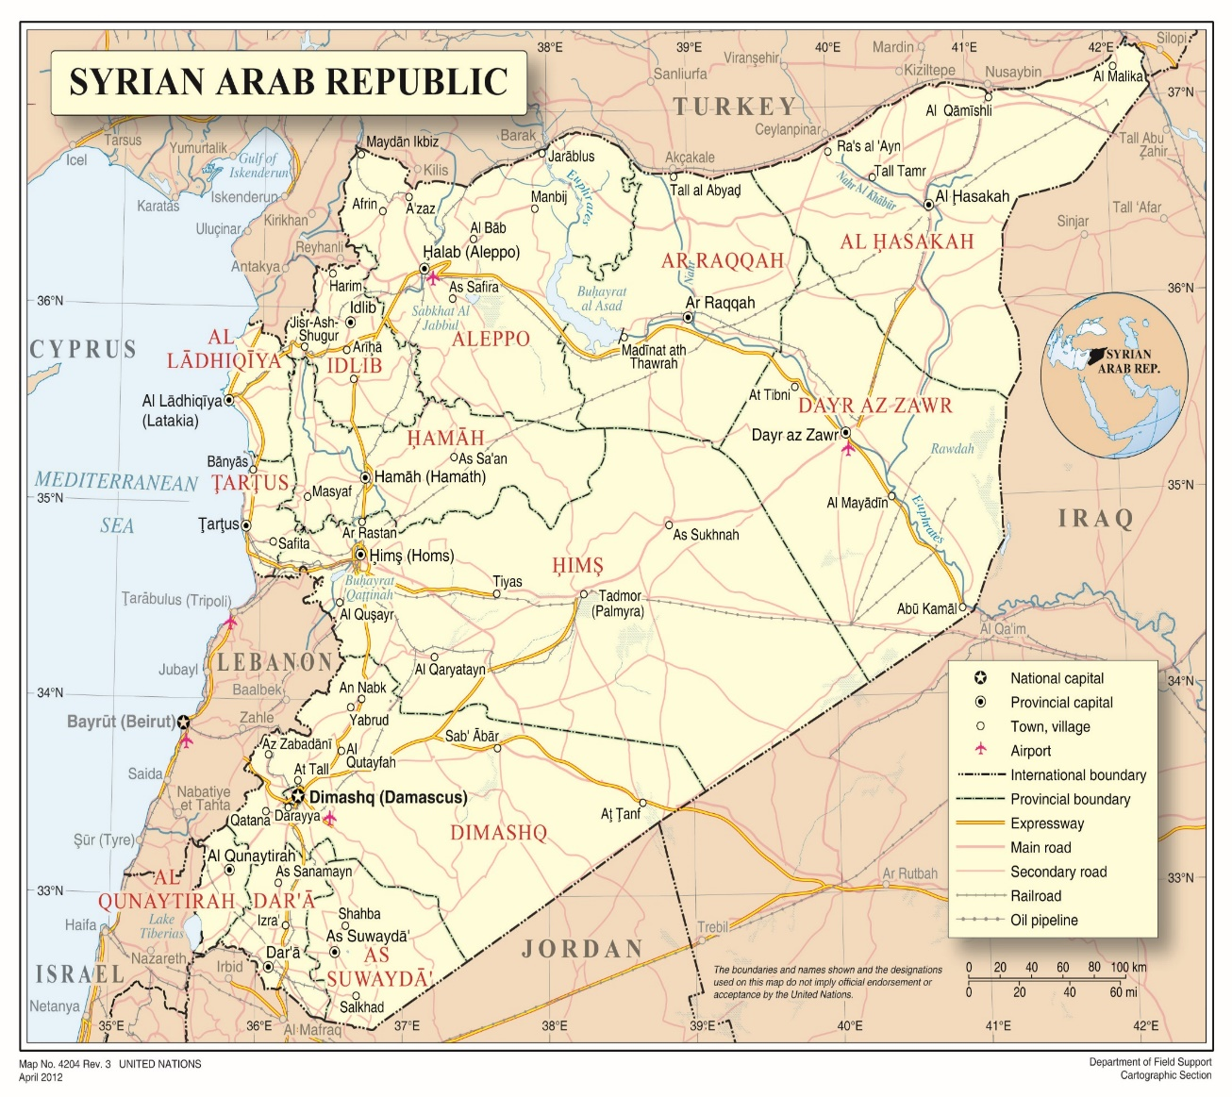

Annex II

Estimated area of influence maps, 2013–2020[107]

A. October 2013

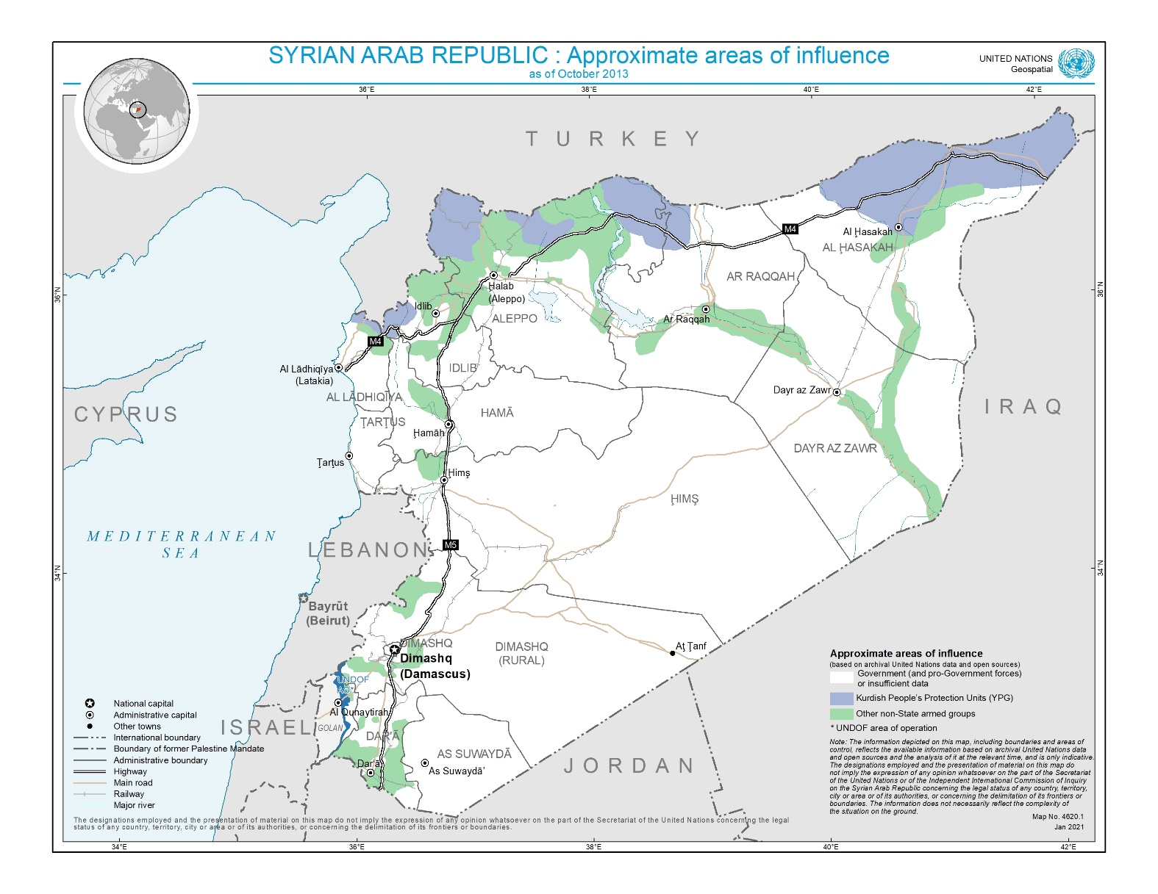

B. June 2014

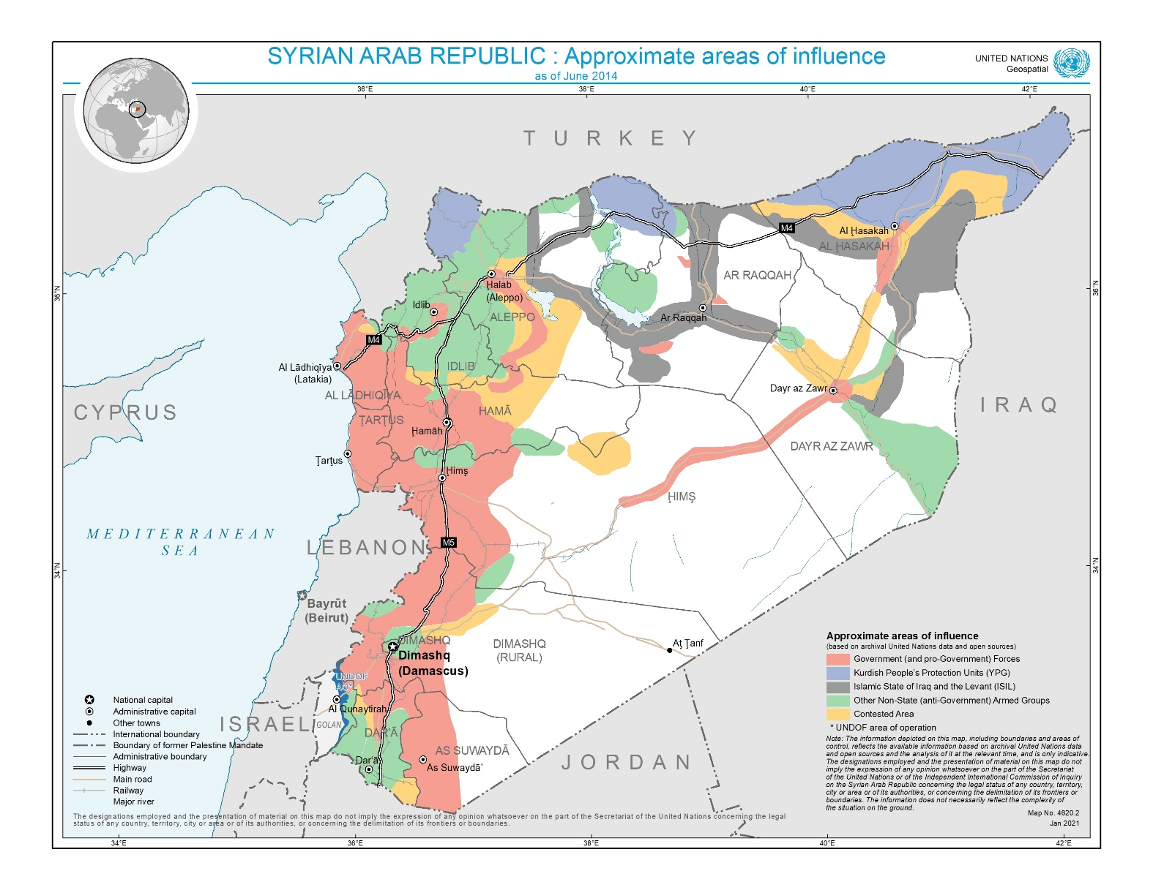

C. January 2015

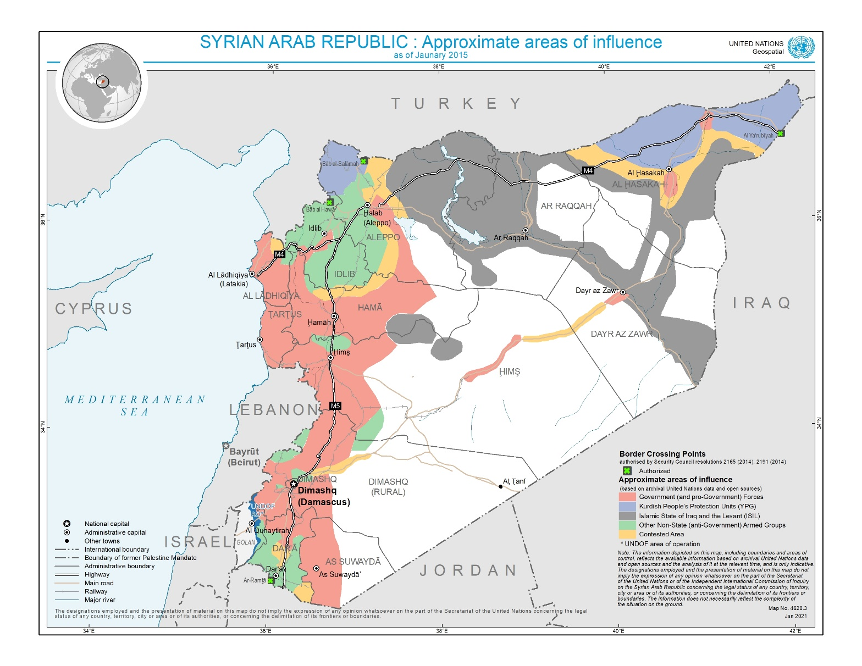

D. December 2015

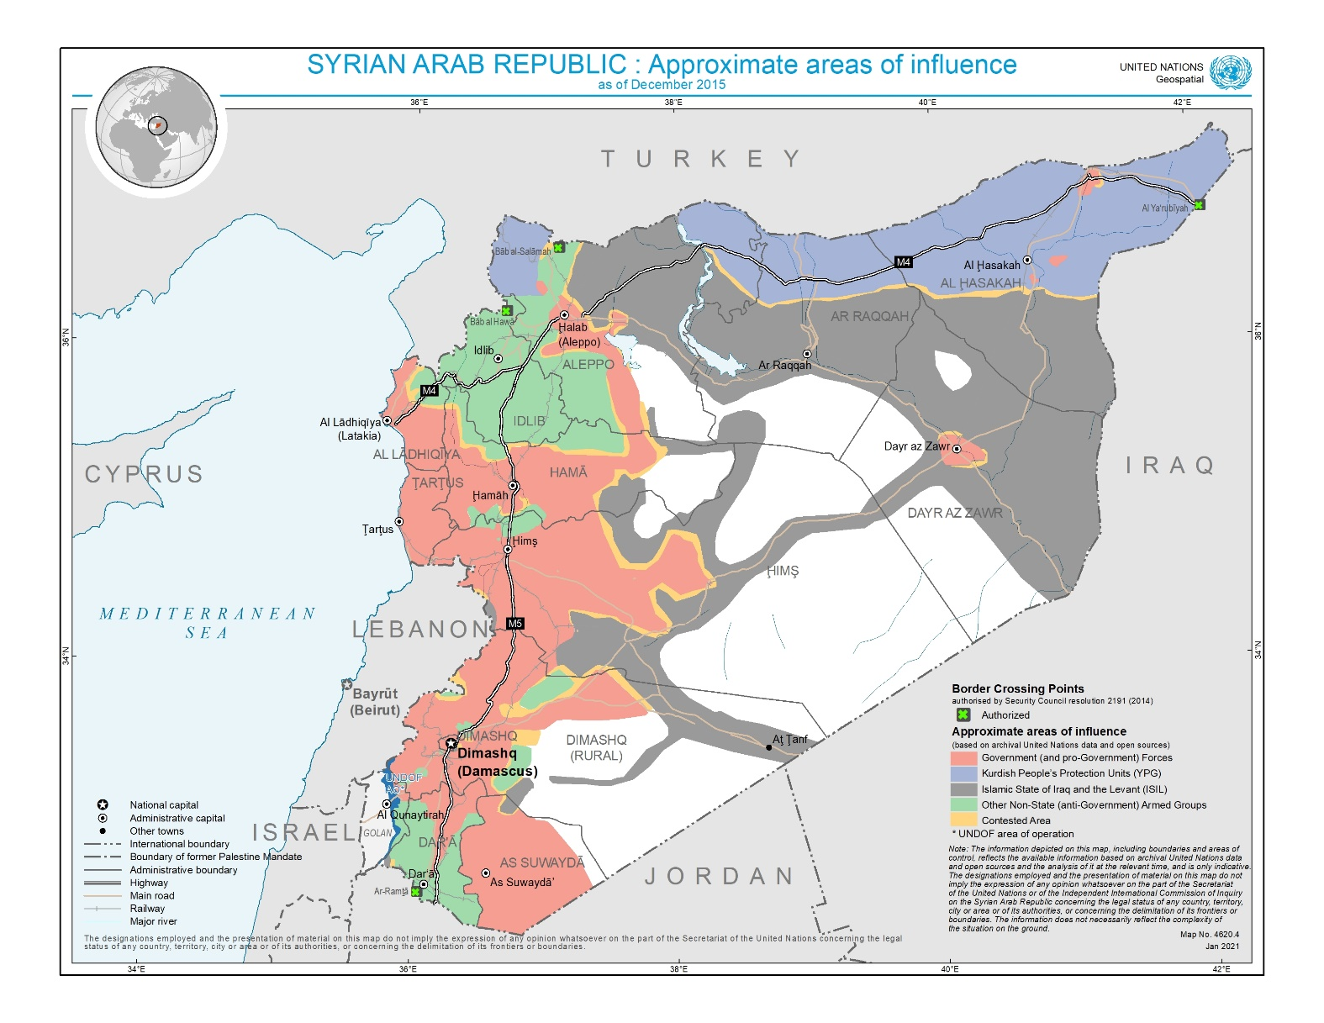

E. July 2016

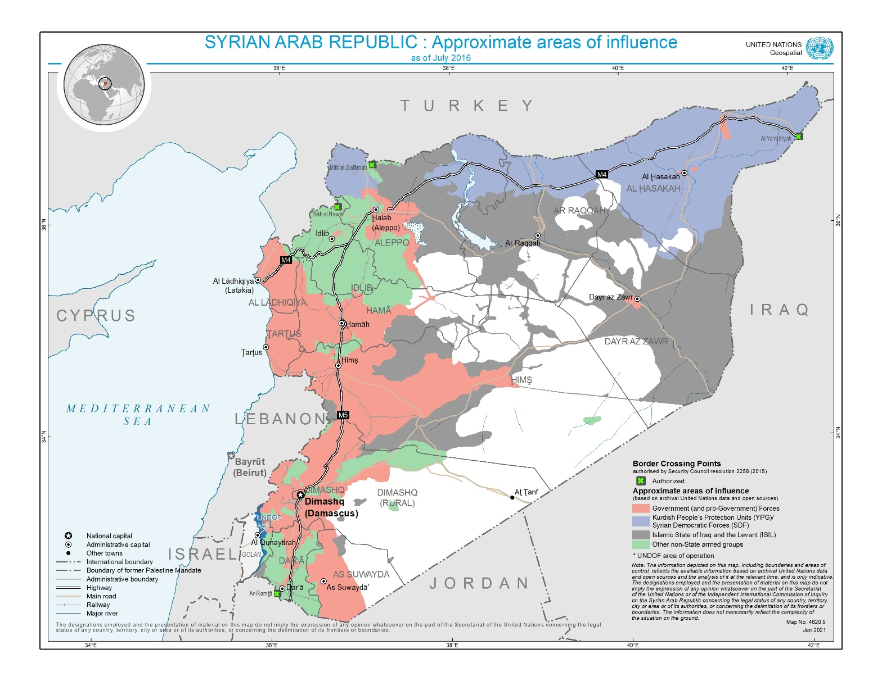

F. December 2016

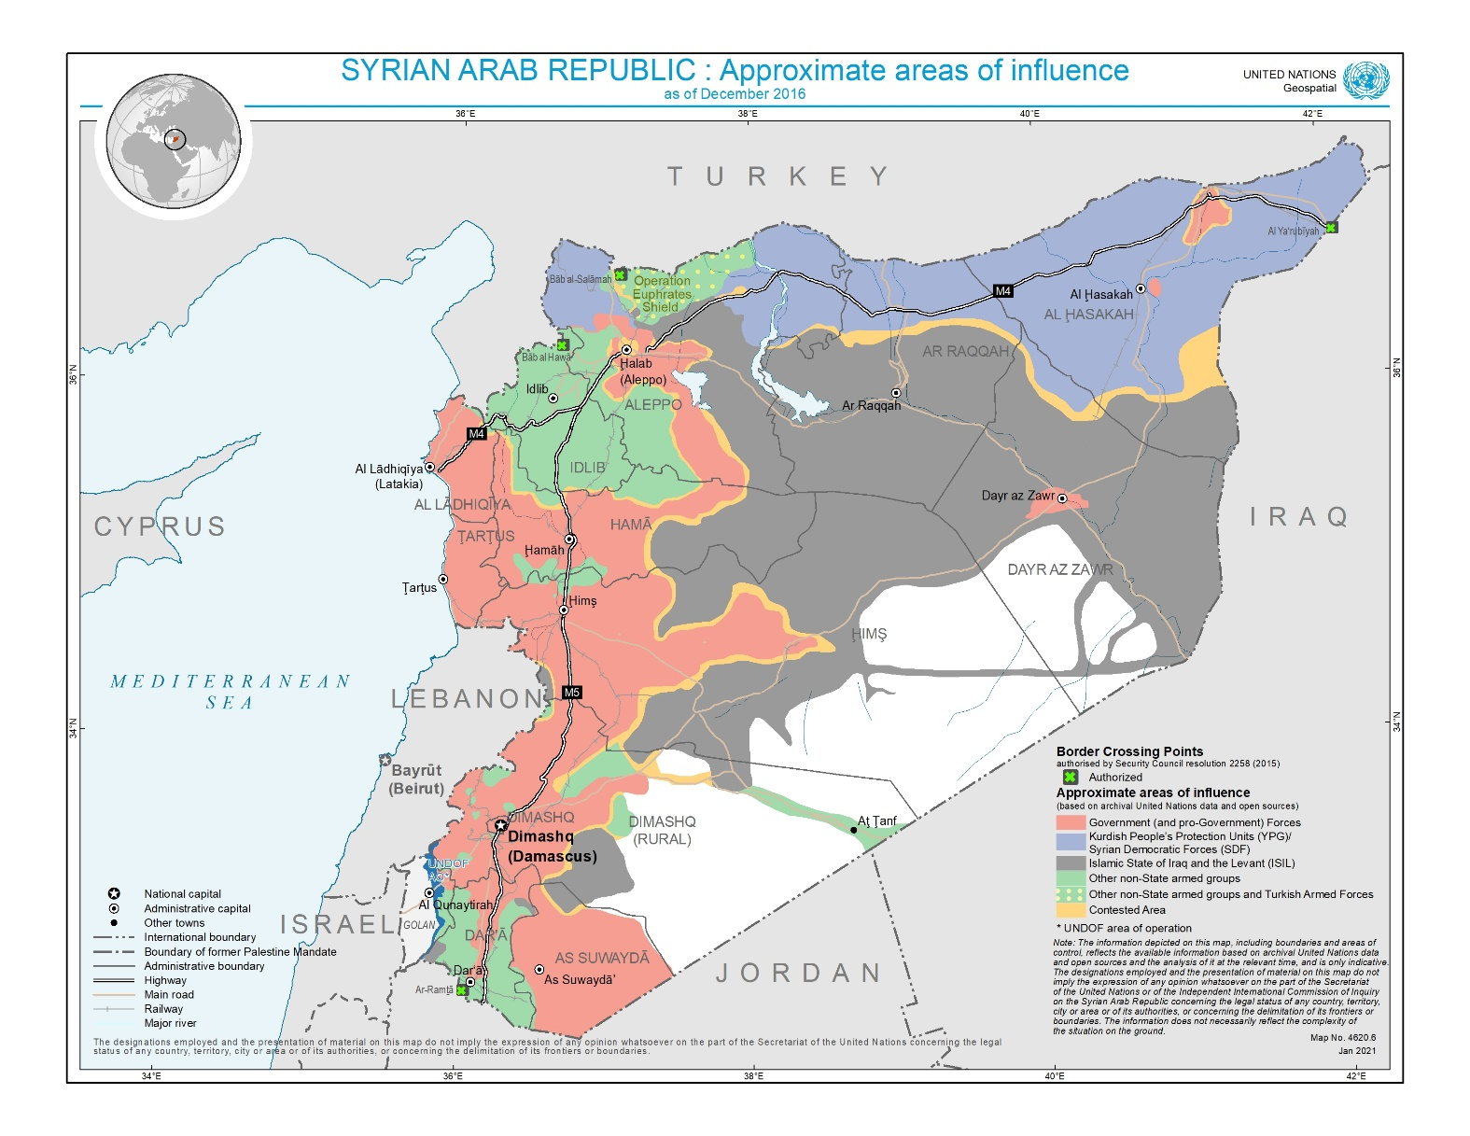

G. May 2017

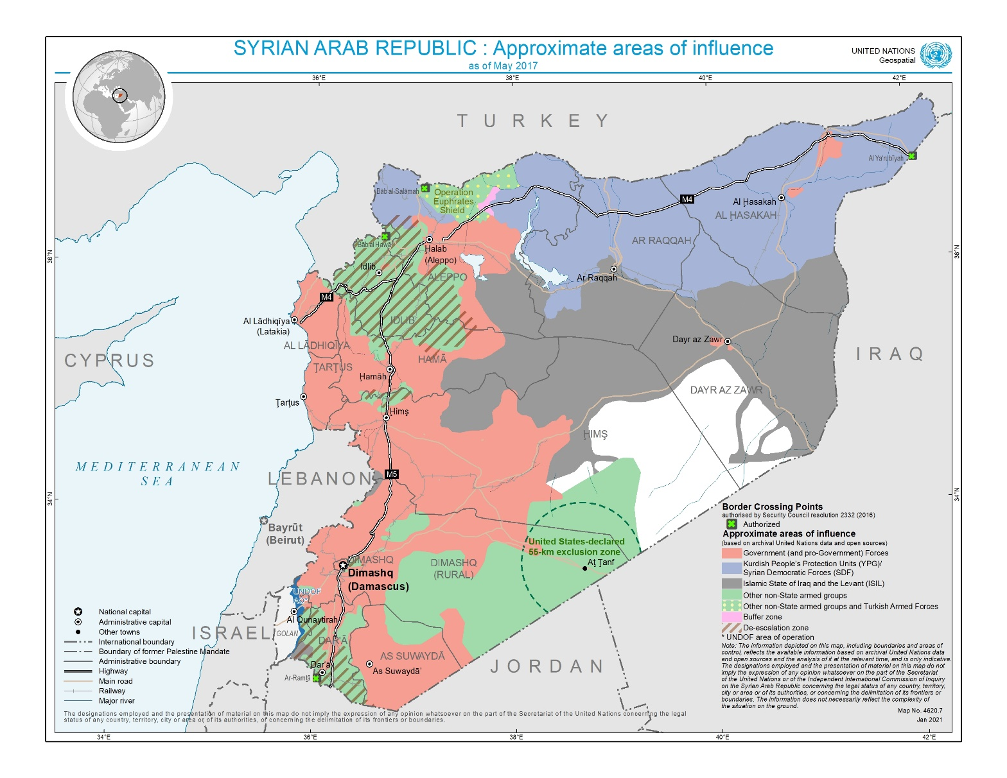

H. May 2018

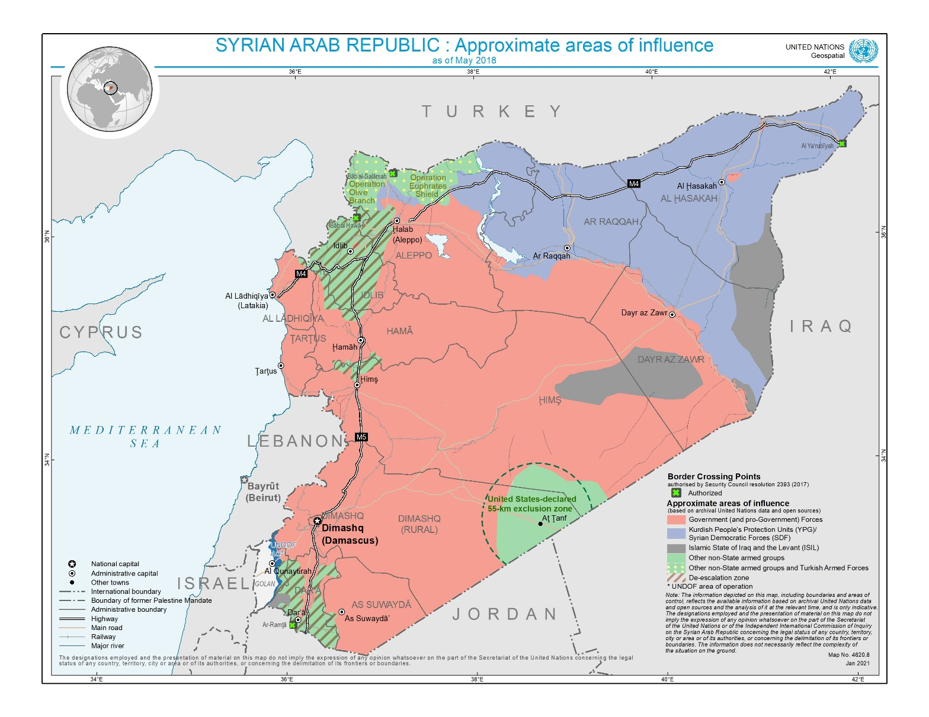

I. June 2019

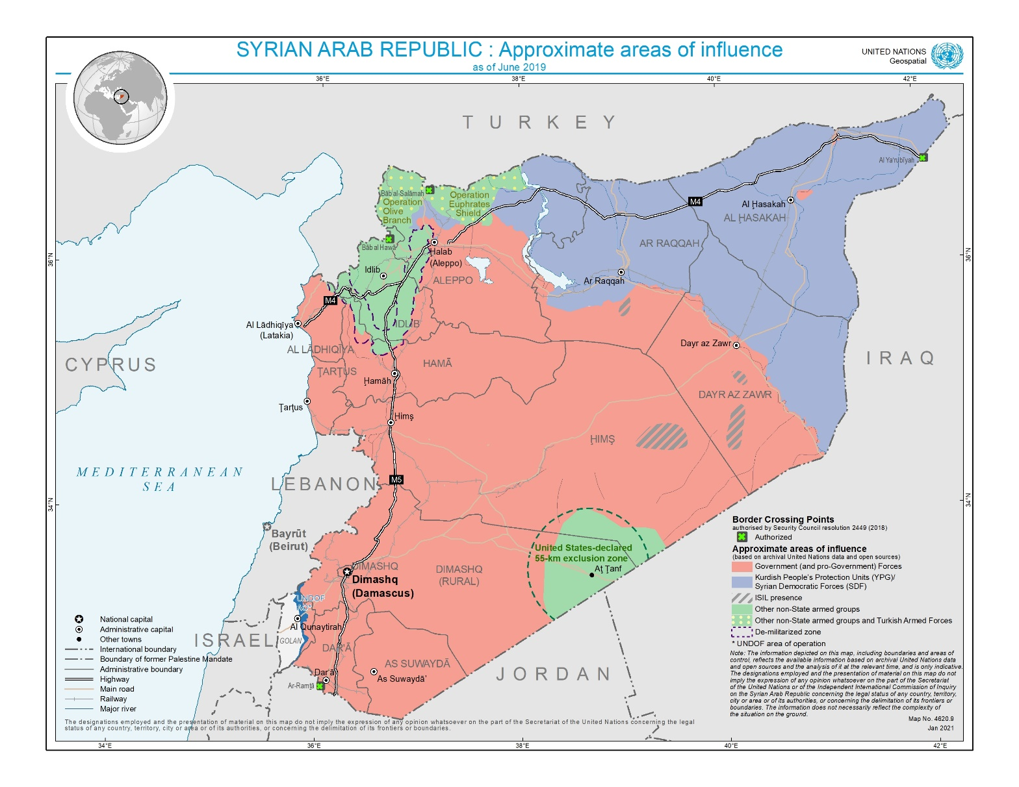

J. November 2020

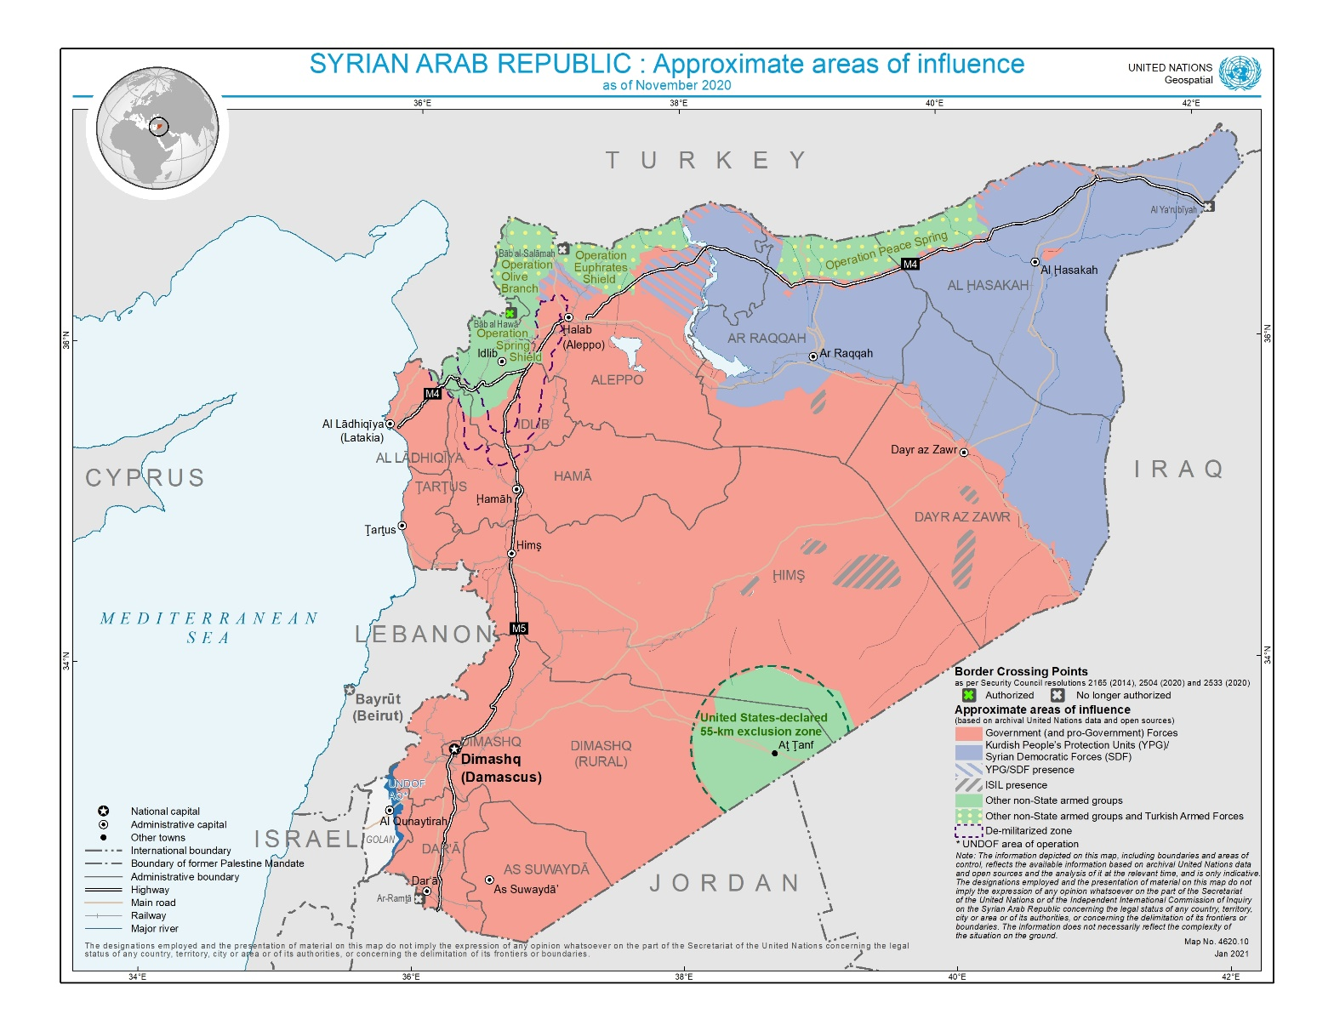

1. * Agreement was reached to publish the present report after the standard publication date owing to circumstances beyond the submitter’s control.
2. ** The annexes to the present report are circulated as received, in the language of submission only.
3. The commissioners are Paulo Sérgio Pinheiro (Chair), Karen Koning AbuZayd and Hanny Megally.
4. A/HRC/46/55.
5. See www.ohchr.org/EN/HRBodies/HRC/IICISyria/Pages/Documentation.aspx.
6. The vast majority of interviews were conducted in person. However, owing to the coronavirus disease (COVID-19) pandemic and the United Nations regular budget liquidity crisis, most interviews in 2020 were conducted virtually, and there were comparatively fewer.
7. The Chair of the Commission visited the Syrian Arab Republic at the invitation of the Government in his personal capacity from 23 to 25 June 2012, where he met with the Deputy Minister for Foreign Affairs, the Minister of Justice, other Government authorities and civil society interlocutors (A/HRC/21/50, para. 6).
8. A/HRC/S-17/2/Add.1, para. 23, listing the international human rights treaties to which the Syrian Arab Republic is a party.
9. A/HRC/S-17/2/Add.1, para. 27; and A/HRC/46/55.
10. A/HRC/S-17/2/Add.1, para. 62.
11. See A/HRC/46/55. For contextual information preceding the conflict, see the concluding observations of the Committee against Torture on the initial report of the Syrian Arab Republic (CAT/C/SYR/CO/1).
12. See A/HRC/S-17/2/Add.1 and A/HRC/19/69.
13. A/HRC/21/50, annex II, paras. 1–3. With that determination, the Commission applied international humanitarian law, including article 3 common to the four Geneva Conventions of 12 August 1949, as well as customary international humanitarian law alongside international human rights law.
14. A/HRC/25/65, annex IV.
15. Notwithstanding its change in name from “Jabhat al-Nusra” to “Jabhat Fatah al-Sham” in July 2016 and to “Hay’at Tahrir al Sham” by early 2017, the Commission continues to regard the group as a terrorist entity as designated by Security Council resolution 2170 (2014), with links to Al-Qaida globally.
16. The international coalition includes more than 60 countries combating ISIL through a variety of means, including airstrikes. See www.state.gov/bureaus-offices/bureaus-and-offices-reporting-directly-to-the-secretary/the-global-coalition-to-defeat-isis/. See also the letter dated 23 September 2014 from the Permanent Representative of the United States of America to the United Nations addressed to the Secretary-General (S/2014/695), invoking Article 51 of the Charter of the United Nations.
17. Russian Federation, Ministry of Defence, “Russian Deputy Minister of Defence Anatoly Antonov discussed the activities of the Russian Aerospace Forces in the Syrian Arab Republic with the United Nations representative”, 13 October 2015. Available at http://syria.mil.ru/en/index/syria/  
    news.htm?f=826&fid=4&blk=12059190&objInBlock=25; and the letter dated 24 August 2016 from the Permanent Representative of Turkey to the United Nations addressed to the President of the Security Council (S/2016/739), invoking Article 51 of the Charter of the United Nations.
18. Report of the Director-General of the Organisation for the Prohibition of Chemical Weapons, entitled “Progress on the elimination of the Syrian chemical weapons programme”, 24 November 2020, para. 11. Available at www.opcw.org/sites/default/files/documents/2020/11/ec96dg03%28e%29.pdf.
19. A/HRC/45/31, para. 30.
20. See http://syria.mil.ru/en/index/syria/news.htm?f=826&fid=4&blk=12059190&objInBlock=25; and S/2016/739.
21. See A/HRC/34/64.
22. Commission of Inquiry, “Sieges as a weapon of war: encircle, starve, surrender, evacuate”, policy paper, paras. 18–19. Available at www.ohchr.org/en/hrbodies/hrc/iicisyria/pages/documentation.aspx.
23. A/HRC/36/55, para. 75.
24. On oaths of loyalty and reconciliation, see also A/HRC/36/55, sect. III.A.1.
25. See Commission of Inquiry, “The siege and recapture of eastern Ghouta”, conference room paper. Available at www.ohchr.org/en/hrbodies/hrc/iicisyria/pages/documentation.aspx.
26. Operational Satellite Applications Programme of the United Nations Institute for Training and Research analysis from October 2017 shows 12,781 damaged or destroyed buildings, including 3,326 structures destroyed and a further 3,962 severely damaged. Although some damage and destruction may have occurred during previous fighting, the majority is attributed to the 2017 offensive. See https://reliefweb.int/sites/reliefweb.int/files/resources/reach_thematic_assessment_syrian_cities_damage_atlas_march_2019_reduced_file_size_1.pdf, pp. 12–13.
27. On 4 October, representatives of various Syrian armed opposition groups announced their formal unification under the umbrella of the Syrian National Army (A/HRC/42/51, para. 16).
28. The operations, in addition to Operation Euphrates Shield, resulted in the assumption by Turkey of obligations under the Geneva Convention relative to the Protection of Civilian Persons in Time of War, including the full range of positive obligations under the law of occupation. See A/HRC/45/31, paras. 67–69; and Commission of Inquiry, “Human rights abuses and international humanitarian law violations in the Syrian Arab Republic, 21 July 2016–28 February 2017”, conference room paper, para. 103. Available at www.ohchr.org/en/hrbodies/hrc/iicisyria/pages/documentation.aspx.
29. “Pro-government forces” is used when there are multiple allied actors operating in the same battlespace and disambiguation to the Commission’s standard of proof is not possible. It can, but does not always, include regular Syrian military, police and intelligence forces, pro-government militia, both foreign and domestic, and elements of foreign allied forces, such as Iranian Republican Guard forces or elements of Lebanese Hezbollah or other groups operating with the acquiescence of Syrian State authorities. In relation to airstrikes, where it was not clear whether an aerial attack was conducted by the Syrian Air Force or Russian Aerospace Defence Forces were responsible for a specific attack, responsibility has been attributed to pro-government forces.
30. A/HRC/S-17/2/Add.1, para. 15.
31. See https://hno-syria.org/#key-figures.
32. A/HRC/19/69, paras. 42–46.
33. A/HRC/28/69, para. 228.
34. A/HRC/21/50, para. 57; and A/HRC/44/61, paras. 80–81.
35. For example, A/HRC/45/31, para. 85.
36. A/HRC/24/46, para. 125; A/HRC/34/64, paras. 57 and 59; and Commission of Inquiry, “Human rights abuses”, para. 53.
37. A/HRC/25/65, para. 86; A/HRC/28/69, para. 228; and A/HRC/43/57, paras. 24–25.
38. A/HRC/28/69, para. 228.
39. A/HRC/23/58, para. 120.
40. Commission of Inquiry, “Assault on medical care in Syria”, conference room paper. Available at www.ohchr.org/en/hrbodies/hrc/iicisyria/pages/documentation.aspx.
41. A/HRC/33/55, paras. 44–49.
42. Commission of Inquiry, “Assault on medical care in Syria”.
43. A/HRC/28/69, annex II, para. 242 (ISIL); A/HRC/27/60, annex IV, para. 68 (Jabhat al-Nusra/Hay’at Tahrir al Sham); and A/HRC/39/65, para. 89 (Kurdish People’s Protection Units).
44. A/HRC/45/31, paras. 41–45.
45. A/HRC/36/55, para. 79; and A/HRC/37/72, sect. IV.A.1 and annex IV, paras. 7–11.
46. https://reliefweb.int/report/syrian-arab-republic/ar-raqqa-city-strategic-response-plan-july-2018.
47. A/HRC/39/65, para. 95.
48. See www.ohchr.org/Documents/HRBodies/HRCouncil/CoISyria/COISyria_Chemical Weapons.jpg.
49. Arms Trade Treaty, article 7.
50. International Committee of the Red Cross, Commentary on the Geneva Convention for the Amelioration of the Condition of the Wounded and Sick in Armed Forces in the Field, 2016, paras. 158–163. The Commission has documented in its reports the use of weapons and materiel, including aircraft, tanks, bombs, rockets and missiles, manufactured in third-party States.
51. A/HRC/46/55.
52. See A/HRC/46/55. For Syrian government forces, see also Commission of Inquiry, “Out of sight, out of mind: deaths in detention in the Syrian Arab Republic”, conference room paper. For ISIL, see Commission of Inquiry, “Rule of terror: living under ISIS in Syria”, conference room paper, and “‘They came to destroy’: ISIS crimes against the Yazidis”, conference room paper. For Hay’at Tahrir Al-Sham, see A/HRC/40/70, para. 57; A/HRC/43/57, para. 38; and A/HRC/44/61, para. 89. Conference room papers available at www.ohchr.org/en/hrbodies/hrc/iicisyria/  
    pages/documentation.aspx.
53. A/HRC/21/50, para. 59 and annex V, sects. I–II; A/HRC/22/59, paras. 47, 50, and 143 and annex IV, sects. I.A–D and F; and A/HRC/23/58, sect. III.B.4.
54. A/HRC/22/59, para. 64 and annex IV, sects. II.A and C.
55. A/HRC/28/69, para. 56.
56. For example, A/HRC/S-17/2/Add.1, paras. 88–89 (Government); A/HRC/25/65, para. 126 (ISIL); A/HRC/24/46 para. 94 (Kurdish People’s Protection Units); and A/HRC/43/57, paras. 33–34 (Hay’at Tahrir Al-Sham).
57. A/HRC/37/72, para. 3.
58. A/HRC/44/61, paras. 95–96.
59. A/HRC/27/60, para. 113; and A/HRC/45/31, paras. 63–64.
60. Compare the World Health Organization data as of the end of 2017 (available at www.emro.who.int/eha/news/seven-years-of-suffering-syria-facts-and-figures.html) with the data as of October 2020 (available at https://applications.emro.who.int/docs/SYR/EMRLIBSYR259E-eng.pdf?ua=1).
61. See www.who.int/countries/syr/ (accessed on 7 January 2021).
62. As of 6 January 2021, data from the “Opposition Assistance Coordination Unit” (see www.syriaig.net/ar/976/content/آخر%20نتائج%20واحصائيات%20كورونا%20في%20الشمال%20السوري(in Arabic)) and the “Autonomous Administration” (see https://twitter.com/enhawarnews/status/1346772026510422021).
63. See www.worldbank.org/en/country/syria/brief/the-toll-of-war-economic-and-social-impact-analysis-esia-of-the-conflict-in-syria-key-facts.
64. See www.wfp.org/countries/syrian-arab-republic#:~:text=WFP%20estimates%20that%209.3%  
    20million,people%2C%20including%20women%20and%20children.
65. A/HRC/21/50, para. 34.
66. A/HRC/36/55, para. 14.
67. A/HRC/45/31, para. 12.
68. See https://hno-syria.org/#key-figures.
69. See www.worldbank.org/en/country/syria/brief/the-toll-of-war-economic-and-social-impact-analysis-esia-of-the-conflict-in-syria-key-facts.
70. See https://reliefweb.int/sites/reliefweb.int/files/resources/reach_thematic_  
    assessment_syrian_cities_damage_atlas_march_2019_reduced_file_size_1.pdf.
71. A/HRC/39/65, sect. V.
72. An agreement initially negotiated in September 2015, known as the Four Towns Agreement, covering Zabadani, Madaya, Fu’ah and Kafraya and surrounding areas, was implemented beginning in April 2017. Negotiations for the agreement took place with armed groups and under the aegis of third-party States, which assisted in brokering it. See also A/HRC/36/55, paras. 18–20.
73. A/HRC/31/68, para. 120; A/HRC/37/72, para. 12 and annex II, sect. V. The Commission notes that the deliberate starvation of civilians is a war crime.
74. Commission of Inquiry, “Sieges as a weapon of war”, para. 12.
75. A/HRC/34/64, para. 93; and A/HRC/36/55, para. 35.
76. For a comprehensive overview of the Commission’s findings, see “‘I lost my dignity’: Sexual and gender-based violence in the Syrian Arab Republic”, conference room paper.
77. See A/HRC/28/69; Commission of Inquiry, “Human rights abuses”; A/HRC/36/55; and A/HRC/37/72. See also A/HRC/43/57, para. 65, on the signing, in June 2019, of an action plan between the Syrian Democratic Forces and the United Nations to end and prevent the recruitment and use of children under the age of 18.
78. Notwithstanding its name changes, as indicated above, the Commission continues to regard the group as a terrorist entity, as designated by Security Council.
79. Commission of Inquiry, “Rule of terror”, paras. 56–57.
80. For a comprehensive overview, see Commission of Inquiry, “‘They have erased the dreams of my children’: children’s rights in the Syrian Arab Republic”, conference room paper. Available at www.ohchr.org/en/hrbodies/hrc/iicisyria/pages/documentation.aspx.
81. A/HRC/34/64, annex I, para. 5.
82. A/HRC/40/70, para. 40; and Commission of Inquiry, “‘They have erased the dreams of my children’”, para. 39 and footnote 75.
83. See [www.unicef.org/mena/media/4086/file/SYR-FastFActs-En.pdf.](https://www.unicef.org/mena/media/4086/file/SYR-FastFActs-En.pdf.pdf)
84. See www.unhcr.org/sy/wp-content/uploads/sites/3/2018/09/Personal-Documentation-En-Jul-2018.pdf.
85. See www.unicef.org/press-releases/not-just-numbers-syrian-families-identify-their-needs-and-concerns-war-enters-tenth.
86. See, e.g., A/HRC/46/55; and Commission of Inquiry, “Death notifications in the Syrian Arab Republic”, policy paper, and “Out of sight, out of mind”. Available at www.ohchr.org/en/hrbodies/hrc/iicisyria/pages/documentation.aspx.
87. Syrian Arab Republic, Law of Personal Status, arts. 109 and 205 (2).
88. Syrian Arab Republic, Legislative Decree No. 276, art. 3.
89. Ibid. art. 3 (b).
90. A/HRC/44/61, para. 80.
91. See https://reliefweb.int/sites/reliefweb.int/files/resources/2019_Syr_HNO_Full.pdf, pp. 36–37.
92. For further discussion, see also https://ohchr.org/Documents/Publications/AttributingIndividualResponsibility.pdf.
93. A/HRC/S-17/2/Add.1, annex III.
94. A/HRC/45/31, para. 46.
95. See, for example, www.inherentresolve.mil/Portals/14/Documents/CIVCAS%20Releases/2020/CJTF-OIR%20Press%20Release-20201215-01-OCT2020%20CIVCAS%20Release%20(1).pdf. Note also that the United Kingdom has accepted responsibility without any finding of a violation in connection with the death of one civilian. See https://questions-statements.parliament.uk/written-statements/detail/2018-05-02/hcws665.
96. Notes verbales exchanged between the Commission and third-party States.
97. A/66/865-S/2012/522, annex, para. 10 (d).
98. See A/67/694-S/2013/19.
99. See https://news.un.org/en/story/2014/05/468962-russia-china-block-security-council-referral-syria-international-criminal-court.
100. A/HRC/28/69, sect. III.D.
101. Human Rights Council resolution 31/17, para. 4.
102. See https://syriaaccountability.org/wp-content/uploads/Trial-Report-11_Public_English_Final.pdf.
103. See https://cja.org/wp-content/uploads/2016/07/Colvin-v-Syria-Complaint.pdf.
104. Third-party States’ responses to notes verbales sent in November 2020 and open sources.
105. Christopher Phillips, *The Battle for Syria: International Rivalry in the New Middle East* (New Haven and London, Yale University Press, 2016), p. 232, quoting Lakhdar Brahimi in an interview with the author in Paris on 31 August 2015.
106. The boundaries and names shown and the designations used on this map do not imply official endorsement or acceptance by the United Nations.
107. The representation of approximate areas of influence is limited to data relevant for the human rights situation in the Syrian Arab Republic and in relation to the mandate and findings of the Commission of Inquiry on the Syrian Arab Republic.