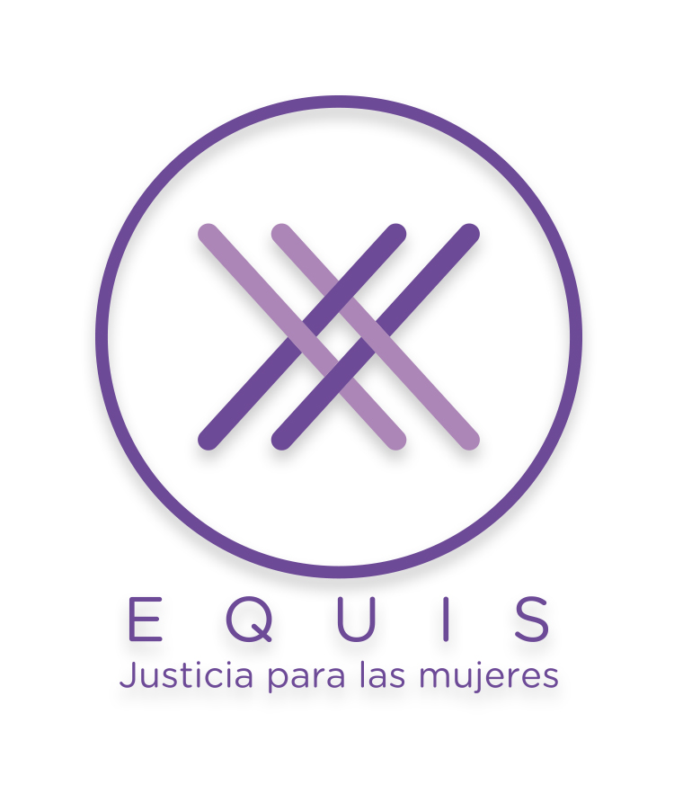
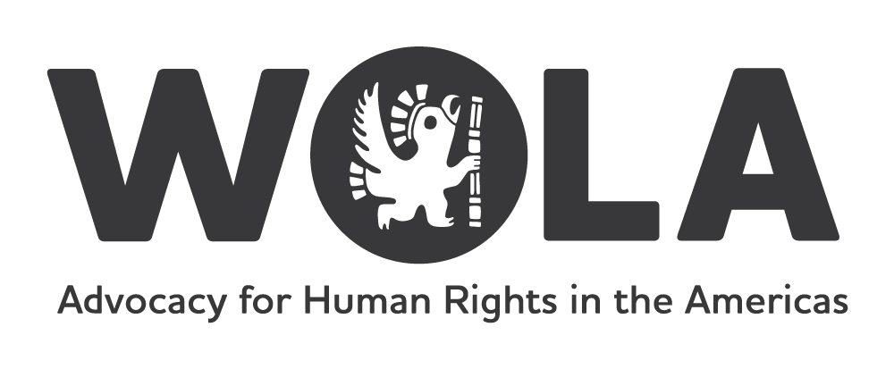

Submission to the Office of the High Commissioner on Human Rights’
Report on UNGASS Implementation and Human Rights

Submitted by:
The Washington Office on Latin America (WOLA)
EQUIS: Justicia para las Mujeres
The International Drug Policy Consortium (IDPC)
Dejusticia

May 18, 2018

This submission was prepared by WOLA, EQUIS: Jusitica para las Mujeres (Mexico), IDPC and Dejusticia (Colombia) on behalf of a working group on women, drug policy and incarceration in Latin America, led by the organizations listed above and in collaboration with the OAS Inter-American Commission on Women. The working group seeks to promote gender-sensitive drug policies rooted in public health and human rights and, specifically, end the mass incarceration of women for low-level drug offenses. The working group is composed of 25 individuals from non-governmental organizations, academia and governments. Members are from 9 Latin American countries, the United States, United Kingdom and Canada. Additional information can be found here: https://womenanddrugs.wola.org/about-the-project

In accordance with the Human Rights Council’s Resolution 37/42, this contribution is intended to provide input into the report of the Office of the High Commissioner for Human Rights (OHCHR) on the implementation of the UNGASS Outcome Document entitled, Our joint commitment to effectively addressing and countering the world drug problem. Our submission focuses on operational paragraphs (OP) within the Outcome Document relevant to promoting gender-sensitive, human rights-based drug policies.

The UNGASS Outcome Document stakes out new ground for the international drug control system in highlighting the importance of promoting gender-sensitive drug policies, recognizing both the particular vulnerabilities and specific needs of women in primary care and treatment programs, as well as within the criminal justice system. Chapter 4 on “Operational recommendations on cross-cutting issues: drugs and human rights, youth, children, women and communities” includes the following sections related to gender and drug policy:

4.b Ensure non-discriminatory access to health, care and social services in prevention, primary care and treatment programmes, including those offered to persons in prison or pretrial detention, which are to be on a level equal to those available in the community, and ensure that women, including detained women, have access to adequate health services and counselling, including those particularly needed during pregnancy;

4.d Continue to identify and address protective and risk factors, as well as the conditions that continue to make women and girls vulnerable to exploitation and participation in drug trafficking, including as couriers, with a view to preventing their involvement in drug related crime;

4.g Mainstream a gender perspective into and ensure the involvement of women in all stages of the development, implementation, monitoring and evaluation of drug policies and programmes, develop and disseminate gender-sensitive and age-appropriate measures that take into account the specific needs and circumstances faced by women and girls with regard to the world drug problem and, as States parties, implement the Convention on the Elimination of All Forms of Discrimination against Women;

4.n Encourage the taking into account of the specific needs and possible multiple vulnerabilities of women drug offenders when imprisoned, in line with the United Nations Rules for the Treatment of Women Prisoners and Non-custodial Measures for Women Offenders (the Bangkok Rules).

Women who use drugs and human rights (Relevant OP: 4.b)

Women who use drugs face significant stigma and, as a result, are often unable to access harm reduction, drug dependence treatment or basic healthcare – most of which are generally not tailored to their gender-specific needs. In contexts where drug use remains criminalized, women may face high levels of violence or harassment from law enforcement officers, as has been widely reported in Central Asia. Women with children or who are pregnant may also face losing custody of their children, forced or coerced sterilisation, or forced abortion. In certain jurisdictions, women who use drugs during pregnancy may also be subject to detention or criminal liability for exposing the fetus to a controlled substance. The Special Rapporteur on the right to health has found that the criminalization of drug use during pregnancy impedes access to healthcare, infringing on the right to health of pregnant women, and the UN Working Group on the issue of discrimination against women in law and in practice has considered such practices to be discriminatory.

Women and the criminal justice system (Relevant OP: 4.d and 4.n)

Punitive drug laws have had a disproportionate negative impact on women. Even though women continue to represent a small proportion of the general prison population, they are also the fastest growing prison population – and this is driven by repressive drug policies. According to the Institute for Criminal Policy Research World Female Imprisonment List, more than 714,000 women and girls are currently being held in penal institutions throughout the world. The data shows that the number of women and girls in prison has increased by 53 percent between mid-2000 and mid-2016, a period in which the worldwide male prison population increased by around 20 percent. The data identifies particularly sharp increases in Guatemala, El Salvador, Brazil, Colombia, Cambodia and Indonesia. In Brazil, the country’s female prison population increased by 342 percent between 2000 and 2016. Women incarcerated for drug offenses account for about 60 percent of the total female prison population in that country. A 2017 study by Equis: Justicia para las Mujeres found that over the previous two years, the number of women incarcerated for drug offenses in Mexico increased by 103.3 percent.

The highest levels of incarceration of women can be found in East and Southeast Asia, where the mass incarceration of individuals charged with low-level, non-violent drug offenses has led to severe prison overcrowding. As of 2015, over 47,000 women were behind bars in Thailand, and about 80 percent of them are convicted of drug offenses. In the Philippines, in early 2016 the Bureau of Corrections reported that about half of the women awaiting or undergoing trial in the Correctional Institute of Women were detained for drug-related offenses. It is important to note, however, that this figure has likely significantly increased since President Duterte launched his war on drugs in the Philippines, leading to over 12,000 deaths and mass incarceration.

Most of these women are arrested for non-violent, low-level yet high-risk activities, such as small-scale drug dealing or transporting drugs. They are often first-time offenders. The incarceration of these women contributes little to reducing the overall scale of the illicit drug market or improving public security, as these women are easily replaced in the illicit drug trade. And yet, they often face disproportionate prison sentences. A 2013 report by Dejusticia and the Collective for the Study of Drugs and the Law (CEDD) documents that the average maximum sentence for a drug offense in the seven Latin American countries studied rose from 34 years in prison in 1950 to 141 years in 2013; in Colombia, micro-trafficking is punished by a higher prison sentence than rape or even murder. Women’s incarceration can have severe and long-lasting consequences.

The “human face” of female incarceration (Relevant OP: 4.d)

Studies conducted on women deprived of their liberty or awaiting sentences for drug-related offenses show that these women often have little or no schooling, live in conditions of poverty, and are heads of household responsible for the care of young, elderly or disabled dependents. They may also be in need of harm reduction services, or of treatment for drug dependence and for mental or physical health problems. Most have suffered some form of sexual violence before and/or during their incarceration.

Women become involved in the drug trade due to poverty and social exclusion, as they are unable to find job opportunities in the licit economy. In Colombia, for example, 76 percent of incarcerated women do not have a high school diploma. In some cases, women are coerced into drug dealing and trafficking by male relatives or intimate partners. Others become involved because it is a family business.

An astounding number are single mothers. In Colombia, of all women who entered prison for drug crimes between 2010 and 2014, 93.4 percent had children, compared to only 76.2 percent of their male counterparts. With regards to women heads of household, 86.4 percent were detained solely for minor, non-violent drug crimes. A 2012 government study in Costa Rica revealed that more than 95 percent of women in prison who were detained for smuggling drugs into prisons were single mothers with the sole responsibility for providing for their children.

The incarceration of mothers can be devastating for their dependents. In the absence of strong social protection networks, their dependents are exposed to abandonment and are further marginalized. In addition, prison further limits the chances of finding decent and legal employment, as women coming out of prison now have a criminal record. All of these factors can perpetuate cycles of poverty, involvement in drug markets and incarceration.

Alternatives to criminalization and incarceration (Relevant OP: 4d and 4n; also 4.j and 4.l)

The UN Special Rapporteur on violence against women, as well as the Committee on the Elimination of all forms of Discrimination against Women, have both called upon States to develop gender-sensitive alternatives to incarceration, and promote a paradigm shift away from incarceration and towards community-based sentencing for female offenders. This will also require a review of national drug laws and policies to ensure proportionate penalties for drug offenses, including the consideration of mitigating factors such as socio-economic vulnerability, being the sole care provider of dependents, and drug dependence, among others.

The rights to equality and non-discrimination are protected under international law, from which different obligations arise. Under the Convention on the Elimination of all forms of Discrimination against Women (CEDAW) and other human rights treaties and standards, States are obliged to ensure equal rights to men and women in all respects, including equal access to health care services for both men and women.

Similarly, the UN Rules for the Treatment of Women Prisoners (Bangkok Rules) – a reference of which is included in OP 4.n of the UNGASS Outcome Document – protect the principle of non-discrimination and the right to health, requiring States to address the specific challenges confronted by women in the criminal justice and prison systems. This includes the use of alternatives to incarceration for women in prison for drug offenses, as well as the need to provide adequate harm reduction and treatment services for women dependent on drugs in prison or other forms of detention. WHO, UNAIDS and UNODC guidelines have also emphasized the need to ensure comprehensive health and reproductive services for women who use drugs, including HIV-related services.

Good practice example: Costa Rica implements an alternative approach

In 2011, Costa Rica revised its drug legislation to introduce greater proportionality of sentencing and gender sensitivity. The reform reduced the length of incarceration for vulnerable women accused of smuggling drugs into prison. The program initially benefited 150 women who were immediately released from prison. Those convicted for this offense can now benefit from alternatives to incarceration. In 2014, the country’s Public Defender’s Office also launched a an inter-institutional support network, which works to divert women in situations of vulnerability away from the criminal justice system and offer them services such as counseling, drug treatment, and job training. The needs of each woman are determined by a caseworker, and a tailored action plan is developed for each client. The goals of the program are to reduce recidivism and help women regain their rights and dignity.

Of particular significance, Costa Rica implemented an important reform to eliminate barriers to re-entry into society for all non-violent offenders. As noted above, criminal records constitute a significant barrier for formerly incarcerated people who are seeking employment. Law 9361, passed in January 2017, reformed the court registry in Costa Rica, allowing for criminal records to be eliminated. The opportunity to erase one’s criminal record is based on criteria that take into account the length of the sentence, the offense committed and, when relevant, the “situation of vulnerability” of the offender.

Recommendations

The OHCHR has a key role to play in encouraging the adoption of drug policies rooted in gender-based human rights. We respectfully encourage the OHCHR to undertake the following actions:

- Establish a focal person in Vienna to coordinate with UN drug control agencies on issues relevant to drugs and human rights – and ensure that the issue of gender remains high on the political agenda in Vienna.
- Participate actively in key high-level UN events on drug control, including at the yearly Commission on Narcotic Drugs meeting, to report on human rights and drug policies, and more specifically on the impact of drug control on women.
- Encourage OHCHR Special Procedures, in particular the Working Group on the Prevention of Discriminations Against Women in Practice and the Law, to analyse and give more visibility to the interactions between their mandates and drug policy.
- Conduct bi-annual assessments of the human rights situation as it relates to drug control, from a gender perspective, which should be submitted to the UNODC for inclusion in its World Drug Report.

We also suggest that the following operational recommendations for member states be included in the OHCHR final report:

Recent, relevant, and reliable national prison data disaggregated by sex is often unavailable from countries and this hinders the possibility of designing effective policies to meet the needs of vulnerable and underrepresented groups. We recommend that the OHCHR urge states to commit to generating and gathering comprehensive data from prison authorities that details the nature and extent of global incarceration for both women and men.

In addition, we call on the OHCHR’s report to request that member states:

- Commit to a rights- and gender-based harm reduction approach to women who use drugs, and end the criminalization, stigmatization, forced treatment and incarceration of women who use or have used drugs.
- Review drug laws and policies to ensure more proportionate sentencing for drug offenses, in order to avoid the imposition of lengthy sentences for women who have committed non-violent drug offenses such as possession of small quantities of drugs, small-scale dealing or engagement in the drug trade as drug couriers – the objective being that incarceration is used only as a last resort.
- Implement alternatives to incarceration for women incarcerated for drug offenses, in particular for those who are pregnant or in charge of dependents.
- Ensure that in cases where women have young children in her custody, the best interest of the child is the guiding principle in processing her sentence.
- Encourage and ensure women’s participation in the development, implementation, evaluation and monitoring of drug policies and programs, especially those women who are directly impacted by drug use, the drug trade or drug policies (in line with OP: 4.g). This should include women drug users; women who are or have been incarcerated; mothers, wives or partners of persons who are incarcerated; and members of communities that have been impacted.

- Recognize that persons from certain sectors of the population – including Afrodescendents, indigenous peoples, other ethnic minorities, migrants, foreigners working as drug couriers, people with disabilities and the LGBTI community – are disproportionately impacted by current drug policies, and ensure that representatives of these groups participate in the debate and in developing these policies.

ENDNOTES http://ap.ohchr.org/documents/dpage_e.aspx?si=A/HRC/37/L.41
http://www.harm-reduction.org/library/law-enforcement-and-women-who-use-drugs
Office of the High Commissioner on Human Rights, “Study on the impact of the world drug problem on the enjoyment of human rights”, 4 September 2015, UN Doc. A/HRC/30/65, para. 53.
Office of the High Commissioner on Human Rights, “Study on the impact of the world drug problem on the enjoyment of human rights”, 4 September 2015, UN Doc. A/HRC/30/65, para. 53.
Alabama Code Section 26-15-3.2: Chemical Endangerment of Exposing A Child to an Environment in Which Controlled Substances are Produced or Distributed; Amnesty International, “Tennessee ‘fetal assault’ law a threat to women's health and human rights” (AMR51/3623/2016), 11 March 2016.
Report of the Special Rapporteur on the right of everyone to the enjoyment of the highest attainable standard of physical and mental health, 3 August 2011, UN Doc. A/66/254, para 41.
Report of the Working Group on the issue of discrimination against women in law and in practice, 8 April 2016, UN Doc. A/HRC/32/44, para. 39.
http://www.prisonstudies.org/news/world-female-imprisonment-list-fourth-edition
http://www.prisonstudies.org/news/world-female-imprisonment-list-fourth-edition
http://www.prisonstudies.org/country/brazil
Collective for the Study of Drugs and the Law (2015), The Incarceration of Women for Drug Offenses, p. 3, http://www.drogasyderecho.org/publicaciones/pub-priv/luciana_i.pdf
EQUIS Justicia para las Mujeres (2017), Politicas de drogas, género y encarcelamiento en México: Una guía para políticas públicas incluyentes, p. 9, http://equis.org.mx/wp- content/uploads/2017/11/GuiaDeDrogas-WEB-2.pdf.
Kittayrak, K., For female offenders, jail often no solution, Bangkok Post, 9 June 2015, http://www.bangkokpost.com/opinion/opinion/586901/for-female-offenders-jail-often-no-solution
See http://www.drogasyderecho.org/publicaciones/pub-col/proportionality-colombia-(addicted-punishment).pdf and www.drogasyderecho.org
See https://www.oas.org/en/cim/docs/WomenDrugsAmericas-EN.pdf and http://idpc.net/publications/2013/11/idpc-briefing-paper-women-drug-offenses-and-penitentiary-systems-in-latin-america
Dejusticia (2016), Women, Drug Policies and Incarceration: A Guide for Policy Reform in Colombia, p. 27, https://www.dejusticia.org/wp-content/uploads/2017/04/fi_name_recurso_866.pdf?x54537
Ibid.
Defensoría Pública de Costa Rica, Estudio de la Defensa Pública de Costa Rica sobre el perfil de la población femenina privada de libertad por introducir drogas a los centros penales, April 2012, p. 4.
WOLA, IDPC, DeJusticia, CIM, OAS (2016), Women, drug policies, and incarceration – A guide for policy reform in Latin America and the Caribbean, https://www.wola.org/analysis/women-drug-policies-and-incarceration/
Report of the Special Rapporteur on violence against women, ‘Pathways to, conditions and consequences of incarceration for women’, 21 August 2013,UN Doc. A/68/340, para. 85.
Committee on the Elimination of Discrimination against Women, General Recommendation 33 on women’s access to justice, 3 August 2015, UN Doc. CEDAW/C/GC/33, para. 48.
Convention on the Elimination of all forms of Discrimination Against Women, articles 12 and 2.
United Nations Rules for the Treatment of Women Prisoners and Non-Custodial Measures for Women Offenders. ECOSOC resolution 2010/16, December 2010.
http://www.who.int/hiv/pub/idu/idu_target_setting_guide.pdf
https://www.wola.org/wp-content/uploads/2017/05/DONE-2-Costa-Rica-77bis_ENG_FINAL-.pdf
https://www.wola.org/wp-content/uploads/2017/05/DONE-3-Red-interinstitucional-Costa-Rica_ENG_FINAL-.pdf
https://mujeresydrogas.wola.org/wp-content/uploads/2017/12/DONE-14-Criminal-Records-in-CR_ENG_FINAL-1.pdf
For more information on data collection with a gender perspective, see: https://www.wola.org/sites/default/files/Data%20English_FINAL.pdf
For more information, see: WOLA, IDPC, DeJusticia, CIM, OAS (2016), Women, drug policies, and incarceration – A guide for policy reform in Latin America and the Caribbean, https://www.wola.org/analysis/women-drug-policies-and-incarceration
For more information on alternatives to incarceration with a gender perspective, see: https://www.wola.org/sites/default/files/Alternatives%20to%20Incarceration_English_Final_0.pdf

