 |  |  | A/HRC/42/17
 | Advance Edited Version |  |  | Distr.: General  9 August 2019  Original: English
Human Rights Council
Forty-second session
9–27 September 2019
Agenda item 2
Annual report of the United Nations High Commissioner
for Human Rights and reports of the Office of the
High Commissioner and the Secretary-General
Situation of human rights in Yemen, including violations and abuses since September 2014
Report of the Group of Eminent International and Regional Experts as submitted to the United Nations High Commissioner for Human Rights*, **
Summary
In the present report, the Group of Eminent International and Regional Experts highlights incidents and patterns of conduct since September 2014, including those between September 2014 and June 2018 not covered in its previous report (A/HRC/39/43), and incidents and patterns between July 2018 and June 2019 in the context of the ongoing conflict and humanitarian crisis.
The Group of Experts found patterns of continued violations by all parties to the conflict, as civilians continued to be killed and injured by the fighting and to suffer violations of their most basic human rights.
I. Introduction
1. In its resolution 36/31, the Human Rights Council requested the United Nations High Commissioner for Human Rights to establish a group of eminent international and regional experts to monitor and report on the situation of human rights in Yemen. The Council mandated the Group to conduct a comprehensive examination of all alleged violations and abuses of international human rights and other appropriate and applicable fields of international law committed by all parties to the conflict since September 2014, to establish the facts and circumstances surrounding the alleged violations and abuses and, where possible, to identify those responsible.
2. In December 2017, the High Commissioner appointed Kamel Jendoubi (Tunisia) (Chair), Charles Garraway (United Kingdom of Great Britain and Northern Ireland) and Melissa Parke (Australia) as the experts. Following the submission by the Group of Experts of its report to the Human Rights Council at its thirty-ninth session (A/HRC/39/43), the Council, in its resolution 39/16, extended the mandate of the Group for a further year, and requested it to submit a comprehensive report to the High Commissioner for presentation to the Council at its forty-second session.
II. Methodology
3. In the present report, the Group of Experts addresses incidents and patterns in Yemen since September 2014, including certain emblematic situations that arose between September 2014 and June 2018 not covered by the Group in its first report, and incidents and patterns occurring between July 2018 and June 2019 as part of the ongoing conflict. In accordance with its mandate, the Group identifies, where possible, those responsible. Owing to the restrictions placed on its access and the limited time and resources available to it, the Group continued to prioritize incidents on the basis of the gravity of allegations. The findings presented do not reflect actual numbers of violations likely to have been committed, but represent only a small sample of the violations committed since September 2014.
4. In January 2019, the Group addressed its requests for submissions to the Government of Yemen, the de facto authorities and the coalition led by Saudi Arabia and the United Arab Emirates supporting the Government of Yemen. In February 2019, the Group of Experts issued an online call for submissions by 1 June 2019. The Group addressed further written requests for specific information to the coalition on 25 March, to the Government of Yemen on 29 March, to the de facto authorities on 10 April, and to all of them on 1 July. As at 24 July, only the de facto authorities had responded. The Group also considered responses from the coalition and the Government of Yemen received in 2018, and letters received from the Governments of Yemen, Saudi Arabia and the United Arab Emirates addressed to the Human Rights Council and senior United Nations officials detailing their positions on the findings of the Group of Experts outlined in its report (A/HRC/39/43).
5. Consistent with established evidentiary standards of United Nations fact-finding bodies, the Group of Experts adopted the “reasonable grounds to believe” standard of proof. It undertook fact-finding practices aimed at ensuring the safety and security of witnesses and victims.
6. Despite the restrictions placed on its access to Yemen following the release of its first report, the Group of Experts continued to gather evidence, including by using methods based on ever-evolving best practices from fact-finding bodies facing similar constraints. It conducted more than 600 interviews with victims, witnesses and other sources, and examined a large volume of documentary and open-source material. Its findings are based on its independent investigations, focusing on allegations of violations of international law relating to situations emblematic of the armed conflict. Where available and appropriate, the Group also examined information from additional sources, reaching independent conclusions on such content after assessing the reliability of the information and credibility of the source.
7. The Group of Experts regrets that, following the release of its first report, the Governments of Yemen, Saudi Arabia, the United Arab Emirates and Egypt did not cooperate with the Group or support its work. While the de facto authorities agreed to the request by the Group to visit areas under its control, the Government of Yemen did not respond to its multiple requests for permission to enter Yemen, thereby preventing access to the country and, consequently, to victims and information. The Group denounces the environment of fear created by some of the parties to the conflict that caused witnesses, victims and organizations to reconsider their cooperation with it. Furthermore, the lack of safe spaces for victims and witnesses to have privacy to speak with investigators had a detrimental impact, especially on cases involving the most vulnerable and marginalized persons, such as gender-based violence, and violations against children and persons with disabilities.
8. The Group of Experts once again expresses its gratitude to the victims and witnesses who shared their experiences, and for the assistance provided by government and non-governmental entities and by United Nations agencies and partners.
III. Legal framework
9. The situation in Yemen qualifies as a non-international armed conflict between the armed forces of the Government of Yemen and the Houthis, to which article 3 common to the Four Geneva Conventions and Additional Protocol II apply, as does customary law. With the coalition’s intervention in 2015, its members became parties to the conflict as co-belligerents on the side of the Yemeni armed forces.
10. A number of other non-international armed conflicts also continue in Yemen, between the Government of Yemen and other non-State armed groups, including Islamic State in Iraq and the Levant and Al-Qaida in the Arabian Peninsula, and among different armed groups, some affiliated with the parties to the main conflict. Provisions regulating non-international armed conflict also apply to these conflicts. These rules are also relevant to the United States of America insofar as it is involved in operations in support of the Government of Yemen against Islamic State in Iraq and the Levant and Al-Qaida in the Arabian Peninsula.
11. The obligations of third States to ensure respect for international humanitarian law are also particularly relevant in this context for any State that influences or may provide support for parties to the conflict, such as France, the Islamic Republic of Iran, the United Kingdom of Great Britain and Northern Ireland and the United States of America.
12. International human rights law is concurrently applicable with international humanitarian law. The Government of Yemen is party to seven of the nine core universal human rights conventions. While the Government’s human rights obligations cover the entirety of the territory of Yemen, the de facto authorities, given their exercise of government-like functions in the areas they effectively control, are also bound by international human rights obligations. Human rights obligations of non-State armed groups and member States of the coalition may arise insofar as they exercise control over certain areas or facilities.
13. International criminal law is relevant insofar as it reflects customary law, as Yemen and most members of the coalition (except for Jordan and Senegal) are not parties to the Rome Statute of the International Criminal Court.
IV. Context and situational update (July 2018 – June 2019)
14. In the past year, the conflict in Yemen continued unabated, including on new fronts (see A/HRC/39/43). While international attention concentrated on the battle for Al-Hudaydah, followed by ceasefire discussions, the parties shifted their focus and resources to frontlines in Ta’izz, Hajjah, Sa’dah, and Al-Dhale’e. Civilians continued to be killed and injured by the fighting and to suffer violations of their most basic human rights. With the persistence of the armed conflict and failure of the parties to act in the best interests of the population, Yemen remained the world’s worst humanitarian crisis.
15. From May 2018, Yemeni armed forces and groups backed by the United Arab Emirates began to mobilize for an offensive, which officially began on 13 June, as they moved towards Al-Hudaydah city amid continued warnings from the United Nations and others of the potentially disastrous humanitarian implications. In mid-July, Yemeni armed forces in the north, with coalition air support, advanced into two districts in Hajjah Governorate, cutting off Houthi supply lines to Hajjah and Sa’dah governorates. Clashes broke out along the frontlines in Hajjah and Sa’dah as parties continued to fight for control of the strategically important parts of the governorates. Meanwhile, forces backed by the United Arab Emirates aligned with the Southern Transitional Council continued to solidify their control in Aden and other southern governorates, engaging in sporadic clashes with forces loyal to the Government, thereby eroding government authority.
16. In early November, fighting around Al-Hudaydah city intensified before Yemeni armed forces and affiliated armed groups halted their offensive, on 13 November. One month later, under the auspices of the Special Envoy of the Secretary-General for Yemen, the parties reached an agreement, referred to as the Stockholm Agreement, for a ceasefire in Al-Hudaydah city, plans for the handover of the ports of Al-Hudaydah, Salif and Ras ‘Issa, a mechanism for activating the exchange of prisoners and a statement of understanding on Ta’izz. Implementation of the Stockholm Agreement progressed slowly while, until May 2019, the de facto authorities blocked access to grain stored at the Red Sea Mills (enough to feed 3.7 million people for a month). Parties have also obstructed access to a 1.1 million barrel oil storage facility in the sea at Ras ‘Issa port, which urgently requires maintenance to avoid a leak, which could have a catastrophic environmental impact on the Red Sea.
17. January 2019 marked the end of a truce between the Houthis and the tribes of Hajour and, inside that part of Hajjah Governorate, the beginning of military operations, which ended with the takeover of Hajour by the Houthis on 8 March. The region, including Mount Kushar and Al-‘Abbaysa, is considered to be strategically important, given that it links several governorates. In early May, Houthi fighters started advancing south, capturing mountains and villages in Al-Dhale’e and Al-Bayda governorates after heavy fighting with Yemeni armed forces and affiliated armed groups.
18. On 14 May, the Houthis claimed responsibility for drone attacks striking oil facilities in Saudi Arabia, which led to an intensification of the coalition air campaign and subsequent missile attacks claimed by the Houthis, including some that reportedly killed and injured civilians at Abha International Airport in Saudi Arabia.
19. On 13 April, the Yemeni parliament convened for the first time since 2015, meeting in Seiyoun, Hadramaut Governorate. The de facto authorities subsequently threatened to strip around 100 parliamentarians living abroad of their immunity and to bring judicial proceedings against them for treason. Also in April, two separate political groupings, made up of individuals and small political parties, were formed in the south in support of the Government of Yemen. In early May, the part of the General People’s Congress based in Sana’a met and elected Ahmed Ali Saleh, the former head of the Republican Guard and son of former President Ali Abdallah Saleh, as second vice-president of the party, while he continued to live in the United Arab Emirates.
20. The United States of America continued to conduct military operations against Al-Qaida in the Arabian Peninsula in support of the Government of Yemen, including through drone strikes, using controversial targeting methods, re-introduced in 2017, that rely on patterns of behaviour for target selection. In March 2019, the President of the United States suspended an order that required the United States military and other government agencies to publish certain civilian casualty data, including those relating to the strikes.
21. In its humanitarian response plan for 2019, the Office for the Coordination of Humanitarian Affairs estimated that 24.1 million people (almost 80 per cent of the population) were in need of assistance to survive. On 29 March 2019, the World Food Programme declared Yemen “the world’s largest food crisis”, referred to by many organizations as “entirely man-made”. On 17 June 2019, the Under-Secretary-General for Humanitarian Affairs and Emergency Relief Coordinator publicly confirmed findings of pockets of famine-like conditions in dozens of places across Yemen.
22. The humanitarian crisis continued to have a disproportionate impact on women and children. While social and economic vulnerabilities predate the conflict, the conflict has contributed to the deterioration of the economic situation. It continued to have a significant impact on vulnerable groups that make up a large part of the complex social strata of Yemen, including social minorities such as the Muhamasheen, persons with disabilities, the elderly, and religious minorities. The destruction and damage the conflict has caused to the already limited infrastructure and access to basic services, such as medical care, education and justice, have significantly affected the resilience of vulnerable communities. Large waves of displacement have also pushed many to seek new coping mechanisms, exacerbating their vulnerabilities and increasing exposure to human rights violations.
V. Violations of international law
A. Violations related to the conduct of hostilities
23. The Office of the United Nations High Commissioner for Human Rights documented at least 7,292 civilians killed (including at least 1,959 children and 880 women) and 11,630 civilians injured (including 2,575 children and 1,256 women ) in Yemen as a direct result of the armed conflict between March 2015 (when it began such tracking) and June 2019. Given, however, the restrictions imposed by the parties and other factors enumerated in the present report limiting humanitarian and human rights work in Yemen, the actual figures are probably much higher. Civilian casualties between September 2014 and March 2015 are not included in these figures.
1. Attacks affecting civilians
(a) Coalition airstrikes
24. In the first year of its mandate, the Group of Experts analysed a number of emblematic coalition airstrikes in the context of the broader patterns exhibited by the strikes. In the incidents investigated, it found concerns with coalition processes and procedures for target selection and execution of airstrikes based upon the apparently disproportionate impact on civilians. The Group further investigated emblematic airstrikes carried out over the past year. Despite reported reductions in the overall number of airstrikes and resulting civilian casualties, the patterns of harm caused by airstrikes remained consistent and significant.
25. The Group of Experts investigated the coalition airstrike carried out in Sa’dah Governorate, on 9 August 2018, on a bus carrying approximately 50 children. It was able to verify that the strike killed at least 11 children aged between 10 and 15 years, and injured at least 12. According to other reports, including by the United Nations, the total number of casualties exceeded 40 civilians killed and 60 injured, including shopkeepers and patrons in the market area where the bus was struck. The Group noted that, while the coalition Joint Incidents Assessment Team acknowledged that the attack should not have been undertaken at the busy market, indicating a failure to take precautions in attack, it failed to consider the presence of a large number of children on the bus, alleging that it was transporting weapons and a Houthi leader. Even assuming that there was a military target, the timing, location, type of weapon used and the high number of civilian casualties, including many children, raises questions about the coalition’s respect for the principle of proportionality.
26. The Group of Experts also investigated an airstrike in Sa’dah Governorate, on 26 March 2019, which hit a shop near Al-Kitaf rural hospital at a busy time in the morning. The airstrike killed eight civilians (five boys and three men) and caused extensive damage to the hospital.
27. The Group of Experts investigated four emblematic airstrikes in Al-Hudaydah between June and October 2018. In three cases, the airstrikes hit buses carrying civilians, including displaced persons fleeing conflict-affected areas, and resulted in deaths and injuries. In one incident, two minibuses at a Houthi checkpoint were hit in close succession, killing 17 individuals, including at least one woman and one child, and injuring 34, including three boys, two girls and a woman. The coalition admitted possible “collateral damage” in this case, which remains under investigation by the Joint Incidents Assessment Team.
28. On 16 May 2019, in Sana’a, a coalition airstrike struck a four-storey residential building, killing at least five civilians (two girls, two men and one woman) and injuring at least eight (four men, two girls, one boy and one woman). The attack took place in the early morning, when most residents were asleep. According to the material received by the Group of Experts, the residents of the building were civilians, and no military targets were identified in the immediate area.
29. The Group of Experts investigated airstrikes in Hajjah Governorate conducted in the first few months of 2019. On 9 March, three consecutive airstrikes hit the home of an individual politically affiliated with Ansar Allah, then a nearby building and a farm where civilians had fled, resulting in at least 19 civilians killed (11 children and eight women).
30. The Group of Experts found reasonable grounds to believe that there may have been violations of international humanitarian law in connection with the above-mentioned airstrikes, as they raise concerns about the identification of military objectives and respect for the principles of proportionality and precautions in attack. Although the Group raised these issues with the coalition in both 2018 and 2019, it received no satisfactory response. Again, the Group has been limited to examining the results of airstrikes, as access to information on the targeting process itself has been denied. The fact that these patterns continue casts a serious doubt about whether the targeting process adopted by the coalition complied with these fundamental principles of international humanitarian law. There is a violation of international humanitarian law in relation to precautions in attack with respect to the airstrike of 9 August 2018, as acknowledged by the Joint Incidents Assessment Team. If there were breaches of the principles of distinction and proportionality in coalition airstrikes, as the Group considers highly likely, these also would amount to serious violations of international humanitarian law. This may lead to criminal responsibility for war crimes at all levels of command. Responsibility for serious violations caused by the persistent failure to correct errors in the targeting process would rest on the highest levels of command, including civilian officials.
(b) Houthi shelling and snipers
31. The Group of Experts received many allegations of civilian deaths and injuries caused by the Houthis using indirect fire weapons with wide-area impact, such as rockets, mortars and artillery, that were indiscriminate or appeared to be directed at civilians and civilian objects. It also received allegations that Houthi snipers had killed civilians intentionally or through indiscriminate use of weapons in populated areas. The Group focused its investigations on a sample of emblematic patterns of conduct in Aden, Al-Hudaydah, and Ta’izz. Civilians in these areas felt the impact from Houthi shelling and small arms fire in all aspects of their daily lives. It was common for people living near frontlines to have their homes and livelihoods destroyed. Those displaced by the fighting in Al-Hudaydah were killed and injured as they fled in buses.
32. Examining emblematic situations from 2015 not previously covered, the Group of Experts investigated shelling and sniper fire by Houthi-Saleh fighters in populated areas in and around Aden and Ta’izz cities that killed and injured hundreds of civilians. In Aden, in five emblematic incidents between March and July 2015, the Group documented nearly 200 civilians killed and 350 injured. The most egregious incident, on 19 July, affected a residential area in Dar Sa’ad district, where the shelling continued for hours, resulting in the death of 107 civilians (including 32 women and 29 children) and the injury of 198 (including 42 women and 28 children). In Ta’izz city, on 21 October, at least 11 civilians were killed (including two children and a woman) and 29 injured (including four children and a woman) when Houthi-Saleh fighters fired 10 to 15 rockets into residential and commercial areas, including the central market. Regardless of whether there were legitimate military objectives in the areas, the imprecise nature of the weapons used and the areas at which they were directed rendered the attacks indiscriminate.
33. In Al-Hudaydah Governorate, where the parties clashed heavily at times between June and November 2018, the Houthis regularly used indirect fire weapons, such as mortars and rockets, in attacks that affected civilians. One such attack, on 5 October, in Al-Khawkhah, appeared to target a military base near a camp for internally displaced persons. During the attack, multiple Houthi shells landed near and inside the camp, resulting in the death of a woman and the wounding of seven civilians (including five boys and one girl). In another incident, on 19 July, in Al-Durayhimi district, Houthi shelling hit civilians fleeing the conflict, with no military targets nearby. The shelling killed four people and injured nine, including three women. In both cases, the imprecise nature of the weapons used rendered the attacks indiscriminate.
34. Over the past year, shelling by the Houthis in and around Ta’izz city continued to harm civilians, despite a decrease in fighting in the areas. In one instance, on 28 April, a rocket landed on a home in Jabal Habashi district, killing five female members of a family, including three children aged 7, 10 and 17. Three other children (aged 3, 4 and 12) were injured. The Group of Experts found that the attack was indiscriminate because of the imprecise nature of the weapon and the area at which it was directed.
35. The Houthis also recklessly or intentionally caused harm to civilians through the use of small arms fire. The Group of Experts investigated incidents where Houthi-Saleh fighters shot at, killed and injured civilians in Aden in 2015. In one case, a civilian was deliberately targeted, while the other attacks appeared to be indiscriminate. On 5 June 2019, in Ta’izz, a Houthi sniper killed a 13-year-old boy near a water collection point. The Group has reasonable grounds to believe that, given the precision of the weapon and the location and timing, the sniper deliberately targeted the boy.
36. From January to March 2019, Houthi fighters and armed members of the Hajour tribes clashed heavily, with Houthis allegedly using indiscriminate shelling. Further allegations of indiscriminate shelling and destruction of protected objects by the Houthis were made following the fighting that began in early 2019, in Al-Dhale’e, between the Houthis and Yemeni armed forces supported by the Security Belt Forces backed by the United Arab Emirates. The Group of Experts was unable to complete its investigations into these incidents at the time of finalizing the present report.
37. The Group of Experts found reasonable grounds to believe that the Houthis were responsible for serious violations of international humanitarian law for having launched indiscriminate attacks resulting in the death or injury of civilians and, in some cases, by directing attacks against civilians. These acts may lead to criminal responsibility for war crimes.
(c) Shelling by Yemeni armed forces and affiliated groups
38. The Group of Experts examined a range of allegations of indiscriminate shelling by Yemeni armed forces and affiliated groups, including armed groups backed by the United Arab Emirates, particularly in Ta’izz, since 2015, and in Al-Hudaydah in 2018.
39. In four of the incidents investigated by the Group in Al-Hudaydah in 2018 and 2019, Yemeni armed forces and affiliated groups backed by the United Arab Emirates used indirect fire weapons with wide-area impact to launch attacks. Two shelling incidents took place in the context of heavy and immediate fighting, while the forces were conducting an offensive. The incidents indicate that the forces used mortar shells on heavily populated areas as a tactic to help them to gain territory. In the other two incidents, the shelling took place across frontlines that were relatively calm at the time of the attacks, hitting heavily populated areas.
40. The Group of Experts also examined several shelling incidents in Ta’izz city allegedly by Yemeni armed forces and affiliated groups; the Group had not completed its investigations into the incidents at the time of finalizing the present report.
41. The Group of Experts found reasonable grounds to believe that the Yemeni armed forces and affiliated groups, including armed groups backed by the United Arab Emirates, were responsible for serious violations of international humanitarian law for having launched indiscriminate attacks due to the weapons used and the locations, regardless of whether there was a military objective in the area. These acts may lead to criminal responsibility for war crimes.
(d) Shelling by undetermined perpetrators
42. On 2 August 2018, three mortars, allegedly fired by Yemeni armed forces and affiliated armed groups backed by the United Arab Emirates, hit a fish market in Al-Hawak district, Al-Hudaydah. They were followed by two mortars, which landed outside Al-Thawrah hospital, killing 41 individuals, mainly civilians (including six children and four women), and wounding 111 (including 19 children and three women). Reports indicated that the target might have been a nearby Houthi base; however, the use of weapons with such a large impact diameter in a civilian populated area amounts to an indiscriminate attack and constitutes a serious violation of international humanitarian law. Further investigations are required to determine which entity is responsible for the attack.
2. Use of landmines by the Houthis
43. The use of landmines, both anti-personnel and anti-vehicle, by the Houthis has resulted in significant harm to civilians. Reports indicate that hundreds of civilians have been killed and many more injured by the devices. The Secretary-General documented 728 child casualties alone (149 killed and 579 injured, mainly boys) from landmines between 2013 and 2018 (S/2019/453, para. 38).
44. In May 2019, the de facto authorities confirmed to the Group of Experts that the Houthis used anti-vehicle mines, but denied the use of anti-personnel mines, referring to their obligations under international humanitarian law, including the Anti-Personnel Mine Ban Convention ratified by Yemen.
45. The Group of Experts investigated reports of civilian casualties caused by anti-personnel and anti-vehicle landmines allegedly emplaced by Houthi fighters in Aden, Al-Hudaydah, Lahij and Ta’izz governorates, and examined further reports of civilian casualties from landmines in Abyan, al-Dhale’e, Al-Bayda, Al-Jawf, Hajjah, Ibb, Ma’rib, Sana’a, Sa’dah and Shabwah governorates. It confirmed civilian casualties from anti-personnel landmines verified as having been emplaced by Houthi fighters in incidents it investigated in Aden, Al-Hudaydah, Lahij and Ta’izz governorates. Civilians encountered the devices outside their homes, on their farms and grazing land, on village paths, near water facilities, and on roadsides. For example, in Ta’izz Governorate, in February 2019, a woman stepped on an anti-personnel landmine while collecting firewood, causing her to lose her leg and wounding another woman. The Group verified civilian casualties from Houthi anti-vehicle landmines in the same governorates. This included anti-vehicle mines emplaced on roads in areas under Houthi control and areas previously under their control. On 1 August 2018, in Al-Hudaydah, the Governorate most affected by landmines, Houthi fighters failed to warn of landmines on the road ahead, and a minibus transporting civilians hit an anti-vehicle landmine, killing a 14-year-old boy and injuring a 17-year-old boy.
46. The Group of Experts has reasonable grounds to believe that the Houthis used anti-personnel and anti-vehicle landmines, in violation of international humanitarian law, notably in the way the mines were emplaced in unmarked locations frequented by civilians, with little or no warning given, which rendered their use indiscriminate. The use of anti-personnel mines is prohibited by the Anti-Personnel Mine Ban Convention, the application of which has been acknowledged by the de facto authorities.
3. Military use and destruction of protected objects, including hospitals and cultural sites
47. All parties to the conflict regularly used civilian objects for military activities, including those with special protection, such as hospitals and religious and cultural sites. In many cases, this had the effect of removing the protection to which these objects were entitled, blurring the distinction between civilian objects and military objectives, and often resulted in damage to civilian property and specially protected sites and killed and injured civilians. This further restricted the extremely limited safe spaces for civilians and exacerbated the dire humanitarian situation.
48. For example, hospitals and cultural heritage sites have been damaged and destroyed after they were used for military purposes by an opposing party, including by coalition airstrikes and from shelling by the Houthis and anti-Houthi resistance groups. For instance, in April 2015, Houthi-Saleh fighters used the Aden People’s Obstetrics Hospital as a position for snipers and military vehicles; a coalition airstrike then damaged it extensively. Resistance (anti-Houthi-Saleh) groups shelled the National Museum of Ta’izz while Houthi-Saleh fighters used it for military purposes in early 2015. After the Resistance took control of the museum in August 2015, the Houthis shelled it in February 2016. In Aden, Houthi-Saleh fighters established a military warehouse and secret detention facility in the Military Museum, which they looted. On 16 July 2015, a coalition airstrike destroyed the north-east wing of the museum.
49. In other cases, parties deliberately destroyed hospitals and cultural sites they controlled. For example, in November 2018, the Houthis occupied the 22 May Hospital in Al-Hudaydah, disrupting services, then used the facility as a firing position before setting fire to parts and destroying medical equipment as they departed. As it was done without apparent military necessity, this amounts to a violation of international humanitarian law. In June 2018, the Al-Fazah Sufi Mosque, built in the seventh century, in Al-Hudaydah was destroyed while the area was under the control of the Giants Brigades, an armed group backed by the United Arab Emirates. The Group of Experts found reasonable grounds to believe that elements of the Giants Brigades were responsible for the intentional destruction of this seventh-century historical religious site, for which no military reason was apparent, which amounts to a violation of international humanitarian law.
50. The Group of Experts also found reasonable grounds to believe that the Houthis deliberately destroyed civilian homes in Hajjah, in March 2019, without apparent military necessity, in violation of international humanitarian law.
B. Violations related to the humanitarian situation
51. Actions taken by the parties to the conflict in their military operations and with respect to humanitarian access greatly contributed to the deterioration of the humanitarian situation. These actions and, in some cases, the failure to take action, indicate a profound lack of respect by all parties for the rights of the people in Yemen. The acute humanitarian needs, including relating to famine, are not an incidental result of the armed conflict, but can be avoided, or at least mitigated.
1. Attacks against objects indispensable to the survival of the population
52. All parties to the conflict used and conducted attacks against objects indispensable to the survival of the civilian population. Coalition airstrikes notably destroyed or damaged farmland, water facilities, essential port infrastructure and medical facilities. The Houthis planted landmines on farmland and used hospitals for military purposes, which prevented their use or contributed to their destruction. These attacks considerably compound the effects of the humanitarian crisis and, if perpetrated in order to deprive the civilian population of the sustenance value of these objects, would amount to violations of international humanitarian law.
2. Blockade and siege-like warfare
53. Access restrictions imposed on Yemen by the coalition, including the de facto naval blockade and the closure of Sana’a International Airport, drastically limited imports and impeded the delivery of relief supplies, thereby significantly contributing to the deterioration of the economy in Yemen. The Group of Experts previously established that these measures had a disproportionate impact on the civilian population, in violation of international humanitarian law. Moreover, such measures, in particular the coalition’s total blockade of Yemen that followed the ballistic missile fired by the Houthis into Saudi Arabia in November 2017, may amount to collective punishment, which is prohibited by international humanitarian law. Siege-like warfare used by the Houthis around Ta’izz city since August 2015 and reported in Hajjah since the end of 2018 has also significantly impeded humanitarian access and put an additional burden on the population. The Group is concerned by reports that the Yemeni armed forces and affiliated groups have been preventing access to Al-Durayhimi city in Al-Hudaydah Governorate since August 2018.
3. Impediments to humanitarian access
54. In addition to restrictions on humanitarian actors for security reasons, both the Government of Yemen and the de facto authorities have imposed bureaucratic constraints that have caused significant additional delays in relief operations. The Group of Experts found that all parties to the conflict had violated their obligation to allow and facilitate rapid and unimpeded passage of humanitarian relief for civilians in need by imposing restrictions on movement of humanitarian personnel and goods into and within Yemen. In addition, aid diversion by the Houthis, and possibly by other actors, has impeded the delivery of humanitarian supplies in accordance with humanitarian principles. Violence against humanitarian personnel, assets and facilities included the murder of a delegate of the International Committee of the Red Cross in April 2018, which led to the withdrawal of humanitarian actors from certain areas.
4. Related human rights
55. Other measures taken by both the Government of Yemen and the de facto authorities have exacerbated the disastrous economic situation, further infringing on the human rights of the population; for example, the relocation by the Government of the Central Bank from Sana’a to Aden in September 2016 contributed to the drastic devaluation of the Yemeni currency and led to the non-payment of hundreds of thousands of civil servants, including teachers and medical personnel, working in areas controlled by the de facto authorities. The governmental tax revenue system collapsed, and the de facto authorities reportedly pursued aggressive tax collection practices to fund war efforts. The Group of Experts is concerned that both the Government and the de facto authorities have failed to meet their human rights obligations, particularly regarding the right to work, the right to an adequate standard of living, including the right to food and water, and the rights to health and education.
5. Starvation as a method of warfare
56. In both international humanitarian and criminal law, starvation covers the deprivation or insufficient supply of food, water and indispensable non-food items, such as medicines. It remains to be established whether the parties have intentionally used starvation to advance their military aims. However, the fact that the acts described above all played a role in depriving the population of objects indispensable to its survival, and have been continued, justifies deep concerns that starvation may have been used as a method of warfare by all parties to the conflict. Such deprivation also amounts to prohibited inhuman treatment. Considered serious violations of international humanitarian law, these acts may lead to criminal responsibility for war crimes.
C. Arbitrary killings, enforced disappearances, arbitrary detention, torture and ill-treatment
1. De facto authorities
57. The Group of Experts investigated numerous cases of arbitrary killings, arbitrary detention, enforced disappearance, torture and ill-treatment by the de facto authorities, including in Ta’izz, Al-Hudaydah, Sana’a and Hajjah. The de facto authorities targeted men, women and boys engaged in activities perceived as opposed to or not endorsing their war efforts, further tightening their authoritarian grip. Opposition was interpreted in the broadest terms, not only including support to a rival political party but also posting critical statements on social media, engaging on human rights-related issues or questioning a local education policy. Certain families were apparently targeted, including following fighting in Hajjah in early 2019. Migrants, individuals associated with the Al-Islah party, and members of the General People’s Congress (particularly after the killing of former President Saleh) were also targeted.
58. The Group of Experts investigated the killing of former President Saleh in early December 2017 and the targeting of persons affiliated with his political party, the General People’s Congress, in the context of the break-up of the alliance with the Houthis. The Group documented human rights violations carried out by the Houthis against Saleh supporters. In one case, the Houthis killed a senior member of the party and two of his family members. In another, the de facto authorities arbitrarily detained tens of women leading protests against Saleh’s killing and requesting the release of the body. Owing to the political tensions surrounding the killing of Saleh, the lack of access and the consequential difficulties in gathering evidence thereon, it has not been possible for the Group to reach a conclusion as to the exact circumstances of his death.
59. The de facto authorities continued to detain individuals arbitrarily. Incommunicado detention and solitary confinement for long periods, frequent transfers between facilities and the use of secret facilities kept detainees out of the reach of their families, any legal protection and judicial oversight. In the few cases where the de facto authorities brought charges against detainees, the Group of Experts observed consistent failures to provide access to legal representation and to inform detainees about charges. It also documented forced confessions, including through torture. In many cases, relatives reported that they had been required to pay money for information on the whereabouts of detainees, for promises of their release, or to see or retrieve the body of a detainee who had died in custody.
60. In Sana’a, detainees were moved between secret facilities and former government detention facilities run by “supervisors” from Houthi-affiliated popular committees. The Group of Experts verified enforced disappearances in 41 cases it investigated in Sana’a, 13 cases in Al-Hudaydah, six cases in Ta’izz and four cases in Hajjah. Some of the victims remained disappeared at the time of writing.
61. Torture and ill-treatment of women and men by the de facto authorities continued to be reported in detention facilities throughout areas under their control. Victims and witnesses described the use of punching, kicking, beating with metal bars, sticks and guns, whipping with electric cables and electric shock, hanging from the ceiling for hours, and nail removal. Relatives of several detainees received the dead body of the victim bearing clear signs of torture.
62. The Group of Experts investigated allegations of sexual violence perpetrated by agents of the de facto authorities from 2016 to 2019 in Political Security Organization, National Security Bureau and other facilities in Sana’a and Ibb. Detainees described the use of rape and sexual assault, including direct assault on genitals (hanging objects and beating), forced nudity and threats of rape, with the aim of humiliating them as part of interrogation and torture techniques. The Group verified 12 cases of sexual violence on five women, six men and a 17-year-old boy.
63. The Group of Experts has reasonable grounds to believe that the de facto authorities have violated the right to liberty and security of person through enforced disappearances, arbitrary arrests and detention, including the violation of fair trial rights, as well as sexual violence, torture and other ill-treatment. This may lead to criminal responsibility for the war crimes of torture, cruel or inhuman treatment, outrages upon personal dignity and the denial of fair trial. The Group also found reasonable grounds to believe that the de facto authorities were responsible for the arbitrary killing of persons affiliated with the General People’s Congress, amounting to arbitrary deprivation of life. These wilful killings are also serious violations of international humanitarian law, which may lead to criminal liability for the war crime of murder.
2. Governments of Yemen, the United Arab Emirates and Saudi Arabia
64. The Group of Experts examined the cases of at least 90 individuals reportedly assassinated by targeted shootings and explosions in Aden city and surrounding governorates between October 2015 and May 2019. Reported targets included former Resistance leaders, senior civilian government staff, religious leaders, community influencers and individuals critical of the Southern Transitional Council and the United Arab Emirates. Of these, 86 killings were committed between 6 October 2015 and 23 October 2018 (when a religious leader was last reportedly killed). The Group investigated a sample of 10 of these incidents, including one case in 2015, two in 2017, six in 2018 and one in 2019, focusing on cases targeting religious leaders.
65. The Group of Experts investigated allegations since its previous report of arbitrary detention, enforced disappearance, torture and ill-treatment involving the United Arab Emirates and affiliated forces at Bir Ahmed Prison II, Al-Bureiqa and numerous unofficial Security Belt and Shabwah Elite detention sites, where suspected political opponents were reportedly held. Movement of detainees between detention sites under the control of the United Arab Emirates (including an unofficial site in Assab, Eritrea), Security Belt Forces and Shabwah Elite have perpetuated enforced disappearances and kept victims out of the reach of legal protection and judicial oversight. Most detainees were eventually sent to Al-Bureiqa, where many were tortured, including by electrocutions, hanging by the arms and legs, sexual violence and long periods of solitary confinement.
66. The Group of Experts continued to document detention-related violations committed by the Government of Yemen at Al-Mounawara Central Prison in Al-Mukalla city, including arbitrary detention and ill-treatment. The Group also documented cases of incommunicado detention of up to three years, and regular torture, including through electrocutions, mock executions and forced nudity, at the unofficial joint Yemeni armed forces/Saudi Arabia Al-Tin detention facility in Seiyoun city. In the context of naval operations around Al-Hudaydah Governorate, the Group found that some of the Yemeni fishermen described in its previous report continued to be held incommunicado in detention facilities in Saudi Arabia (A/HRC/39/43, para. 72). Eight had been missing for more than two years at the time of writing.
67. The Group of Experts continued to investigate rape and other forms of sexual violence by United Arab Emirates personnel at Al-Bureiqa between 2016 and late 2018. The cases involved anal and oral rape, including penile rape, rape with objects, and gang rape. Such violence was used regularly in conjunction with other forms of torture and ill-treatment to humiliate detainees, force confessions and forcibly recruit them, as indicated by 12 verified cases of rape of six men and one boy, multiple sexual assaults, and forced nudity.
68. The Group of Experts has reasonable grounds to believe that the Governments of Yemen, Saudi Arabia and the United Arab Emirates violated the right to liberty and security of person, namely through enforced disappearances, arbitrary arrest and detention, and torture and other ill-treatment, including sexual violence. This may lead to criminal responsibility for the war crimes of torture, cruel or inhuman treatment, outrages upon personal dignity, rape, and the denial of fair trial. The Group also found reasonable grounds to believe that the United Arab Emirates and affiliated Security Belt Forces were responsible for at least 10 killings, which amount to arbitrary deprivation of life. These wilful killings amount to serious violations of international humanitarian law, which may lead to criminal liability for the war crime of murder. These findings raise serious concerns with respect to the other reported cases of assassination.
D. Violations of fundamental freedoms
69. The Group of Experts found that the Government of Yemen, the coalition and the de facto authorities continued to place severe restrictions on the right to freedom of opinion and expression, in violation of international human rights law. In areas controlled by the de facto authorities, the increased harassment of any perceived dissent has included restrictions on the rights to freedom of peaceful assembly and association, resulting in an environment resembling a police State, where people live in fear and exercise self-censorship. The further consolidation of power by the security forces backed by the United Arab Emirates in Aden and the South included widespread targeting of dissidents, which forced many to flee or to go into hiding.
70. Government forces, including forces backed by the United Arab Emirates, and the de facto authorities continued to arbitrarily detain, threaten and otherwise target individuals who openly questioned or criticized them, including political opponents, journalists, human rights defenders and religious leaders. For example, as at the time of writing, at least 13 journalists and media workers remained in detention in Sana’a for charges relating to their work.
71. The Government of Yemen and forces backed by the United Arab Emirates prevented journalists and human rights organizations from operating freely in Aden and along the west coast, the coalition continued to deny them access to United Nations flights, while the de facto authorities obstructed their free access to areas under their control. Investigations into some allegations of restrictions on freedom of movement imposed by parties to the conflict had not been completed at the time of writing.
72. Women human rights defenders, journalists and activists throughout Yemen continued to face gender-based persecution, and to be targeted by all sides as a consequence of their work. The Group of Experts documented 40 such cases, with many women still facing simultaneous threats from all sides.
73. There are also reasonable grounds to believe that the right to freedom of religion or belief has been violated in Yemen. The de facto authorities continued to persecute Baha’is on the basis of their belief, including by detaining and charging them with apostasy, openly deriding and demonizing the Baha’i faith in legal filings, issuing death sentences and threatening their supporters.
E. Gender-based violence
74. In 2018 and 2019, new oppressive gender norms have proliferated, and women and girls are further marginalized under the control and coercion of the parties to the conflict. Society in Yemen was already patriarchal before the conflict, and many women and girls, particularly from minority or rural communities, lived in a profoundly unequal and dangerous situation. The conflict has exacerbated that situation, and the parties have exploited gender norms to commit violations or to worsen the impact of such violations. The limited support against gender-based violence afforded by the criminal justice system collapsed in 2019. Law enforcement actors generally posed a direct threat to women’s security, and the parties actively obstructed protection networks, factors that all risk entrenching inequality and gender-based violence even further. Women, children and men remain at serious risk of all forms of gender-based violence, including sexual violence.
75. Members of Security Belt Forces backed by the United Arab Emirates and of Yemeni armed forces continued to commit sexual violence; the Group of Experts verified 37 cases committed between 2016 and 2019 in addition to the violations enumerated above. Members of the 35th Armoured Brigade raped one woman and two boys, attempted to rape a girl, and sexually assaulted a man and a boy. Members of Security Belt Forces raped 18 women, four boys and a girl, attempted to rape a woman, and kidnapped six women. Sources reported that these cases are part of a wider pattern of sexual violence, including the targeting of vulnerable persons from migrant, refugee and Muhamasheen communities.
76. The cases involving the 35th Armoured Brigade described in the previous paragraph were reported in Al-Shamaytayn, a rural district of Ta’izz Governorate where many vulnerable displaced persons and marginalized Muhamasheen reside. From 2017 to 2019, members of the 35th Armoured Brigade kidnapped individuals and subjected them to rape, including gang rape, and other forms of sexual violence, including as a means to humiliate and subjugate members of these communities.
77. The aggressive behaviour of Security Belt Forces against migrants continued over the past year. From April to June 2019, Security Belt Forces detained more than 5,000 migrants in dire conditions in new makeshift facilities, on national security grounds. In 2018, the Group of Experts found widespread cases of rape of migrant women, girls and boys committed by Security Belt Forces at a previous facility in Aden, raising similar concerns for migrants at the new facility.
78. The Group of Experts investigated allegations of gender-based violence by members of the de facto authorities, including hostage-taking of women and girls. In 2018 and 2019, Houthi fighters in Sana’a and Al-Hudaydah kidnapped and detained women and girls for periods of up to eight months in order to blackmail relatives. In one case, they did so to force a Houthi defector to surrender; in others, they detained women and girls on the accusation of travelling without a male guardian, and held them for ransom. Kidnapping places the women and girls concerned at risk of sexual violence and attracts stigma in Yemen, placing them at further risk of gender-based violence.
79. The Group of Experts has reasonable grounds to believe that all parties to the conflict committed gender-based violence, including sexual violence, of persons in detention, and also that members of the Security Belt Forces backed by the United Arab Emirates and of the 35th Armoured Brigade of the Yemeni armed forces committed rape and other forms of sexual violence, and that members of the de facto authorities committed hostage-taking of women and girls. Perpetrators may be held responsible for war crimes, as such acts amount to serious violations of international humanitarian law. The Government of Yemen, the United Arab Emirates insofar as it is in control of areas and/or facilities, and the de facto authorities have also violated international human rights law, which prohibits rape and other forms of sexual violence, as well as hostage-taking. The Group continues to investigate further allegations of gender-based violence, noting that those presented as verified and described in the present report indicate broader patterns of such violence involving all parties to the conflict.
F. Violations affecting children
80. Children in Yemen bear the wounds of the conflict, which continued to have a devastating impact on the realization of their fundamental rights. These include the rights to life, survival and development; protection from violence, injury and abuse, including sexual violence and forced marriage; liberty and security of person; the right not to be recruited into the armed forces or armed groups; and the rights to health, food and education. Furthermore, many of these violations also amount to violations of international humanitarian law, some of which may lead to criminal responsibility for war crimes.
81. Almost all cases of attacks involving civilians and indiscriminate attacks documented by the Group of Experts resulted in child casualties. The Secretary-General reported that, from 1 April 2013 to 31 December 2018, 2,776 children were killed in Yemen (1,940 boys, 787 girls and 49 children of unspecified sex) and 4,732 were injured (3,490 boys and 1,242 girls). Most of the child casualties were recorded between 2015 and 2018, with an increase in child casualties in 2018. The majority were attributed to the coalition, followed by the Houthis (S/2019/453, para. 33).
82. Following the coalition’s removal from the list of parties killing and maiming children in 2016, it claimed to have taken measures to improve the protection of children; nonetheless, children continued to be killed and injured by coalition airstrikes. For example, as detailed above, the Group of Experts verified that the coalition airstrike of 9 August 2018 on a bus in Sa’dah Governorate killed at least 11 boys aged between 10 and 15 and injured at least 12 others (United Nations and other reports indicated that as many as 39 boys had been killed).
83. According to the Secretary-General, of the 3,034 children recruited throughout the war in Yemen, 1,940 (64 per cent) were recruited by the Houthis (see(S/2019/453). The Group of Experts observed that Houthis pursued the practice of child recruitment, documenting that at least 12 boys as young as 12 years of age were recruited – in Amran, Ta’izz, Sana’a and Sa’dah governorates – and used by the Houthis between June 2018 and July 2019. Four of the children (between 14 and 16 years old) were used in combat roles, and one 12-year-old was used as a porter. The figures provided by the Secretary-General of children recruited by the Houthis would appear to indicate that Houthi recruitment is more prevalent than the Group has been able to verify.
84. Government of Yemen and coalition-affiliated forces also continued to recruit children. The Group of Experts verified the recruitment of children (all boys), since 2017, by the Security Belt Forces backed by the United Arab Emirates, the Shabwah Elite and Giants Brigade forces, the Yemeni armed forces, and affiliated resistance groups from Ta’izz. The Group received information indicating that these groups had recruited at least 27 children as young as 13 years old. This included at least 22 children – some as young as 13 years old – recruited by Security Belt and Giants Brigade forces backed by the United Arab Emirates, used in combat roles throughout the military campaign in Al-Hudaydah in 2018. Five boys reportedly died and five others were injured during that campaign. Shabwah Elite forces continued to recruit children, with five children aged between 14 and 16 years recruited during a new campaign in January 2019, one of whom was reportedly killed in combat. The Group also verified cases of child recruitment by resistance groups in Aden in 2015 and 2016.
85. The Group of Experts has reasonable grounds to believe that the Houthis, Yemeni armed forces, affiliated resistance groups and the Security Belt, Giants Brigade and Shabwah Elite forces backed by the United Arab Emirates committed violations of international human rights law by recruiting children. Individuals in those groups may also have been responsible for the war crime of conscripting or enlisting children under the age of 15 years into armed forces or groups, or of using them to participate actively in hostilities.
86. The damage and destruction to which health facilities have been subjected continued to limit access to health care in Yemen. In addition, communicable diseases and limited or no access to life-saving vaccines left children at an increased risk of morbidity and mortality related to vaccine-preventable diseases. According to humanitarian service providers, as at December 2018, 2 million children under 5 years of age and 1.14 million pregnant and lactating women required treatment for acute malnutrition. Children presenting clear symptoms of psychological distress have evidenced the impact of the conflict on the mental health of children.
87. The Group of Experts documented the military use of at least 18 schools in Ta’izz, which rendered them military targets. The schools had been used since 2015; first by the Houthis, then by the Yemeni armed forces, Security Belt Forces backed by the United Arab Emirates and Sudanese forces as part of the coalition. The Group received similar reports from Al-Hudaydah. It also documented incidents of children being killed or injured while attending or on their way to school. For example, on 7 April 2019, in Sawan, Sana’a, a military facility storing weapons and explosive material set up near three schools by Houthi fighters exploded, killing at least 10 students (eight girls and two boys) and injuring dozens.
VI. Accountability
88. The Group of Experts remains concerned about the pervasive lack of accountability for the violations of international law committed by all parties to the conflict in Yemen, many of which may amount to war crimes.
89. The National Commission of Inquiry is an essential body to address impunity. To that end, it must be structurally and functionally independent. Its reports show noticeable progress. It is essential that the National Commission be impartial in assessing the conduct of all parties, and effective in its investigations, with findings backed by a thorough legal analysis grounded in international law. The Group of Experts regrets that it has not been possible to establish formal cooperation with the National Commission.
90. The Group of Experts reiterates its concerns with respect to the independence of the Joint Incidents Assessment Team set up by Saudi Arabia to review alleged violations by the coalition. Transparency is a key factor, given the lack of available information about the Team’s functioning, methodology and policies, and the insufficient legal analysis presented in its public findings. A review of the Team’s latest conclusions, as published in various press releases, raises concerns as to the impartiality of its investigations and the thoroughness and credibility of its analysis and findings. The assessment of the targeting process is particularly worrying, as it implies that an attack hitting a military target is legal, notwithstanding civilian casualties, hence ignoring the principle of proportionality. While the Team acknowledged human errors in the targeting process and some technical errors in a few cases, it did not expressly hold the coalition responsible for any violation.
91. The de facto authorities indicated to the Group of Experts that they had not found any of their members responsible for violations of human rights law or international humanitarian law. Given the lack of meaningful information provided to the Group regarding investigation processes, the Group questions whether the de facto authorities have examined and investigated alleged violations of international law, in accordance with international standards, at all.
92. Third States have a specific influence on the parties to the conflict in Yemen, or directly or indirectly support them, including by means of intelligence and logistic support, as well as arms transfers. Such is the case of France, the Islamic Republic of Iran, the United Kingdom of Great Britain and Northern Ireland and the United States of America, among other States. States may be held responsible for providing aid or assistance for the commission of international law violations if the conditions for complicity are fulfilled. States are obliged to take all reasonable measures to ensure respect for international humanitarian law by other States. Furthermore, the Arms Trade Treaty, to which France and the United Kingdom are parties, prohibits the authorization of arms transfers with the knowledge that these would be used to commit war crimes. The legality of arms transfers by France, the United Kingdom, the United States and other States remains questionable, and is the subject of various domestic court proceedings. The Group of Experts observes that the continued supply of weapons to parties involved in the conflict in Yemen perpetuates the conflict and the suffering of the population.
93. Credible and viable accountability options are few. A genuine and comprehensive accountability process will be essential to achieving long-term peace and stability in Yemen. Steps to collect and preserve evidence are essential to prepare the ground for such a process.
VII. Conclusions and recommendations
A. Conclusions
94. The Group of Experts has reasonable grounds to believe that the Governments of Yemen, and the United Arab Emirates and Saudi Arabia to the extent they have control, are responsible for human rights violations, including arbitrary deprivation of the right to life, enforced disappearances, arbitrary detention, rape and other forms of sexual violence, torture, ill-treatment and child recruitment, and violations of fundamental freedoms, and economic, social and cultural rights.
95. The Group of Experts has reasonable grounds to believe that the de facto authorities are responsible for human rights violations in the areas over which they exercise effective control, including arbitrary deprivation of the right to life, arbitrary detention, enforced disappearances, sexual violence, torture, ill-treatment and child recruitment, and violations of fundamental freedoms, and economic, social and cultural rights.
96. The Group of Experts has reasonable grounds to believe that the parties to the armed conflict in Yemen have committed a substantial number of violations of international humanitarian law. Subject to a determination by an independent and competent court, the Group finds that:
(a) Individuals in the Government of Yemen and the coalition have conducted attacks using indirect-fire weapons and small arms fire in violation of the principle of distinction, acts that may amount to war crimes;
(b) Individuals in the Government of Yemen and the coalition, including Saudi Arabia and the United Arab Emirates, may have conducted airstrikes in violation of the principles of distinction, proportionality and precaution, and may have used starvation as a method of warfare, acts that may amount to war crimes;
(c) Individuals in the Government of Yemen and the coalition, including Saudi Arabia and the United Arab Emirates, have committed acts that may amount to war crimes, including murder, torture, cruel or inhuman treatment, rape, outrages upon personal dignity, denial of fair trial, and enlisting children under the age of 15 or using them to participate actively in hostilities;
(d) Individuals in the de facto authorities have conducted attacks using indirect-fire weapons and small arms fire in violation of the principle of distinction, including launching direct attacks against civilians or civilian objects and indiscriminate attacks, and may have used starvation as a method of warfare, acts that may amount to war crimes;
(e) Individuals in the de facto authorities have committed acts that may amount to war crimes, including murder, torture, cruel or inhuman treatment, and outrages upon personal dignity, denial of fair trial, hostage-taking, and enlisting children under the age of 15 or using them to participate actively in hostilities.
97. Where possible, the Group of Experts has identified individuals who may be responsible for international crimes, and has transmitted those names to the High Commissioner. More information is needed on some incidents documented by the Group to establish responsibilities.
B. Recommendations
98. To ensure justice for all victims of violations of international human rights and humanitarian law, and in the light of the ongoing armed conflict, the Group of Experts recommends that parties to the conflict:
(a) Immediately cease all acts of violence committed against civilians in violation of applicable international human rights and international humanitarian law, and take all feasible precautions to protect civilians from the effects of hostilities;
(b) Immediately put an end to any measures that exacerbate the humanitarian crisis; in particular, cease attacks against objects indispensable to the survival of the population take the steps necessary to remove disproportionate restrictions on the safe and expeditious entry into Yemen of humanitarian supplies and other goods indispensable to the civilian population; facilitate the rapid and unimpeded passage of humanitarian relief for civilians in need; and take the appropriate steps to ensure the realization of the right to an adequate standard of living of the population, in particular women and children;
(c) Immediately put an end to enforced disappearances and arbitrary detention; ensure that all cases of detention are promptly reviewed by a competent judicial authority, and that detainees are either promptly charged or released; and ensure that the rights of detainees are respected, including those inherent to a fair trial and the right not to be subjected to torture and ill-treatment;
(d) Respect, protect and fulfil the rights to freedom of expression and other fundamental freedoms; ensure that all those deprived of their liberty on these grounds, including journalists and human rights defenders, are immediately released; ensure that journalists and human rights defenders can conduct their activities without harassment or being subjected to legal proceedings in violation of international human rights law; and cease the persecution of women human rights defenders;
(e) Immediately put an end to all forms of sexual and gender-based violence against women, children and men, including in detention;
(f) Cease and prevent the recruitment and use of children in the armed conflict; further ensure the demobilization and effective disarmament of all children who were recruited and/or used for military purposes; and implement effective measures for their rehabilitation, physical and psychological recovery, and reintegration into society;
(g) Conduct prompt, transparent, independent, impartial, thorough, credible, effective and gender-sensitive investigations of all violations and crimes in accordance with international standards, and ensure accountability for the perpetrators, and justice for the victims; and take measures to ensure the protection of all victims and witnesses in such processes.
99. The Group of Experts recommends that other States and regional and international organizations:
(a) Promote and support all efforts, notably by the Special Envoy of the Secretary-General for Yemen, to reach a cessation of hostilities and achieve a sustainable and inclusive peace and to ensure accountability for serious violations and crimes;
(b) Take all reasonable measures to ensure respect for international humanitarian law by all parties to the conflict, taking into account their level of influence; in particular, refrain from providing arms that could be used in the conflict.
100. Furthermore, the Group of Experts recommends that the Human Rights Council:
(a) Ensure that the situation of human rights in Yemen remains on its agenda by renewing the mandate of the Group of Experts; request the Group to report periodically to the Council and to collect and preserve evidence of alleged violations; and ensure that the resources provided to the Group allow for the effective delivery of its mandate;
(b) Urge the Security Council to emphasize the human rights dimensions of the conflict in Yemen, and the need to ensure that there will be no impunity for the most serious crimes.

Annex I
Updated List of Main Actors
1. Kingdom of Saudi Arabia
Serial | Name | Position | Date Assumed  Role/Remarks
1 | Crown Prince Mohammad Bin Salman | Minister of Defence | 23 January 2015
2 | General Fayyadh al-Ruwaili | Chairman of the Joint Chiefs of Staff | 27 February 2018
3 | Prince Lieutenant General Fahad bin Turki bin Abdalazeez | Joint Forces Commander | Coalition Commander
4 | Lieutenant General Fahd bin Abdallah al-Mtair | Land Forces Commander | 27 February 2018
5 | Prince Lieutenant General Turki bin Bandar bin Abdalazeez al-Saud | Air Force Commander | 27 February 2018
6 | Admiral Fahd bin Abdulla al-Ghufaili | Naval Commander | 4 November 2017
7 | Lieutenant General Mazyad Sulaiman al-Amro | Air Defence Commander | 27 February 2018
8 | Lieutenant General Jarallah bin Mohammed bin Jarallah al-Elwait | Strategic Missile Force Commander | 27 February 2018
9 | Major General Pilot Abdullah al-Ghamdi | Air Operations Director | Coalition Deputy Commander
2. United Arab Emirates
Serial | Name | Position | Location | Date Assumed Role/Remarks
1 | Sheikh Khalifa bin Zayed al-Nahyan | Supreme Commander |  | 3 November 2004
2 | Sheikh Mohammed bin Zayed al-Nahyan | Deputy Supreme Commander
3 | Mohammed bin Rashid al-Maktoum | Minister of Defence
4 | Lieutenant General Hamad Mohammed Thani al-Romaithi | Chief of Staff of the Armed Forces |  | 3 January 2005
5 | Major General Eisa Saif al-Mazrouei | Deputy Chief of Staff
6 | Major General Saleh Mohammad Saleh al-Ameri | Commander of Ground Forces
7 | Major General Ibrahim Nasser Mohammed al-Alawi | Commander of Air Force and Air Defence
8 | Major General Sheikh Saeed Bin Hamdan Bin Mohammad al-Nahyan | Commander of Navy |  | On 11 October 2017 replaced Rear Admiral Ibrahim  al-Musharrakh
9 | Brigadier General Ali Ahmed el-Tanjee | Coalition Commander | Aden  al-Hudaydah | May 2015 - January 2016  2018 - 2019
10 | Brigadier General Ali al-Nuaimee | Coalition Commander | Aden | January 2016 - July 2016
11 | Brigadier General Sultan al-Habsee | Coalition Commander | Aden | July 2016 - January 2017
12 | Brigadier General Naser al-Otaibee | Coalition Commander | Aden | January 2017 – July 2017
13 | Brigadier General Ahmed al-Blushee | Coalition Commander | Aden | July 2017 – January 2018
14 | Brigadier General Muhammad al-Hasani | Coalition Commander | Aden | January 2018 – July 2018
15 | Brigadier General Awad Saeed al-Ahbabi | Coalition Commander | Aden | July 2018 – January 2019
16 | Brigadier General Rashed Saeed al-ghafli aka Abu Mohammed | Coalition Commander | Aden | January 2019 – July 2019
17 | Brigadier General Abd al-Salam al-Shahi | Coalition Commander | Western Coast | 2015 – 2019
18 | Abu Khalifa Said el-Mahri | Coalition Intelligence Officer | Aden, Abyan, Lahij | 2015 – 2019
3. Government of Yemen
a. Yemen Armed Forces
Serial | Name |  | Positon |  |  | Location | Date Assumed Role/Remarks
1 | President Abd Rabbu Mansour Hadi |  | Supreme Commander of the Armed Forces |  |  |  | February 2012
2 | Major General Ali Mohsen al-Ahmar |  | Vice President |  |  |  | 3 April 2016
3 | Major General Mohammad Ali al-Maqdashi |  | Minister of Defence |  |  |  | 8 November 2018
4 | Major General Abdullah Salem Ali Al-Nakhai |  | Chief of the General Staff |  |  |  | 8 November 2018
5 | Major General Tahir Ali al-Aqaili |  | Adviser to the Supreme Commander |  |  |  | 8 November 2018
6 | Major General Khaled Qassem Fadhal |  | Adviser to Minister of Defence |  |  |  | 31 December 2018
7 | Major General Saghir Aziz |  | Joint Operations Commander |  |  |  | 11 July 2019
8 | Major General Saleh Mohammad Timis |  | 1st Military District Commander | Seiyoun, Hadramaut |  |  | 22 November 2016
9 | Major General Faraj Salamin al-Bahasani |  | 2nd Military District Commander | al-Mukalla, Hadramaut |  |  | Since 2015
10 | Major General Faisal Qaid Hassan |  | 3rd Military District Commander | Ma’rib |  |  | 26 May 2018
11 | Major General Fadhl Hasan |  | 4th Military District Commander | Aden |  |  | 21 November 2016
12 | Major General Yahya Hussien Salah |  | 5th Military District Commander | Midi, Hajjah |  |  | 17 February 2018
13 | Major General Hashem Abdallah al-Ahmar |  | 6th Military District Commander | al-Jawf |  |  | 17 February 2018
14 | Major General Mohsen Ahmed Mohammed al-Khabi |  | 7th Military District Commander | Nahim, Sana’a |  |  | 5 August 2018
b. Main Actors in Aden Governorate
Serial | Name | Position | Location | Date Assumed  Role/Remarks
1 | Major General Aydaroos al-Zubaidi | President of Southern Transitional Council (STC) | al-Tawaihi | 11 May 2017
2 | Sheikh Hani Bin Brek | Vice President of the Southern Transitional Council | al-Tawaihi | Previous position was State Minister from 6 January 2016 until 27 April 2017
3 | Major General Shallal al-Shaye | Public Security Director | al-Tawaihi, Gold moor coast | 8 December 2015
4 | Brigadier General Wadah Omer Abdul Aziz | Commander Security Belt and 3rd Support Brigade | Ras Abbas camp | March 2016
5 | Brigadier General Mounir Muhamoud Ali, aka Abu Yamamah | Commander  1st Support Brigade  Emergency Forces | Craiter | March 2016
6 | Imam Ahmed Muhammed Abdu al-Salwy, aka Imam Al-Nubi | Camp 20 | Craiter | No military rank,  Imam is his given name, not his title
7 | Colonel Yusran al-Maqtari | Counter-terrorism force commander | al-Tawaihi | Reported to Security Director
8 | Ghassan al-Agrrabi | Bir Ahmad II detention facilities
9 | Colonel Mohammad Saleh al-Qamli | Criminal Investigation Director | Khormaksar | Since 2015
10 | Brigadier General Louay Awad Mohamed Zamiki | Commander of 3rd Presidential Protection Brigade | Khormaksar | 28 March 2019,  replacing Brigadier Ibrahim Haydan
11 | Brigadier General Mahran Qubati | Commander of 4th Presidential Protection Brigade | Dar Sa’ad | December 2016
12 | Brigadier General Abdullah al-Subaihi | Commander of 39th Armoured Brigade | Bader Camp, Khormaksar | 9 January 2016
13 | Brigadier General Nasser Ahmed al-Ju’aimilani | Commander of 89th Infantry Brigade | Bader Camp, Khormaksar
14 | Brigadier General Salim Haydan | Commander of the 4th Presidential Protection for the protection of the facilities | Bader Camp, Khormaksar | 14 March 2018
15 | Major General Nasser al-Nuba | Military Police Forces Commander and Commander of Aden Branch | al-Tawaihi, Aden | 20 May 2018
16 | Major General Fadl Ba'ash | Commander of the Special Security Forces | Aden, Lahij, Abyan |  | 9 January 2017
17 | Brigadier General Nasser Al-Anbury | Commander of Special Security Forces, Aden Branch | Aden |  | 14 January 2016
18 | Brigadier General Amjad Khalid | Commander of the Logistics Military Brigade | Aden |  | 19 February 2017
19 | Colonel Anis Mohamed Abdo Mohsen Al-Ouli | Commander of Military Police | Aden |  | July 2019
c. Main Actors in Abyan Governorate
Serial | Name | Position | Location | Date Assumed  Role/Remarks
1 | Major General Abu Baker Hussien Salim | Governor of Abyan and Commander of Abyan Axis and 15th Infantry Brigade | Abyan Axis, Zinjibar | 11 March 2017
2 | Brigadier General Mohammad Ahmed Mulhem | Commander of the 111th Infantry Brigade Commander | Ahor, Abyan | 6 July 2015
3 | Brigadier General Saif Ali Mohammed al-Qefish | Commander of 115th Infantry Brigade | Abyan Axis Shaqra | 17 March 2018
4 | Brigadier General al-Hamzah Ali Salim al-Jadani | Commander of the 119th Infantry Brigade | Abyan | 30 March 2018
5 | Brigadier General Khader al-Nub | Director of General Security | Abyan | 14 November 2017
6 | Colonel Abd al-Latif al-Sayyad | Commander of  Security Belt Forces | Abyan | Mid-2016
7 | Lieutenant Colonel Mohammed al-Oban | Deputy Commander of Security Belt Forces | Abyan

d. | Main Actors in Lahij Governorate
Serial | Name | Position | Location | Date Assumed  Role/Remarks
1 | Brigadier General Ahmed Abdullah al-Turky | Governor of Lahij and Commander of the 17th Infantry Brigade | Lahij, Hafan | 24 December 2017
2 | Brigadier General Saleh al-Sayyed | Security Director | Lahij | 20 November 2016
3 | Jalal Nasser al-Rubaie | Security Belt Commander | Lahij | 22 December 2018
4 | Colonel Hader al-Shukhaty | Commander  4th Support Brigade | Lahij, al-Rebat
5 | Colonel Mukhtar al-Nubi | Commander  5th Support Brigade | Lahij
e. | Main Actors in Shabwah Governorate
Serial | Name |  |  | Position |  |  | Location |  | Date Assumed  Role/Remarks
1 | Brigadier General Azeez Naser al-‘Atiqi |  |  | Atiq Axis commander and 30th Infantry Brigade commander |  |  | Atiq |  | January 2017
2 | Awad Massod Al Dahboul |  |  | Shabwah Security Director |  |  | Shabwah |  | 3 June 2016
3 | Lt. Col. Mohammed Salem Al Buhair Al-Qamish |  |  | Shabwah Elite Forces Commander |  |  | Belhaf |  | October 2017
4 | Lt. Col. Wajdi Ba'aum Al-Khelaifi |  |  | Commander of the Martyrs' Axis, Shabwah Elite Forces |  |  | Nassab and Markha
5 | Major Mahdi Mohammed Barahma |  |  | Shabwah Rapid Intervention Forces
6 | General Muhammed Saleh Farah al-Kirby |  |  | Harad Base |  |  | Shabwah
7 | Sheikh Saleh Farid Muhsen al-Olaki |  |  | Influence |  |  | Shabwah
f. Main Actors in Ta’izz Governorate
Serial | Name | Position |  |  |  | Location |  |  |  | Date Assumed Role/Remarks
1 | Ali Al-Ma’mari | Former Governor |  |  |  | Ta’izz |  |  |  | January 2016 – September 2017
2 | Ameen Ahmed Mahmoud | Former Governor |  |  |  | Ta’izz |  |  |  | December 2017 – December 2018
3 | Nabil Abdu Shaman | Governor |  |  |  | Ta’izz |  |  |  | 31 December 2018
4 | Abdulqawi al-Mekhlafi | Deputy Governor |  |  |  | Ta’izz |  |  |  | Engaged in mediation related to ceasefires and road access
5 | Major General Khaled Qassem Fadhal | Former Ta’izz Axis Commander |  |  |  | Ta’izz |  |  |  | 31 December 2018 Adviser for Minister of Defence
6 | Major general Samir Abdallah al-Sabri | Ta’izz Axis Commander and 145th Infantry Brigade |  |  |  | Ta’izz |  |  |  | 31 December 2018
7 | Brigadier General Adnan Rozaiq | head of Ta’izz Axis Operation Branch and commander of 5th Presidential Protection Brigade |  |  |  | Ta’izz |  |  |  | 17 November 2017  Earlier, he formed and led the resistance group called the Hasm Battalions
8 | Brigadier General Abdel Rhman al-Shamsani | 17th Infantry Brigade |  |  |  | Ta’izz
9 | Major General Sadeq Sarhan | commands the 22nd Brigade |  |  |  | Ta’izz |  |  |  | He was appointed at the beginning of the conflict and has had to rebuild a brigade that in large part sided with the Houthi/Saleh alliance
10 | Brigadier General Adnan Al-Hammadi | 35th Armoured Brigade |  |  |  | Ta’izz |  |  |  | April 2015
11 | Abu Bakr al-Jabuli | 4th Mountain Infantry Brigade |  |  |  | Hefan front |  |  |  | Abu Baker is not a military officer
12 | Abdulaziz Ahmed Nasser Al-Majidi | 170th Air defence Brigade |  |  |  | The Al-Shamayatain Front |  |  |  | 20 February 2018
13 | Adel Abdu Fare’a aka Abu Al-Abbas | Commander of the Abu Al-Abbas Battalions |  |  |  | al-Kadha |  |  |  | In October 2017, the USA and KSA designated him a terrorist
14 | Abdulhafedh Al-Faqeeh | Influence, Islah leader |  |  |  | Ta’izz
15 | Abdu Farhan “Salem” | Influence, Islah Leader |  |  |  | Ta’izz
g. Main Actors in al-Hudaydah Governorate
 | Name |  | Position |  | Location |  |  | Date Assumed  Role/Remarks
1 | Abdulrahman bin Saleh al-Mahrami Yafi'i , aka Abu Zerah |  | Giants Forces Commander |  | West Coast, al-Hudaydah |  |  | The Giants “Al Amaliqah” Brigades are comprised of between 20,000 and 28,000 fighters
2 | Ra’ed al-Habhi |  | 1st Giants Brigade |  | The coast-al-Durayhimi
3 | Hamdi Shukri |  | 2nd Giants Brigade |  | Zabid-al-Jarahi
4 | Abd Ruhman al-lahji |  | 3rd Giants Brigade |  | The coast- al-Durayhimi |  |  | The Third Brigade is supported by Nabil Mashouchi
5 | Nizar al-Wajeh |  | 4th Giants Brigade |  | Tuhayta
6 | Mohammed Albokri |  | 5th Giants Brigade |  | Fazzah
7 | Brigadier General Tariq Saleh |  | National Resistance Forces |  | Jah/Fazzah
8 | Ali al-Kanini |  | 7th Giants Brigade |  | Hays
9 | Sulaiman Munaser Al-Zarnouki |  | Commander of Al- Zaraniq Brigades |  | al-Hudaydah
10 | Ahmad al-Kawkabani |  | Tihama Resistance |  | Mujaylis, al-Durayhimi, al-Hudaydah
11 | Major General Haitham Qasim Tahir |  | Field Commander |  | Jabaliyah |  |  | Former Minister of Defence 1990 - 1994
12 | Bassam Al- Mahdhar |  | 3rd Infantry Brigade |  | al-Hudaydah

h. | Main Actors in al-Mahra Governorate
Serial | Name | Position | Location | Date Assumed  Role/Remarks
1 | Rajah Saeed Ba’Krait | Governor | Origin from Hawf | 27 November 2017
2 | Sheikh Muslim bin Hazahs | Vice Governor
3 | Ahmed “Qahtan” Muhawi al-Mujibi | Former Security Director |  | Replaced by Colonel Mufti Suhail Nahyan Salem Al-Samouda
4 | Ali Salem al-Harizi | Former Assistant Governor for Desert Region | Orgin from Miz’yunah | In February 2018 dismissed as border guard commander.  In July 2018 dismissed from the post of Vice Governor
5 | Abdullah Issa bin Afrar | STC member | al-Mahra | Lived in Saudi Arabia till 2017
6 | Colonel Mohsen Ali Naser | Military Police Commander | al-Mahra | 15 July 2019
4. De facto authorities
a. Political and Military Main Actors
Serial | Name | Position | Location | Date Assumed  Role/Remarks
1 | Abdulmalik Badr al-Din al-Houthi | Leader of the Houthis | Sana’a | Political, no military rank
2 | Mohammed Ali Abdulkarim al-Houthi | Member of the Supreme Political Council | Sana’a | Military, no rank  18 March 2019
3 | Mahdi al-Mashat | President of Supreme Political Council | Sana’a | Promoted to marshal rank
4 | Major General Yahya Mohammed al-Shami | Assistant of supreme commander | Sana’a | 28 November 2016
5 | Abdulkarim Ammer Aldain al-Houthi | Minister of interior | Sana’a | 5 May 2019
6 | Yahya Badr al-Din al-Houthi | Minister of education | Sana’a | April 2016
7 | Major General Mohammed Nasser al-Atifi | Minister of defense | Sana’a | Previously missiles group commander
8 | Major General Zakaria Yahya al-Shami | Deputy chief of staff | Sana’a | On 28 November 2016 appointed as minister of transportation
9 | Major General Mohammed Abdulkarim al-Ghumari | Chief of general staff | Sana’a | 13 December 2016
10 | Major General Ali Hamud al-Mushki | Deputy head general staff | Sana’a
11 | Major General Abdullah Yahya al-Hakim aka Abu Ali al-Hakim | Chief of military intelligence | Sana’a | 22 August 2017
12 | Brigadier General Amer Ali al-Marani | Military intelligence | Sana’a | Deputy of military intelligence chief
13 | Major General Mehdi Mqulah | General reserve forces | Sana’a | 11 December 2016
14 | Major General Ibrahim Ali al-Shami | Air force & Air Defence Commander | Dilamy Base | Died/killed in January 2019
15 | Major General Abd al-Khaliq Badr al-Din al-Houthi aka Abu-Yunus | Commander of special forces | al-Hudaydah | al-Hudaydah front commander
16 | Major General Mubarak Salih al-Mishin | 3rd military district commander | Ma’rib
17 | Major General Abdulatif Homood Almahdi | 4th military district commander | Ta’izz | Previously was Major General Abu Ali al-Hakim
18 | Major General Yusif Ahssan Ismail al-Madani | 5th military district commander | al-Hudaydah | Married to daughter of Husayn Badr al-Din al-Houthi
19 | Brigadier General Zakaria al- Mutta’ | Military commander,  republican guard commander | Active in many fronts
20 | Major General Salih Mosfir Alshaer | Assistant of minister of defence | Sana’a
21 | Major General Abu Ali al-kahlani | head of military logistics and support | al-Hudaydah
22 | Major General Muhammad Fadhl | Navy and coastal defence commander | Sana’a
23 | Major General Muhammad al-Miqdad | Chief of operations | Sana’a
24 | Major General Abdulqader Ahmad Qassem al-Shami | President of political security | Sana’a
25 | Major General Abdurab Saleh Jurfan | President of national security | Sana’a | Member of security and military committee
26 | Mutlaq Amer al-Marani aka Abu Emad | Deputy director | Sana’a | national security bureau (‘NSB’)

b. | Main Actors in Ta’izz Governorate
Serial | Name | Position | Location | Date Assumed  Role/Remarks
1 | Major General Abdel al-Lateef Hmoud Yahya al-Mahdi, aka Abu Naser al-Shaith | Commander of the 4th military district | Ta’izz | April 2017, replacing Abdullah Yahya al-Hakim (Abu Ali)
2 | Brigadier General Ahmad Sharaf al-Din | Assistant of 4th military district commander | Ta’izz
3 | Major General Hmoud Ahmad Dahmush | Chief of staff, 4th military district | Ta’izz | April 2017
4 | Brigadier General Ahmad Abdullah al-Sharafi | Ta’izz axis commander | Ta’izz | Replace Abdullah Hizam Naji al-Dhaban
5 | Mansour Ali al-Lakumi, aka Abu Naser al-Jahli | Ta’izz general supervisor | Ta’izz | Since 2014
6 | Abdulmalik Yahya Ali al-Shahari, aka Abu Shehab | Ta’izz security supervisor | Ta’izz | Killed in 2017
7 | Ameen Abdullah al-Baher | Governor of Ta’izz | Ta’izz | October 2018, replace Abdu Ali al-Janadi who appointed in November 2015
8 | Brigadier General Abdel al-Khaliq Mohammed al-Junaid | Director of security | Ta’izz | October 2018, replace Brigadier Mansoor al-Maiasi
9 | Abu Wael al-Houbara, | Social supervisor | Ta’izz
10 | Ibrahim Amer, | Ansar Allah's educational officer in Ta’izz | Ta’izz
11 | Amin Hamidan | Ta’izz Province's deputy, supervisor of Ta’izz coastal districts | Ta’izz
12 | Ali Yahya Al-Hamel aka Abu Ali | Supervisor, al-Saleh prison | Ta’izz | Directly in charge of the national security bureau at al-Saleh prison
13 | Najib Qaed al-Najdin | Influence | Ta’izz
14 | Sheikh Mohammed Abdullah Nayef | Influence | Ta’izz | Influence on his tribe
15 | Abdulwali al-Jabari | Influence, GPC |  | He was previously the head of the GPC party in Ta’izz
16 | Harith al-Azi | Ta’izz security directorate |  | January 2019
c. | Main Actors in al-Hudaydah Governorate
Serial | Name | Position | Location |  | Date Assumed  Role/Remarks
1 | Major General Abdulqalik Badr al-din al-Houthi | Governor of Al-Hudaydah and Commander of Special Forces | al-Hudaydah
2 | Major General Yusif al-Madani | 5th military district commander | al-Hudaydah |  | April 2017
3 | Hadi Mohammed al-Kouhlani Abu Ali | security supervisor | al-Hudaydah |  | Kouhlani is alleged to be the former bodyguard and protection officer of Abdul Malik Al-Houthi
4 | Brigadier General Ali Ibrahim al-Mutawakel | Military leader | al-Hudaydah airport |  | Likely killed in June 2018
5 | Ali Hassan al-Marani, aka Abu Muntather | Supervisor | West coast |  | Likely killed in June 2018
6 | Hamair Ibrahim Arij aka Ibrahim Adhabo | Houthi leader | al-Hudaydah
7 | Mohammed Ayash Qahim | Governor | al-Hudaydah |  | Replace al-Hassan Haij
8 | Muhammad Said al-Hariri | 5th military district | al-Hudaydah
9 | Khaled al Jaaq | Manager of the military intelligence detention facility | al-Hudaydah
10 | Abdul Lateef Alsharafee, aka Abu Akra | Supervisor of Hunesh detention facility | al- Hudaydah

Annex II
MAPS
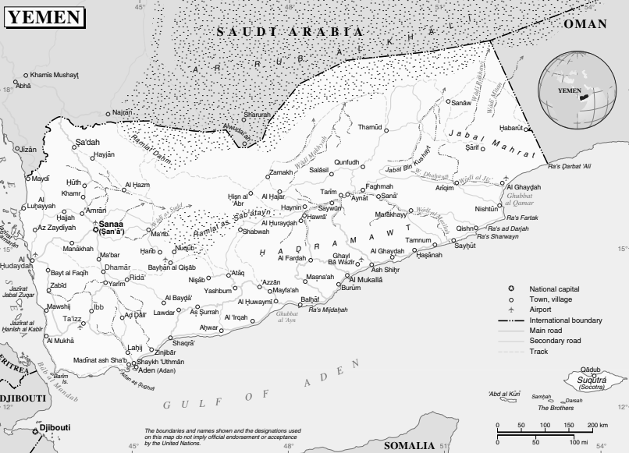
Aden Governorate
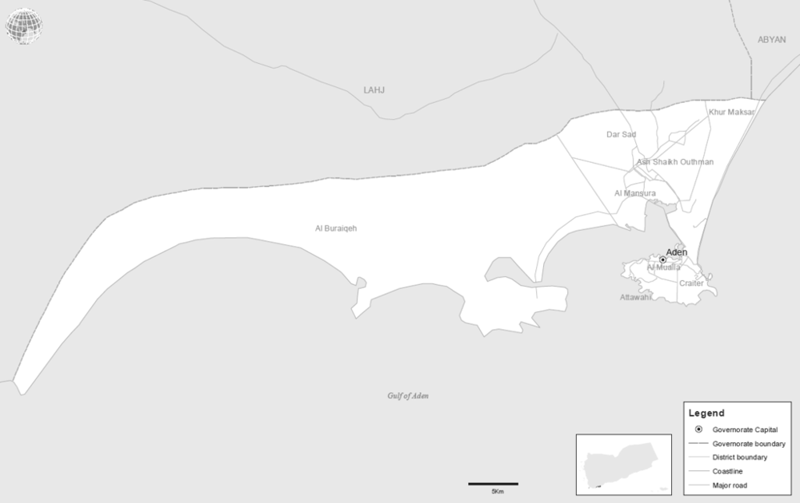
Sana’a Governorate
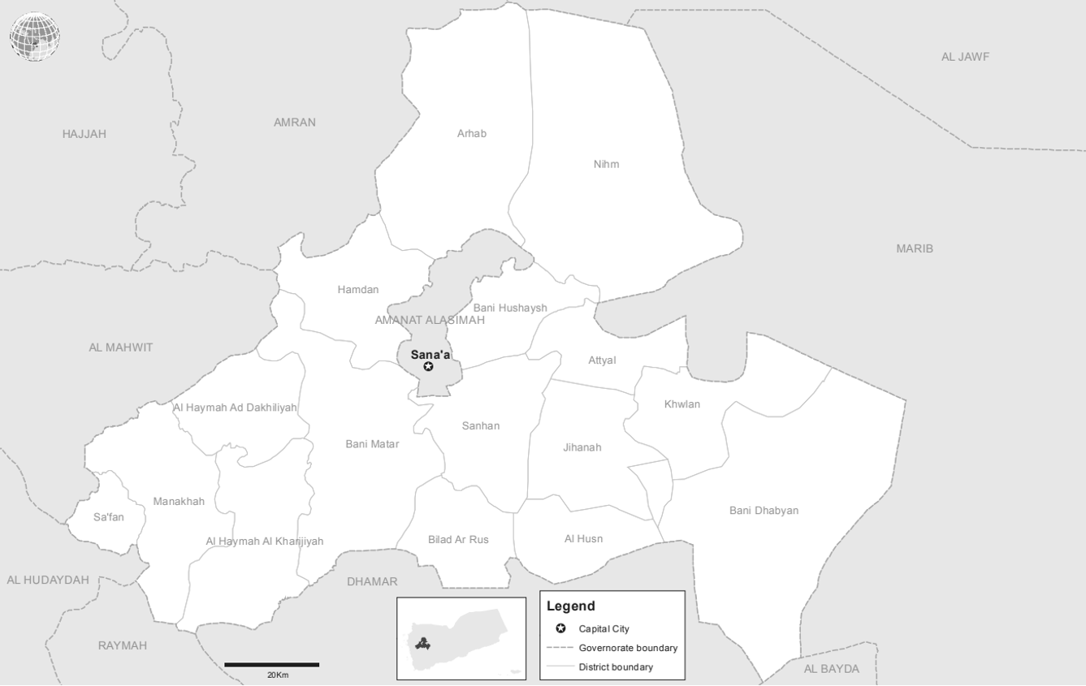
Sa’dah, Hajjah, and Al-Jawf governorates
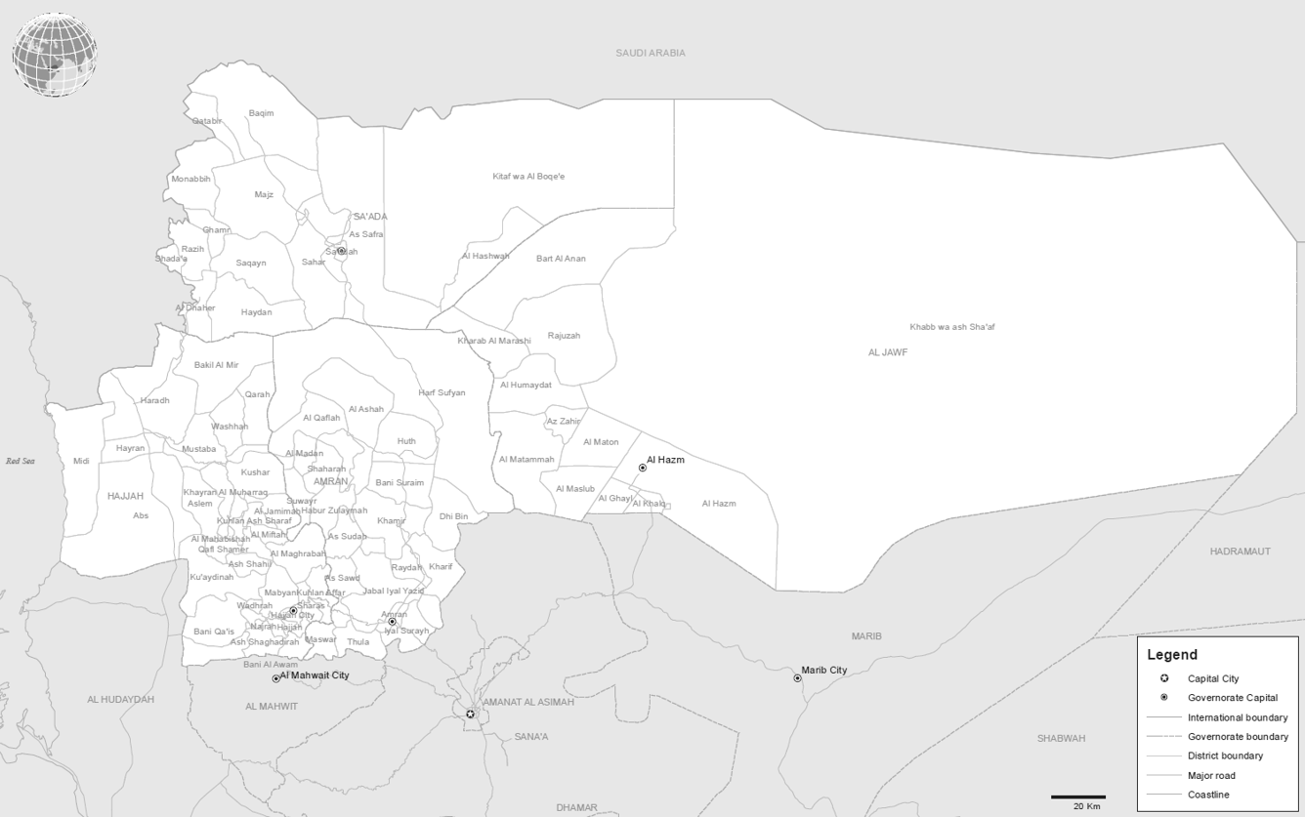
Ta’izz Governorate
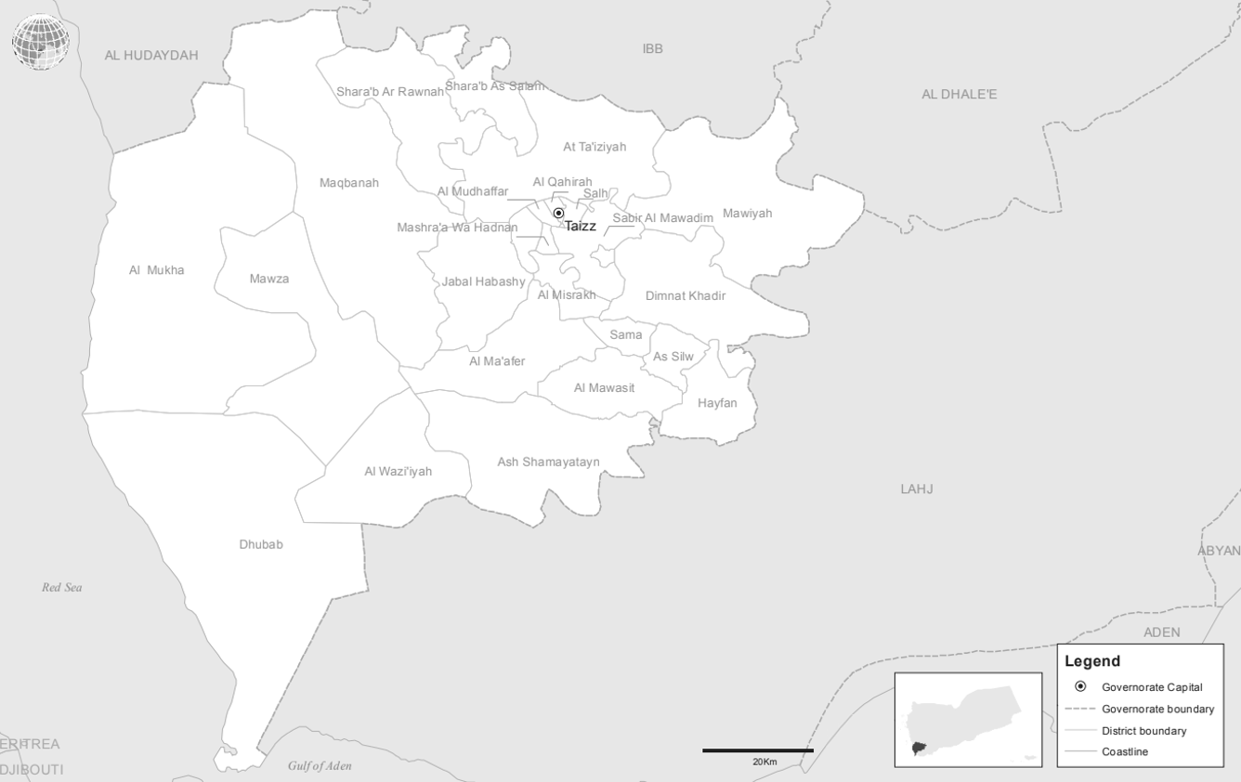
Al-Hudaydah Governorate
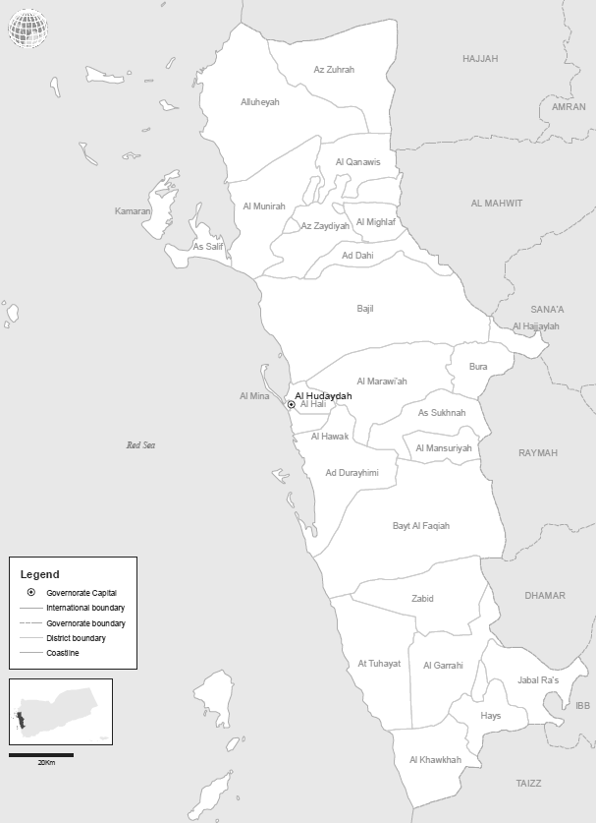

* Agreement was reached to publish the present report after the standard publication date owing to circumstances beyond the submitter’s control.
** The annexes to the present report are circulated as received, in the language of submission only.
A conference room paper containing the detailed findings of the Group of Experts (A/HRC/42/CRP.1) will be made available on its webpage at www.ohchr.org/EN/HRBodies/HRC/YemenGEE/Pages/Index.aspx.
Following its previous practice, in the present report the Group of Expert uses the term “de facto authorities” to refer to the authorities based in Sana’a, where Ansar Allah as a political movement is the main actor (supported by former President Saleh until his killing in December 2017). The de facto authorities are supported by an armed group, referred to as the “Houthis”, which includes affiliated Popular Committees. Prior to the death of President Saleh, these armed groups were referred to as “Houthi-Saleh” fighters.
At the time of its formation, in March 2015, the coalition included Bahrain, Egypt, Jordan, Kuwait, Morocco, Qatar, Saudi Arabia, Senegal, the Sudan and the United Arab Emirates. Qatar left the coalition in June 2017; Morocco reportedly left in February 2019.
See also A/HRC/42/CRP.1.
Translated as “the marginalized”, the term designates a community subjected to social caste-based discrimination. Though Yemeni law does not discriminate against the Muhamasheen, they are commonly referred to pejoratively as Al-Akhdam, meaning servants.
https://www.mod.gov.sa/en/Leaders/Minister/Pages/default.aspx.
Replaced General Abdulrahman bin Saleh al-Bunyan who had this post since 2014. See: https://www.spa.gov.sa/viewfullstory.php?lang=en&newsid=1729621.
Replaced Prince Lieutenant General Fahad bin Turki bin Abdalazeez. See: http://www.janes.com/article/78278/top-saudi-commanders-replaced.
Replaced Major General Mohammed Saleh al-Outaibi. See: https://www.spa.gov.sa/viewstory.php?lang=en&newsid=1729618.
Replaced Admiral Abduallah bin Sultan bin Mohammad al-Sultan.
Replaced Lieutenant General Mohammed bin Awadh bin Mansour Suhaim.
https://uaecabinet.ae/en/biography.
https://uaecabinet.ae/en/details/news/ chief-of-staff-of-armed-forces-promoted-to-the-rank-of-minister.
Equivalent rank of Major General listed; actual rank in Navy is Rear Admiral.
https://arabic.cnn.com/middle-east/article/2018/09/18/saudi-led-coalition-launches-offensive-strategic-yemeni-port-city; see also: https://twitter.com/amalka4_al, and https://al-ain.com/article/al-hodeidah-yemen-arab-alliance-al-taniji.
https://almawqeapost.net/news/32379; see also https://www.alquds.co.uk/%EF%BB%BF%D8%A7%D9%84%D8%A5%D9%81%D8%B1%D8%A7%D8%AC-%D8%B9%D9%86-%D9%82%D9%8A%D8%A7%D8%AF%D9%8A-%D9%81%D9%8A-%D8%AD%D8%B2%D8%A8-%D8%A7%D9%84%D8%A5%D8%B5%D9%84%D8%A7%D8%AD-%D8%A7%D8%AD%D8%AA%D8%AC.
https://www.alayyam.info/news/7V89EB9O-3B9G6V-A58A; see also https://www.alwatanvoice.com/arabic/news/2019/07/15/1259578.html; and https://www.cratersky.net/posts/19296.
https://www.skynewsarabia.com/middle-east/1065290-%D9%82%D8%A7%D9%8A%D9%94%D8%AF-%D8%A7%D9%84%D8%AA%D8%AD%D8%A7%D9%84%D9%81-%D8%A8%D8%A7%D9%84%D8%B3%D8%A7%D8%AD%D9%84-%D8%A7%D9%84%D8%BA%D8%B1%D8%A8%D9%8A-%D9%8A%D8%B9%D9%84%D9%86-%D8%AA%D8%AD%D8%B1%D9%8A%D8%B1-%D9%85%D8%B7%D8%A7%D8%B1-%D8%A7%D9%84%D8%AD%D8%AF%D9%8A%D8%AF%D8%A9-%D8%A8%D8%A7%D9%84%D9%83%D8%A7%D9%85%D9%84.
https://www.nytimes.com/2012/02/25/world/middleeast/yemen-to-get-a-new-president-abed-rabu-mansour-hadi.html.
Presidential Decree 48 (2016). https://www.facebook.com/alimohsensalehalahmar/posts/1011971235550346/.
Presidential Decree 71 (2018). https://buyemen.net/news67338.html; see also https://almasdaronline.com/article/republic-decrees-appointing-minister-of-defence-chief-of-staff-and-governor-of-aden; and UN document S/2019/83.
Ibid.
Replaced Major General Tahir Ali al-Aqaili.
Presidential Decree 182 (2018). Available on https://www.almashhad-alyemeni.com/121600.
Presidential Decree 189 (2018)available on https://almasdaronline.com/articles/162681.
https://m.facebook.com/story.php?story_fbid=2496705833693803&id=476830182348055.
Presidential Decree 154 (2016). https://www.almashhad-alyemeni.com/61690.
https://buyemen.net/news48340.html; see also https://arabic.sputniknews.com/arab_world/201508161015325772.
Presidential Decree 109 (2018) Replacing Major General Ahmed Hassan Gibran. Available on https://www.alsahwa-yemen.net/p-18771.
Yemen’s Southern Powder keg, Chatham House, Peter Salisbury, 2018. Presidential Decree 155 (2016).
Presidential Decree 20 (2018). Available on: https://www.almashhad-alyemeni.com/104230. Also, https://www.youtube.com/watch?v=tbu9zpVUNPM.
Presidential Decree 20 (2018) Replacing Major General Wae’l al-Dulaymi who had been in that position since 2015. See https://al-arabi.com/s/21767.
Presidential Decree 151 (2018). See https://al-ain.com/article/yemen-president-army.
Governor of Aden from 7 December 2015 until 27 April 2017. The Council HQ is located in the neighbourhood of al-Fath near the Gold moor coast, al-Tawahi in Aden. See STC website, available: https://stc-eu.org/ar/sueduebergangsrat/. Also see https://www.facebook.com/Aidrooszubidi; https://twitter.com/AidrosAlzubidi; https://www.facebook.com/Aidrooszubidi.
Presidential Decree 45 (2016). Available at: https://mail.almasdaronline.info/article/78623.
Interview with Major General Shallal al-Shaye, 25 April 2018. See also https://reliefweb.int/report/yemen/southern-transitional-council-and-waryemen.
Interview with Brigadier General Wadah Omer Abdul Aziz, 25 April 2018.
Presidential Decree 60 (2016).
Interview with Brigadier General Mounir Muhamoud Ali (aka Abu Yamamah), 25 April 2018.
Presidential Decree 60 (2016).
UN document S/2018/68. See also https://almasdaronline.com/articles/168745.
https://www.alayyam.info/news/756V6IC0-5G1XDM; see also https://aden-alhadath.info/amp/56956.
Presidential Decree 51 (2019). Available on: https://www.facebook.com/1784290338507592/photos/a.1795004187436207/2304017236534897/?type=3. See also: https://adenkbr.news/60171/.
https://almasdaronline.com/articles/168745.
https://aawsat.com/home/article/539666.
Presidential Decree 44 (2018). Available at: http://adenobserver.com/read-news/31235.
Presidential Decree 97 (2018). Available at: https://almahrahpost.com/news/2772#.XSxL5HllLIU.
Presidential Decree 6 (2017). See https://aden-alhadath.info/amp/12865.
https://almasdaronline.com/articles/168745; see also: https://shabwaah-press.info/news/33180.
Transport Brigade Commander Amjad al-Qahtani promoted to Brigadier General. Available at: http://yemen-now.com/news1510335.html.
According to the Yemen Ministry of Interior, available at: https://imoyemen.com/news/7775.
On 11 March 2017 appointed as a governor, Presidential Decree 20 (2017). Available at: https://almawqeapost.net/news/17543, also on http://aden-tm.net/NDetails.aspx?contid=22963.
https://www.sahafah24.net/y/show207243.html.
Presidential Decree 45 (2018). Available at: https://almandeb.news/?p=98572. See also: https://www.eremnews.com/news/arab-world/yemen/1247463.
http://www.marsad.news/news/31106; see also: https://www.al-omanaa.com/news72621.html.
Appointed on 14 November 2017, replacing Brigadier General Abdullah al-Fadhli. See UN document S2019/83, Annex 4 and UN document S/2018/68, Annex 6.
http://www.dailymail.co.uk/wires/ap/article-3009836/In-south-Yemen-militia-leader-presidents-ally.html.
http://www.mei.edu/content/popular-committees-abyanyemen- necessary-evil-or-opportunity-security-reform.
UN Document S/2019/83, Annex 4.
UN Document S/2018/68.
https://almashhadalaraby.com/news/58755; see also: https://cratersky.net/posts/7810.
UN document S/2019/83 and UN document S/2018/68, annex 6. See also https://adenkbr.news/77088/; https://almashhadalaraby.com/news/101775; and https://almashhadalaam.com/posts/6593.
https://imoyemen.com/news/5813.
Presidential Decree 6 (2017), available at http://mosnad.net/news.php?id=18513, and http://yemen-now.com/news1444016.html.
UN document S/2018/68.
Ibid.
https://shabwaah-press.info/news/2068; see also https://almashhadalaraby.com/news/35534.
Caught in the Middle: A Conflict Mapping of Ta’izz Governorate, Friedrich Ebert Stiftung, August 2018, available at: https://www.deeproot.consulting/single-post/2018/08/16/Caught-in-the-Middle-A-Conflict-Mapping-of-Taiz-Governorate (“Stiftung Conflict Mapping of Ta’izz”).
https://www.aljazeera.net/news/arabic/2017/9/26/%D8%A7%D8%B3%D8%AA%D9%82%D8% A7%D9%84%D8%A9-%D9%85%D8%AD%D8%A7%D9%81%D8%B8-%D8%AA%D8%B9%D8%B2-%D9%84%D8%B9%D8%AF%D9%85-%D8%B5%D8%B1%D9%81-%D8%B1%D9%88%D8%A7%D8%AA%D8%A8-%D8%A7%D9%84%D9%85%D9%88%D8%B8%D9%81%D9%8A%D9%86; see also https://yemen-press.com/news100441.html.
Presidential Decree 83 (2017). See http://www.alharf28.com/p-1394. See also Stiftung Conflict Mapping of Ta’izz.
Presidential Decree 79 (2018). See https://almawqeapost.net/news/37080.
Stiftung Conflict Mapping of Ta’izz.
Ibid.
Presidential Decree 189 (2018), available at https://almasdaronline.com/articles/162681.
Presidential Decree 188 (2018), available at https://almawqeapost.net/news/37080.
Replaced Major General Fadhl Hasan.
Stiftung Conflict Mapping of Ta’izz, page 27.
http://aljanadpost.net/p-3939.
Interview with Brigadier General Adnan al-Hammadi, 28 June 2019.
Presidential Decree 2 (2018). Available at: http://www.alharf28.com/p-2592.
Stiftung Conflict Mapping of Ta’izz.
Ibid.
Ibid.
https://abaadstudies.org/news-59781.html; see also https://www.facebook.com/as118833/; https://www.facebook.com/as118833/videos/1104347846371558/?v=1104347846371558; https://twitter.com/samwrax/status/1007530583902351360; https://twitter.com/mohammedalqadhi/status/1008997894404403201; http://en.adenpress.news/news/271; and https://www.janes.com/article/84439/uae-backed-yemeni-operation-making-progress-in-al-hudaydah.
https://reliefweb.int/report/yemen/who-are-uae-backed-forces-fighting-western-front-yemen.
https://abaadstudies.org/news-59781.html; see also https://almasdaronline.com/article/source-assignment-of-major-general-haitham-qassem-as-a-commander-of-a-military-council-leading-combat-operations-on-the-west-coast; andhttps://reliefweb.int/report/yemen/who-are-uae-backed-forces-fighting-western-front-yemen.
Ibid.
Ibid.
United Nations document S/2019/206.
https://abaadstudies.org/news-59781.html; see also https://almasdaronline.com/article/source-assignment-of-major-general-haitham-qassem-as-a-commander-of-a-military-council-leading-combat-operations-on-the-west-coast; and https://reliefweb.int/report/yemen/who-are-uae-backed-forces-fighting-western-front-yemen.
Ibid.
United Nations document S/2019/206.
Ibid.
Ibid.
Ibid.
Ibid.
Appointed on 18 November 2017 by President Hadi, replacing Mohammed Abdullah Kudah. See http://sanaacenter.org/publications/analysis/7606.
https://almawqeapost.net/news/32281; see also http://sanaacenter.org/publications/analysis/7606.
https://almahrahpost.com/news/5006#.XS8tuXllLIU.
https://almawqeapost.net/interviews/37936; see also http://sanaacenter.org/publications/analysis/7606.
https://www.almashhad-alyemeni.com/138905.
https://www.un.org/securitycouncil/sanctions/2140/materials/summaries/individual/abdulmalik-al-houthi.
https://almasdaronline.com/articles/165447.
https://www.yemenipress.net/archives/143698.
https://ar-ar.facebook.com/ymmalshami/.
http://en.althawranews.net/2019/05/president-al-mashat-appoints-minister-of-interior/.
https://www.yamanyoon.com/?p=55797.
S/2017/81.
http://www.yemen.gov.ye/portal/transport/%D8%A7%D9%84%D9%88%D8%B2%D9 %8A%D8%B1/tabid/705/Default.aspx.
S/2018/68; S/2019/83.
https://www.un.org/securitycouncil/sanctions/2140/materials/summaries/individual/abdullah-yahya-al-hakim.
https://www.yemenpress.org/yemen/republican-decree-appointing-abu-ali-al-hakim-head-of-general-intelligence-agency/.
https://ar.shafaqna.com/fn/278805/; http://www.alsyasiah.ye/25272.
Combat Strength of General Reserve Force consists of Presidential Protection Brigades, Special Operations Command and Missile Brigades Group.
https://www.26sep.net/news_details.php?sid=148629.
https://www.un.org/press/en/2016/sc12493.doc.htm.
https://www.yemenipress.net/archives/98721.
UN document S/2018/68.
Ibid.
Ibid.
Ibid.
UN document S/2017/81.
UN document S/2018/68.
Mahdi al-Shamat issued presidential decree 23 (2017). Available at: http://www.almahweet.net/?p=7380.
https://www.almasirah.net/details.php?es_id=12112&cat_id=3.
Ibid.
Ibid.
UN document S/2017/81.
He is also the general supervisor of al-Saleh prison. See https://www.almasirah.net/details.php?es_id=12112&cat_id=3.
Mahdi al-Shamat issued “presidential decree 156 (2018)”, see https://www.al-arabi.com/s/26667.
http://www.26sep.net/news_details.php?lng=arabic&sid=143947.
http://www.almshhadalyemeni.net/93090/.
http://www.taiz-news.com/?p=146289.
https://www.al-arabi.com/s/2062.
Ibid.
Ibid.
Stiftung Conflict Mapping of Ta’izz.
Stiftung Conflict Mapping of Ta’izz.
https://taizonline.com/news13232.html.
UN document S/2018/68.
Saleh al-Samad issued “presidential decree 24 (2017)”, available at: http://www.masa-press.net/2017/04/25/%D8%B5%D9%86%D8%B9%D8%A7%D8%A1-%D8%AA%D8%B9%D9%8A%D9%86-%D9%85%D9%87%D9%86%D8%AF%D8%B3-%D8%A7%D9%84%D8%AD%D8%B1%D9%88%D8%A8-%D8%A7%D9%84%D8%B3%D8%AA-%D9%88%D8%A7%D9%84%D9%85%D8%B7%D9%84%D9%88/; see alsohttps://shabwahalhadath.info/print/14295.
https://mancheete.com/posts/3946; see also https://www.eremnews.com/news/arab-world/yemen/1620129.
https://www.alarabiya.net/ar/arab-and-world/yemen/2018/06/14/%D8%A7%D9%84%D8%AD%D8%AF%D9%8A%D8%AF%D8%A9-%D9%85%D9%82%D8%AA%D9%84-%D9%82%D9%8A%D8%A7%D8%AF%D9%8A%D9%8A%D9%86-%D8%AD%D9%88%D8%AB%D9%8A%D9%8A%D9%86-%D9%88%D8%A7%D9%84%D9%85%D9%8A%D9%84%D9%8A%D8%B4%D9%8A%D8%A7%D8%AA-%D8%AA%D9%81%D8%AE%D8%AE-%D8%A7%D9%84%D9%85%D9%8A%D9%86%D8%A7%D8%A1.html; https://www.mandabpress.com/news49514.html.
https://www.mandabpress.com/news49514.html.
https://almoheetpress.net/news769.html.
https://almushahid.net/31743/.
UN document S/2017/81.

