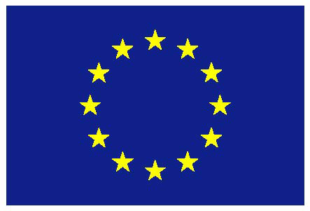
European Union

UNITED NATIONS

1th session of the Open-ended intergovernmental working group to elaborate the content of an international regulatory framework on the regulation, monitoring and oversight of the activities of private military and security companies

Intervention by the European Union

Geneva, 20 May 2019
- CHECK AGAINST DELIVERY -

1st session of the Open-ended intergovernmental working group to elaborate the content of an international regulatory framework on the regulation, monitoring and oversight of the activities of private military and security companies
EU intervention

The European Union would like to thank the Chairperson-Rapporteur and the Secretariat for the work done for the preparation of, and during, this first session.

In the past years, we have been actively and constructively engaged in bringing about a consensus in the establishing of the Open-ended intergovernmental working group. This working group was mandated to elaborate the content of an international regulatory framework on the regulation, monitoring and oversights of the activities of private military and security companies, noting that the current mandate does not make any presumptions about the ultimate legal nature of the potential future framework.

We are pleased to note that the draft Program of Work has been amended by the Chair-Rapporteur in line with the suggestions received at the meeting of the regional coordinators. We are also pleased about the openness shown by the Chairperson-Rapporteur, at the meeting of the regional coordinators, in inviting the Co-Chairs of the Montreux Document Forum and the International Code of Conduct Association (ICoCA) to participate in this session.

We hope that the same openness will be shown in the consideration of inviting relevant experts, in accordance with the HRC Resolution 36/11, in the future session(s). We believe that the participation of relevant experts throughout the session's activities would enrich the discussion and contribute to the elaboration of the content of the internationally regulatory framework in a meaningful way.

The debate on PMSCs (Private Military and Security Companies) is complex and fast evolving and demands a multifaceted response to the challenges faced. Regulations for PMSCs must be in line with existing international humanitarian law and international human rights law. We should not lose sight of our shared objective to prevent abuses, and provide remedy where abuses occur. The companies, and their clients, need a predictable environment to operate in, in respect of international human rights law and international humanitarian law. Human rights defenders and victims need reliable avenues for access to remedy, be it through judicial or non-judicial mechanisms.

Since the very beginning our position is that PMSCs do not operate in a vacuum and that legal international frameworks exist. In this regard, the Montreux Document clearly outlines existing obligations on States under international law and has played an instrumental role in steering this complex debate into the right direction. The EU joined the Montreux Document as the first regional organisation in 2012 and have been supportive of its further universalisation since. The awareness around these issues has also significantly increased in recent years within our own organisation.

We hope that the discussions in this first session of the working group mandated to elaborate the content of an international regulatory framework will continue in the direction of further complementing and strengthening existing initiatives such as the Montreux Document Forum and the International Code of Conduct Association.

We are looking forward to open and constructive discussions in this first session of the new Open-ended intergovernmental working group.

Thank you

