**Return to in-person meetings of the Council during the 44th session**

**Draft information note for NGOs**

***(Latest update: 07 July 2020 – Subject to change)***

Contents

Introduction 1

NGO Liaison Office 1

1) Dates and information 2

2) Plenary meetings 2

3) Accreditation to HRC44 2

Floating secondary badge 3

4) Oral statements and lists of speakers 3

4.1. Online registration system 3

4.2 Confirmation of speaking slots 3

4.3 Access to Assembly Hall and overflow room 4

4.4 List of speakers on HRC Extranet 4

4.5 Uploading of NGO statements in the light of COVID-19 4

4.6 Video-messages for HRC44 4

5) Side events 6

6) Reprisals 6

7) Programme of work, additional information and useful contacts 6

# Introduction

The purpose of this document is to provide information to civil society representatives considering participation in the forthcoming 44th session of the Human Rights Council. This is based on information available at this moment and will therefore be revised and updated in the coming days and weeks.

**IMPORTANT: This is a living document. All parts highlighted in yellow are subject to change.**

# NGO Liaison Office

**Due to the COVID-19 situation, the NGO Liaison Office of the Human Rights Council Secretariat will be closed. The Office stays reachable for any queries through the usual e-mail address:** [**hrcngo@ohchr.org**](mailto:hrcngo@ohchr.org)

**Due to the COVID-19 context, there will be no distribution of documents in the meeting rooms. Likewise, distribution of any material or document in the meeting rooms, at the tables and boards outside meeting rooms or elsewhere in the Palais des Nations is not permitted.**

# Dates and information

**The 44th session of the Human Rights Council is scheduled to take place from 30 June to 20 July 2020.**

The session will have to be organized in a significantly different manner from any session held in the past. As a result of the measures taken by UNOG to ensure physical distancing and prevent the spread of COVID-19, the number of people allowed in a given conference room (delegates, NGO representatives as well as UN staff) will be considerably restricted.

A new *modus operandi* has been be designed to allow plenary meetings to be held in-person, while taking into consideration the limited capacity of the chosen conference room.

# Plenary meetings

The seating arrangements of a chosen conference room will change in order to comply with physical distancing rules. To ensure the required 1.5 meters physical distance, when entering and exiting the conference rooms, separate doors have been assigned as either entrance door or exit door. Within the conference rooms, participants will be asked to keep the required 1.5 meters of physical distance at all times and to circulate clockwise only, which will be indicated by appropriate signage. The maximum occupancy of all conference rooms has been altered to ensure the required physical distance, and seats will be blocked off to discourage people from sitting too close to one another. To ensure that the required physical distance is kept at all times, delegates are expected to leave the premises as soon as the meetings are over and to avoid congregating inside and outside conference rooms.

In general, participants will be encouraged to follow Council meetings by webcast whenever possible, and to **enter the conference room only to take the floor**. NHRI and civil society representatives inscribed on the list of speakers for a given debate are prioritised to enter the conference room.

The HRC will hold its plenary meetings in **Assembly Hall** and will use **Room XII** as an overflow room to accommodate all participants who cannot be accommodated in the plenary room. Room XX might be used to accommodate panels.

# Accreditation to HRC44

All participants will need to register to the relevant INDICO meeting in order to access Palais des Nations and the meeting room(s). Please note that **only one representative per NGO can be present in the meeting room**. With the objective to keep the number of persons present at UNOG premises at the minimum, and to adhere to the instructions issued by the host country Switzerland concerning large events, access to UNOG premises will be restricted to those participating at meetings of intergovernmental and expert bodies, in accordance with relevant modalities for NGO participation.

Accreditation to the session is **required through INDICO** at the following link: <https://indico.un.org/event/20201/>. **This requirement also applies to participants through video-messages.**

When submitting a registration request, delegates are requested to indicate if they already possess an annual accreditation or if they need a temporary badge to be issued for the session only. Representatives with annual badges will be able to access the Palais des Nations upon registration, with their existing annual badge. Please indicate this and upload a picture of your badge in apposite field of registration.

### Floating secondary badge

UNOG Security will issue **one generic badge (“floating secondary badge”) for each NGO** **registered through INDICO.** This specific badge will not indicate the name of the person, but will be associated to the NGO. This badge is **not personal**, and it can therefore be shared among representatives of the same NGO. It will have to be collected, by one NGO representative, at Pregny Gate as from **Monday, 29 June at 2 PM**.

Please note that **only representatives wearing their personal badge (either Annual or temporary) as well as this secondary badge, will be able to access the meeting room**. This is a requirement by UNOG Security, aimed at ensuring that only one representative per NGO is present in the meeting room at any time. This will also allow a larger number of NGOs to have the right to access the work of the Council, while ensuring traceability and safety for all participants.

# Oral statements and lists of speakers

## 4.1. Online registration system

The online registration system for the 44th session can be found on the usual website: <https://ngoreg.ohchr.org>. The credentials used for registration to debates cannot be brought forward from the previous sessions. NGOs are therefore reminded that they need first to create a new account in the platform as soon as registrations are open for a new session, and afterwards proceed with the specific activity requests. The system is scheduled to open **on** **25 June at 2 PM.**

**IMPORTANT:** The registration to all debates will close **one day before the meeting** in which the respective debate/dialogue is scheduled to start.

**The list of speakers will be made available on the Extranet on Monday, 29 June and constantly updated.**

## 4.2 Confirmation of speaking slots

As per usual practice, all NGOs are requested to confirm their speaking slots. This applies to video-messages as well. Due to COVID-19, the confirmation is no longer possible in person (folder with lists of speakers in Room XX). Therefore, the Secretariat has established a new, electronic procedure.

In order to confirm your speaking slot, please send an email to [**ngoconfirmation@ohchr.org**](mailto:ngoconfirmation@ohchr.org) with the subject line “CONFIRMATION HRC44 - [the name of your NGO]”. In the body of the email, please state clearly:

* The name of your NGO;
* The debate(s) for which you are re-confirming your speaking slot(s);

Before re-confirming you speaking slots, please make sure you will have physical access to the Palais des Nations or you are going to deliver a video-message. Only re-confirm if you know that you are going to take the floor.

As per usual practice, **all NGOs are requested to confirm their speaking slots for each debate the working day before the meeting takes place (if the debate is on Monday, please confirm by Friday)**. **Confirmations made the same day will not be taken into account.**

## 4.3 Access to Assembly Hall and overflow room

The session will take place in Assembly Hall, except for the voting process, which will take place in Room XX. It is currently under discussion whether the panels, scheduled for HRC44, will have to take place in Room XX. Information will be provided as soon as possible.

Due to the limited number of seats available, physical access to meetings in conference rooms can only be authorized for a very small number of persons. For this reason, access to Assembly Hall may be limited only to NGOs inscribed on the lists of speakers for the debates scheduled for each meeting, and in any case only until the maximum capacity of the room is reached.

A spillover room will be put at disposal of those NGOs that might not be able to access Assembly Hall. The designated room is **Room XII**, and is going to be available from 10 am to 1 pm and from 3 to 6 pm. The session will be webcasted in the room in English only. In case any NGO, inscribed on the list of speaker for a debate, could not be accommodated in Assembly Hall, they will be asked to wait in Room XII.

Please remember that meeting participants are kindly invited to leave the premises as soon as the meetings are over, and to refrain from congregating at any time inside or outside the meeting rooms. People who have been identified as being particularly at risk should not be attending any meetings in person.

## 4.4 List of speakers on HRC Extranet

The lists of speakers for the 44th session will be made available on the HRC Extranet and constantly updated. In the light of the prohibition of printed copies in the Palais des Nations, no lists will be available in a conference room.

## 4.5 Uploading of NGO statements in the light of COVID-19

In accordance with the note verbale dated 22 May 2020 from the Director-General of UNOG, the document distribution counters will continue to be closed for the time being, and there will be no distribution of documents in conference rooms. Therefore, all NGOs are invited to upload their statements through the online registration system (at least the day before the debate takes place, in order to ensure that interpreters receive them online in advance of their delivery. Interpreters may reserve their right not to interpret oral statements, which are not made available to them).

All oral statements could also be submitted to UNOG Conference Services ([msu2@un.org](mailto:msu2@un.org)) and to [hrcstatement@ohchr.org](mailto:hrcstatement@ohchr.org) before the meetings.

**All documents must be uploaded and circulated in accessible formats** (Word document or accessible PDF).

## 4.6 Video-messages for HRC44

As during the resumed 43rd session of the Council, NGOs in consultative status with ECOSOC, with active designations in Geneva, would be given the opportunity to deliver video-statement insofar as interactive dialogues are concerned, pending further decision from the Council at the opening of HRC44 on 30 June, and additionally for panels and the adoptions of UPR outcomes as set out in HRC decision 19/119.

Video-messages will **not be sent using WeTransfer anymore** as during the resumed HRC43, but will be uploaded directly through the online registration system at <http://ngoreg.ohchr.org/>. The system has been modified so that NGOs do not have to select the type of their attendance (in person or by video) when creating their account, but **for each individual debate**.

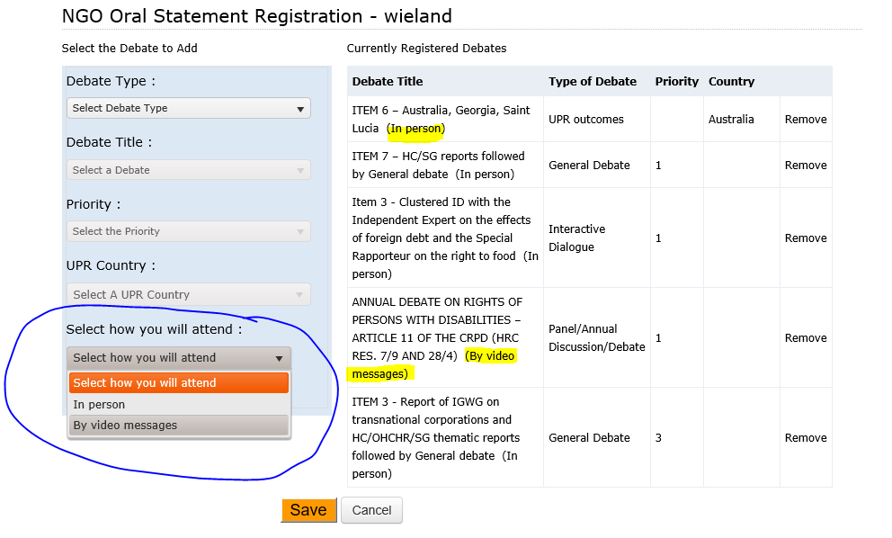

After registering for a debate, **NGOs can upload the video-message at a later stage**. It is not necessary to upload it at the moment of registration.

**Please upload the video-message at least 24 hours before the debate on the working day prior to the debate**. If the video is scheduled for Monday, please make sure to send it by Friday COB. Video-messages received past this deadline will not be displayed.

When selecting “By video-messages”, NGOs will have to enter the name of the speaker and upload the following files:

1. The transcript of the statement;
2. A scan of the passport of the speaker;
3. The accreditation letter of the speaker;
4. The video file.

Please note that the video file has to **adhere strictly** to the below time limits:

|  |  |
| --- | --- |
| ​Interactive dialogues | ​​​​​​​1 minute and 30 seconds ​​​ |
| Panel discussions | ​​​​​​​​ 2 minutes ​ ​ |
| UPR outcomes | 2 minutes |

The same [rules and technical specifications](https://ohchr.org/Documents/HRBodies/HRCouncil/GuidelinesNGOVideoStatements.pdf) for video-messages still apply.

**Please note that all participants via video-message also need to be accredited through INDICO (see point 3.1) by checking the option:**

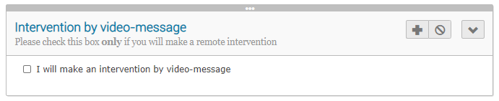

**The accreditation through INDICO is mandatory.**

*By submitting a video statement to the HRC Secretariat for the purpose of screening it during an official meeting of the HRC, the video statement will become an official record of the HRC session and considered as a UN audio-visual asset that can re-disseminated to media organizations worldwide on a non-commercial basis, in accordance with guidelines of the Department of Global Communications, and will be included in the webcast archive of the meeting on webtv.un.org.*

# 

# Side events

In accordance with information from the United Nations Office at Geneva, side events cannot be held in the Palais des Nations in the COVID-19 context. Organizers of side events may consider holding these events either outside the Palais des Nations or virtually. The Secretariat will bear no responsibility or liability whatsoever related to the holding of such events. For any questions, please do not hesitate to contact the Secretariat at: [hrcngo@ohchr.org](mailto:hrcngo@ohchr.org).

# Reprisals

Any act of intimidation or reprisal for cooperation in the context of the HRC should be promptly reported to the HRC Secretariat.

# Programme of work, additional information and useful contacts

All relevant information on the resumed 43rd and 44th session will be made available on the HRC website and the [HRC Extranet](https://extranet.ohchr.org/_layouts/15/LoginPage/login.aspx?ReturnUrl=%2fsites%2fhrc%2f_layouts%2f15%2fAuthenticate.aspx%3fSource%3d%252Fsites%252Fhrc&Source=%2Fsites%2Fhrc). Credentials for the Extranet are as follows:

* Username: **hrc extranet**
* Password: **1session**

Due to the COVID-10 situation, the NGO Liaison Office of the Human Rights Council Secretariat will be closed. The Office stays reachable for any queries through the usual e-mail address: [hrcngo@ohchr.org](mailto:hrcngo@ohchr.org)

For any doubts concerning accreditation, please address your questions to [hrcaccreditation@ohchr.org](mailto:hrcaccreditation@ohchr.org)

Due to the COVID-19 context, there will be no distribution of documents in the meeting rooms. Likewise, distribution of any material or document in the meeting rooms, at the tables and boards outside meeting rooms or elsewhere in the Palais des Nations is not permitted.

***

For updated information, consult the website: <https://www.ohchr.org/EN/HRBodies/HRC/Pages/NgoParticipation.aspx>