**In-person meetings of the Council during the 45th session**

**Information note for NGOs**

***(Latest update: 11 September 2020 – Subject to change)***

Contents

Introduction 1

NGO Liaison Office 1

1) Dates and information 2

2) Plenary meetings 2

3) Accreditation to HRC45 2

Floating secondary badge 3

4) Oral statements and lists of speakers 3

4.1. Online registration system 3

4.2 Confirmation of speaking slots 3

4.3 Access to Assembly Hall and overflow room 4

4.4 List of speakers on HRC Extranet 4

4.5 Uploading of NGO statements in the light of COVID-19 4

4.6 Video-messages for HRC45 4

Recommended technical specifications for video messages 6

5) Side events 7

6) Reprisals 7

7) Programme of work, additional information and useful contacts 7

# Introduction

The purpose of this document is to provide information to civil society representatives considering participating in the plenary of the forthcoming 45th session of the Human Rights Council. This is based on information available at this moment and will therefore be revised and updated in the coming days and weeks.

**IMPORTANT: This document is subject to change.**

# NGO Liaison Office

**Due to the COVID-19 situation, the NGO Liaison Office of the Human Rights Council Secretariat will be closed. The Office will be available for any queries through the usual e-mail address:** [**hrcngo@ohchr.org**](mailto:hrcngo@ohchr.org)

**Due to the COVID-19 context, there will be no distribution of documents in the meeting rooms. Likewise, distribution of any material or document in the meeting rooms, at the tables and boards outside meeting rooms or elsewhere in the Palais des Nations is not permitted.**

# Dates and information

**The 45th session of the Human Rights Council is scheduled to take place from 14 September to 6 October 2020.**

As a result of the measures taken by UNOG to ensure physical distancing and prevent the spread of COVID-19, the number of people allowed in a given conference room (delegates, NGO representatives as well as UN staff) will be considerably restricted. A *modus operandi* is designed to allow plenary meetings to be held in-person, while taking into consideration the limited capacity of the given conference room.

# Plenary meetings

The seating arrangements of a given conference room will change in order to comply with physical distancing rules. To ensure the required 1.5 meters physical distance, when entering and exiting the conference rooms, separate doors will be assigned as either entrance door or exit door. Within the conference rooms, participants will be asked to keep the required 1.5 meters of physical distance at all times and to circulate clockwise only, which will be indicated by appropriate signage. The maximum occupancy of all conference rooms has been altered to ensure the required physical distance, and seats will be blocked off to discourage people from sitting too close to one another. To ensure that the required physical distance is kept at all times, delegates are expected to leave the premises as soon as the meetings are over and to avoid congregating inside and outside conference rooms.

In general, participants will be encouraged to follow Council meetings by webcast whenever possible, and to **enter the conference room only to take the floor**. NHRI and civil society representatives inscribed on the list of speakers for a given debate are prioritised to enter the conference room.

The HRC will hold its plenary meetings in **Assembly Hall** and will use **Room XII** as an overflow room to accommodate all participants who cannot be accommodated in the plenary room.

# Accreditation to HRC45

With the objective to keep the number of persons present at UNOG premises at the minimum, and to adhere to the instructions issued by the host country Switzerland concerning large events, access to UNOG premises will be restricted to those participating at meetings of intergovernmental and expert bodies, in accordance with relevant modalities for NGO participation.

All participants will need to register to the 45th session through INDICO in order to access Palais des Nations and the meeting room(s). Please note that **only one representative per NGO can be present in the Assembly Hall.**

Accreditation to the session is **required through INDICO** at the following link: <https://indico.un.org/event/20200/>. The registration will open on **31 August 2020**. Please note that **this requirement also applies to those participating through video-messages.**

When submitting an accreditation request, delegates are requested to indicate if they already possess an annual or temporary grounds pass at UNOG or if they need a temporary conference badge to be issued for the session only. Representatives with annual or temporary grounds passes will be able to access the Palais des Nations, upon registration to the HRC, with their existing annual badge. Please indicate that you are already in possession of the grounds pass and upload a picture of your grounds pass in relevant field in INDICO platform.

It is mandatory, for all participants, **to provide a valid phone number**, for contact tracing purpose.

The Pass and ID Unit at Pregny Gate is open daily Mondays through Fridays, from 8:00 to 17:00, for any badge issuance. It is recommended to bring proof of registration for ease of access (Indico badge, Indico registration email, Indico Event Pass).

### Floating secondary badge

UNOG Security will issue **one generic badge (“floating secondary badge”) for each NGO** **with** **representatives** **registered through INDICO.** This specific badge will not indicate the name of the person, but will be associated to the NGO. This badge is **not personal**, and it can therefore be shared among representatives of the same NGO. It will have to be collected by one NGO representative at Pregny Gate **as of Friday, 11 September, from 2 PM.**

Please note that **only representatives wearing their personal badge (either annual/temporary grounds pass or a conference badge) as well as the secondary floating badge, will be able to access the Assembly Hall**. This is a requirement by UNOG Security, aimed at ensuring that only one representative per entity is present in the Assembly Hall at any time. This limitation will allow a larger number of NGOs to be present in the Assembly Hall while ensuring traceability and safety of all participants.

# Oral statements and lists of speakers

## 4.1. Online registration system

The online registration system for the 45th session can be found on the usual website: <https://ngoreg.ohchr.org>. The credentials used for registration to debates cannot be brought forward from the previous sessions. NGOs are therefore reminded that they need first to create a new account in the platform as soon as registrations are open for a new session, and afterwards proceed with the specific activity requests. The system opened **on** **Tuesday, 8 September at 2 PM.**

**IMPORTANT:** The registration to all debates will close **one day before the meeting** in which the respective debate/dialogue is scheduled to start.

**The lists of speakers for the first week were made available on the Extranet on Wednesday, 9 September. All the lists will be posted in due time and constantly updated.**

## 4.2 Confirmation of speaking slots

As per usual practice, all NGOs are requested to confirm their speaking slots. This applies to video-messages as well. Due to COVID-19, the confirmation is no longer possible in person (folder with lists of speakers in Room XX). Therefore, the Secretariat has established an electronic procedure.

In order to confirm your speaking slot, **please send an email to** [**ngoconfirmation@ohchr.org**](mailto:ngoconfirmation@ohchr.org) with the subject line “***CONFIRMATION HRC45 - [the name of your NGO]***”. In the body of the email, please state clearly:

* The name of your NGO;
* The debate(s) for which you are re-confirming your speaking slot(s);

Before re-confirming you speaking slots, please make sure you will have physical access to the Palais des Nations or you are going to deliver a video-message. Only re-confirm if you know that you are going to take the floor.

As per usual practice, **all NGOs are requested to confirm their speaking slots for each debate the working day before the debate takes place.** For debates taking place on a Monday, please confirm by Friday. **Confirmations made the same day will not be taken into account.**

## 4.3 Access to Assembly Hall and overflow room

The session will take place in **Assembly Hall**, except for the voting process, which will take place in Room XX. Due to the limited number of seats available, physical access to meetings in conference rooms can only be authorized for a very small number of persons. For this reason, **access to Assembly Hall may be limited only to NGOs inscribed on the lists of speakers for the debates scheduled for each meeting**, and in any case **only to one representative per NGO wearing the secondary floating badge** and **until the maximum capacity of the room is reached**.

A spillover room will be put at disposal of those NGOs that might not be able to access Assembly Hall. The designated room is **Room XII**. The session will be webcast in the room. In case any NGO, inscribed on the list of speaker for a debate, could not be accommodated in Assembly Hall, they will be asked to wait in Room XII.

Please remember that meeting participants are kindly invited to leave the premises as soon as the meetings are over, and to refrain from congregating at any time inside or outside the meeting rooms. People who have been identified as being particularly at risk should not be attending any meetings in person.

With regard to masks, **all persons physically present inside conference rooms are requested to wear a face covering mask**, which they will be required to supply themselves. **Masks may be removed when the person is taking the floor.**

## 4.4 List of speakers on HRC Extranet

The lists of speakers for the 45th session will be made available on the HRC Extranet and constantly updated. In the light of the prohibition of printed copies in the Palais des Nations, **no list will be made available in the conference room**.

## 4.5 Uploading of NGO statements in the light of COVID-19

In accordance with the note verbale dated 22 May 2020 from the Director-General of UNOG, the document distribution counters will continue to be closed for the time being, and there will be no distribution of documents in conference rooms. Therefore**, all NGOs are invited to upload their statements through the online registration system at least the day before the debate takes place**, in order to ensure that interpreters receive them online in advance of their delivery. Interpreters may reserve their right not to interpret oral statements, which are not made available to them in due time.

All oral statements should also be submitted to UNOG Conference Services ([msu2@un.org](mailto:msu2@un.org)) and to [hrcstatement@ohchr.org](mailto:hrcstatement@ohchr.org) before the meetings.

**All transcripts must be uploaded and circulated in accessible formats** (Word or accessible PDF).

## 4.6 Video-messages for HRC45

In the light of COVID-19 pandemic, NGOs in consultative status with ECOSOC, with active designations in Geneva, would be given the opportunity to deliver video-statement insofar as interactive dialogues are concerned, and for panels and the adoptions of UPR outcomes as set out in HRC decision 19/119.

**Video-messages will have to be uploaded directly through the online registration system** at <http://ngoreg.ohchr.org/>. The system has been modified so that NGOs do not have to select the type of their attendance (in person or by video) when creating their account, but **for each individual debate**.

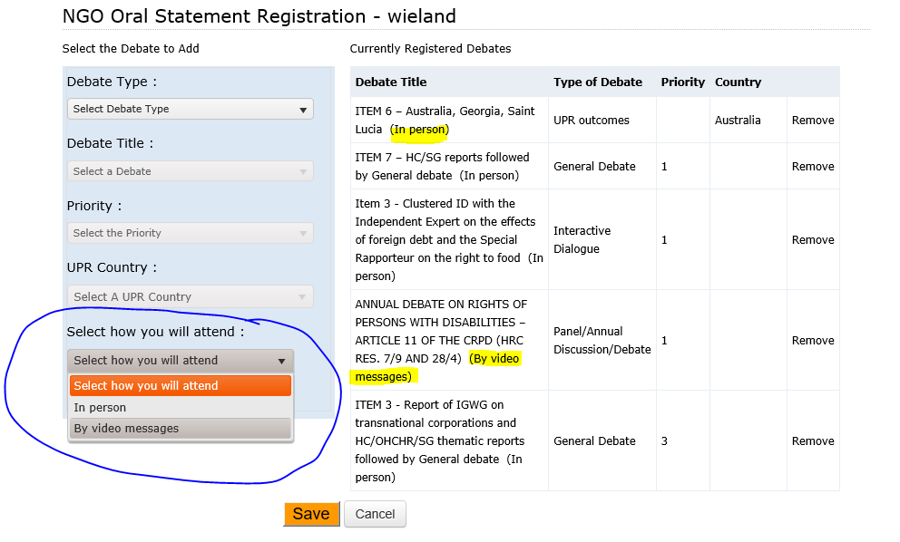

After registering for a debate, **NGOs can upload the video-message at a later stage**. It is not necessary to upload it at the moment of registration.

**The deadline to upload the video-message is at 6PM on the day prior to the debate.** If the debate is scheduled to take place on a Monday, please make sure to upload your video-message **by** **Friday**. Video-messages received past this deadline will not be displayed.

When selecting “By video-messages”, NGOs will have to enter the name of the speaker and upload the following files:

1. The transcript of the statement;
2. A scan of the passport of the speaker;
3. The accreditation letter of the speaker;
4. The video file.

As mentioned before, these files can be uploaded at a later stage. Please note that the video file has to **adhere strictly** to the below time limits:

|  |  |
| --- | --- |
| ​Interactive dialogues | ​​​​​​​1 minute and 30 seconds ​​​ |
| Panel discussions | ​​​​​​​​ 2 minutes ​ ​ |
| UPR outcomes | 2 minutes |

After registration, it is still possible to switch between video-message or in person attendance by clicking on the attendance type you would like to change, and then save:

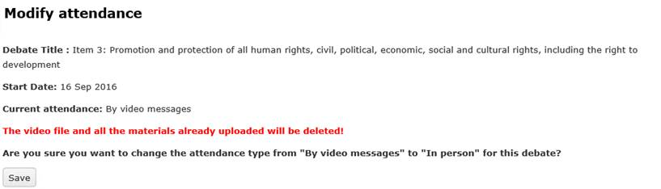

**Captioning of the video is strongly encouraged** in order to ensure accessibility of persons with disabilities. In order to facilitate this procedure, NGOs are able to upload a specific file for subtitles directly in the online registration system. This is not a mandatory field and it can be left blank:

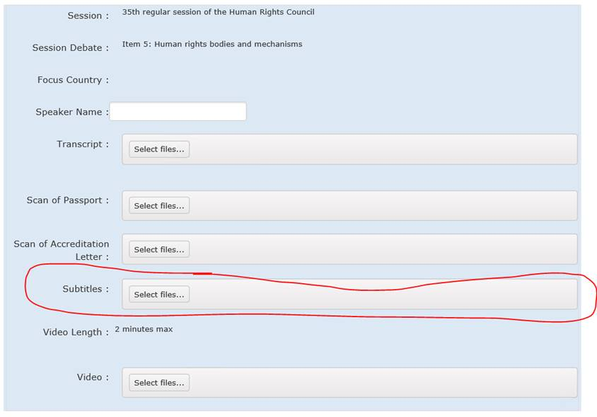

**Guidelines on how to produce subtitles** are available at the HRC NGO Participation page, under *“Point 8. Participating in the Human Rights Council by video message”*.

**Please note that all participants via video-message also need to be accredited through INDICO (see point 3) by checking the option:**

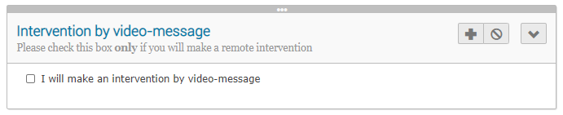

**The accreditation through INDICO is mandatory.**

*By submitting a video statement to the HRC Secretariat for the purpose of screening it during an official meeting of the HRC, the video statement will become an official record of the HRC session and considered as a UN audio-visual asset that can re-disseminated to media organizations worldwide on a non-commercial basis, in accordance with guidelines of the Department of Global Communications, and will be included in the webcast archive of the meeting on webtv.un.org.*

### Recommended technical specifications for video messages

1. **MP4**The MP4 or MPEG-4 file format is a digital multimedia container format most commonly used to store video and audio, but it can also be used to store other data such as subtitles and still images.
   * video encoding: **H.264**
   * audio encoding: **Min 44100Hz**
   * video resolution: **Min 640x480**

**Max 1920x1080**

**Frame rate 24, 30 fps**

1. **MOV**MOV is the Apple Inc. Quicktime multimedia container file that contains one or more tracks, each of which stores a particular type of data: audio, video, effects, or text (e.g. for subtitles).
   * video encoding: **H.264**
   * audio encoding: **Min 44100Hz**
   * video resolution: **Min 640x480**

**Max 1920x1080**

**Frame rate 24, 30 fps**

1. **AVI/WMV**Audio Video Interleaved (AVI) is a multimedia container format introduced by Microsoft that can contain both audio and video data in a file container that allows audio-with-video playback.

Windows Media Video (WMV) is a video compression format for several proprietary codecs developed by Microsoft.

* + video encoding: **WMV3** (Windows Media Video 9)
  + audio encoding: **Min 44100Hz**
  + video resolution: **Min 640x480**

**Max 1920x1080**

**Frame rate 24, 30 fps**

When using a smartphone, shoot the video in landscape (horizontal) mode.

Please note that no professional equipment is required to record video messages. Most modern consumer electronics (smartphones, laptops, etc.) are capable of recording video that complies with the specifications.

**All files will be played using VLC Media Player.** **Please note that the Secretariat does not bear responsibility if files that do not comply with the recommended specifications cannot be displayed in our audio-visual system.**

# Side events

In accordance with information from the United Nations Office at Geneva, **side events cannot be held in the Palais des Nations in the COVID-19 context**. Should NGOs organise events either outside the Palais des Nations or virtually, the Secretariat will bear no responsibility or liability whatsoever related to the holding of such events.

For further information, please contact the Secretariat at: [hrcngo@ohchr.org](mailto:hrcngo@ohchr.org).

# Reprisals

Any act of intimidation or reprisal for cooperation in the context of the HRC session should be promptly reported to the HRC Secretariat.

# Programme of work, additional information and useful contacts

All relevant information on the 45th session is made available on the HRC website and the [HRC Extranet](https://extranet.ohchr.org/_layouts/15/LoginPage/login.aspx?ReturnUrl=%2fsites%2fhrc%2f_layouts%2f15%2fAuthenticate.aspx%3fSource%3d%252Fsites%252Fhrc&Source=%2Fsites%2Fhrc). Credentials for the Extranet are as follows:

* Username: **hrc extranet**
* Password: **1session**

For any further questions or information, please contact us through the usual e-mail address at [hrcngo@ohchr.org](mailto:hrcngo@ohchr.org) For any doubts concerning accreditation, please address your questions to [hrcaccreditation@ohchr.org](mailto:hrcaccreditation@ohchr.org)

***

For updated information, consult the website: <https://www.ohchr.org/EN/HRBodies/HRC/Pages/NgoParticipation.aspx>